Network Connectivity Check

**Project Overview: Network Connectivity Check**

This project automates the process of verifying network connectivity to a list of predefined IP addresses. It logs the results, alerts the administrator in case of issues, and helps in maintaining proactive network monitoring.

**1. Features**

* Reads a list of IP addresses from a file (ip_list.txt).
* Pings each IP address to check connectivity.
* Logs results (reachable/unreachable) to connectivity.log.
* Sends an email alert to the administrator if any IP is unreachable.

**2. File Structure**

**a. Script File (check_connectivity.sh)**

The main shell script performs the connectivity checks and sends alerts.

**b. IP Address File (ip_list.txt)**

Contains the list of IP addresses to be monitored.

**c. Log File (connectivity.log)**

Logs the results of each connectivity check.

**3. Implementation**

**IP Address File:**

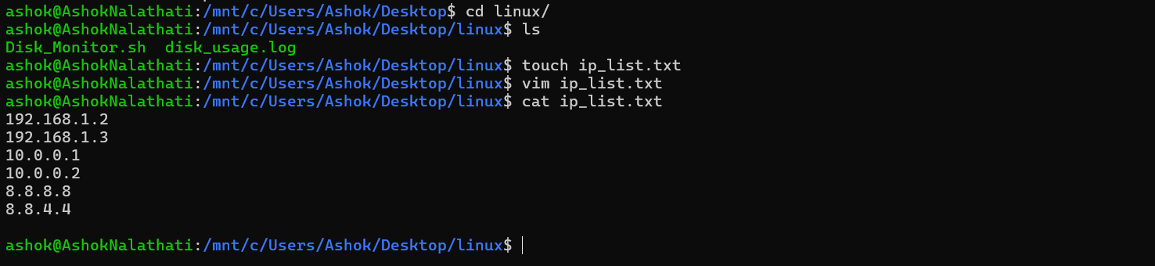

**Script:**

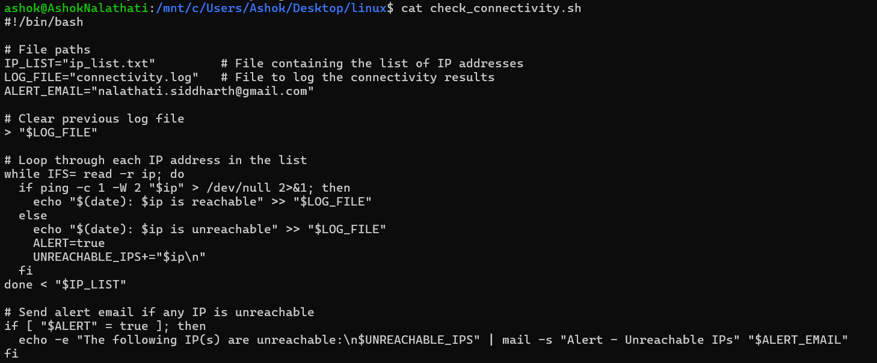

**Running the Script:**

**Log File:**

