**LCD Initialization Flow:**

The ILI9341 software initialization procedure is outlined below:

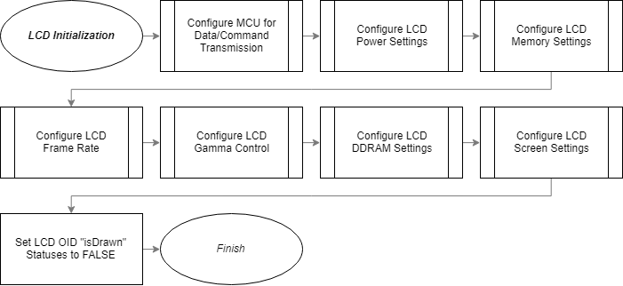

The processes in LCD Initialization are:

1. Configure MCU for Data/Command Transmission
   * Enable Master-MCU SPI Interface/control pins for Master-Slave transmissions.
2. Configure LCD Power Settings
   * Set several ILI9341 voltage-control parameters.
3. Configure LCD Memory Settings
   * Sets ILI9341 memory access control and pixel format.
4. Configure LCD Frame Rate
   * Sets ILI9341 normal-operating frame rate.
5. Configure LCD Gamma Control
   * Selects ILI9341 gamma curve and its positive/negative gamma corrections.
6. Configure LCD DDRAM Settings
   * Sets ILI9341 LCD address-accessing settings.
7. Configure Screen Settings
   * Sets ILI9341 screen update-scheme/orientation.
8. Set LCD OID “isDrawn” Statuses to FALSE
   * Sets driver OID objects default “isDrawn” status to FALSE.