Abstract

This lab assignment has us taking one of our previous lab assignments and integrating the calculator with php. We will perform the calculations on the side of the server and then post back the answers to the page for the user to view.

Steps of the Process

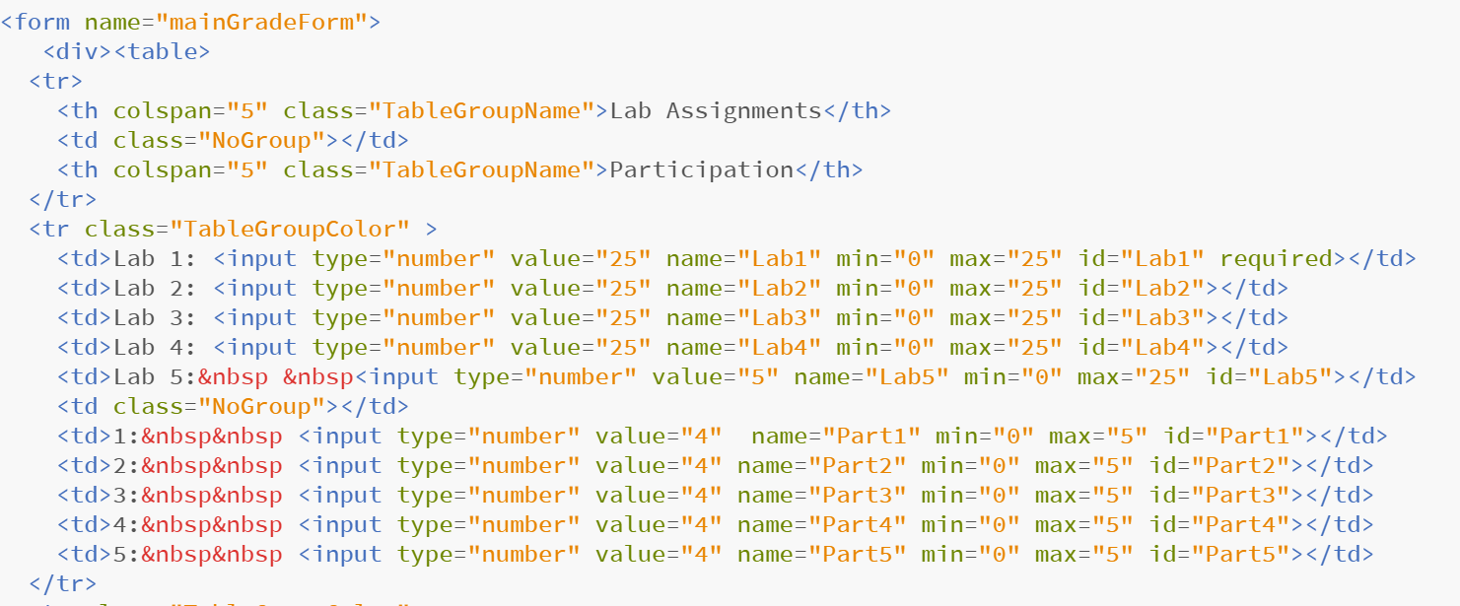

This is the code for my html page that I started with. I have tables set up for the page so that it looks nice.

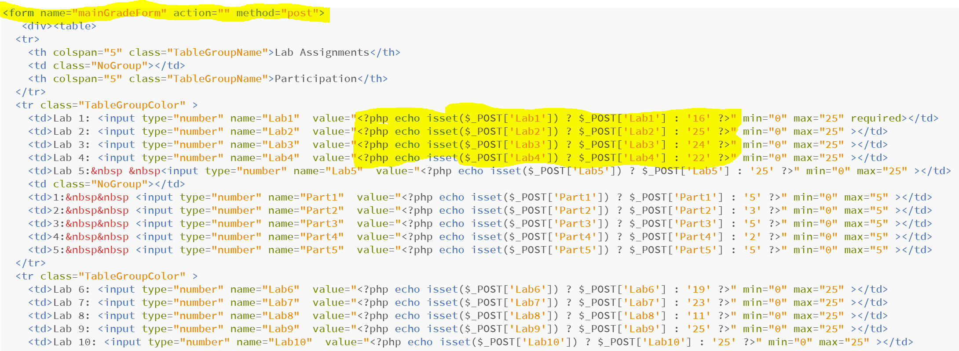

I then went in and inserted php into my table and used the isset function to make sure that the variables were collected when they were entered. I also use this to post back to the page the previous values after the page is submitted so that you can change the values. I left the action blank so that it would reload the page.

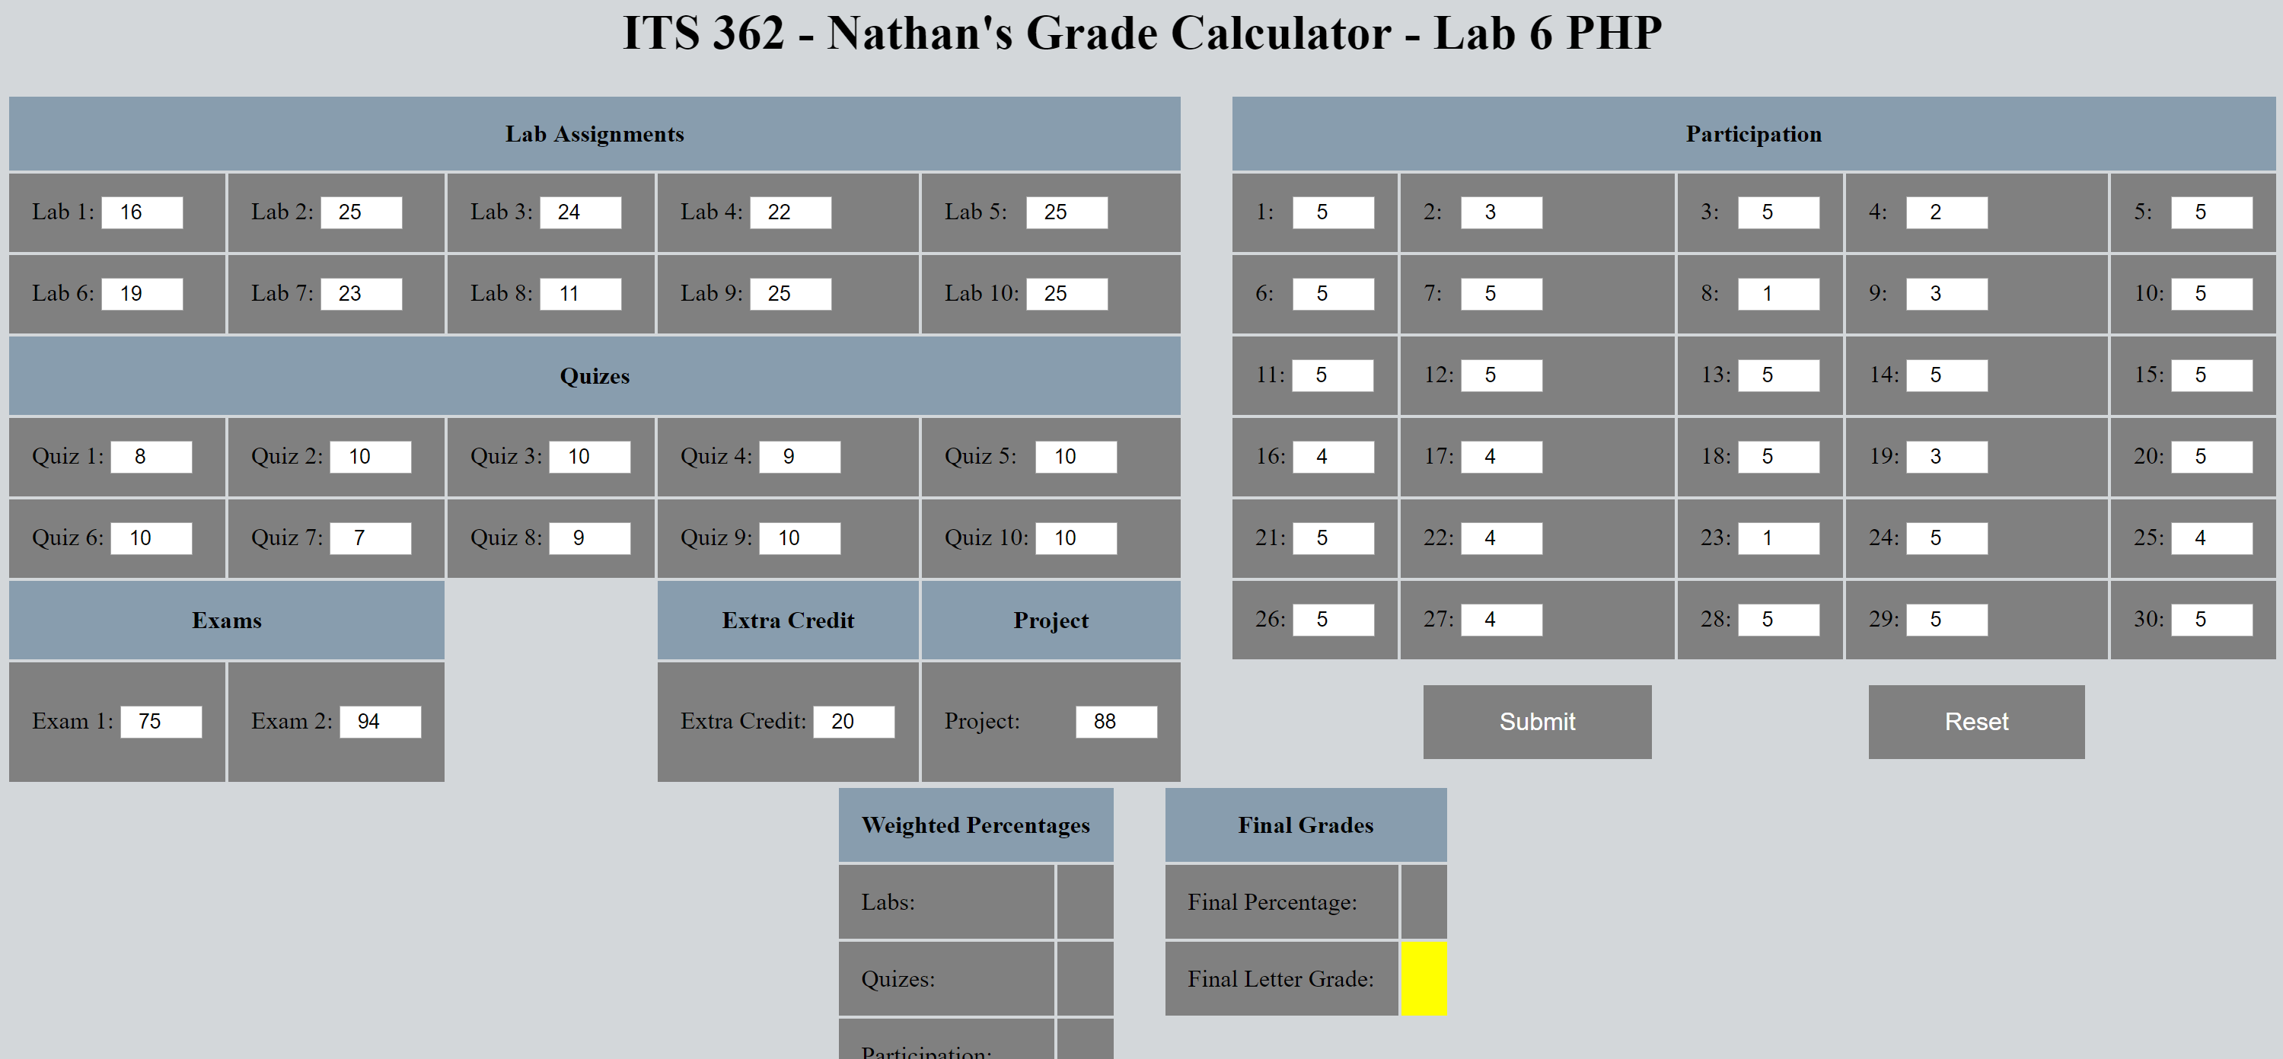

This is what my page looks like with the values loaded in to start so that you don’t have to set them yourself.



My submit button on my page.

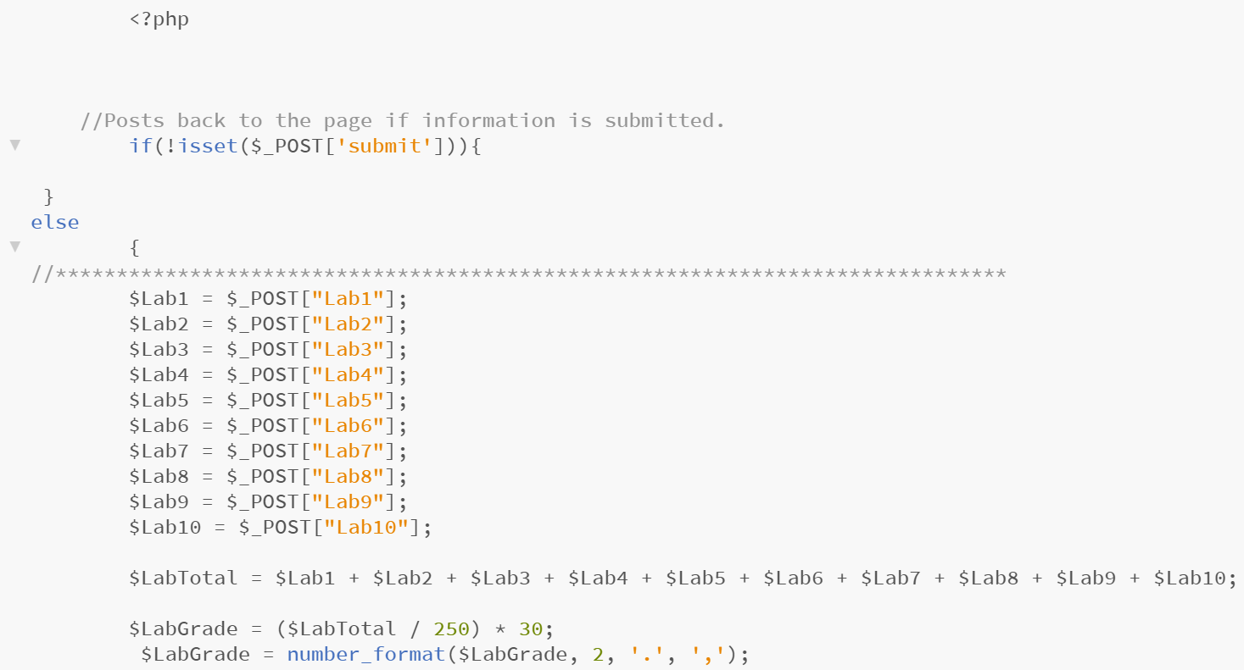

I then do the binding of values to my submitted values and calculate the data that is entered.



This is how I calculate the final grade for the class.

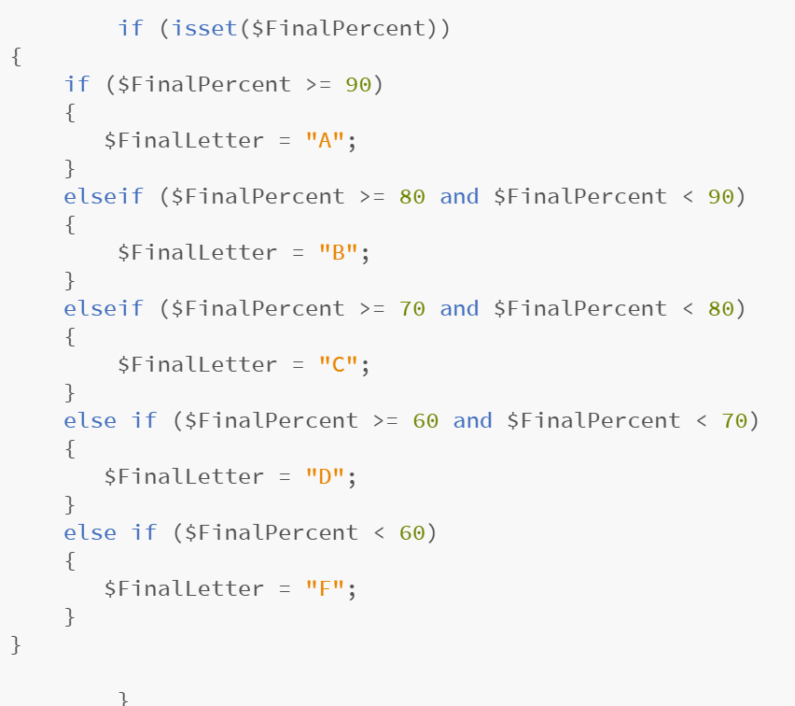

I then figure out what percent correlates to the correct letter grade the student would receive.

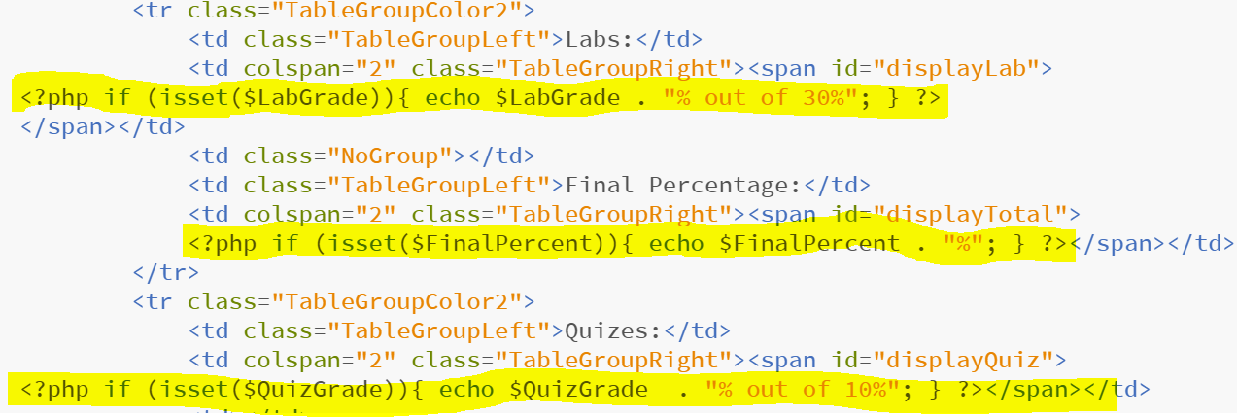

I then output the values that I calculated server side and echo those back out if they are not empty.

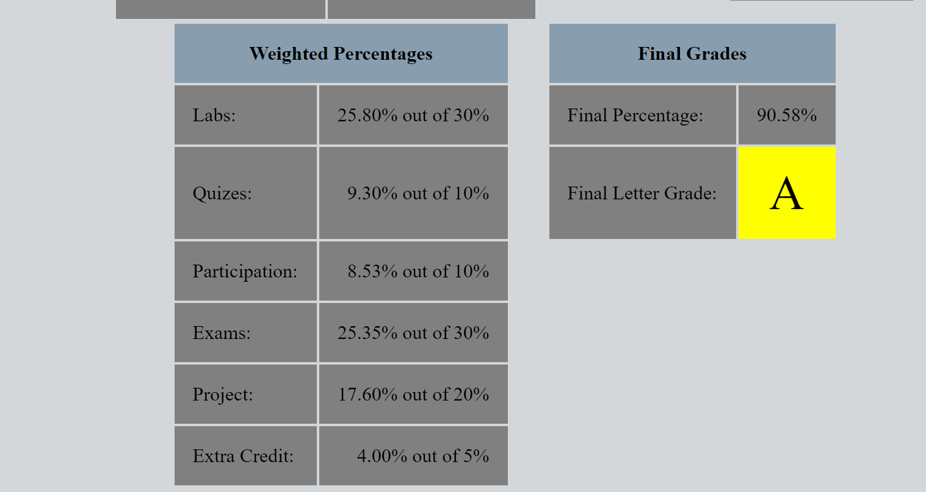

This is what the final output of my document looks like when it ran and displayed with a POST on the clients browser.

Conclusion

This lab was not too difficult once you figure out the interaction between the server side and client side. I had a hard time working in my VM which led me to be delayed. I contemplated not turning this in because of how late it was going to be, but finally decided I needed to absolutely turn it in. I had a hard time getting my own xampp server running on my laptop as well. VM’s this semester has not been treating me well. Overall I think my php calculator turned out quite nice.