Cognizant Technology Solutions

Heap Dump Analysis
Version 1.0



 | Prepared By / Last Updated By | Reviewed By | Approved By
Name | S K Bharadwaj Samavedam | Shankar Krupa Sagari
Role | PA | SA
Signature

- Table of ContentsBasics of heap
  - What is Heap?
  - What is Heapdump?
  - When to Generate?
  - How to Generate?
- HeapDump Analysis
  - Introduction
  - How does it work?
  - Text Dump Structure
  - How do I Run Heap Analyzer?
  - Conclusion
- Change Log

1. Basics of Heap

1.1 What is heap?
The Heap is a large contiguous swath of memory reserved by the JVM at startup which it manages. All objects created by your application are allocated in the heap.

The Heap is usually broken in to generations.

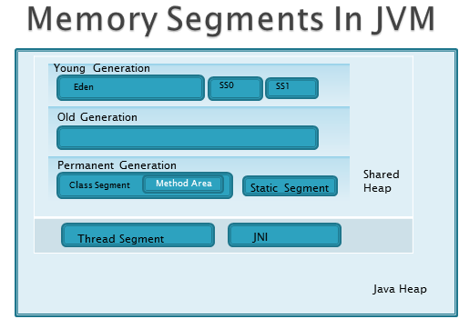

- Java heap is partitioned into shared heap and thread/resources segment
- Shared Heap module contains, young generation, old generation and permanent generation.
- Garbage collection will happen only in shared Heap
- Shared Heap
  - Young Generation: This is the segment where initiated object is stored. Young generation contains
    - Eden
    - Two survival spaces SS0 and SS1
  - Old Generation : This is the segment where initiated object is stored and all the objects which are alive even after some cycles of the minor garbage collection
  - Permanent Generation : This segments contains Class segment and static segment
    - Class Segment: This contains the class meta data. The size of the meta data will decide where the initiated object is to be stored, either in Eden or Old generation.
- Note : All string objects are initiated in the class segment
    - Static Segment: This contains all the static details of the class.

1.2 What is heapdump?
A heap dump is a snapshot of JVM memory. It shows the live objects on the heap along with the references between objects .It is used to determine memory usage patterns and memory leak suspects.

1.3 When to generate?

- Memory leak in the java heap produce java.lang.OutOfMemoryError exceptions in log files. However not all out of memory are caused by java heap memory leaks. Out of memory can also be caused by following conditions.
- Java heap fragmentation .This fragmentation occurs when no contiguous chunk of free heap space is available from which to allocate java objects. Various causes of this problem exist including the presence of pinned or dosed objects or because repeated allocation of large objects.
- Note: Dosed objects are the immovable objects on the Java heap. GC does not move these objects during compaction. These are the major cause of heap fragmentation.

- Memory leaks in native heap .This problem occur when a native component, like DB2 connections, is leaking.
- The condition when the allocated heap memory is insufficient. Every application or technology has basic heap memory requirement. If that is not fulfilled, then it is certain that out of memory error will occur

1.4 How to generate?
1. Automatic:
- To enable automated heap dump generation, enable in administrative console of particular Application server.
- When the Java heap is exhausted, Java Virtual Machine triggered generation is enabled by default.
- To enable signal-based Java Heap dumps, the IBM_HEAPDUMP=TRUE environmental variable or the appropriateJAVA_DUMP_OPTS must be set.
- Naïve Fatal Error /Out of memory occurs will generate Heap dumps.
- They are produced also if the JVM terminates unexpectedly.
2. Manual
- By sending a signal to the JVM from the operating system
- By using the HeapDump() method inside Java code that is being executed
- Use kill -3 (PID: Process ID) on Unix/Linux machines.
- Using WASAdmin tool in windows.

Invoke the generateheapdump operation on a JVM Mbean ,for example .
Find JVM objectname:<wsadmin> set objectName [ $AdminControl queryNames WebSphere:type =JVM,process=<servername> ,node =<nodename>,*]
Invoking the generateheapdump operation on JVM MBean : <wsadmin >

$AdminControl invoke $objectName generateHeapDump.

2.0 Heap Dump Analysis

2.1 Introduction
- Java Heap dump contains a list of all the objects that are in a Java heap.
- Java Heap dumps could be very large (as much as giga bytes)
- It's not always easy to analyze large dumps.
- IBM HeapAnalyzer can analyze IBM Java heap dumps from Java SDK 1.3.1 and 1.4.x.
- IBM Heap Analyzer is provided “as-is”.
- Heap dumps are of different types like .PHD, HPROF, Binary and other.
File format .PHD file into consideration for analysis. And the tool used is IBM Heap Analyzer Version (4.0.6) for heap dump analysis.

Download the .jar file from internet.
https://www.ibm.com/developerworks/community/groups/service/html/communityview?communityUuid=4544bafe-c7a2-455f-9d43-eb866ea60091

Click on download Heap Analyzer

ICONS
Class
Instance
Array

2.2 How does it work?
- Reads IBM Java heap dump file and parse each object/class information.
- Creates graphs based on parsed information.
- Creates trees based on the graphs.
- Runs Java heap leak detection engine to display Suspected Java heap leak areas.

2.3 Text Dump Structure
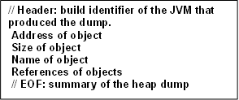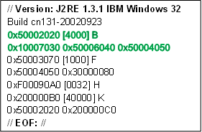
Structure of Heapdump:
Heapdump name convention: heapdump. <Date>.<timestamp><PID>.phd
Example: Heapdump.10102012.45869.phd
Note: PID is the process ID.
Creating a graph:

Text Dump:
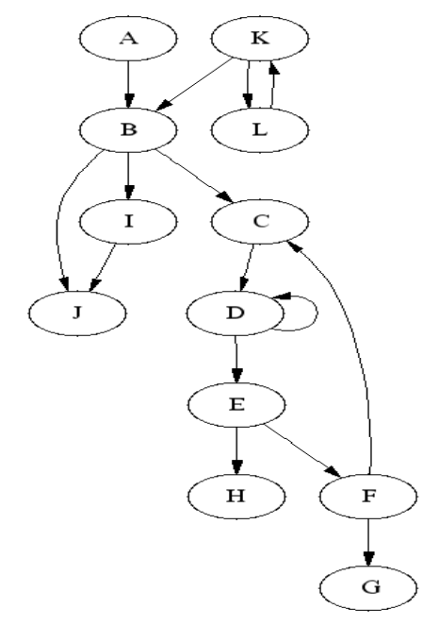

0x30000080 [10000] G
0x50001010 [6000] A
0x50002020
0x50002020 [4000] B
0x10007030 0x50006040 0x50004050
0x50003070 [1000] F
0x50004050 0x30000080
0x50004050 [1104] C
0x50005060
0x50005060 [1032] D
0x50003090 0x50005060
0x50006040 [1904] I
0x10007030
0x10007030 [1024] J
0x50003090 [504] E
0xF00090A0 0x50003070
0xF00090A0 [0032] H
0x200000B0 [40000] K
0x50002020 0x200000C0
0x200000C0 [8000] L
0x200000B0

0x50001010 [6000] A
0x50002020
0x50002020 [4000] B
0x10007030 0x50006040 0x50004050

Note: JVM will take care of mapping the address (0x10007030 [1024] ) and the object instance(J) in a Hash map as key – value pair .
From the above snippet of dump, object A is having reference with object B. Similar kind Object B is having reference with C,I,J. Graph is plotted based the references .
- Definitions:
- Root object: An object for which no (different) object holds a reference.
- Parent object: An object (for example, A) that holds at least one reference to some (different) object (for example, B). In this case, A is said to be the parent of B.
- Owner object: If an object has more than one parent object, a parent object is chosen as owner object. Total size is calculated only with owner objects.
- Child object: An object (for example, B) for which at least one (different) object (for example, A) holds a reference. In this case B is said to be the child of A.
- Type: Collection of same objects
- Size: The size of an object is the amount of memory that is required to hold that object in memory.
- Total size: The subtree size of an object is the sum of its size and the sizes of all the objects that it reached from its children. Note that each object is assigned a unique parent and root during processing.
If there’s substantial difference in total size between a parent and its child, it’s called a total size drop.

2.4 How do I run HeapAnalyzer
- Usage <Java 2 SDK path>java –Xmx[heapsize] –jar
- ha<HeapAnalyzer version>.jar
- For example, java –Xmx<1024> –jar ha135.jar

When this java.lang.OutOfMemoryError while you are processing heapdumps,
Please try increasing the maximum heap size (-Xmx) value to give the JVM more memory.
Heapdump name convention: heapdump. <Date>.<timestamp><PID>.phd
Example: Heapdump.10102012.45869.phd

- Open the heap dump in the tool.

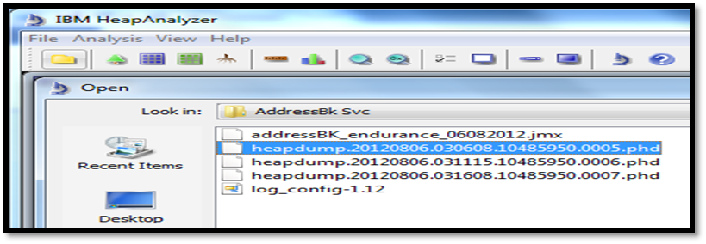

The above heap dumps are have taken in different timings. Choose any of the available heapdumps for analysis.
- Processing a heap dump:
- Progress is shown during processing heapdump.
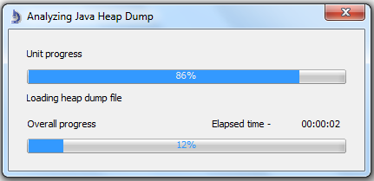

- After opening the heapdump it looks like this.
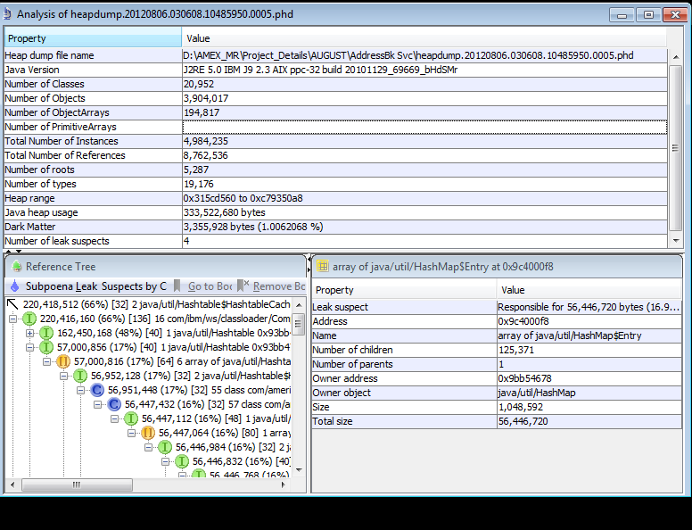
Properties pane
Node Details pane
Reference Tree view

Node Details pane
Reference Tree view
- Memory leak suspects are compiled under “Subpoena Leak Suspect(s)” menu in Tree View.
Click on Analysis menu and select Tree view menu item to display heap tree.

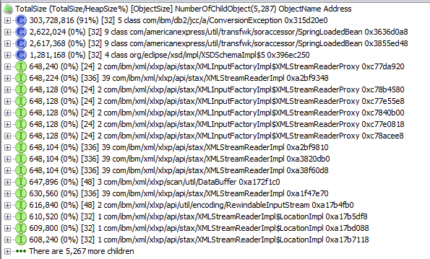

The following is tree view of the heapdump.

Each tree node as in the following format:
TotalSize (TotalSize/HeapSize %)[ObjectSize] NumberOfChildObject(Number of root objects) Name Address

Detail node information:
You can search for total size drop between parent and child or you can find an address by selecting a node and clicking on right mouse button.

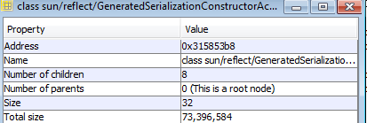
Node Information:
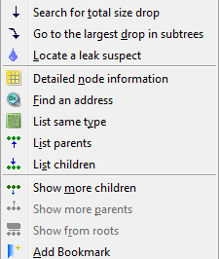

Locate areas where java heap suspected. Report show that 91% heap size utilized in the above heap dump.
- To find the exact leak suspect, follow below steps.
- Right click on the class to suspect a leak.
- Select locate a leak suspect.
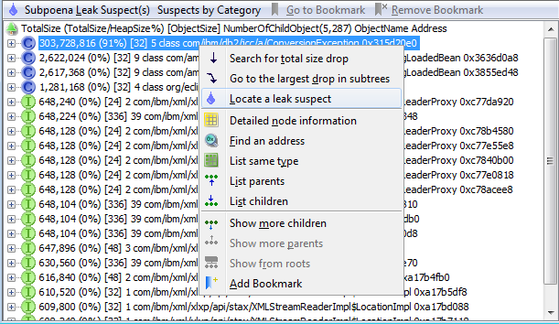

2.5 Conclusion
Leak Suspect Screen Shot:
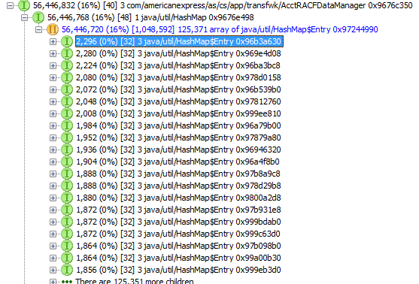
// Header: build identifier of the JVM that produced the dump.
Address of object
Size of object
Name of object
References of objects
// EOF: summary of the heap dump

// Header: build identifier of the JVM that produced the dump.
Address of object
Size of object
Name of object
References of objects
// EOF: summary of the heap dump

Explanation:
Above leak suspect is caused by “AcctRACFDataManager” Object. This object is used in almost all projects .It is used to identify the test data or database instance to a particular application.
Here it is clear that AcctRACFDataManager (Parent Object) is having around 20 Child Objects of a transaction in an application.
Some Child objects are not related to the test scenario flow. These non-referenced child objects present in the heap which might create a leak.
Note: The above explanation is referred from Amex-MR project.

3. Change log

Version Number  Properties pane  Properties pane  Properties pane | Changes Made
V1.0 | Nov-2012
 | Page No. | Changed By | Effective Date | Changes Effected

