Match on hinge on 19th august

First date(23rd August):We went for bowling and then went to a café called got tea I generalyy don’t like taking photos somehow I didnt mind it with you and the amount of fun I had on this date I just knew you ae the one just the events of the day made me sure about you

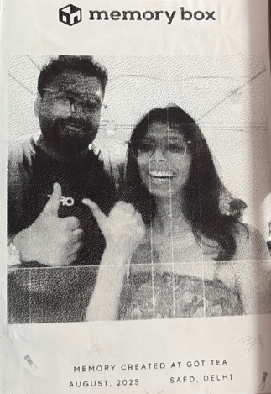

Second date (29th August):we went to escape room and even though I had done escape room withb people this one was the most fun one even though we didn’t complete it it was soooooo funn and then we went to mkt where whatever we bought you ate a little and passed the whole thing to me I like the fact that u were treating me as your personal dustbin

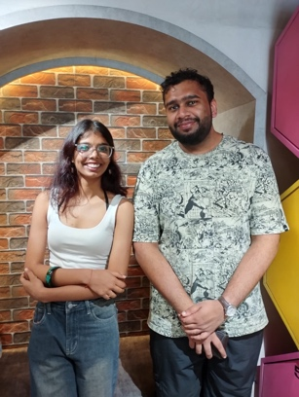

3d date (14th sept): we went for watching conjuring and I had so many plans to scare you but you already were soooo scareddd that I was like ok let you be you were slowly and slowly sinking into your chair as much as you could be I was having more fun in seeing ypu scared than the movie then later we tied to go karting but didn’t and then food also we looked at a couple pf places but didn’t go iny one I was so scared that things are not going according to plan because its getting late too but then I looked at you and somehow all of this was not irritating you and I was just amazed ki again I have said this like 1000 times but you ae jst too good absolutely oerfect ohh then we ate a very random mcdonalds



4th date(29th september):so we waited fo my sister to come back home so we could drop off her dogs andwe watched lilo and stictch wnt to an arcade where you beat me unfairly in air hockey then we went to galaxy pizza with your friends I was so awkward and tense abput it you have no idea I think you do have some idea because I was bitng my nails so much but still you don’t know how tense I was but then somehow again just looking at you even though I was tense just looking at you made it worth it somehow then we wnt to the same arcade again where you beat me on a rigged bike racing game and then u asked me to get the bear from the claw machine and I was able to on my fist try the happiness on you face just made me so happyyyyyy

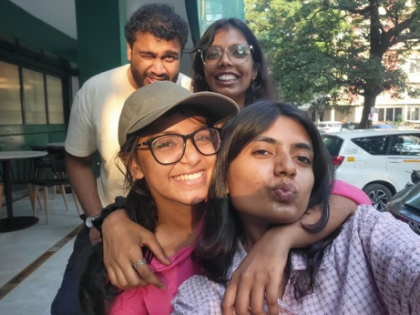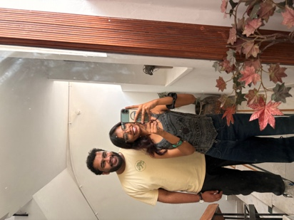

5th date (5th october): we went to see the Shinchan movie after you had been clubbing the whole night and I was so worried for you as you had not slept for an whole day now and considering how much you value sleep I was so honoured that you chose to spend the next whole day with me then we went to a mystery room again and while we wee roaming kamla nagar you got multiple cals from home so we went back even though you were so tense I was just limke I have to take you home ight now u were tired sleepy mp had a headache but still the fact you were trying not to destroy the date it was so cuteee
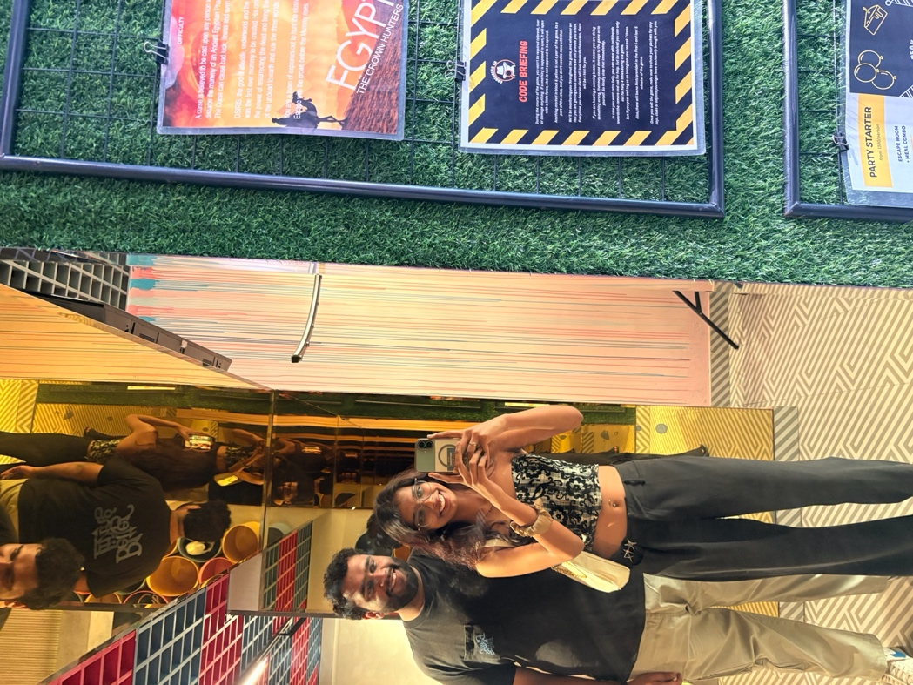
On 9th october you finally told me you kinda like me now

6th date (13th and 14th october):we were supposed to come to my home on 13th as 14th is my birthday we started watching another movie 5 feet apart which is your favourite movie but that also is not complete yet like lilo and stitch inhad so much fun making coffee with you on 13 th and then at my home also and the amount of thoughtful gifts you gave me made me cry the amount of little little things you noticed and got me was amazing anf the highlight of my night was when I was massaging you you just g=hugged my and slept that was just so cute and somehow it just made me so comfortable and ypu wee contantly saying now I like you that was just my best birthday ever

7th date(17th october):we wnt go karting whee I let you win again beause when youn were loosing you were driving rashly so fo the bettement of both of us I let you win which you still don’t accept then we went to theos which is like my favourite restaurant of all time and mystery oom again in the end I was kinda sad as I was not gonna see you for like 2 weeks now atlest and one thing happened ecently which was making me overthink toooo much which you know what it was but as you were leaving you saw the d=sadness in my face and decided to finally tell me ok we are in a relationship right now but I expect a proper proposal which is the pont of this journal you have no clue the hapiness you gave me that day the amount of happiness excited ness and just there ae no words to describwe the hapiness

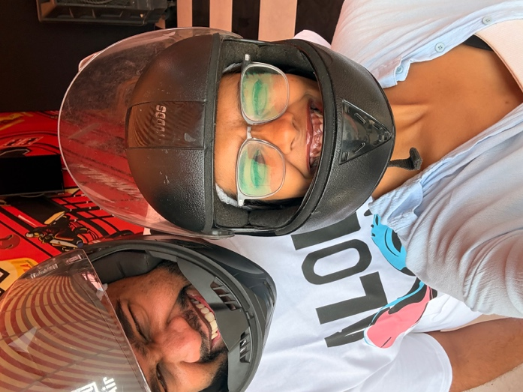
8th date (2nd nov):again I was picking you after clubbing which again you chose me over sleep here we were supposed to go to majnu ka tilla at 10 ig but the fact I tickled you for 3 hours just to get back at you for bullying me and then we went to mkt by 1 even though it was kinda of a time waste it was so fun and there you nmade me the absurd offer of you giving me a kiss on my cheek for not tickling you anymore we roamed in mkt took a polaroid too again don’t like photos but with you I am just ery comfortable eventhough you bully me so much then we went tgo your flat I gave you a massage again and finnaly got a very embaassing photo of you from you adhaar cad but then as you were getting angry I had to give up that ohot for the kiss on the cheek it made me very happy again but I was so shy I receiving itttt that I knew I was gimn a turn red that’s why I =just ran from your flat afte that

