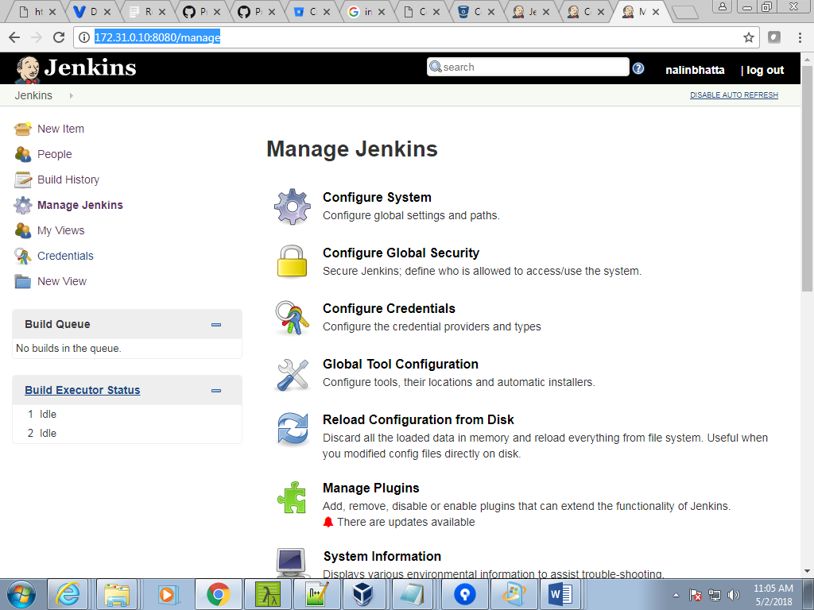

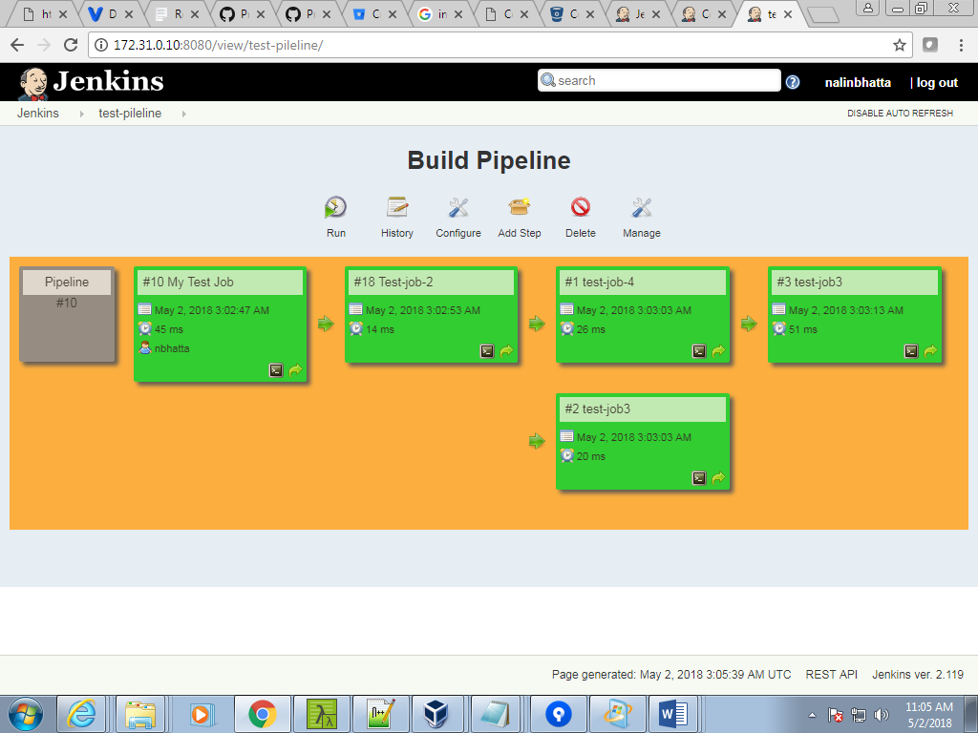

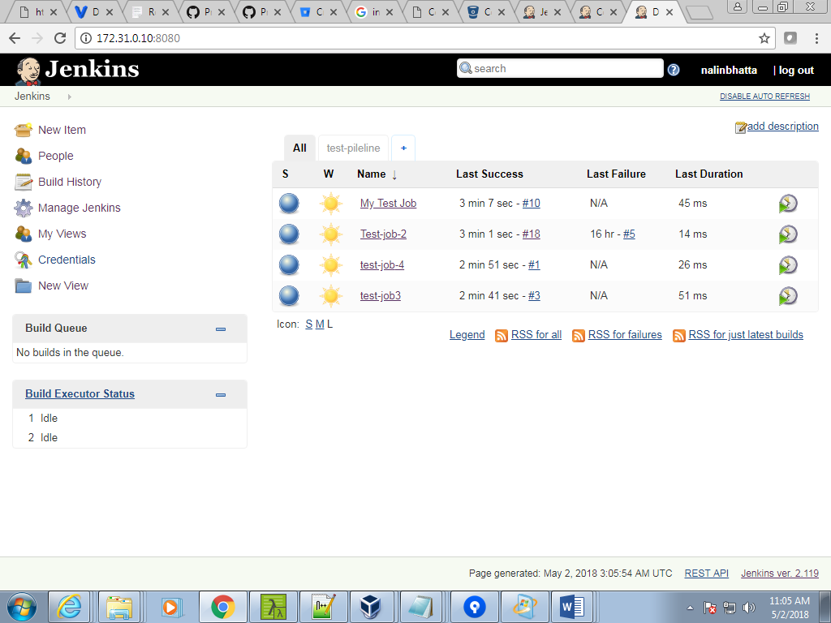

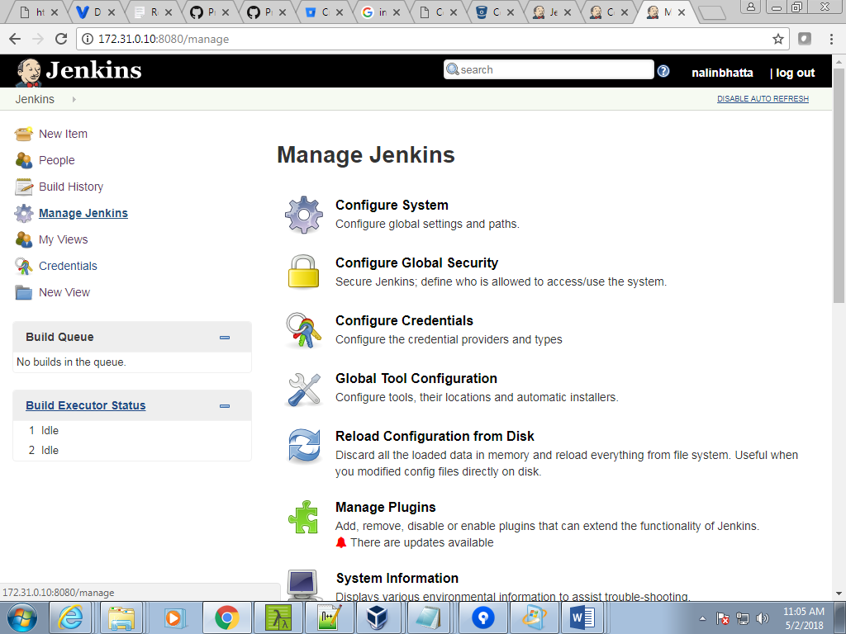

Maven: Mvn is build tools

Build – test –complie

Compile the code

Yum install maven –y

Git clone <https://github.com/amitvashist7/jenkins2-course-spring-boot.git>

For compile

[**jenkins2-course-spring-boot**](https://github.com/amitvashist7/jenkins2-course-spring-boot)/[spring-boot-samples](https://github.com/amitvashist7/jenkins2-course-spring-boot/tree/master/spring-boot-samples)/**spring-boot-sample-atmosphere**

**mvn compile**

**mvn test**

**----**

**Webhooks : sometimes it done by jenkins –**

**Its chekout the code and com**

**Mvn package : make the code in pakage**

**[root@centos-cantrol target]# pwd**

**/root/jenkins2/jenkins2-course-spring-boot/spring-boot-samples/spring-boot-sample-atmosphere/target**

**[root@centos-cantrol target]#**

**java -jar jenkins.war : to up jenkins**

**show workspace**

**[root@centos-cantrol workspace]# pwd**

**[root@centos-cantrol workspace]# root/jenkins**

**[root@centos-cantrol workspace]# cd /root/.jenkins/**

**Ls**

**[root@centos-cantrol workspace]# cd workspace/**

**Ls**

**--====================pipeline==========**

**sh 'mvn clean package'**

**def project_path ="spring-boot-samples/spring-boot-sample-atmosphere/"**

**archiveArtifacts ="${project_path}/target/*.jar"**

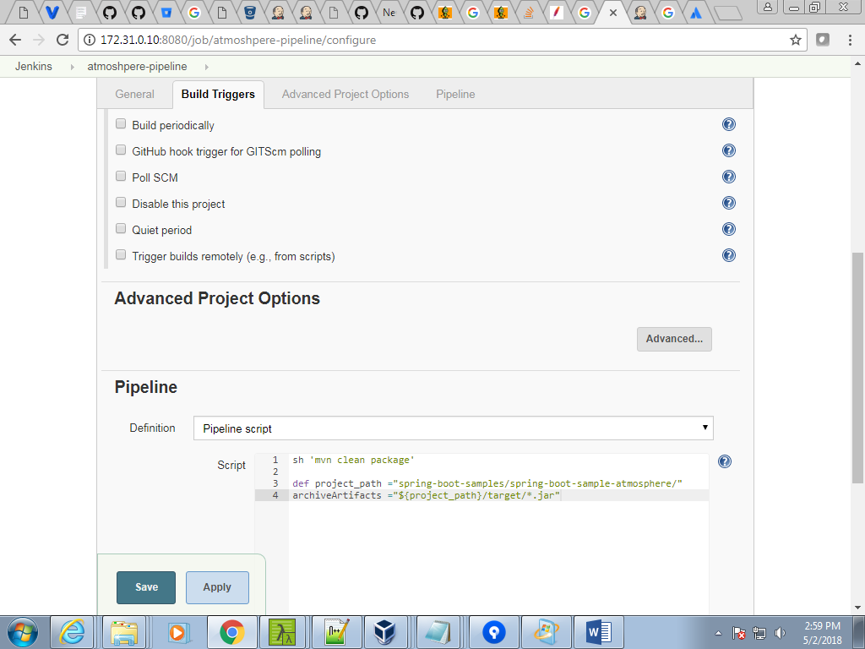

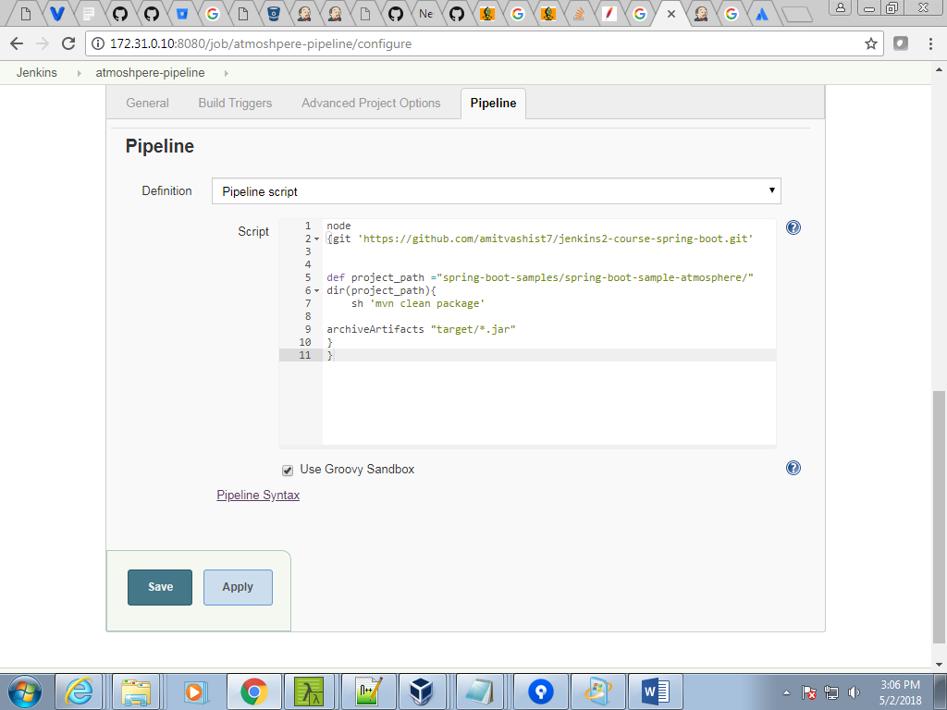

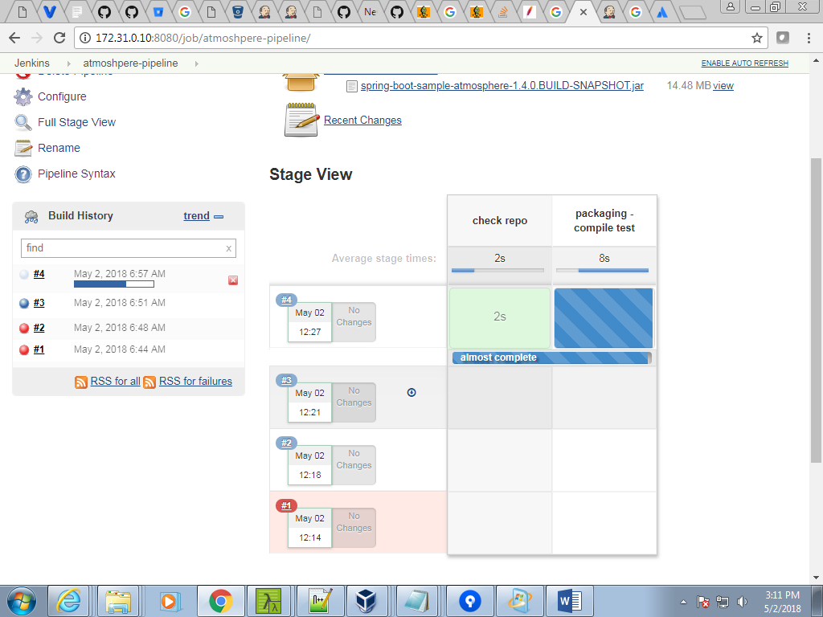

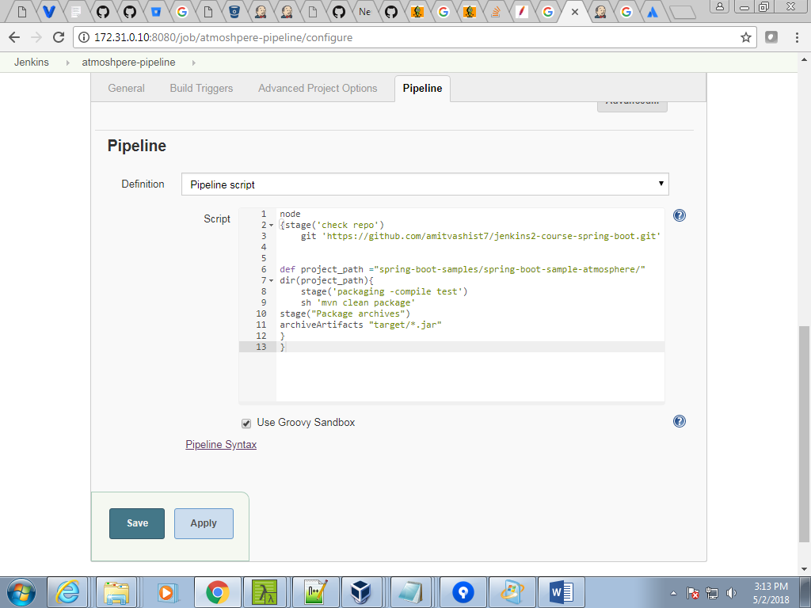

Webhook type

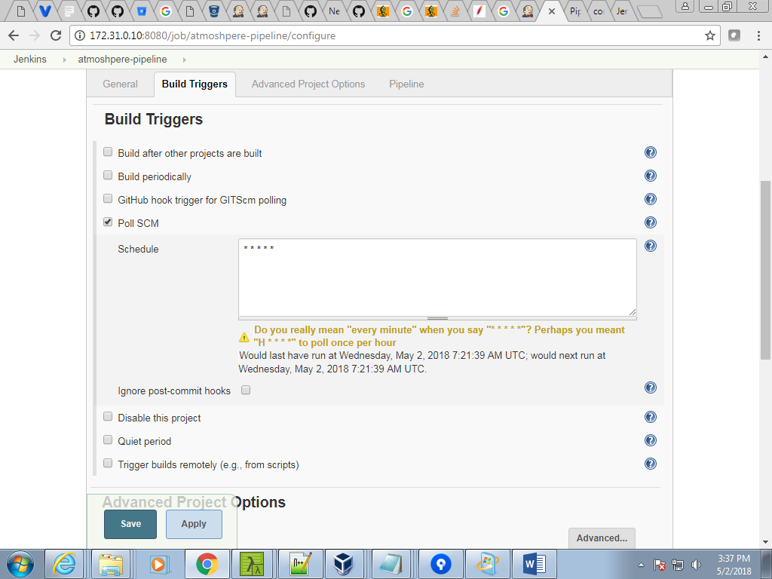

Mailhog (docker image ) + docker

Run on docker conatianer

[vagrant@centos-cantrol ~]$ sudo su -

Last login: Tue May 1 09:34:50 UTC 2018 on pts/1

[root@centos-cantrol ~]# yum install docker –y

[root@centos-cantrol ~]# docker run --restart unlees -stopped --name mailhog p 1025:1025 - 8025:8025 -d mailhog/mailhog

Nofifcaion

|  |
| --- |
| node{ |
|  |  |
|  | notify('Started') |
|  |  |
|  | try { |
|  |  |
|  | stage('Clean Repo') { |
|  | sh 'rm -rf *' |
|  | } |
|  | stage('checkout') { |
|  | git 'https://github.com/amitvashist7/jenkins2-course-test-project.git' |
|  | } |
|  |  |
|  | stage('Build & Compile') { |
|  | sh 'mvn compile' |
|  | } |
|  |  |
|  | stage('Code Testing') { |
|  | sh 'mvn test' |
|  | } |
|  | stage('Packaging') { |
|  | sh 'mvn package' |
|  | } |
|  |  |
|  | stage('archival') { |
|  | publishHTML([allowMissing: true, alwaysLinkToLastBuild: false, keepAll: true, reportDir: 'target/site/jacoco/', reportFiles: 'index.html', reportName: 'Code Coverage', reportTitles: '']) |
|  | step([$class: 'JUnitResultArchiver', testResults: 'target/surefire-reports/TEST-*.xml']) |
|  | archiveArtifacts "target/*?ar" |
|  | } |
|  |  |
|  |  |
|  | notify('Success') |
|  | stage('Deploy to Stage Env') { |
|  | sh "echo '<h1>TASK BUILD ID ${env.BUILD_DISPLAY_NAME}</h1>' > apps/index.html" |
|  | sh 'docker-compose up -d --build' |
|  | } |
|  |  |
|  | stage ('parallel job') { |
|  | parallel task1: { sh 'echo "task1"' }, |
|  | task2: { sh 'echo "task2"' }, |
|  | task3: { sh 'echo "task2"' } |
|  | } |
|  |  |
|  | stage('Getting Ready for AWS') { |
|  | sh 'cp -rf apps/index.html /etc/ansible/AWS/WEB/templates/jenkins.html' |
|  |  |
|  | } |
|  |  |
|  | stage('WAR File Ready for AWS'){ |
|  | sh 'cp -rf sample.war /etc/ansible/AWS/APP/templates/' |
|  | sh 'cp -rf target/petclinic.war /etc/ansible/AWS/APP/templates/' |
|  |  |
|  | } |
|  |  |
|  | stage('EC2 Provisiong'){ |
|  | sh 'ansible-playbook -i /etc/ansible/AWS/EC2/env/hosts /etc/ansible/AWS/EC2/aws_ec2_site.yaml' |
|  | } |
|  |  |
|  | stage('Waiting for EC2 to sattel down'){ |
|  | sh 'sleep 200' |
|  |  |
|  | } |
|  |  |
|  | stage('Deploy App code to AWS EC2'){ |
|  | sh 'ansible-playbook -i /etc/ansible/ec2.py /etc/ansible/AWS/WEB/web_deploy.yaml -u ec2-user --key-file=/etc/ansible/AWS/myansiblekey.pem' |
|  | } |
|  |  |
|  |  |
|  | } catch (err) { |
|  | notify ("Error ${err}") |
|  | currentBuild.result = 'FAILURE' |
|  | } |
|  |  |
|  | } |
|  |  |
|  |  |
|  | def notify(status){ |
|  | emailext ( |
|  | to: "amitvashist7@gmail.com", |
|  | subject: "${status}: Job '${env.JOB_NAME} [${env.BUILD_NUMBER}]'", |
|  | body: """<p>${status}: Job '${env.JOB_NAME} [${env.BUILD_NUMBER}]':</p> |
|  | <p>Check console output at <a href='${env.BUILD_URL}'>${env.JOB_NAME} [${env.BUILD_NUMBER}]</a></p>""", |
|  | ) |
|  | } |

[root@centos-cantrol ~]#

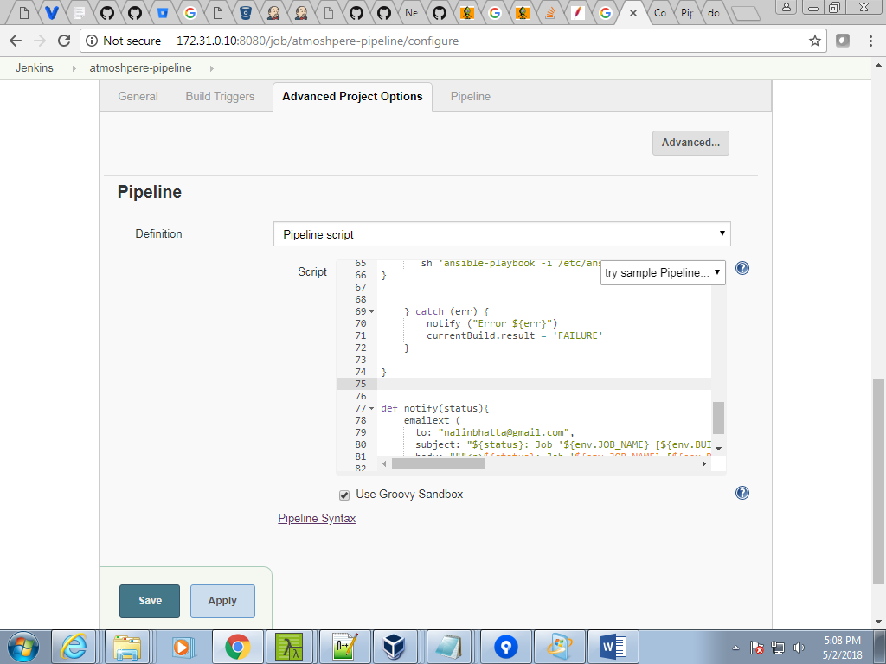

[root@centos-cantrol ~]# systemctl start docker

[root@centos-cantrol ~]# docker run --restart unless-stopped --name mailhog -p 1025:1025 -p 025:8025 -d mailhog/mailhog

docker run --restart unless-stopped --name mailhog

-p 1025:1025 -p 8025:8025 -d mailhog/mailhog

[root@centos-cantrol ~]# systemctl status docker

--==========================================

Docker

Manke new vagrant file with name host name manager and change ip

Command

C:\Users\training135\dockerTest

λ Vagrant.exe

Vagrant.exe up

Vagrant.exe status

Vagrant.exe ssh Manager

Loaded plugins: fastestmirror

base | 3.6 kB 00:00:00

extras | 3.4 kB 00:00:00

[root@Manager ~]# systemctl start docker.service

[root@Manager ~]# docker –v

[root@Manager ~]# systemctl status docker.service

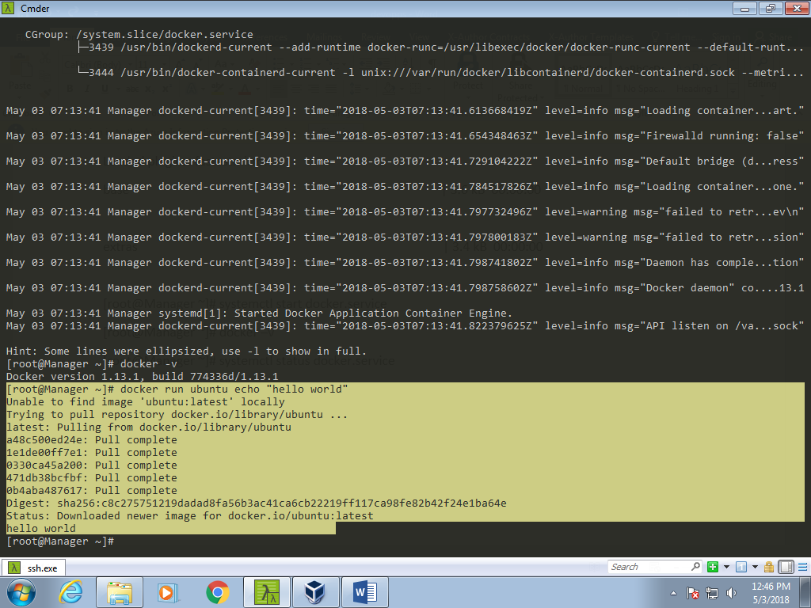

Run from unbantu container “hello world”

[root@Manager ~]# docker images

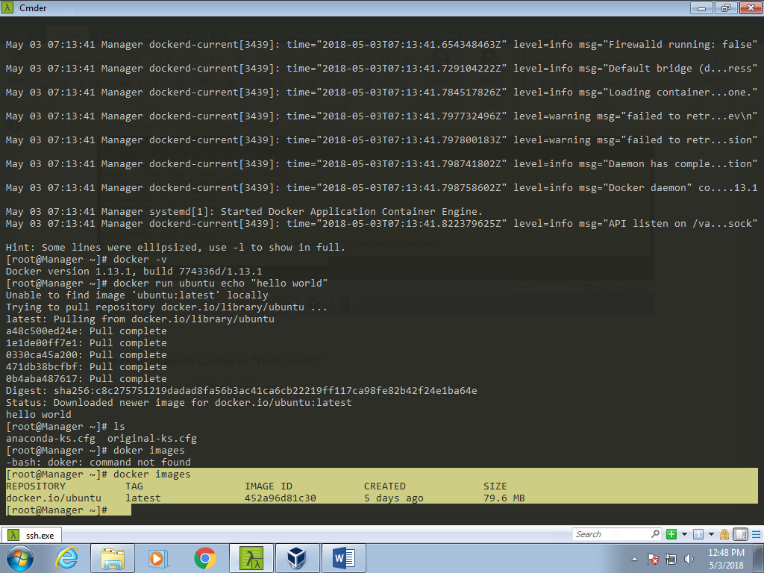

Docker ps –a : list of container running and stoped too.

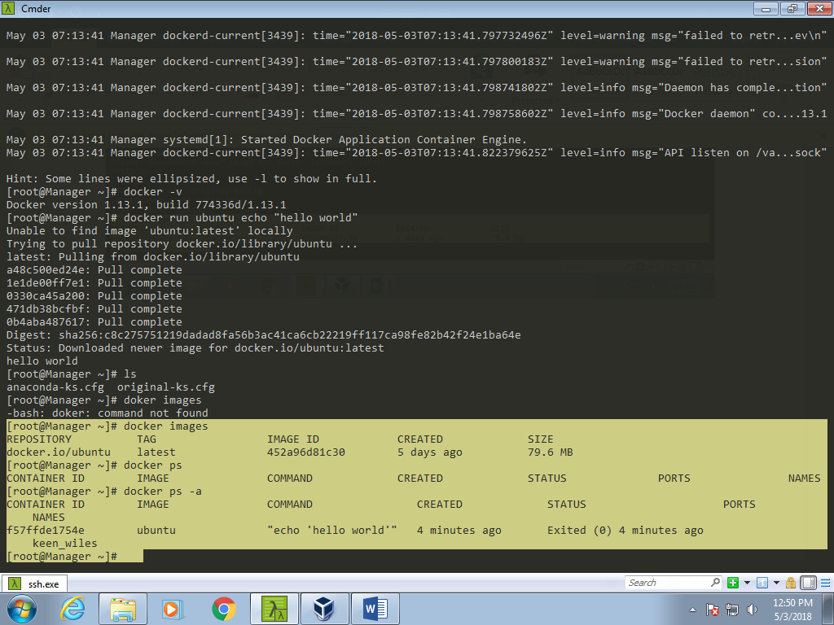

docker run busybox echo "hello busy test"

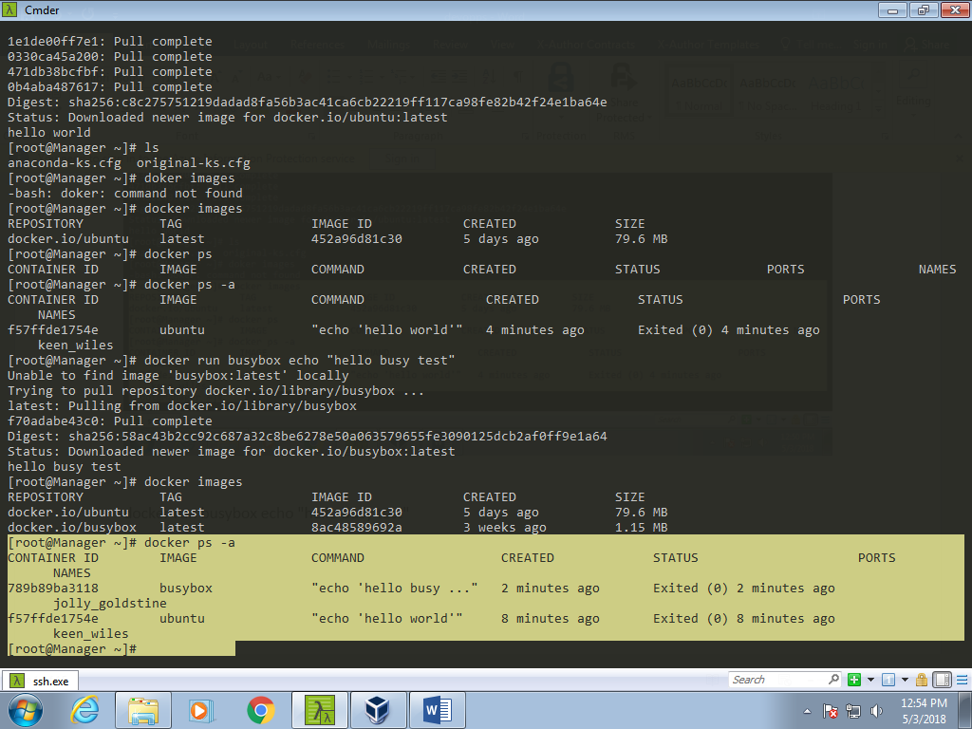

Login to dockerhub : hub.docker.com

docker search apache

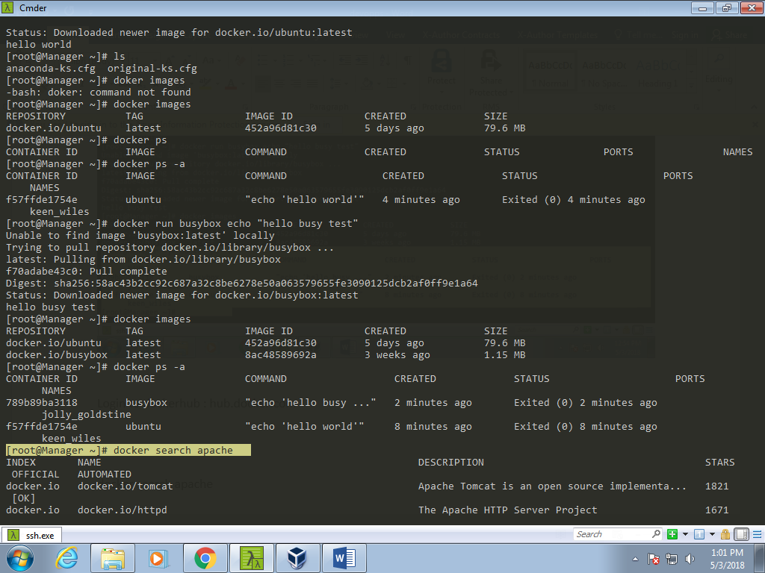

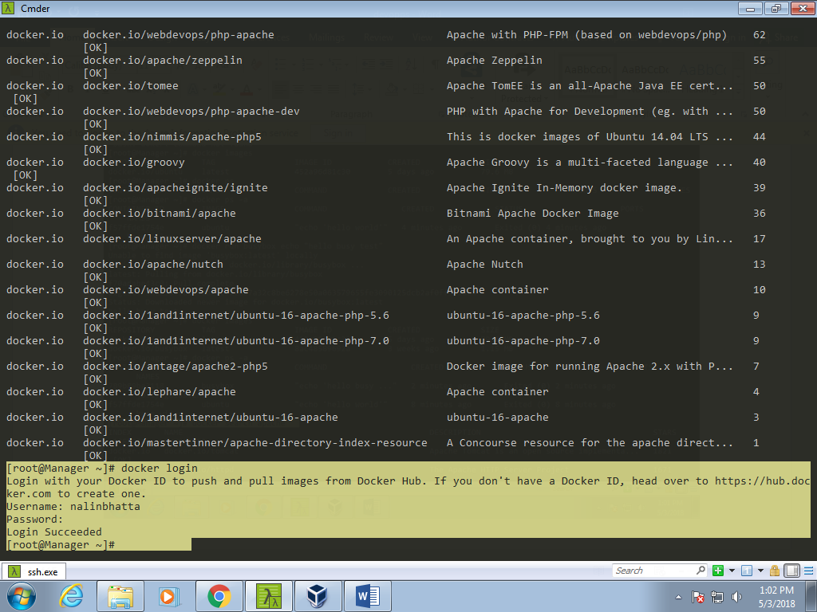

Tow types of container

1. Intractive
2. Daemaonized

Doker inspect –formate

Docker run –itd – name job1 ubuntu /bin/bash

Docker ps

Docker stop job1

Docker ps

Docker start job1

Docker run –it – name job2 unbuntu /bin/bash

Docker attached job2

Docker commit -- help

Docker ps

Docker commit – help

Docker commit 09125865476a45a bs-devops:v1.0

Docker ps

Docker images

Docker run –it bs-devops /bin/bash

History

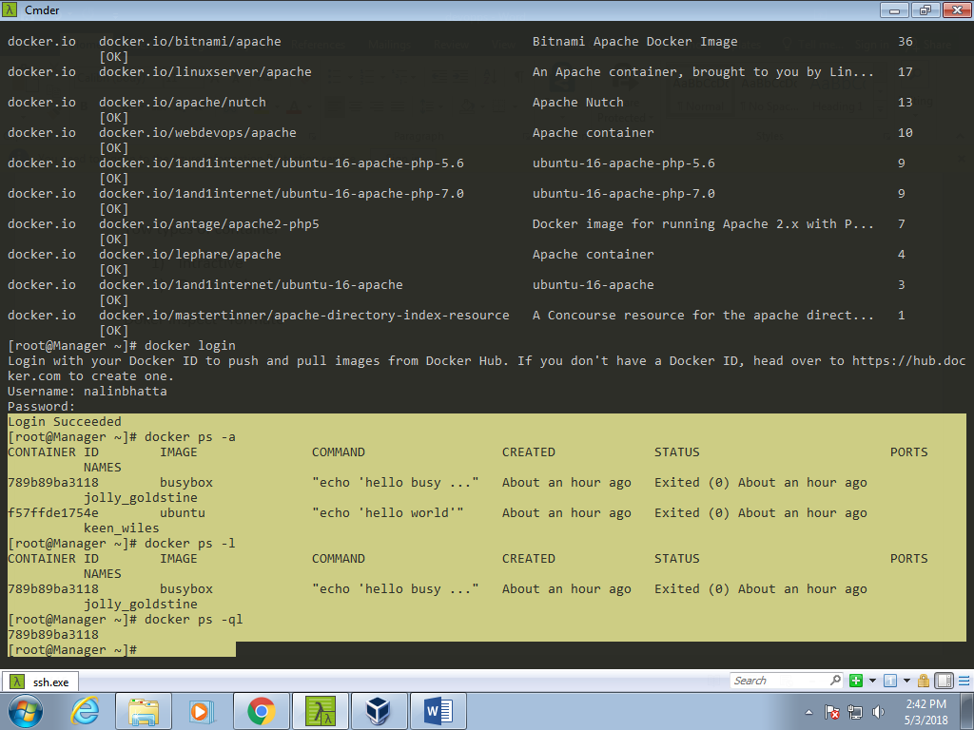

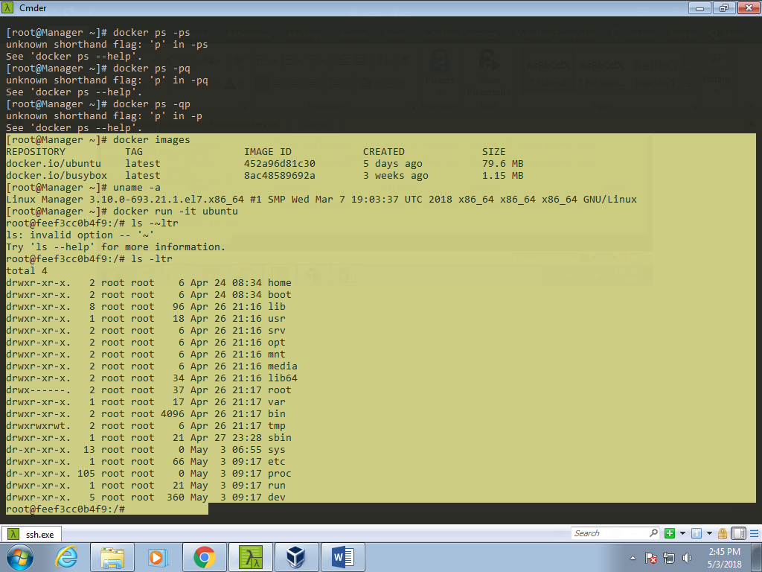

[root@Manager ~]# docker rm $(docker ps -aq)

[root@Manager ~]# docker run -itd ubuntu/bin/bash

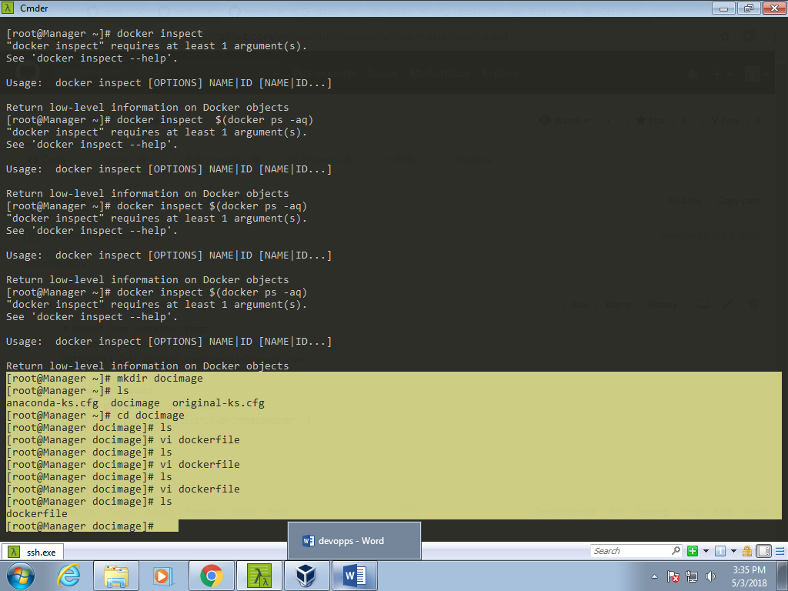

Docker file configration

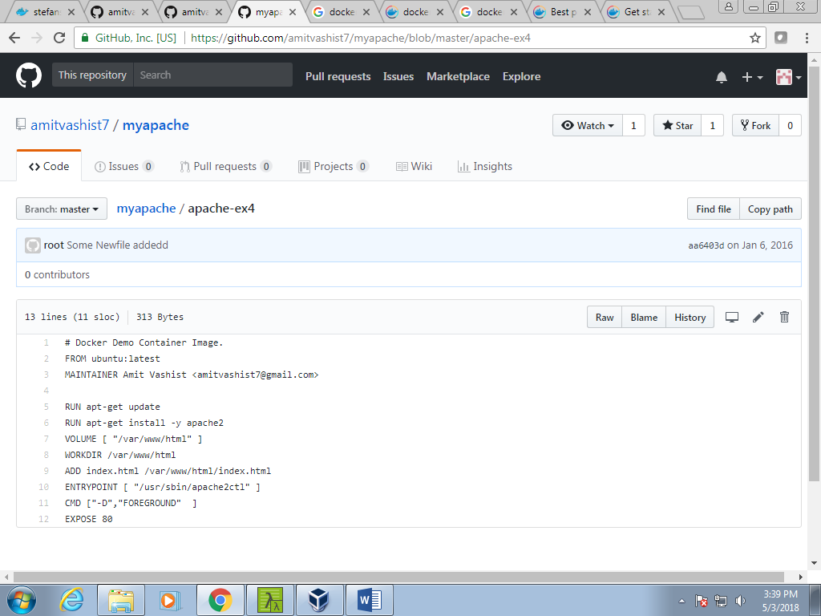

|  |
| --- |
| # Docker Demo Container Image. |
|  | FROM ubuntu:latest |
|  | MAINTAINER Amit Vashist <amitvashist7@gmail.com> |
|  |  |
|  | RUN apt-get update |
|  | RUN apt-get install -y apache2 |
|  | VOLUME [ "/var/www/html" ] |
|  | WORKDIR /var/www/html |
|  | ADD index.html /var/www/html/index.html |
|  | ENTRYPOINT [ "/usr/sbin/apache2ctl" ] |
|  | CMD ["-D","FOREGROUND" ] |
|  | EXPOSE 80 |

<https://github.com/amitvashist7/myapache>

SOME COMMANDS

[root@acs myapache]# history

1 yum install epel-release -y

2 yum-config-manager --add-repo \

3 yum install docker-ce -y

4 yum install -y yum-utils device-mapper-persistent-data lvm2

5 yum-config-manager --add-repo https://download.docker.com/linux/centos/docker-ce.repo

6 history

7 yum-config-manager --enable docker-ce-edge

8 yum install docker-ce -y

9 systemctl status docker.service

10 systemctl start docker.service

11 systemctl status docker.service

12 docker -version

13 docker --version

14 docker -v

15 systemctl status docker.service

16 docker run ubuntu echo "Hello World"

17 docker images

18 docker ps

19 docker ps -a

20 docker run busybox echo "hELLO bUSYBOX"

21 docker images

22 docker ps

23 docker ps -a

24 docker search apache

25 docker login

26 docker ps -a

27 docker ps

28 docker ps -l

29 docker ps -q

30 docker ps -ql

31 docker ps -q

32 docker ps -aq

33 docker images

34 uname -a

35 docker run -it ubuntu

36 docker ps

37 docker ps -a

38 docker run -it ubuntu

39 docker ps -a

40 docker ps -aq

41 docker kill $(docker ps -aq)

42*

43 docker ps -aq

44 docker ps

45 docker run -itd ubuntu /bin/bash

46 docker ps

47 docker inspect $( docker ps -aq)

48 cat /var/lib/docker/containers/d8c69eaa53a86424fc4577c28c66f4b199b4307da7ec6d2e6d3a9b30808d3f5f/hosts

49 docker ps

50 docker run -itd ubuntu /bin/bash --name job1

51 docker ps

52 docker ps -a

53 ls

54 docker run -itd --name job1 ubuntu /bin/bash

55 docker ps

56 docker stop job1

57 docker ps

58 docker start job1

59 docker ps

60 history

61 docker run -it --name job2 ubuntu /bin/bash

62 docker ps

63 docker attach job2

64 docker commit --help

65 docker ps

66 docker commit --help

67 docker commit 0919371c10a9 bs-devops:v1.0

68 docker ps

69 docker images

70 docker run -it bs-devops /bin/bash

71 docker run -it bs-devops:v1.0 /bin/bash

72 history

73 mkdir myapache

74 ls

75 cd myapache/

76 ls

77 vi dockerfile

78 ls

79 docker build -t myapache-ex1 .

80 ls

81 docker images

82 docker run -d myapache-ex1:latest

83 docker ps

84 docker ps -ql

85 docker inspect $(docker ps -ql)

86 curl 172.17.0.6

87 ip addr

88 ls

89 ds

90 ls

91 vi dockerfile

92 docker ps -aq

93 docker kill $(docker ps -aq)

94 ls

95 docker ps -aq

96 docker ps

97 ls

98 docker build -t myapache-ex2:v1.0 .

99 echo "Welcome to the world of DevOps Docker Containers" > index.html

100 docker build -t myapache-ex2:v1.0 .

101 docker images

102 docker run -d myapache-ex2:v1.0

103 docker ps

104 curl localhost

105 ls

106 docker ps

107 docker ps -ql

108 docker inspect $(docker ps -ql)

109 curl 172.17.0.2

110 q\

111 docker ps -ql

112 docker kill $(docker ps -ql)

113 ls

114 docker run -d myapache-ex2:v1.0 -p 8080:80

115 docker ps

116 ls

117 docker run -d -p 8080:80 myapache-ex2:v1.0

118 docker ps

119 curl localhost:8080

120 docker ps

121 history

[root@acs myapache]#

* Docker compose

**docker-compose.yml**

|  |
| --- |
| nginx: |
|  | image: nginx:latest |
|  | ports: |
|  | - '80:80' |
|  | volumes: |
|  | - ./nginx:/etc/nginx/conf.d |
|  | - ./logs/nginx:/var/log/nginx |
|  | - ./wordpress:/var/www/html |
|  | links: |
|  | - wordpress |
|  | restart: always |
|  |  |
|  | mysql: |
|  | image: mariadb |
|  | ports: |
|  | - '3306:3306' |
|  | volumes: |
|  | - ./db-data:/var/lib/mysql |
|  | environment: |
|  | - MYSQL_ROOT_PASSWORD=aqwe123 |
|  | restart: always |
|  |  |
|  |  |
|  | wordpress: |
|  | image: wordpress:4.7.1-php7.0-fpm |
|  | ports: |
|  | - '9000:9000' |
|  | volumes: |
|  | - ./wordpress:/var/www/html |
|  | environment: |
|  | - WORDPRESS_DB_NAME=wpdb |
|  | - WORDPRESS_TABLE_PREFIX=wp_ |
|  | - WORDPRESS_DB_HOST=mysql |
|  | - WORDPRESS_DB_PASSWORD=aqwe123 |
|  | links: |
|  | - mysql |
|  | restart: always |

=-============================================

Docker swam .

New tool like swarm

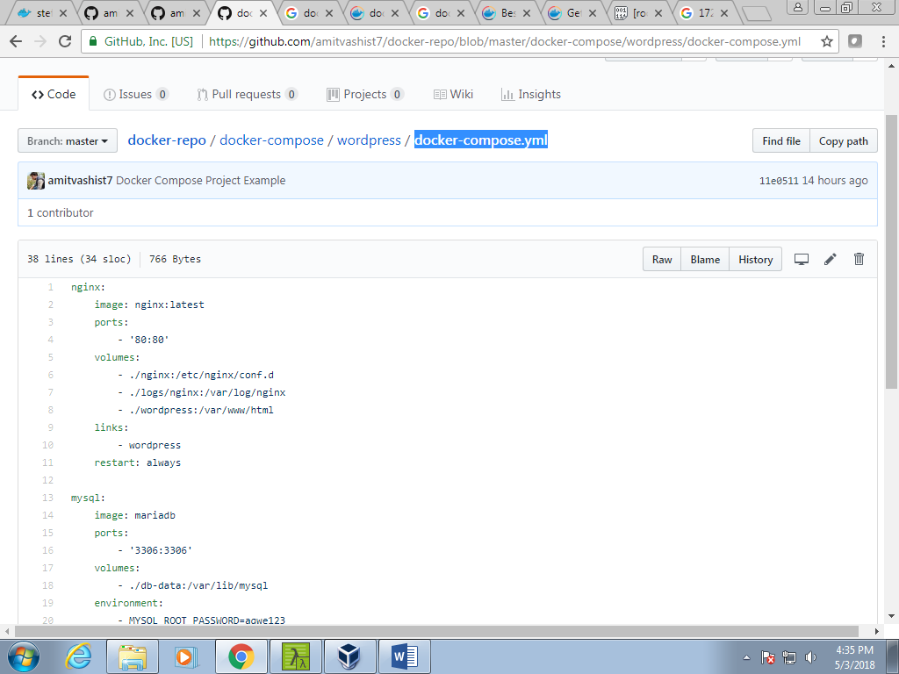

|  |
| --- |
| Docker |
|  | ======> |
|  |  |
|  | # yum remove docker \ |
|  | docker-client \ |
|  | docker-client-latest \ |
|  | docker-common \ |
|  | docker-latest \ |
|  | docker-latest-logrotate \ |
|  | docker-logrotate \ |
|  | docker-selinux \ |
|  | docker-engine-selinux \ |
|  | docker-engine |
|  |  |
|  |  |
|  | # yum install epel-release -y |
|  |  |
|  | # yum-config-manager \ |
|  | --add-repo \ |
|  | https://download.docker.com/linux/centos/docker-ce.repo |
|  |  |
|  | # yum install -y yum-utils device-mapper-persistent-data lvm2 |
|  |  |
|  | # yum-config-manager --enable docker-ce-edge |
|  |  |
|  | # yum install docker-ce -y |
|  |  |
|  | # systemctl start docker |
|  |  |
|  | # vi dockerfile |
|  |  |
|  | # Use an official Python runtime as a parent image |
|  | FROM python:2.7-slim |
|  |  |
|  | # Set the working directory to /app |
|  | WORKDIR /app |
|  |  |
|  | # Copy the current directory contents into the container at /app |
|  | ADD . /app |
|  |  |
|  | # Install any needed packages specified in requirements.txt |
|  | RUN pip install --trusted-host pypi.python.org -r requirements.txt |
|  |  |
|  | # Make port 80 available to the world outside this container |
|  | EXPOSE 80 |
|  |  |
|  | # Define environment variable |
|  | ENV NAME World |
|  |  |
|  | # Run app.py when the container launches |
|  | CMD ["python", "app.py"] |
|  |  |
|  | [root@acs dev-env]# cat requirements.txt |
|  | Flask |
|  | Redis |
|  | [root@acs dev-env]# |
|  |  |
|  | [root@acs dev-env]# cat app.py |
|  | from flask import Flask |
|  | from redis import Redis, RedisError |
|  | import os |
|  | import socket |
|  |  |
|  | # Connect to Redis |
|  | redis = Redis(host="redis", db=0, socket_connect_timeout=2, socket_timeout=2) |
|  |  |
|  | app = Flask(__name__) |
|  |  |
|  | @app.route("/") |
|  | def hello(): |
|  | try: |
|  | visits = redis.incr("counter") |
|  | except RedisError: |
|  | visits = "<i>cannot connect to Redis, counter disabled</i>" |
|  |  |
|  | html = "<h3>Hello {name}!</h3>" \ |
|  | "<b>Hostname:</b> {hostname}<br/>" \ |
|  | "<b>Visits:</b> {visits}" |
|  | return html.format(name=os.getenv("NAME", "world"), hostname=socket.gethostname(), visits=visits) |
|  |  |
|  | if __name__ == "__main__": |
|  | app.run(host='0.0.0.0', port=80) |
|  | [root@acs dev-env]# |
|  |  |
|  |  |
|  |  |
|  | # docker build -t friendlyhello . |
|  |  |
|  | # docker run -p 4000:80 friendlyhello |
|  |  |
|  | # curl localhost:4000 |
|  |  |
|  | # docker login |
|  |  |
|  | [root@acs dev-env]# docker tag friendlyhello amitvashist7/get-started:part2 |
|  | [root@acs dev-env]# docker image ls |
|  | REPOSITORY TAG IMAGE ID CREATED SIZE |
|  | amitvashist7/get-started part2 57e8a5853476 4 minutes ago 156MB |
|  | friendlyhello latest 57e8a5853476 4 minutes ago 156MB |
|  | python 2.7-slim 829e955d463b 5 days ago 144MB |
|  | [root@acs dev-env]# |
|  |  |
|  |  |
|  | # [root@acs dev-env]# docker push amitvashist7/get-started:part2 |
|  |  |
|  |  |
|  | Install Docker Compose: |
|  |  |
|  | # sudo curl -L https://github.com/docker/compose/releases/download/1.21.0/docker-compose-$(uname -s)-$(uname -m) -o /usr/local/bin/docker-compose |
|  |  |
|  | # chmod +x /usr/local/bin/docker-compose |
|  |  |
|  | [root@acs dev-env]# cat docker-compose.yml |
|  | version: "3" |
|  | services: |
|  | web: |
|  | # replace username/repo:tag with your name and image details |
|  | image: amitvashist7/get-started:part2 |
|  | deploy: |
|  | replicas: 5 |
|  | resources: |
|  | limits: |
|  | cpus: "0.1" |
|  | memory: 50M |
|  | restart_policy: |
|  | condition: on-failure |
|  | ports: |
|  | - "80:80" |
|  | networks: |
|  | - webnet |
|  | networks: |
|  | webnet: |
|  | [root@acs dev-env]# |
|  |  |
|  |  |
|  |  |
|  |  |
|  |  |
|  | **Docker Swarm:** |
|  |  |
|  | [root@acs dev-env]# docker swarm init --advertise-addr 172.31.0.50 |
|  | Swarm initialized: current node (e998bp1380ajdofjudaeg401f) is now a manager. |
|  |  |
|  | To add a worker to this swarm, run the following command: |
|  |  |
|  | docker swarm join --token SWMTKN-1-60gnux0pamiw99unlunj9e3jo9j0icwv7j6krehhetjufpvrwg-ctncvnj8sulr1q9q480ulfahw 172.31.0.50:2377 |
|  |  |
|  | To add a manager to this swarm, run 'docker swarm join-token manager' and follow the instructions. |
|  |  |
|  | [root@acs dev-env]# |
|  |  |
|  |  |
|  |  |
|  | [root@worker01 ~]# docker swarm join --token SWMTKN-1-60gnux0pamiw99unlunj9e3jo9j0icwv7j6krehhetjufpvr wg-ctncvnj8sulr1q9q480ulfahw 172.31.0.50:2377 |
|  | This node joined a swarm as a worker. |
|  | [root@worker01 ~]# |
|  |  |
|  |  |
|  | [root@acs dev-env]# docker stack deploy -c docker-compose.yml getstartedlab |
|  | Creating network getstartedlab_webnet |
|  | Creating service getstartedlab_web |
|  | [root@acs dev-env]# |
|  |  |
|  |  |
|  | [root@acs dev-env]# docker service ls |
|  | ID NAME MODE REPLICAS IMAGE |
|  | PORTS |
|  | v0wuveumqqld getstartedlab_web replicated 5/5 amitvashist7/get-started:part2 *:80->80/tcp |
|  | [root@acs dev-env]# |
|  |  |
|  | [root@acs dev-env]# docker service ps getstartedlab_web |
|  | ID NAME IMAGE NODE DESIRED STATE CURRENT STATE ERROR PORTS |
|  | s885y0of9n7x getstartedlab_web.1 amitvashist7/get-started:part2 worker02 Running |
|  | Running 48 seconds ago |
|  | spm768ww27x2 getstartedlab_web.2 amitvashist7/get-started:part2 worker01 Running |
|  | Running 47 seconds ago |
|  | m3phnmdqytq8 getstartedlab_web.3 amitvashist7/get-started:part2 worker02 Running |
|  | Running 46 seconds ago |
|  | yiqgcwbhokb2 getstartedlab_web.4 amitvashist7/get-started:part2 acs Running |
|  | Running about a minute ago |
|  | wigvj19fcc0l getstartedlab_web.5 amitvashist7/get-started:part2 worker01 Running |
|  | Running 48 seconds ago |
|  | [root@acs dev-env]# |
|  |  |
|  |  |
|  | [root@acs dev-env]# docker service scale getstartedlab_web=2 |
|  |  |
|  |  |
|  |  |
|  | Take down the app and the swarm |
|  | Take the app down with docker stack rm: |
|  |  |
|  | # docker stack rm getstartedlab |
|  | Take down the swarm. |
|  |  |
|  | # docker swarm leave --force |
|  |  |
|  |  |
|  |  |
|  | Add a new service and redeploy |
|  |  |
|  | [root@acs new-app-deploy]# cat docker-compose.yml |
|  | version: "3" |
|  | services: |
|  | web: |
|  | # replace username/repo:tag with your name and image details |
|  | image: amitvashist7/get-started:part2 |
|  | deploy: |
|  | replicas: 2 |
|  | restart_policy: |
|  | condition: on-failure |
|  | resources: |
|  | limits: |
|  | cpus: "0.2" |
|  | memory: 200M |
|  | ports: |
|  | - "80:80" |
|  | networks: |
|  | - webnet |
|  | visualizer: |
|  | image: dockersamples/visualizer:stable |
|  | ports: |
|  | - "8080:8080" |
|  | volumes: |
|  | - "/var/run/docker.sock:/var/run/docker.sock" |
|  | deploy: |
|  | placement: |
|  | constraints: [node.role == manager] |
|  | networks: |
|  | - webnet |
|  | networks: |
|  | webnet: |
|  | [root@acs new-app-deploy]# |
|  |  |
|  |  |
|  | # docker stack deploy -c docker-compose.yml getstartedlab |
|  |  |
|  | [root@acs new-app-deploy]# docker service scale getstartedlab_web=10 |
|  | getstartedlab_web scaled to 10 |
|  | overall progress: 10 out of 10 tasks |
|  | 1/10: running |
|  | 2/10: running |
|  | 3/10: running |
|  | 4/10: running |
|  | 5/10: running |
|  | 6/10: running |
|  | 7/10: running |
|  | 8/10: running |
|  | 9/10: running |
|  | 10/10: running |
|  | verify: Service converged |
|  | [root@acs new-app-deploy]# docker service scale getstartedlab_web=2 |
|  | getstartedlab_web scaled to 2 |
|  | overall progress: 2 out of 2 tasks |
|  | 1/2: running |
|  | 2/2: running |
|  | verify: Service converged |
|  | [root@acs new-app-deploy]# |
|  |  |
|  | Done. |

