**CS 390 – FALL 2021**

**PURDUE UNIVERSITY**

**Lab 3**

**Name:** Nalin Ahuja

**Login**: ahuja15

**PUID:** 0030482364

October 27, 2021

**Student Information**

* Name: Nalin Ahuja
* Email: [ahuja15@purdue.edu](mailto:ahuja15@purdue.edu)

**Project Information**

* Git Repository: [Link](https://github.com/nalinahuja/CS390-NIP/tree/main/lab3)

**Resources****Used**

* CS 390-NIP Lecture Slides: [Lecture 8](https://docs.google.com/presentation/d/e/2PACX-1vRWrPIn5AHjjMYkEi7o44ZNvt_qqhly65Ep9YrsD5UBp6aPvFLQX7Q1v-1LSEe-FQiKY2KzjsNA3-p8/pub?start=false&loop=false&delayms=3000#slide=id.p)
* API Documentation: [Keras](https://keras.io/), [TensorFlow](https://www.tensorflow.org/)

*Lab report continues onto next page*

**Style Transfers**

*Content Style Transfer*

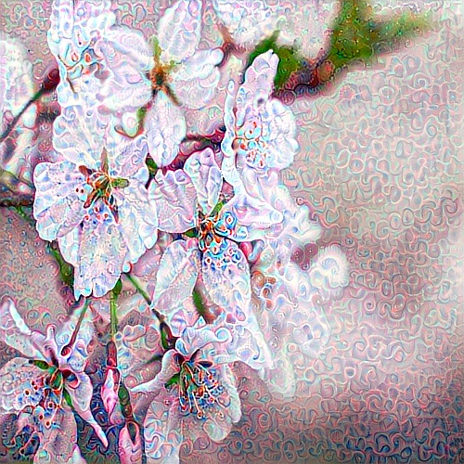

*Content Style Transfer*

*Content Style Transfer*

*All style transfers can be downloaded* [*here*](https://github.com/nalinahuja/CS390-NIP/tree/main/lab3/media)*.*