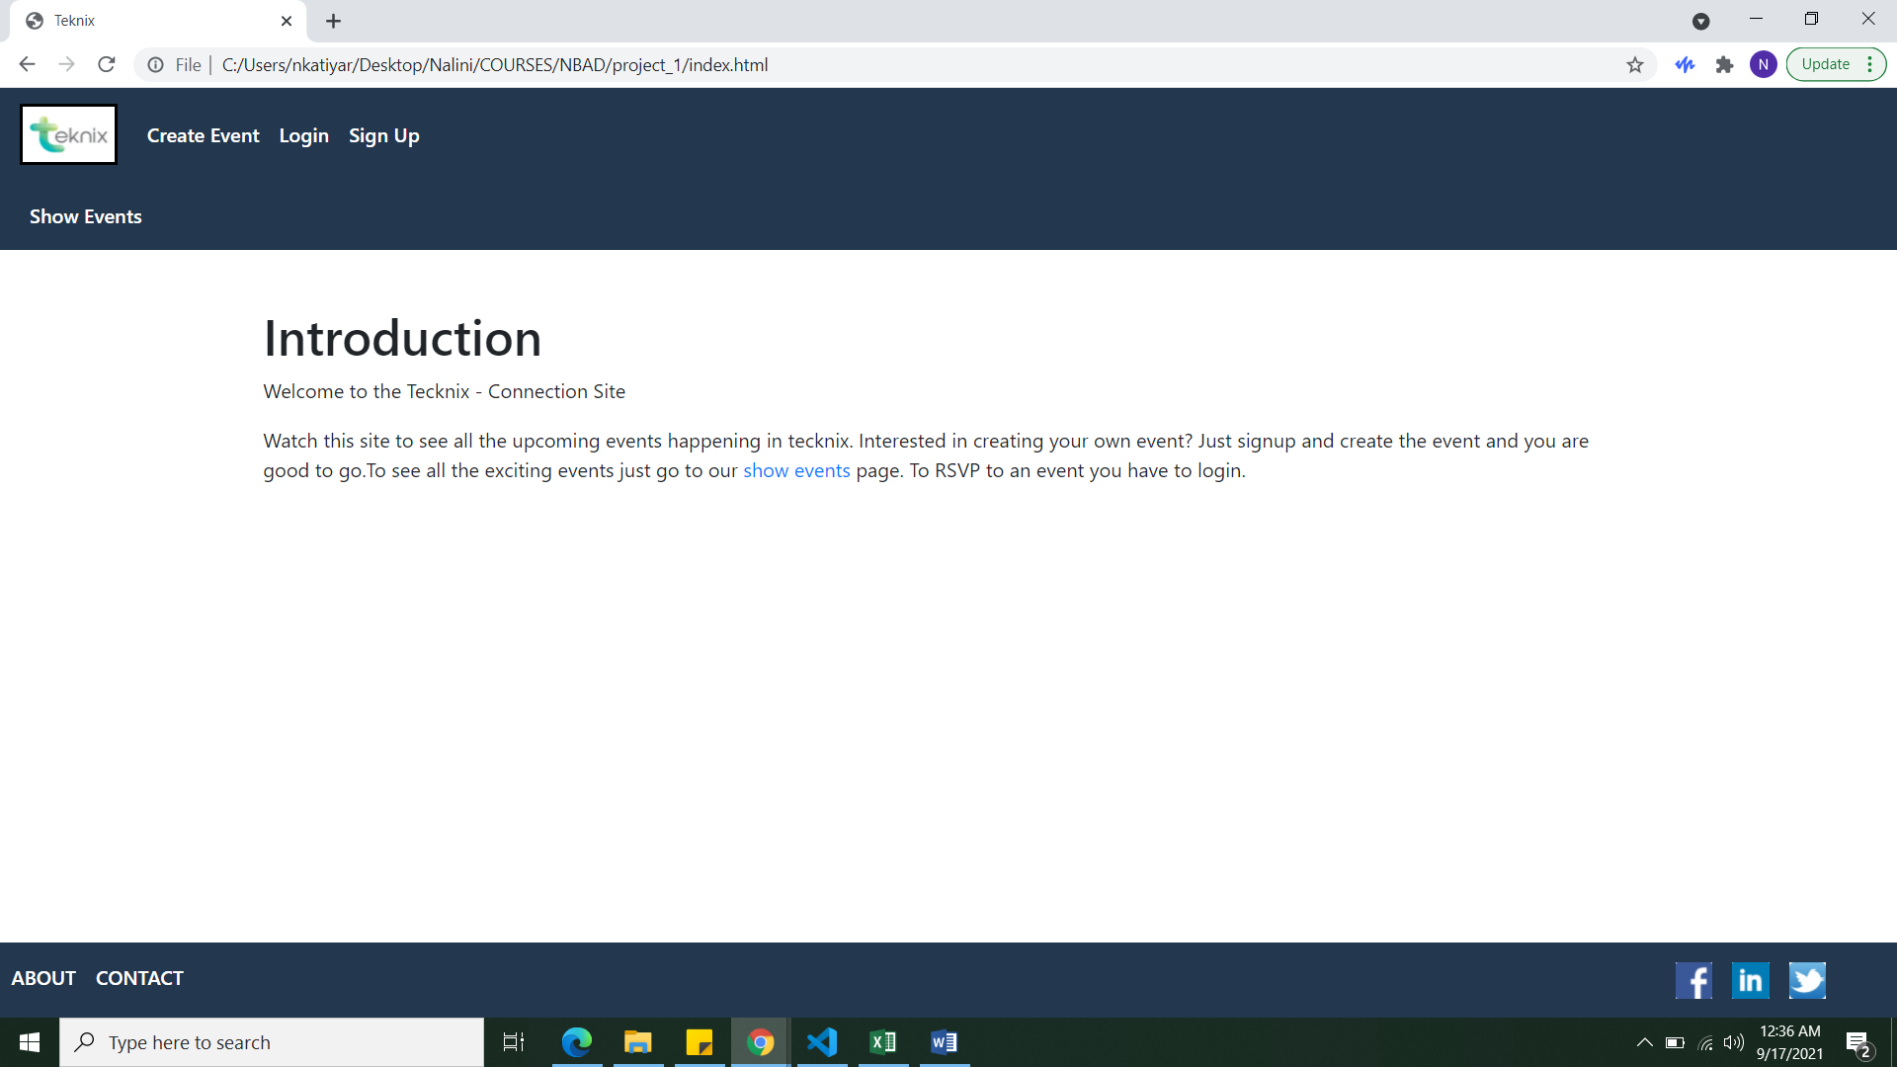

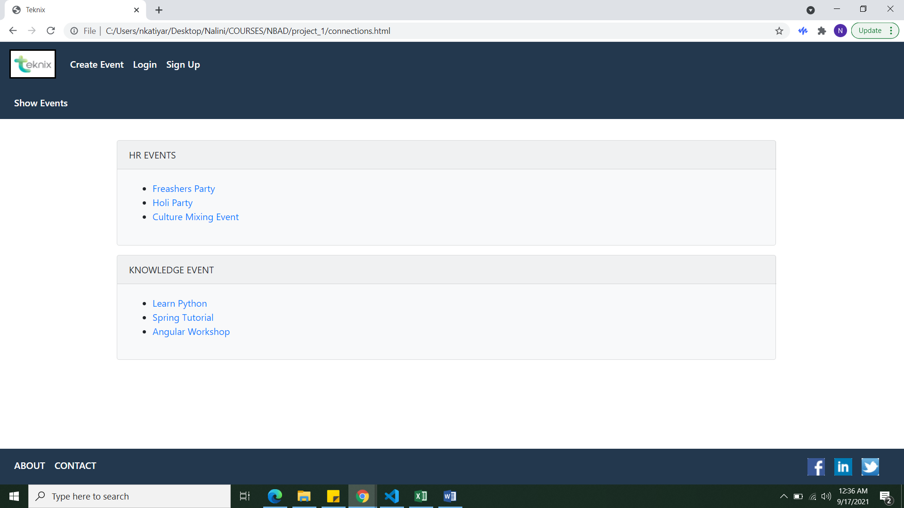

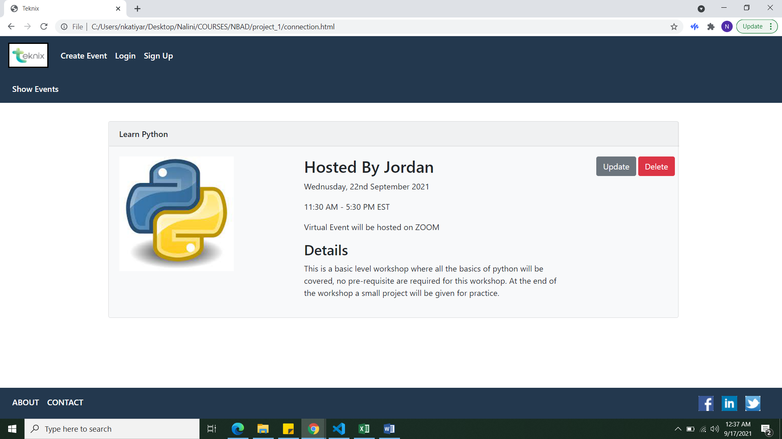

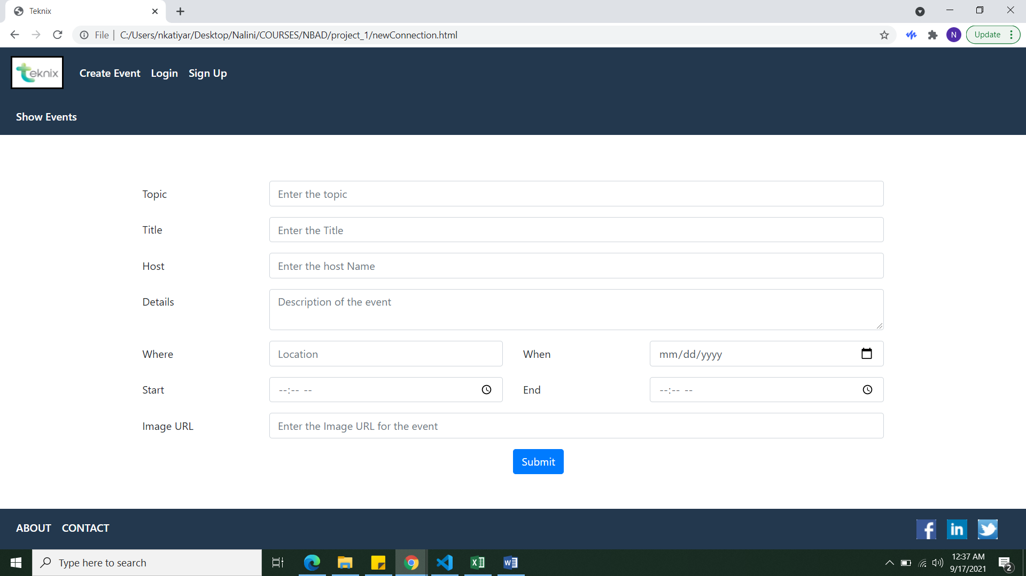

1. Explanation of status, stopping point, and issues if incomplete

My project is complete the only issue I am facing is getting a local copy of bootstrap. While changing the file path to the local copy I am getting the following error.



The solution I got was to create a server.

1. Discuss the easy and challenging parts of the assignment. How did you overcome all or some of the challenges?

The easy part was creating the HTML pages. The challenging part was to decide on the domain of the project. To decide the domain I got some help from talking to people around me.