**Report**

1. DATASTET 1
2. To-print parameter set to “no”

Command executed in cmd

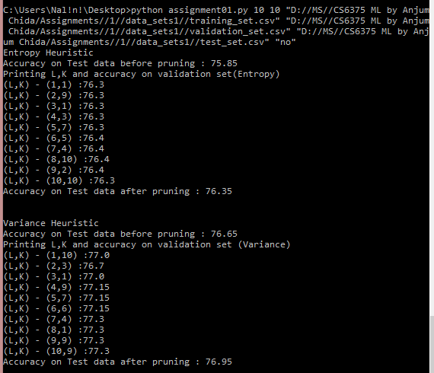

Result -



1. To-print parameter set to “yes”

Command executed - 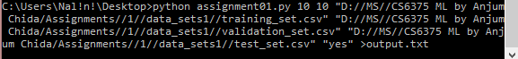

Since the output is large – moved into the file output.txt, attached below –



1. DATASTET 2
2. To-print parameter set to “no”

Command executed in cmd



Result -

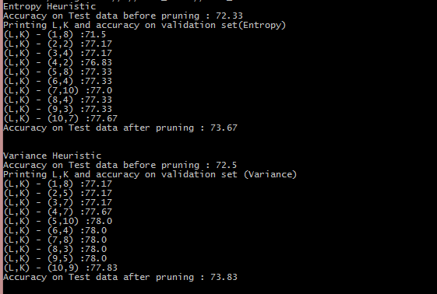

1. To-print parameter set to “yes”

Command executed -



Since the output is large – moved into the file output2.txt, attached below –

