**Instructions to setup CI:**

1. <http://localhost:8153/go/pipelines> go to this URL on your machine
2. Click on Pipelines button under admin in the top menu bar
3. Click on Add new pipeline group and name the group and click on save
4. Click on create a new pipeline within this group
5. Give a name of your choice and click next
6. Select material type from dropdown, here it is github
7. Give the URL of the repository as <https://github.com/nalinikanth/CIDemo.git>
8. Select branch as master
9. Check poll for new changes it will poll all the new changes and click next
10. You can define Initial stage, enter stage name say stage1
11. And enter initial job name/ task name say job1
12. Select task type as more
13. Enter command as “bash” and arguments as

*-c*

*javac -cp :./junit-4.10.jar:.:./selenium-server-standalone-2.53.0.jar:. FacebookLogin.java FacebookLoginTest.java TestRunner.java*

1. Click finish
2. You should be able to the window like below

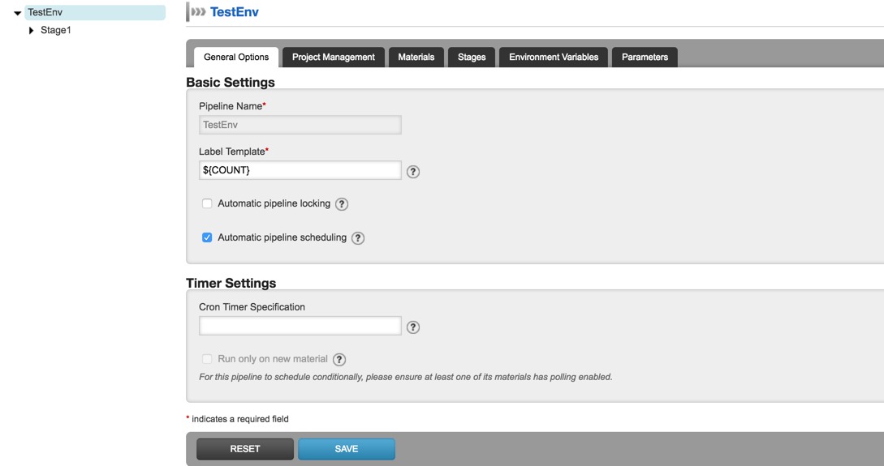

16. You can edit stage/jobs/tasks here.

17. Click on add new stage and job give the command as bash and arguments as

-c

java -cp :./junit-4.10.jar:.:./selenium-server-standalone-2.53.0.jar:. TestRunner