EmPath Roadmap and Delivery Checklist
Python prototype • Plano 75025, 75024, 75023 and 75074 • One week • 15–18 hours
Goal: compare residential access to temples, groceries and pharmacies using distance-only and environmental-friction routes.
Figure 1
Project pathway and time budget
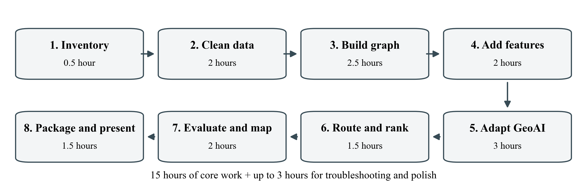
Step / suggested day | Core time | Save before moving on
1. Inventory / Day 1 | 0.5 h | Sources + four-area coverage checklist
2. Clean data / Day 1 | 2 h | Clean spatial inputs + quality report
3. Build graph / Day 2 | 2.5 h | Graph + access connectors + audit
4. Add features / Day 3 | 2 h | Edge features + data dictionary
5. Adapt GeoAI / Day 4 | 3 h | Working model adapter + model card
6. Route and rank / Day 5 | 1.5 h | Routes + residential rankings
7. Evaluate and map / Day 6 | 2 h | Comparison table + interactive map
8. Package / Day 7 | 1.5 h | Run instructions + five-minute slides
Troubleshooting / as needed | Up to 3 h | Resolve blockers; polish after core works

Time boxes guide priorities; they do not guarantee completion. Reserve extra hours for missing data, graph repairs or model compatibility.

1 Inventory and Setup
☐ Open EmPath.code-workspace in VS Code; select .venv/bin/python and the EmPath Jupyter kernel.
☐ Read README.md, docs/CONFIRMED_SCOPE.md and docs/RELATED_PROJECTS.md. Reuse existing scripts and cleaned files.
☐ For every required layer, mark each ZIP: downloaded / partial / available online / unverified.
☐ Record source link, vintage, resolution, format, license/access terms, intended use and local file path.
Save: docs/DATA_SOURCES.md and docs/COVERAGE_CHECKLIST.md. Done: every required input has a status and next action.

2 Acquire and Clean Data
Input / priority | Source ID | Required check
Study boundary / required | D1 | All four ZCTAs; distinguish ZIPs from ZCTAs
Walking network / required | D2 + OSM | Roads alone do not establish sidewalks or crossings
Residential origins / required | D3 | Verify residential use and plausible entrances
Destinations / required | OSM | Temple, grocery and pharmacy; verify category/access
Edge canopy / required for canopy scenario | D4 | Fine-scale coverage; NoData and 2021 vintage
Behavioral evidence / if used | R1 | Understand route alternatives and choice labels
Neighborhood canopy / context | D5 | Use for context, not as sidewalk shade

☐ Run .venv/bin/python scripts/clean_data.py --zipcodes 75025 75024 75023 75074; retain raw snapshots.
☐ Use GeoPandas, pandas, requests and Shapely: validate IDs/geometry, flag duplicates, preserve missing values; use EPSG:26914 for metric operations.
☐ Select roughly 5–10 verified residential origins per ZIP. Use OSMnx for destination candidates; verify names and access points. Missing OSM tags do not establish missing facilities.
Save: cleaned GeoPackages, origins.gpkg, destinations.gpkg and quality_report.md. Done: coverage and unresolved gaps are documented for all four areas.

3 Build and Audit the Walking Graph
☐ Use OSMnx graph_from_polygon(network_type="walk", retain_all=True); start with the four-ZCTA union plus roughly 500 m context. Expand if routes are truncated.
☐ Save the original GraphML. Inspect against Plano sidewalks and trails; do not turn sidewalk polygon boundaries into route edges.
☐ Attach origins/destinations at plausible pedestrian access points. Check nearest-node connectors for fences, inaccessible entrances and major-road crossings.
☐ Record connected components and disconnected origins. Preserve unreachable results; add trail connections only after checking topology, access and duplicates.
Tools: OSMnx, NetworkX, GeoPandas, Folium. References: Street Shadow (R2); UNA architecture (R5).
Save: walking_graph.graphml, access_connectors.gpkg, network_audit.md. Done: inspect at least one plausible route per ZIP.

4 Add Environmental Features
☐ Acquire a manageable clip of Texas 2021 canopy (D4); use Rasterio and NumPy to sample a documented edge corridor, initially a 10 m buffer.
☐ Store edge ID, length_m, canopy_fraction, valid_pixel_fraction, feature vintage and verified crossing constraints. Keep unknown values flagged.
☐ Check feature ranges and missingness by ZIP. Canopy is a proxy; do not describe it as time-specific shade or measured heat stress.
☐ Add traffic, weather, imperviousness or modeled shadows only after core features work. Neighborhood Tree Equity Score values remain contextual.
Save: edge_features.gpkg and docs/DATA_DICTIONARY.md. Done: each scoring feature has units, provenance and missingness checks.

5 Reuse and Adapt One GeoAI Component
Figure 2
Separate environmental prediction from routing and residential ranking
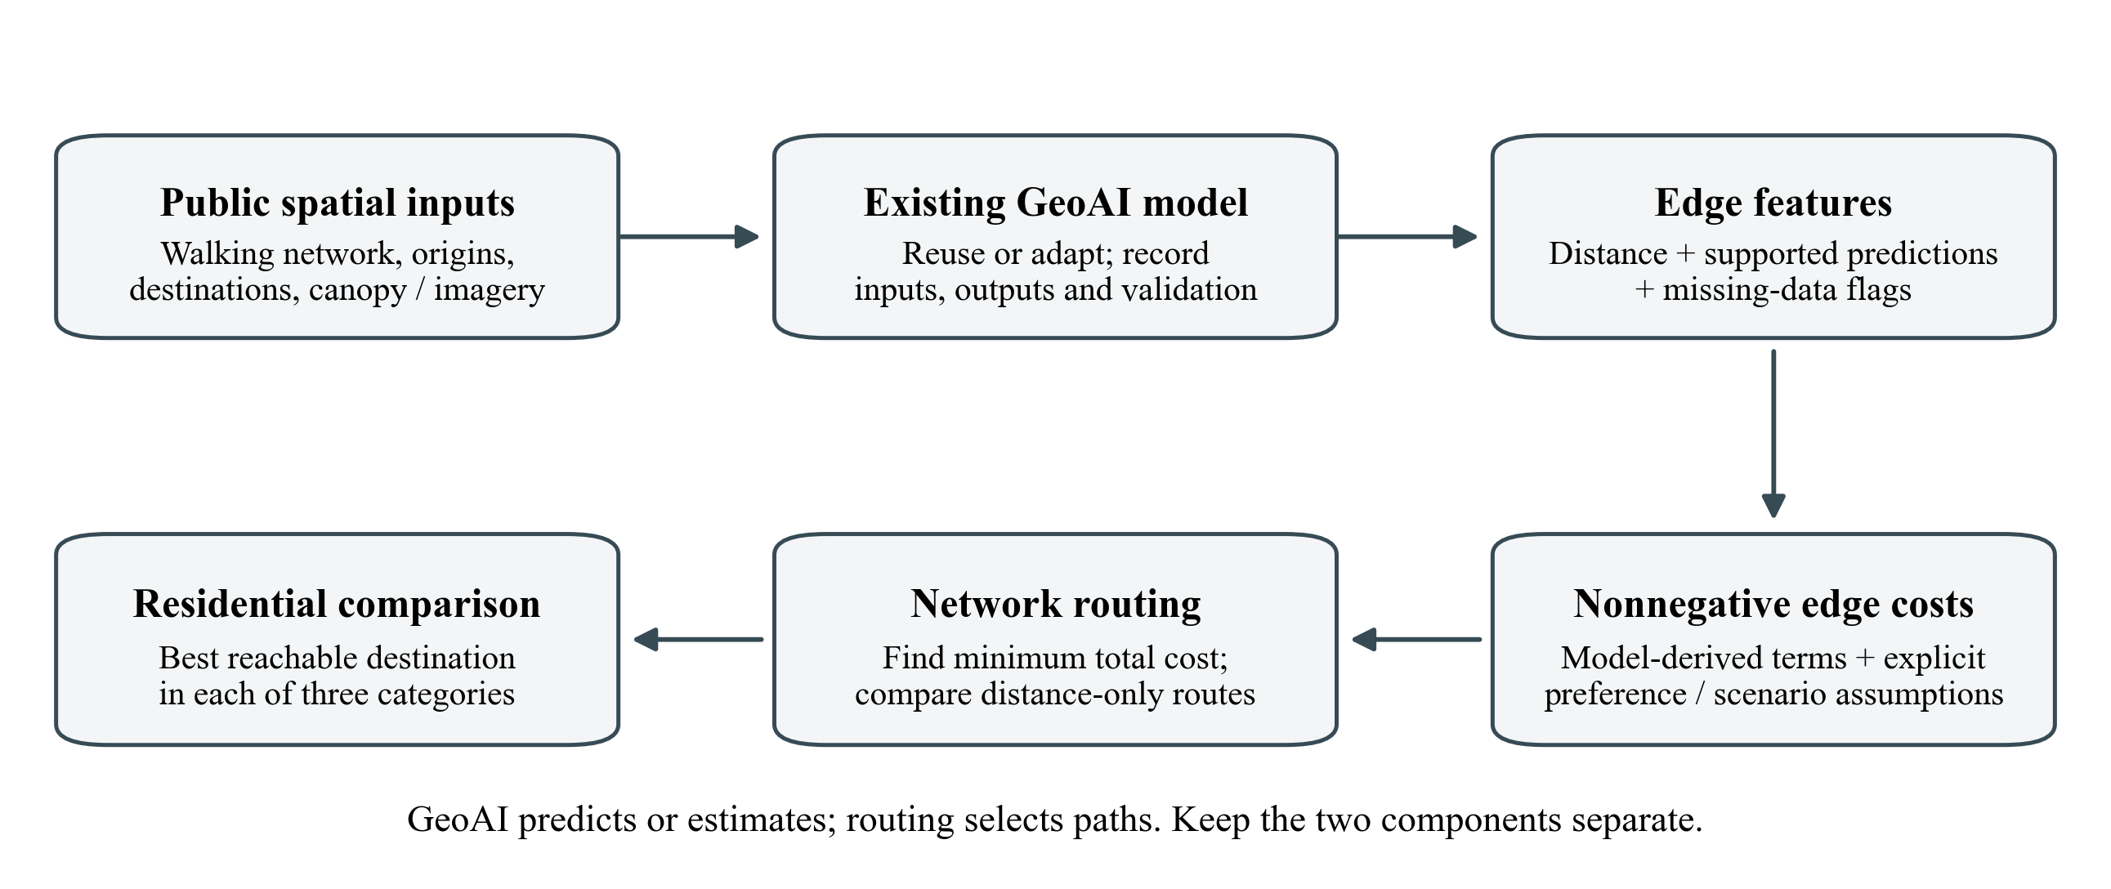
Option | Use when | Evidence to save
Existing environmental model | Runnable model + compatible public inputs are available | Model/version, prediction samples and local feature checks
Released route-choice analysis (R1) | Investigating shade–distance preferences | Reproduced notebook, parameters and transfer limitations
XGBoost or LightGBM adaptation | An existing suitable workflow and observed labels are available | Prediction target, inputs and held-out performance

☐ Choose ONE path. Reuse published code or pretrained weights; no new architecture or training from scratch is required.
☐ Write: model name/version; inputs; predicted quantity; original training geography; adaptation; role in edge costs; license.
☐ For Singapore choices, reproduce the released analysis; split by participant when fitting/evaluating. Treat it as behavioral calibration, not automatically deep learning.
☐ Check the event’s GeoAI requirement. A precomputed ML canopy product is an input, not a newly implemented model.
☐ Separate route predictions from additive edge costs. Label manual penalties as assumptions; do not claim learned weights for unobserved factors.
Save: model adapter/notebook and docs/MODEL_CARD.md. Done: the model runs, outputs are checked and reuse is explicit. Record any unresolved GeoAI gap.

6 Calculate Routes and Rank Origins
☐ Define nonnegative additive edge costs. State units, model-derived terms and scenario assumptions. Applying a sunlight preference to canopy requires an explicit transfer assumption.
☐ Use NetworkX Dijkstra-based routing twice: distance-only baseline and environmental-friction costs.
☐ For each origin, select the lowest-cost reachable destination within each of the three categories. Destinations need not occur in every ZIP; retain surrounding network context.
☐ Rank by an equal-weight sum of the three category costs. Flag missing/unreachable categories; do not rank incomplete origins as fully accessible.
Tools: NetworkX, OSMnx, pandas, GeoPandas. References: Street Shadow (R2), CoolWalks (R3), Walk Score framing (R6).
Save: routes.gpkg and residential_rankings.csv with origin/ZIP, destination IDs, distances, category costs, total cost and reachability.

7 Evaluate and Build the Map
☐ Audit at least one route per ZIP and one major crossing; inspect connectors, access and suspicious jumps.
☐ Compare one baseline/alternative route pair: distance, canopy proxy and modeled cost. Test two plausible penalty settings; record ranking changes without forcing a preferred result.
☐ Evaluate model predictions separately. Performance on foreign observations does not establish accuracy for Plano pedestrians.
☐ Use Folium layer controls, markers, tooltips and popups for boundaries, origins, destination categories and route comparisons. Precompute results; use matplotlib for presentation figures.
☐ Use Streamlit only if interactive Python queries are essential and time remains. Prepare screenshots; basemap tiles can still require internet.
Save: output/empath_demo.html, evaluation.csv and docs/LIMITATIONS.md. Done: a viewer can see which origin ranks better and why. References: LA study (R4), City Health Dashboard (R6).

8 Package and Present
☐ Update README.md: installation, interpreter/kernel, execution order, data retrieval, source attribution and model/library versions.
☐ Verify the demo loads from a fresh session. Cache computed outputs and preserve a screenshot or recording backup.
☐ Prepare five-minute slides: problem/user → data/scope → graph/GeoAI → demo/finding → limitations/next steps.
☐ Disclose coverage gaps, proxy assumptions and geographic transfer. Environmental accessibility does not certify safety or medical suitability.

Final Handoff Checklist
Deliverable | Completion test
Sources + coverage checklist | Links, vintages, status and limitations for all four ZIP areas
Clean inputs + quality report | Raw provenance retained; geometry/schema gaps documented
Graph + edge features | Audited connections; stable IDs; missing values flagged
Model adapter + model card | Runs; reuse is attributed; target and limitations explained
Routes + rankings + evaluation | Three category costs; distance baseline; unreachable results retained
Demo + code + README | Loads reproducibly; dependencies and run sequence documented
Slides + backup | Fits five minutes; demonstration survives a live-download failure

Scope and Teamwork Rules
☐ Keep all four study areas. Reduce sampled origins, optional features or scenarios before expanding the model or interface.
☐ Use up to three additional hours for blockers and polish. Never replace missing evidence with fabricated values.
☐ Optional teammate: own either network/data QA or model evaluation; return a file and a documented check. ArcGIS Pro review is optional; exchange GeoPackage/GeoJSON.
☐ Future work: local validation, detailed crossings/traffic, time-dependent heat/shade and point-to-point lowest-friction navigation.

Source and Reference Key
Use the links below at the numbered steps. Existing project bibliography: docs/RELATED_PROJECTS.md and docs/resources.md.
ID | Source link | Use / limitation
D1 | Census ZCTA boundaries | Study boundary; ZCTAs approximate postal ZIPs
D2 | Plano sidewalk surfaces | Polygon inventory; not routing edges
D2 | Plano trail centerlines | Candidate walking connections; verify access
D3 | Plano address points | Origin candidates; verify residential use/entrance
D3 | Plano parcels | Supporting geometry; not residential classification
D4 | Texas 2021 canopy raster | 10 m canopy proxy; substantial download may be needed
D5 | Tree Equity Score | Neighborhood context, not sidewalk shade
OSM | OSMnx user reference | Walking graph and destination queries; local completeness varies

ID | Case study / implementation | What to reuse
R1 | Melnikov et al. (2022), study | Observed shade–distance route choices; geographic transfer uncertain
R1 | Singapore public data and code | Released analysis notebook; inspect data definitions
R2 | Street Shadow Python repository | modules/graphs.py: shade fractions, weights and routing; manual preference parameter
R3 | CoolWalks, Wolf et al. (2025) | Shade-sensitive costs and comparisons; code is Julia
R4 | LA sidewalk heat study, Colaninno et al. | Homes-to-essentials heat/accessibility framing; full workflow uses QGIS
R5 | UNA Python repository | Origin/destination architecture; optional reference, not another required dependency
R6 | Walk Score methodology | Amenity-access score framing; not heat labels
R6 | City Health Dashboard | Context and map communication; walkability uses Walk Score

Tool | Documentation | Purpose
NetworkX | Shortest paths | Weighted routing
Rasterio | Windowed raster reads | Feature extraction; requires readable raster, not just ZIP URL
Folium | Mapping user guide | Interactive HTML map

Core libraries: GeoPandas, pandas, Shapely, requests, NumPy, OSMnx, NetworkX, Rasterio, Folium and matplotlib. Add model-specific libraries only after selecting the model. Implementation remains Python-based.

