EmPath Implementation Roadmap
Purpose: build a Python prototype that compares residential access to temples, groceries and pharmacies using distance-only and environmental-friction routes.
Scope: Plano ZIP areas 75025, 75024, 75023 and 75074, represented by Census ZCTA boundaries (U.S. Census Bureau, n.d.). Budget: one week, 15 hours of core work plus up to 3 hours for troubleshooting and polish.
Minimum demonstration: approximately 5–10 verified residential origins per ZIP, individual destinations in three categories, one environmental scenario and one reused or adapted GeoAI component. Keep the four-area scope; reduce sample size or optional features if needed.

Workflow at a Glance
Step | Time | Deliverable
1. Inventory | 0.5 h | Sources and coverage checklist
2. Clean inputs | 2 h | Clean data and quality report
3. Build network | 2.5 h | Walking graph and connection audit
4. Add features | 2 h | Edge features and data dictionary
5. Adapt GeoAI | 3 h | Model adapter and model card
6. Route and rank | 1.5 h | Routes and residential rankings
7. Evaluate and map | 2 h | Comparison results and interactive map
8. Package | 1.5 h | README, slides and backup

How the Algorithms Work
Think of EmPath as a walking map with a burden score attached to each small path segment. The system uses six separate operations:
1. Build the map. A graph is a collection of dots and connecting lines. Dots represent junctions or access points; lines represent walkable segments. Homes and destinations attach to this network.
2. Describe each segment. Record distance and supported environmental information, such as a canopy estimate. A missing connection remains a gap; it is not repaired merely because two dots are close.
3. Use the existing AI model. The model estimates the quantity it was designed to predict, such as an environmental feature. A behavioral model may instead estimate shade–distance preferences. Neither model can infer every walking need from a map alone.
4. Assign walking costs. Convert supported estimates into a nonnegative segment cost, alongside distance. A cost is a comparison score, not automatically minutes or medical risk. Document any manually chosen penalty.
5. Choose a route. Dijkstra’s algorithm tracks the lowest accumulated cost found while exploring connected paths. It returns a minimum-cost route; it does not need to list every possible route. The same algorithm can optimize distance or friction simply by changing the costs.
6. Compare homes. For each home, find the lowest-cost reachable temple, grocery and pharmacy. Add those three category costs with equal weights for the prototype. Lower totals rank better; flag missing services rather than quietly ignoring them.
Example: the shorter route below has a larger exposure penalty. The illustrative totals are 400 + 300 = 700 for Route A and 600 + 50 = 650 for Route B. Distance-only routing selects A; friction routing selects B. Real penalties require evidence or an explicit scenario assumption.
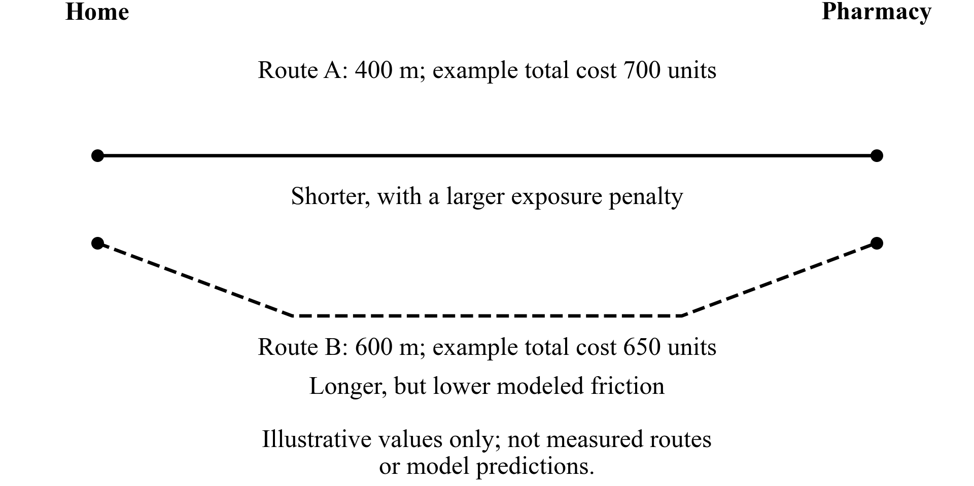

1 Inventory Sources and Coverage
- Open EmPath.code-workspace in VS Code. Select .venv/bin/python and the EmPath Jupyter kernel. Read README.md and docs/CONFIRMED_SCOPE.md.
- List boundaries, walking infrastructure, residential origins, destinations, environmental features and model inputs. For each ZIP, mark coverage as downloaded, partial, available online or unverified.
- Record provider, source URL, vintage, resolution, format, reuse terms, intended use and local file. Reuse scripts/audit_walking_coverage.py for walking coverage.
Tools: pandas, GeoPandas, requests. Save: sources table and four-area coverage checklist. Done when every required input has a status and next action.

2 Download and Clean Essential Inputs
- Run .venv/bin/python scripts/clean_data.py --zipcodes 75025 75024 75023 75074. Preserve raw snapshots; inspect the generated quality report (City of Plano, n.d.-a, n.d.-b, n.d.-c, n.d.-d).
- Check IDs, geometry, duplicates and missing values. Use EPSG:26914 for metric operations and EPSG:4326 for map display.
- Use Plano address points for a small verified residential sample. Parcels support checking but do not prove residential use or pedestrian entrances.
- Query OSM destination candidates: pharmacies, supermarkets/groceries and appropriate places of worship. Verify names, categories and access points. Missing tags do not prove that a facility is absent.
Tools: GeoPandas, Shapely, pandas, requests, OSMnx. Save: cleaned GeoPackages, origins.gpkg, destinations.gpkg and quality_report.md. Done when all four areas have documented coverage or explicit gaps.

3 Build and Audit the Pedestrian Network
- Use OSMnx graph_from_polygon with network_type="walk" and retain_all=True. Start with the four-ZCTA union plus roughly 500 m surrounding context; expand if routes are truncated (OSMnx contributors, n.d.).
- Save the original GraphML. Compare with Plano sidewalk surfaces and trails. Sidewalk polygons are supporting data, not ready-made routing edges.
- Connect origins and destinations through plausible access points. Audit nearest-node connectors for fences, inaccessible entrances and major crossings. Record components and disconnected origins.
- Inspect at least one route per ZIP. Add municipal paths only after checking access, topology and duplicates; preserve unreachable results.
Tools: OSMnx, NetworkX, GeoPandas, Folium. Reference: Street Shadow for graph-to-route structure (jlgonrod, n.d.); UNA for origin/destination architecture (City Form Lab, n.d.). Save: walking_graph.graphml, access_connectors.gpkg and network_audit.md.

4 Add Environmental Features
- Acquire a manageable clip of the Texas 2021 10 m canopy raster. Sample a documented corridor around each edge; start with a 10 m buffer and record that choice (Diamond et al., 2023).
- Save edge ID, length_m, canopy_fraction, valid_pixel_fraction, source vintage and verified crossing constraints. Check ranges and missingness by ZIP; preserve NoData.
- Treat canopy as an environmental proxy, not time-specific shade or measured heat stress. Keep Tree Equity Score values as neighborhood context. Add weather, traffic, imperviousness or shadows only after core features work (American Forests, n.d.; Wolf et al., 2025).
Tools: Rasterio, NumPy, GeoPandas, Shapely. Reference: CoolWalks for shade-sensitive costs (Wolf et al., 2025). Save: edge_features.gpkg and DATA_DICTIONARY.md. Done when every scoring feature has units, provenance and coverage checks. See Rasterio contributors (n.d.) for raster-processing documentation.

5 Reuse or Adapt One GeoAI Component
Choose one feasible approach: integrate an existing environmental predictor with compatible public inputs, or adapt a released shade–distance route-choice workflow. New model architecture or training from scratch is not required.
- Check that the chosen method meets the hackathon’s GeoAI requirement. Record model/version, license, input features, predicted quantity, original training geography and local adaptation.
- For the Singapore study, inspect the public data and reproduce its released analysis before modifying it. Keep participants grouped when fitting and evaluating. Behavioral calibration is not automatically deep learning (Melnikov et al., 2022).
- Use XGBoost or LightGBM only if a suitable existing workflow and meaningful observed labels are available. Install only the selected model’s dependencies.
- Keep route-level predictions separate from additive edge costs. Identify manually specified penalties as assumptions; do not claim learned preference weights for unobserved factors.
Save: model adapter or notebook and MODEL_CARD.md. Done when the model runs, outputs are checked and reuse is explicit. A precomputed ML canopy product is an input, not proof of a newly implemented model; record any unresolved GeoAI gap.

How the Components Connect
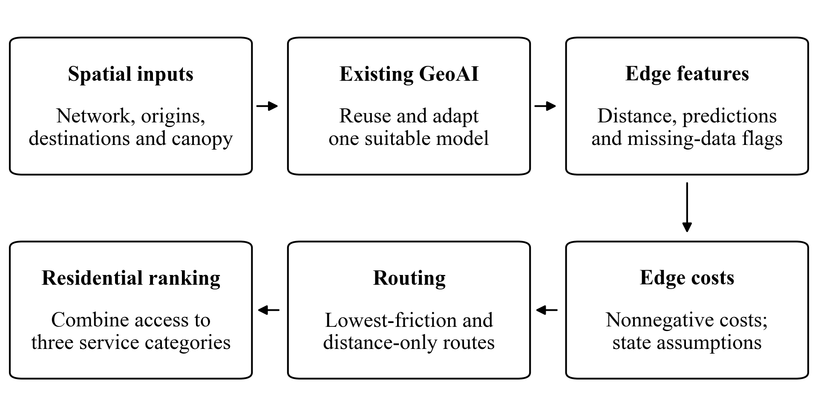

6 Calculate Routes and Residential Rankings
- Define nonnegative additive edge costs with explicit units. Separate model-derived terms from scenario assumptions. Applying sunlight preferences to canopy requires a disclosed transfer assumption.
- Use NetworkX Dijkstra-based routing for distance-only and environmental-friction scenarios. Find the lowest-cost reachable destination in each of the three categories for each origin (NetworkX developers, n.d.).
- Rank origins by an equal-weight sum of category costs. Flag missing or unreachable categories; do not present incomplete origins as fully accessible. Destinations need not occur inside every ZIP.
Tools: NetworkX, OSMnx, pandas, GeoPandas. References: Street Shadow, CoolWalks and Walk Score’s amenity framing (Walk Score, n.d.). Save: routes.gpkg and residential_rankings.csv with origin/ZIP, destination IDs, distances, category costs, total cost and reachability.

7 Evaluate and Build the Demonstration
- Audit at least one route per ZIP and one major crossing. Inspect connectivity, access and suspicious jumps.
- Compare a baseline/alternative route pair using distance, canopy proxy and modeled cost. Test two plausible penalty settings and record ranking changes. Report the result even if routes do not improve.
- Evaluate the reused model separately. Performance on observations outside Plano does not establish accuracy for Plano pedestrians.
- Build one Folium map with boundaries, origins, destinations, ranked-origin popups and route alternatives. Precompute results; add Streamlit only if essential and time remains (Folium contributors, n.d.).
Tools: Folium, pandas, matplotlib and model-specific evaluation tools. References: LA sidewalk heat study for research design (Colaninno et al., 2025); City Health Dashboard for communication (City Health Dashboard, n.d.). Save: empath_demo.html, evaluation.csv and LIMITATIONS.md. Done when a viewer can explain a ranking; prepare screenshots because basemap tiles may need internet.

8 Package and Present
- Update README.md with installation, interpreter/kernel, execution order, download instructions, attribution and tested model/library versions. Verify the demo from a fresh session.
- Prepare five-minute slides: problem and user; data and scope; graph and GeoAI; demonstration and finding; limitations and next steps. Save a backup recording or screenshots.
- Hand off sources/coverage, clean-data provenance, graph/features, model adapter/card, routes/rankings, evaluation, demo, code and slides. Reuse generated outputs rather than write a separate long report.
Completion check: the demo loads reproducibly, recommendations are explainable, gaps are disclosed and the presentation fits five minutes. Environmental accessibility does not certify safety or medical suitability.

Working Rules
- Use 15 hours for the core workflow and up to 3 additional hours for blockers or polish. Reduce sampled origins or optional layers before expanding the interface or model.
- Python is the reproducible pipeline: VS Code, Jupyter and a browser. ArcGIS Pro is optional for a teammate’s review; exchange GeoPackage/GeoJSON files.
- Optional teammate: own either network/data QA or model evaluation, with a specific file and documented check to return.
- Future expansion: local preference validation, detailed crossing/traffic data, time-dependent heat/shade and point-to-point lowest-friction navigation.

References
American Forests. (n.d.). Tree Equity Score methods and data. https://www.treeequityscore.org/methodology?tab=data-download
City Form Lab. (n.d.). UNA urban network analysis [Computer software]. GitHub. https://github.com/City-Form-Lab/urban_network_analysis
City Health Dashboard. (n.d.). Walkability. https://www.cityhealthdashboard.com/metric/walkability
City of Plano. (n.d.-a). Address points [Data set]. https://maps.planogis.org/arcgiswad/rest/services/OpenData/AddressPoints/FeatureServer/0
City of Plano. (n.d.-b). Parcels [Data set]. https://maps.planogis.org/arcgiswad/rest/services/OpenData/Parcels/FeatureServer/1
City of Plano. (n.d.-c). Sidewalks [Data set]. https://maps.planogis.org/arcgiswad/rest/services/OpenData/Sidewalks/FeatureServer/0
City of Plano. (n.d.-d). Trail centerlines [Data set]. https://maps.planogis.org/arcgiswad/rest/services/OpenData/TrailCenterlines/FeatureServer/0
Colaninno, N., Basu, R., Hosseini, M., Alhassan, A., Liu, L., & Sevtsuk, A. (2025). A sidewalk-level urban heat risk assessment framework using pedestrian mobility and urban microclimate modeling. Environment and Planning B: Urban Analytics and City Science, 52(5). https://doi.org/10.1177/23998083241280746
Diamond, D., Sunde, M., & Elliott, L. (2023). Texas statewide landcover, ecological systems, and percentage canopy classifications (10-meter resolution) (2021) [Data set]. Zenodo. https://zenodo.org/records/8200761
Folium contributors. (n.d.). User guide. https://python-visualization.github.io/folium/latest/user_guide.html
jlgonrod. (n.d.). Street Shadow [Computer software]. GitHub. https://github.com/jlgonrod/street_shadow
Melnikov, V. R., Christopoulos, G. I., Krzhizhanovskaya, V. V., Lees, M. H., & Sloot, P. M. A. (2022). Behavioural thermal regulation explains pedestrian path choices in hot urban environments. Scientific Reports, 12, Article 2441. https://doi.org/10.1038/s41598-022-06383-5
NetworkX developers. (n.d.). Shortest paths. https://networkx.org/documentation/stable/reference/algorithms/shortest_paths.html
OSMnx contributors. (n.d.). User reference. https://osmnx.readthedocs.io/en/stable/user-reference.html
Rasterio contributors. (n.d.). Windowed reading and writing. https://rasterio.readthedocs.io/en/stable/topics/windowed-rw.html
U.S. Census Bureau. (n.d.). ZIP Code Tabulation Areas [Data set]. TIGERweb. https://tigerweb.geo.census.gov/arcgis/rest/services/TIGERweb/tigerWMS_ACS2024/MapServer/2
Walk Score. (n.d.). Walk Score methodology. https://www.walkscore.com/methodology.shtml
Wolf, H., Vierø, A. R., & Szell, M. (2025). CoolWalks for active mobility in urban street networks. Scientific Reports, 15, Article 14911. https://doi.org/10.1038/s41598-025-97200-2

