**AZURE MONITORING**

**Azure Monitor Agent (AMA)**

Azure Monitor Agent (AMA) collects monitoring data from the guest operating system of Azure and hybrid virtual machines. One agent for all

It is a VM Extension by default for AZURE VM’S

AMA will support AZURE VM, Other could, and On-premises VM’S.

Only ONCE YOU Start creating a data collection rule, it will start working.

Install the agent and configure data collection

Azure Monitor Agent uses data collection rules, where you define which data you want each agent to collect. Data collection rules let you manage data collection settings at scale and define unique, scoped configurations for subsets of machines. You can define a rule to send data from multiple machines to multiple destinations across regions and tenants.

Azure > Monitoring>Data collection rule

Data collection

Alert types

1. Metrics (Performance counters) Ex windows -CPU, MEMORY DISK
2. Logs (windows event log and other logs) – EX Application logs and Security logs

Below are from Metrics -

In the data collection rule, we need to choose the name of the resource and required parameters for alert creation

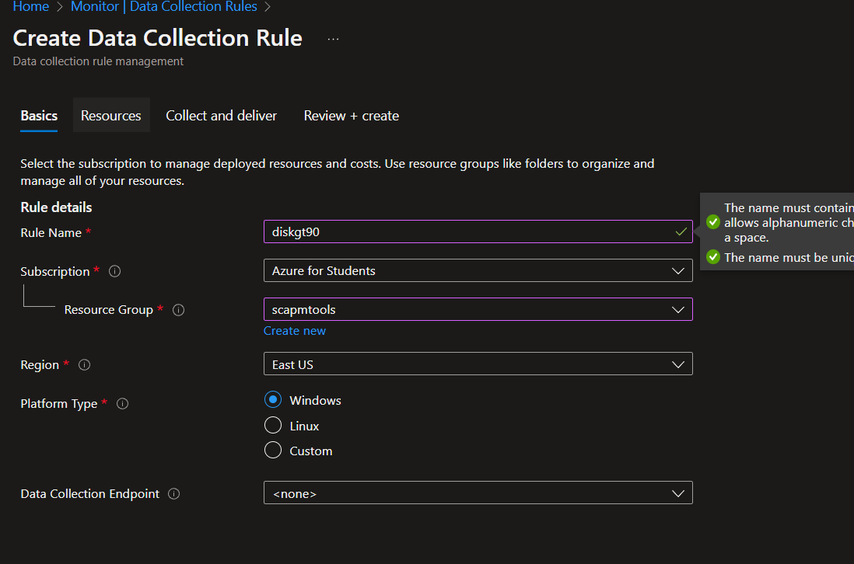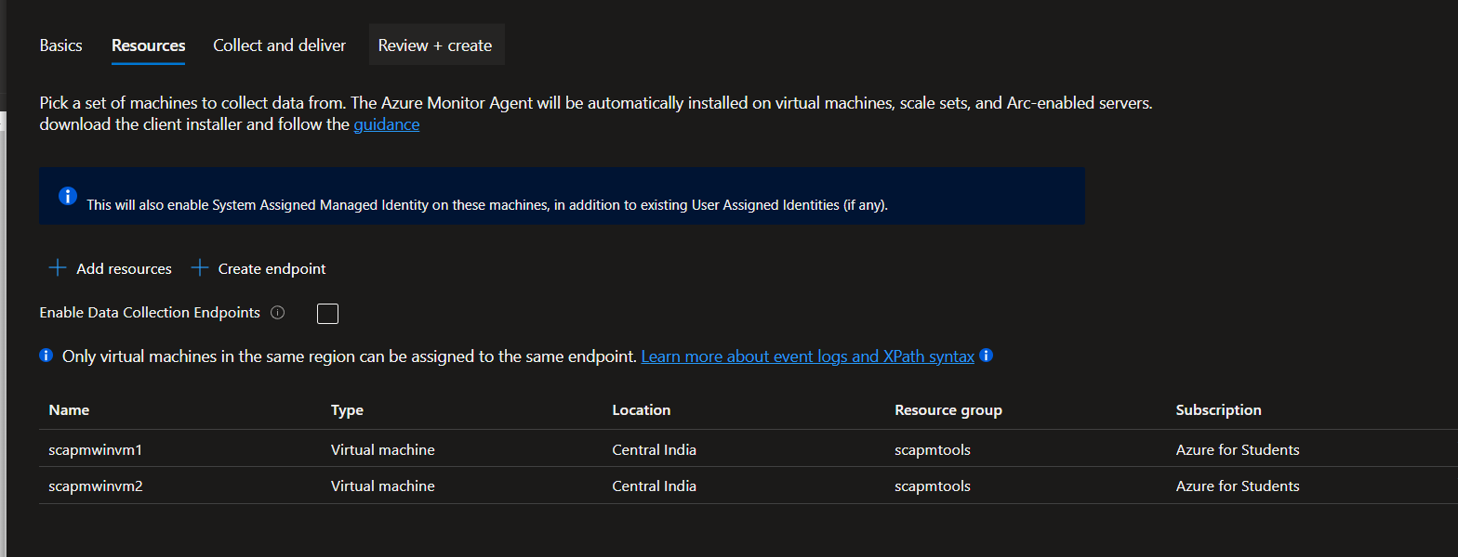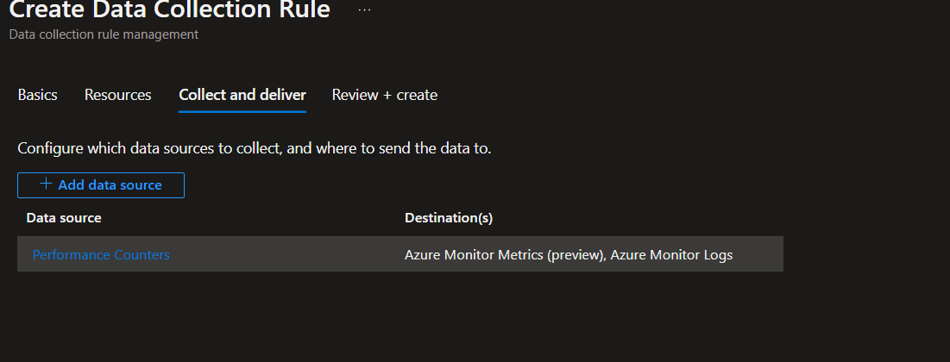

**Create An Alert**

Scope - Virtual machine

Condition – Signals (CPU , Disk etc ) { Attributes in SCAPM}

Alert logic (Condition/formula) Operator = greater than / less than / equal

Threshold = 90, Frequency = 5 minutes Action -

Action group name = Team’s name (windows team)

Contain action = EMAIL, phone. message other **Details**

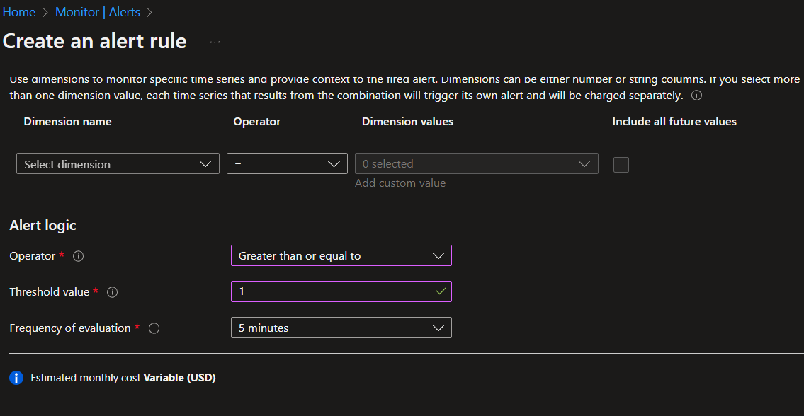

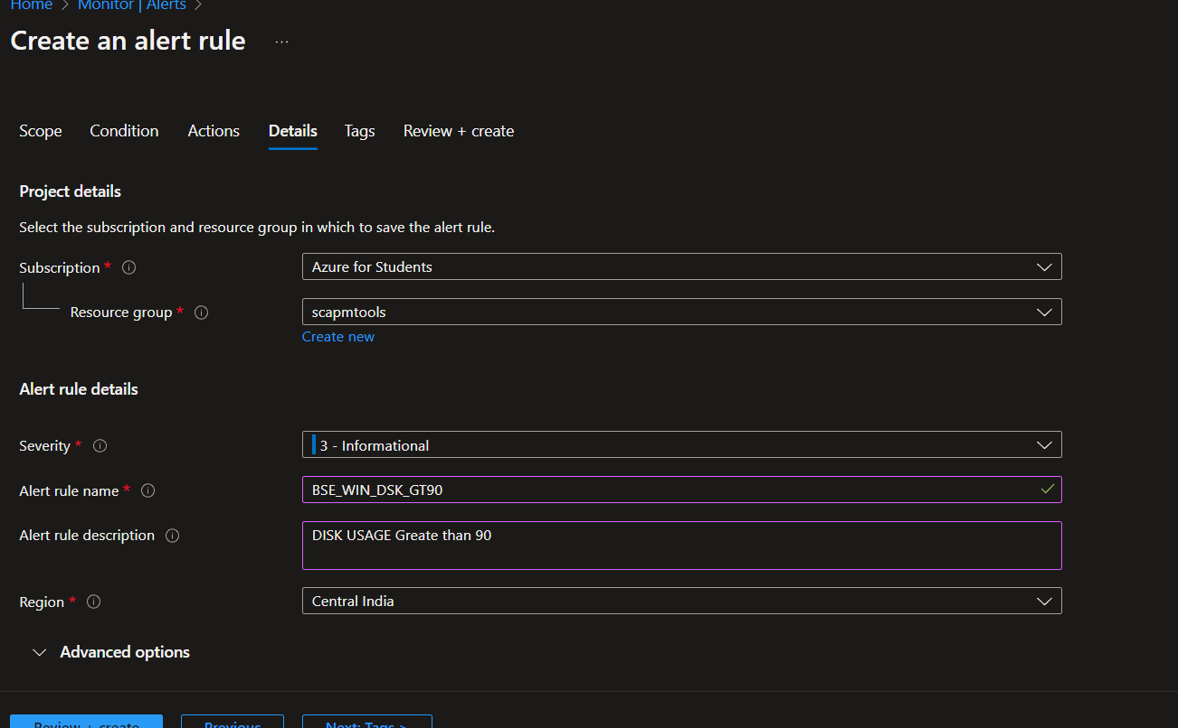







Email Alert

