**Electronic Fetal monitoring:**

**1)direct (internal fetal monitoring):**

It is accomplished by attaching a bipolar spiral electrode directly to the scalp of the fetus and reading the values

The fetal heart rate (FHR) is measured by calculating the time between successive R waves in the fetal ECG. A cardiotachometer continuously updates the FHR with each new R wave, providing real-time monitoring. The beat-to-beat variability helps assess fetal well-being.

**R wave** is a specific part of the ECG waveform representing the ventricular contraction of the heart.

**2)External fetal heart:**

rate monitoring uses ultrasound Doppler to detect the fetal heartbeat through the mother's abdomen. A transducer emits ultrasound waves, and a sensor detects frequency shifts caused by the fetal heart's movement and blood flow. This method can be challenging in obese women (because of extra fat).

**Attribute values**

1. **(Base Line Value)**

The **baseline value** is like the usual or steady heart rate of the fetus over a period of time, usually 10 minutes. It’s the heart rate when nothing unusual is happening—like when the baby isn’t moving a lot or there aren't any contractions. This helps doctors understand what the normal heart rate for the baby is

As a fetus grows, its heart rate slows down, dropping about 1 beat per minute each week from 16 weeks to full term. This is because the parasympathetic nervous system, which slows the heart, develops over time.

* **Baseline FHR** is the average heart rate over 10 minutes.
* **Bradycardia**: FHR less than 100 BPM.
* **Tachycardia**: FHR more than 160 BPM.
* The **sympathetic system** speeds up the heart rate, while the **parasympathetic system** slows it down.

1. **baseLine variability:**

Beat-to-beat variability refers to the fluctuations in the time interval between each heartbeat. It's an important indicator of how well your cardiovascular system is functioning and is controlled by the autonomic nervous system, which has two main parts:

1. **Sympathetic Nervous System:** This acts like a "push" that speeds up your heart rate.
2. **Parasympathetic Nervous System:** This acts like a "pull" that slows down your heart rate.

These fluctuations happen because of how the sinoatrial (SA) node in your heart regulates the rhythm of your heartbeat. This node creates tiny variations in the baseline heart rate from beat to beat, and this is called "baseline variability."

1. **Accelerations and decelarations:**

Deviation from baseline and has temporary related to uterine contactions.

**Acceleration –** rise in HR above baseline

**Deceleration -** deep below baseline

**Terms to explain the fetal distress**

* 1. **Reassuring fetal distress:** This means the **baby's health is good**, and any concerns have been resolved. The baby's heart rate patterns are normal, which suggests the baby is not in distress.
  2. **Non-Reassuring fetal distress:** this means there are signs that the **baby might be in distress**, and it’s not clear if the baby is okay. The heart rate patterns are concerning, and it might indicate that the baby is not getting enough oxygen.

1. **Methods for Monitoring FHR**:
   * **Fetal stethoscope**: A special tool used to listen to the baby’s heartbeat.
   * **Doppler ultrasound**: Uses sound waves to check the baby's heartbeat.
   * **Continuous electronic monitoring**: Tracks the baby's heartbeat and the mother's contractions all the time.
2. **When Using a Stethoscope (Auscultation)**:
   * Listen to the baby's heartbeat for a full 60 seconds.
   * Do this right after a contraction finishes.
   * Repeat this process over at least three different contractions.

This helps ensure that the baby's heartbeat is healthy during labor.

@question

Aythe ikkadunna attributes doppler ultrasound use chesi teeskunnavi aa

1. **Monitoring Methods:**
   * **Low-Risk Pregnancies:**
     + **Intermittent Auscultation:** Listening to the baby’s heartbeat at specific intervals (e.g., every 30 minutes).
     + **Continuous Electronic Monitoring:** Using devices (external or internal) to track the baby’s heartbeat continuously.
   * **High-Risk Pregnancies:**
     + Same methods as low-risk pregnancies but with shorter intervals (e.g., every 15 minutes).
2. **Evaluation Intervals:**
   * **First Stage of Labor:**
     + Low-risk: Evaluate every 30 minutes.
     + High-risk: Evaluate every 15 minutes.
   * **Second Stage of Labor:**
     + Low-risk: Evaluate every 15 minutes.
     + High-risk: Evaluate every 5 minutes

When we look at a fetal heart rate (FHR) trace, we focus on three main things:

* Base Line fetal heart rate
* Beat – to beat variability (Sysmphatic and parasymphatic)
* FHR accelerations and decelarations
* **External Tocography**:
  + A device (transducer) is placed on the mother’s abdomen to measure the strength of uterine contractions during labor.
  + The transducer is placed between the top of the uterus (fundus) and the belly button.
  + When the uterus contracts, it pushes against the transducer, creating a curve on a monitor that shows the contraction.
  + The baseline pressure is usually around 20 mmHg.
  + The device can measure how often and how long contractions happen, but not how strong they are.
* **Heart Rate Control During Labor**:
  + The baby’s heart rate is controlled by systems that depend on proper blood flow and oxygen levels.
  + Labor naturally reduces the baby’s oxygen supply at times, which is usually okay for a healthy baby.
  + If the baby’s placenta (the organ that provides oxygen and nutrients) isn’t working well, the baby might not handle labor stress well and needs continuous monitoring to detect any signs of distress early.

**Before 30 Weeks of Pregnancy**:

* The uterus is mostly quiet with very little activity.

**Braxton Hicks Contractions**:

* If a contraction is stronger than 20 mmHg, it’s often called a Braxton Hicks contraction. These are practice contractions that usually start after 20 weeks.

**After 30 Weeks**:

* Uterine activity starts to increase gradually.

**Labor Begins**:

* When uterine activity reaches between 80-120 Montevideo units (a measurement for contractions), clinical labor begins. This means the contractions are strong enough to start the process of childbirth.

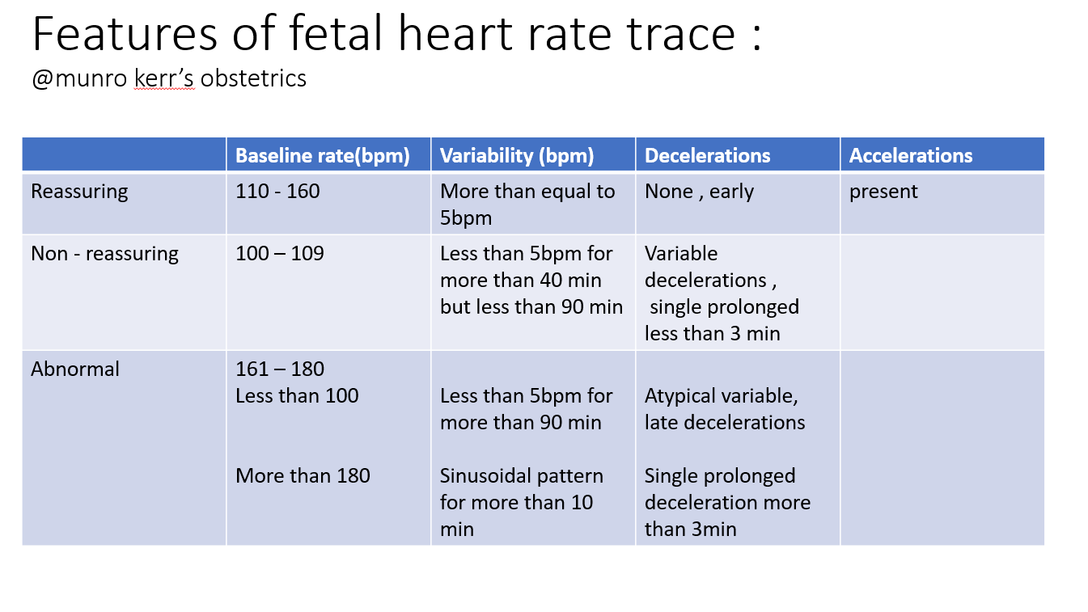

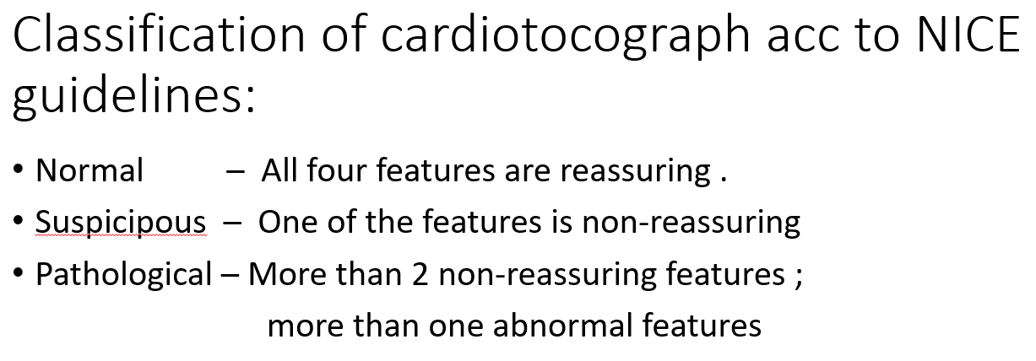

**i.e NSP generally depends upon (base line rate bpm), variability, decelerations, accelerations**

**THREE TIER FETAL HEART RATE INTERPRETATION SYSTEM:**

* **CATEGORY 1: NORMAL**

Include all of the following

* Base line rate : 110- 160
* Baseline FHR variability : moderate
* Late or variable decelerations : Absent
* Early decelerations : present or absent
* Accelerations : present or absent
* **Category 2 - Indeterminate Baseline Rate:**
* **Bradycardia**: The baby’s heart rate is too slow, but the pattern isn’t completely absent, so it's not considered severe**.**
* **Tachycardia:** The baby’s heart rate is too fast.
* **Baseline FHR (Fetal Heart Rate) Variability:**
* **Minimal Variability:** The heart rate changes only slightly, which could mean the baby is resting or not getting enough oxygen**.**
* **Absent Variability (Without Recurrent Decelerations):** The heart rate stays the samewithout much change, but this isn’t combined with repeated drops in heart rate, so it's not as concerning**.**
* **Marked Variability**: The heart rate changes a lot, showing big swings up and down. This could mean the baby is reacting strongly to something, like stress.

**Accelerations and Decelerations:**

1. **Absence of Induced Accelerations:**
   * If the baby’s heart rate doesn’t speed up (accelerate) when the baby is stimulated, it might indicate a problem**.**
2. **Periodic or Episodic Decelerations:**
   * These are drops in the baby’s heart rate that happen either regularly or at random times.
3. **Recurrent Variable Decelerations with Minimal or Moderate Baseline Variability:**
   * The baby’s heart rate drops frequently, but the usual pattern of the heart rate (baseline variability) isn’t too concerning.
4. **Prolonged Decelerations:**
   * The baby’s heart rate stays low for a long time (between 2 and 10 minutes), which can be a sign of stress.
5. **Recurrent Late Decelerations with Moderate Baseline Variability:**
   * The baby’s heart rate drops late after contractions, but the usual heart rate pattern is still somewhat normal.
6. **Variable Decelerations with Other Characteristics:**
   * The heart rate drops, but takes a long time to return to normal, or has unusual patterns like overshoots (brief rise above normal) or shoulders (brief dips). These might suggest the baby is under stress.

**Category 3 - Abnormal Patterns:**

This category includes situations where the baby's heart rate is concerning. It happens when there's no normal change in the heart rate pattern (called "absent baseline variability") along with any of the following:

1. **Recurrent Late Decelerations:**
   * The baby’s heart rate keeps dropping late after contractions, indicating possible stress.
2. **Recurrent Variable Decelerations:**
   * The baby’s heart rate frequently drops in an irregular way, which could be a sign of trouble.
3. **Bradycardia:**
   * The baby’s heart rate is consistently too slow**.**
4. **Sinusoidal Pattern:**

**Fetal Pulse Oximeter**:

This is a tool used to check how much oxygen the baby is getting during labor. After the water breaks (membranes rupture), a small sensor, like a pad, is gently placed through the cervix (the opening to the womb) and against the baby's face. This sensor measures the baby's oxygen levels.

* **Normal Oxygen Level**: If the baby's oxygen level is 30% or higher, it's considered normal.
* **Low Oxygen Level**: If the level is below 30%, it means the baby might not be getting enough oxygen and could be in danger.

**Classes to be predicted:**

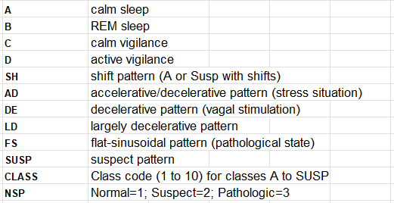

**Class labels given :**

