SIMATS ENGINEERING
ASSESSMENT TOOL 3 - LOW (CAPSTONE PROJECT)
COURSE CODE: CSA0927 COURSE NAME: Programming in Java
COURSE OUTCOME COVERED
CO5: Construct database-driven web applications by implementing JDBC connectivity
to perform SQL operations such as insert, update, and delete using different statement
types. (BL3,BL6)
Assessment Tool Weightage: 40%
QUESTIONS: 1 Total Marks: 100

ANNEXURE A
CAPSTONE PROJECT

Code of Conduct:
I N. Navya Sri Vasavi (192411204) (Name / Reg No) certify that this submission is my original work and that I have adhered to the guidelines specified for this assessment. I understand that any violation of academic integrity rules will result in disciplinary
action.
Signature of the student: Vasavi

Implementation of a Java-Based Virtual Classroom System
A CAPSTONE PROJECT REPORT
Submitted in the partial fulfilment for the Course of
CSA0927 – JAVA PROGRAMMING
to the award of the degree of
BACHELOR OF ENGINEERING
IN
COMPUTER SCIENCE AND ENGINEERING
Submitted by
N. Navya Sri Vasavi -192411204 , B. Lahari Sri – 192421421, Challa Priyadarshini-192311118 , Ch. Srikanth - 192311159
Under the Supervision of
DR. PUSHPALATHA S

SIMATS ENGINEERING
Saveetha Institute of Medical and Technical Sciences
Chennai-602105


SIMATS ENGINEERING
Saveetha Institute of Medical and Technical Sciences
Chennai-602105

DECLARATION

We, N. Navya Sri Vasavi -192411204, B. Lahari Sri – 192421421, Challa Priyadarshini 192311118, Ch. Srikanth – 192311159 of the CSE, Saveetha Institute of Medical and Technical Sciences, Saveetha University, Chennai, hereby declare that the Capstone Project Work entitled ‘Implementation of a Java-Based Virtual Classroom System’ is the result of our own Bonafide efforts. To the best of our knowledge, the work presented herein is original, accurate, and has been carried out in accordance with principles of engineering ethics.

Place: CHENNAI
Date: 08/09/2026

N. Navya Sri Vasavi -192411204,
B. Lahari Sri – 192421421,
Challa Priyadarshini -192311118,
Ch. Srikanth – 192311159



SIMATS ENGINEERING
Saveetha Institute of Medical and Technical Sciences
Chennai-602105
BONAFIDE CERTIFICATE
This is to certify that the Capstone Project entitled “Implementation of a Java-Based Virtual Classroom System” has been carried out by [N. Navya sri Vasavi, B. Lahari sri, Ch priyadarshini, Ch. Srikanth] under the supervision of Dr. Pushpa Latha S and is submitted in partial fulfilment of the requirements for the current semester of the B. Tech [CSE] program at Saveetha Institute of Medical and Technical Sciences, Chennai.
SIGNATURE SIGNATURE
Dr. Sasi Rekha Dr. PushpaLatha S
Program Director Professor
Department of CSE Department of CSE
Saveetha School of Engineering Saveetha School of Engineering
SIMATS SIMATS

Submitted for the Project work Viva-Voce held on ___________________________ .

INTERNAL EXAMINER EXTERNAL EXAMINER

ACKNOWLEDGEMENT

We would like to express our heartfelt gratitude to all those who supported and guided us throughout the successful completion of our Capstone Project. We are deeply thankful to our respected Founder and Chancellor, Dr. N.M. Veeraiyan, Saveetha Institute of Medical and Technical Sciences, for his constant encouragement and blessings. We also express our sincere thanks to our Pro-Chancellor, Dr. Deepak Nallaswamy Veeraiyan, and our Vice-Chancellor, Dr. S. Suresh Kumar, for their visionary leadership and moral support during the course of this project.

We are truly grateful to our Director, Dr. Ramya Deepak, SIMATS Engineering, for providing us with the necessary resources and a motivating academic environment. Our special thanks to our Principal, Dr. B. Ramesh for granting us access to the institute’s facilities and encouraging us throughout the process. We sincerely thank our Head of the Department, Dr. Sasi Rekha for her continuous support, valuable guidance, and constant motivation.

We are especially indebted to our guide from the Department of CSE, Dr. PushpaLatha S for his creative suggestions, consistent feedback, and unwavering support during each stage of the project. We also express our gratitude to the Project Coordinators, Review Panel Members (Internal and External), and the entire faculty team for their constructive feedback and valuable inputs that helped improve the quality of our work. Finally, we thank all faculty members, lab technicians, We thank our parents, and friends for their continuous encouragement and support.
N. Navya Sri Vasavi -192411204
B. Lahari Sri – 192421421
Challa Priyadarshini-192311118
Ch. Srikanth - 192311159

ABSTRACT
The Implementation of a Java-Based Virtual Classroom System focuses on developing a software platform that supports online teaching and learning through a centralized digital classroom environment. Educational institutions manage several activities such as course communication, distribution of learning materials, assignment collection, attendance, and academic announcements. When these activities are handled manually or through disconnected applications, information can become difficult to organize and retrieve.
The proposed system provides an integrated virtual classroom environment in which faculty members can create and manage courses, establish classrooms, upload learning resources, publish announcements, create assignments, record attendance, and monitor student submissions. Students can log into the system, access enrolled classrooms, view course resources, check assignment requirements, submit academic work, and view relevant classroom information.
The application is designed using Java as the primary programming language. Object-oriented programming principles are used to divide the application into logical classes and modules. A relational database is used to store users, courses, classrooms, enrollments, learning materials, assignments, submissions, attendance, and announcements. JDBC provides communication between the Java application and the database.
Role-based authentication is included to distinguish student and faculty capabilities. Validation and exception handling are considered to improve reliability. The system is designed as a modular application so that additional features can be integrated in future versions without replacing the core classroom-management functionality.
The project demonstrates how Java programming, database management, software engineering, and user-interface design can be combined to solve a practical educational problem. The resulting system provides a foundation for a more comprehensive learning management platform.
Keywords: Java, Virtual Classroom, E-Learning, Online Education, Course Management, Assignment Management, Attendance, JDBC, Database.

TABLE OF CONTENTS
Chapter No | TOPIC | PAGE NO.
 | Abstract | 5
1 | Introduction  1.1 Background Information  1.2 Project Objectives  1.3 Significance  1.4 Scope  1.5 Methodology Overview | 8-10  8  8  9  9  10
2 | Problem Identification and Analysis  2.1 Description of the Problem  2.2 Evidence of the Problem  2.3 Working principle  2.4 Supporting Data/Research | 11-12  11  11  12  12
3 | Solution Design and Implementation  3.1 Development and Design Process  3.2 Tools and Technologies Used  3.3 Solution Overview  3.4 Engineering Standards Applied  3.5 Solution Justification | 13-15  13  13  14  14  15
4 | Module 1 Name  Module 2 Name  Module 3 Name  Results and Recommendations  4.1 Evaluation of Results  4.2 Challenges Encountered  4.3 Possible Improvements  4.4 Recommendations | 16  16  16  17-20  17  18  19  20
5 | Reflection on Learning and Personal Development  5.1 Key Learning Outcomes  5.2 Academic Knowledge  5.3 Technical Skills  5.4 Problem-Solving and Critical Thinking  5.5 Conclusion of Personal Development | 21-24  21  21  22  23  24
6 | Conclusion  6.1 Future Enhancement | 25  26
 | References | 27
 | Appendices | 28-30

LIST OF FIGURES
Figure No. | Topic | Page No.
Fig 1.1 | System Architecture | 14
Fig 1.2 | Dashboard page | 28
Fig 1.3 | User login and Authentication | 28
Fig 1.4 | Live classroom and content management | 29
Fig 1.5 | Assignments and Assessments Managements | 29
Fig 1.6 | Reports and Group Discussion | 30

LIST OF TABLES
 | Topic | Page No.
3.2 | Tools and Technologies | 13
4.1 | Evaluation of Results | 17

CHAPTER 1

INTRODUCTION

1.1 Background Information
Education has increasingly adopted digital technologies to support teaching, communication, resource distribution, assessment, and academic administration. A virtual classroom is a software environment that reproduces important classroom activities in a digital form. Instead of depending exclusively on a physical classroom, students and faculty can use an application to access academic information and perform routine learning activities. Traditional classroom management involves several repeated tasks. Faculty members prepare course materials, communicate instructions, collect assignments, maintain attendance, and provide feedback. Students need to obtain materials, remember deadlines, submit work, and remain informed about announcements. If each task is handled through a separate mechanism, the overall process becomes difficult to coordinate. A centralized virtual classroom system addresses this problem by connecting related activities. The proposed system associates students with classrooms, classrooms with courses, and academic resources with the relevant classroom. This relationship allows information to be retrieved according to the user's role and enrollment. Java is selected for the implementation because it provides strong support for object-oriented programming, modular design, exception handling, database connectivity, and reusable components. These characteristics are appropriate for developing an academic management application in which different modules need to interact with common data. The system is therefore designed not merely as a file-sharing application but as a structured classroom-management platform. Its purpose is to provide a consistent workflow for authentication, course access, learning resources, assignments, attendance, and announcements.

1.2 Project Objectives
• To analyze the requirements of a digital classroom environment.
• To design and implement a Java-based virtual classroom application.
• To provide separate functionality for students and faculty members.
• To maintain course and classroom information in a structured database.
• To provide a centralized mechanism for learning-material access.
• To support assignment creation, submission, and tracking.
• To support attendance recording and retrieval.
• To provide classroom-specific announcements.
• To apply object-oriented programming and software engineering principles.
• To test the integrated application and evaluate its effectiveness.

1.3 Significance
The project is significant from both an educational and technical perspective. From an educational perspective, it demonstrates how classroom activities can be organized in a digital environment. From a technical perspective, it provides practical experience in Java, database connectivity, system analysis, software design, testing, and documentation. In an existing manual or fragmented approach, faculty may distribute materials through email or messaging applications, maintain attendance in spreadsheets, announce deadlines through separate channels, and receive assignments through different mechanisms. Students must remember where information was shared and may have difficulty identifying the most recent version of a resource. The proposed system brings these activities into one Java-based application. A faculty member can create a classroom and associate academic resources with it. Students who are enrolled in that classroom can access the corresponding materials and assignments. Attendance and announcements are also linked to the classroom.
1.4 Scope
The system scope includes student and faculty authentication, virtual classroom creation, course management, enrollment, learning-material access, assignment management, submission tracking, attendance management, announcements, and database storage. The project is intended as an academic prototype and can be adapted to a department, small institution, or training environment. The system focuses on core classroom management rather than attempting to reproduce every feature of a commercial learning management system. Real-time video conferencing, advanced artificial intelligence, automated examination proctoring, large-scale cloud infrastructure, and sophisticated analytics are treated as future enhancements unless they are specifically implemented in the final application. Such an environment may work for small activities, but it becomes increasingly difficult to manage when the number of courses, students, assignments, and resources increases. There is also a greater possibility of inconsistent records because the same information may need to be entered or updated in multiple locations.

1.5 Methodology Overview
The development methodology begins with requirement analysis. The functional needs of students and faculty are identified and divided into manageable modules. The next stage is system design, where the architecture, database entities, relationships, user roles, and workflows are defined. During implementation, Java classes and application components are developed according to the approved design. JDBC is used to connect the application to the relational database. Each module is tested individually before integrated testing is performed. Defects discovered during testing are analyzed, corrected, and tested again. The final stage involves evaluation and documentation. The completed system is examined against the original objectives. The project report documents the problem, design decisions, implementation approach, results, limitations, and future possibilities. The need for the project arises from the increasing importance of organized digital academic environments. A classroom system should allow information to remain available beyond a single physical class session. Students should be able to retrieve resources and assignment requirements at appropriate times, while faculty should be able to maintain classroom information without repeatedly preparing separate records. A centralized system also creates a consistent data model. Instead of storing a student name in several unrelated files, the student can be represented once and associated with classrooms, assignments, submissions, and attendance through database relationships. This reduces unnecessary duplication and supports more reliable retrieval. The project also provides a practical learning opportunity for applying Java programming to a realistic problem. The development process requires more than writing individual programs; it requires requirements analysis, architecture, database design, security considerations, testing, and technical documentation.

CHAPTER 2

PROBLEM IDENTIFICATION AND ANALYSIS

2.1 Description of the Problem
Academic classroom management involves several related activities, but these activities are frequently handled independently. A faculty member may maintain attendance separately from assignment records and distribute materials through another channel. Students must therefore manage information across multiple locations. The core problem is not simply the absence of an online classroom. The deeper problem is the lack of integration between users, courses, classroom resources, assignments, attendance, and communication. Without these relationships, it is difficult to provide a consistent view of the academic activities associated with a particular classroom. Another problem is role management. Students and faculty have different responsibilities. Students should be able to access resources and submit work, while faculty should be able to create and modify classroom information. A system without role-based access may expose functions to users who should not perform them. Data consistency is also important. If attendance, assignments, and enrollment are stored independently without relationships, it becomes difficult to determine which student belongs to which classroom or which assignment belongs to which course. A database-backed solution is therefore required.

2.2 Evidence of the Problem
• Academic information can become scattered across different communication channels.
• Manual attendance records require repeated data entry and maintenance.
• Assignment deadlines can be difficult to track when announcements and submissions are separated.
• Learning materials may become difficult to locate when there is no centralized repository.
• Faculty may spend additional time repeating information through multiple channels.
• Students may not have a single dashboard showing their current classroom activities.
• Separate records increase the possibility of inconsistent or outdated information.

2.3 Working Principle
The working principle of the proposed system is based on authentication, role identification, classroom association, and database-backed operations. A user first provides credentials. After successful authentication, the system identifies the role and loads the relevant interface. When a faculty member performs an operation, the Java application validates the request and stores the result in the database. When a student requests information, the application identifies the student's enrollment and retrieves only the relevant classroom records. Manual attendance and assignment tracking can consume time and may introduce errors. When records are maintained by hand or in multiple spreadsheets, updates must be performed carefully to avoid inconsistencies. Without a central classroom dashboard, students may not have a clear view of their current activities. A centralized interface can organize information according to course and enrollment. Students are primary stakeholders because they depend on the system for classroom access, learning materials, assignments, announcements, and attendance information. Faculty members are responsible for creating and maintaining academic content. The institution benefits from more structured digital records. An administrator, if included, can oversee users and system configuration.
2.4 Supporting Data and Research
The design is supported by common principles of learning-management software and database-driven application development. A virtual classroom requires mechanisms for identity management, resource organization, communication, assignment handling, and record maintenance. These requirements translate naturally into software modules and relational database entities. From a software engineering perspective, the system benefits from modular design. Authentication, classroom management, assignment management, attendance, and announcements can be implemented as separate components while sharing common user and database services. This approach improves maintainability and makes testing more manageable. Using different applications for different classroom tasks creates disconnected information. A student may receive a notification in one application, a document in another, and an assignment through a third mechanism.

CHAPTER 3

SOLUTION DESIGN AND IMPLEMENTATION

3.1 Development and Design Process
The system is developed through a sequence of requirement analysis, architecture design, database design, module implementation, integration, testing, and evaluation. The purpose of following a structured process is to reduce implementation errors and ensure that each component contributes to the overall classroom workflow. Validation prevents incomplete or invalid values from entering the database. Required fields, date values, identifiers, and file references should be checked before processing. Java exception handling can be used to manage database errors, invalid operations, and unexpected runtime conditions without terminating the application abruptly. The Java application can represent major entities as classes such as User, Student, Faculty, Course, Classroom, Assignment, Submission, Attendance, Material, and Announcement. Encapsulation keeps data fields controlled through class methods. Inheritance can be used to share common properties between different user types. Service classes can implement operations such as classroom creation and assignment processing, while data-access classes can contain JDBC queries. This separation allows the business rules to remain independent from the database implementation.

3.2 Tools and Technologies Used
Technology | Purpose
Java | Core application programming
JDBC | Communication between Java and the relational database
MySQL / Relational Database | Persistent storage
IDE | Coding, debugging, and project management
SQL | Database definition and data operations
Git | Source-code version management
HTML/CSS or Java UI components | Interface implementation, depending on final application

3.3 Solution Overview
The system follows a layered architecture consisting of a presentation layer, application or business-logic layer, and data layer. The presentation layer handles user interaction. The application layer processes authentication, classroom operations, assignments, attendance, and announcements. The data layer communicates with the relational database.The architecture encourages separation of responsibilities. User-interface code should not directly contain complex database logic. Instead, application services or data-access components can perform database operations and return structured results to the interface.

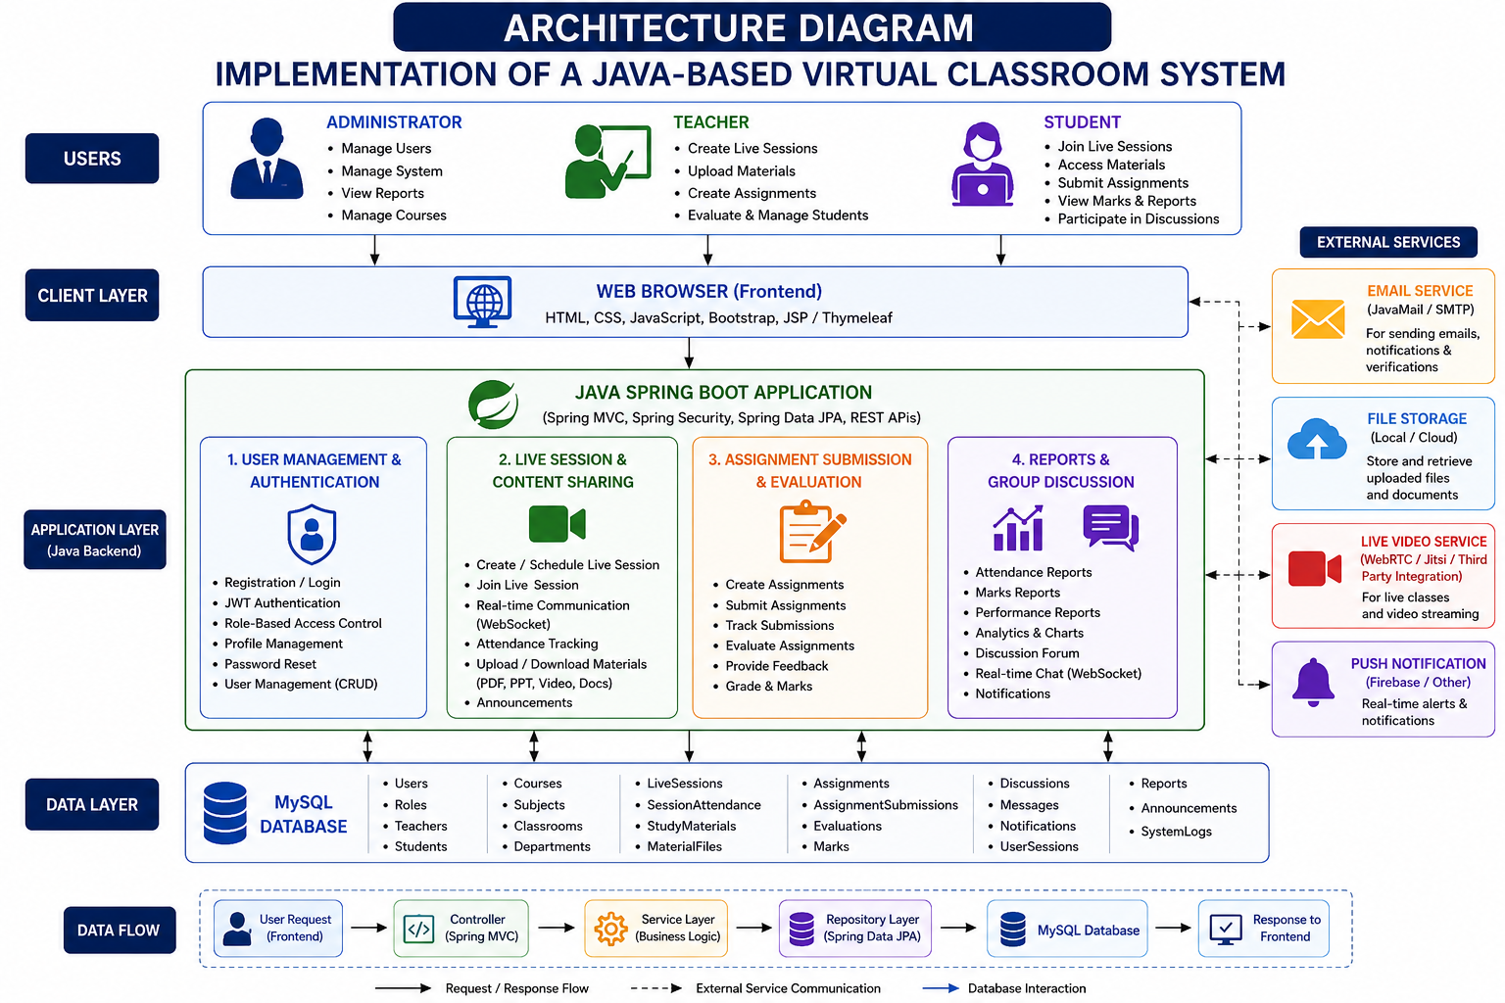
Fig 1 System Architecture

3.4 Engineering Standards Applied
Faculty members create assignments by entering a title, description, deadline, and classroom association. The Java application validates the information and stores it in the assignment table. Students enrolled in the classroom can retrieve the assignment and submit their work. The submission record identifies the student and assignment so that the faculty member can review the correct work. The attendance process begins when faculty members select a classroom and identify the students associated with it. Attendance is recorded with a date and status. Database relationships allow attendance information to be retrieved for a particular student, classroom, or date. Faculty members add learning materials to a classroom. Depending on the implementation, the database may store the file itself or store a controlled reference to the file location. Students retrieve materials only from classrooms to which they have access. For development, the application and database can run on the same computer. For institutional use, the application may be deployed on a server with controlled database access and backup procedures. Maintenance includes correcting defects, updating dependencies, improving security, optimizing database queries, and adding new modules. This chapter established the technical foundation of the system and explained how the Java application, database, security, workflows, and testing activities fit together.

3.5 Solution Justification
The general workflow begins with registration or creation of an account. During login, the system validates credentials and determines the user's role. The selected dashboard presents operations permitted to that role. Classroom operations are then performed through Java service components, and the results are stored in the database.
The relational database forms the persistent storage layer of the application. A normalized design is preferred so that repeated information is minimized and relationships between entities are represented explicitly.
• users – common login and role information.
• students – student-specific details.
• faculty – faculty-specific details.
• courses – course code, name, description, and related information.
• classrooms – virtual classroom information and faculty ownership.
• enrollments – relationship between students and classrooms.
• materials – learning-resource metadata and file references.
• assignments – assignment description, classroom, and deadline.
Modulus:
Module 1: User Management and Authentication
The User Management and Authentication Module is responsible for managing user accounts and controlling access to the Virtual Classroom System. It also manages user profile information, password management, and logout functionality. Role-based authentication ensures that each user can access only the features and resources permitted for their role, thereby improving the security, privacy, and reliability of the virtual classroom system.
Module 2: Live Classroom and Content Management
The Live Classroom and Content Management Module enables teachers and students to conduct and participate in online classes. Teachers can create and manage virtual classrooms, schedule live sessions, and share learning materials such as PDFs, documents, presentations, videos, and notes. Students can join live classes and access the uploaded content through the platform. The module provides a centralized environment for delivering educational resources and supports effective interaction between teachers and students.
Module 3: Assignment and Assessment Management
The Assignment and Assessment Management Module manages the creation, distribution, submission, and evaluation of assignments and online assessments. Teachers can create assignments, set deadlines, upload questions, and evaluate student submissions. Students can view assigned tasks, submit their answers, and participate in online quizzes or tests. The module also records marks and generates assessment results, helping teachers monitor student performance and students track their academic progress.
Module 4: Reports and Group Discussion
The Reports and Group Discussion Module helps teachers and students communicate, collaborate, and monitor academic performance. Teachers can generate reports related to student attendance, assignments, assessments, marks, and overall performance. The group discussion feature allows students and teachers to share ideas, ask questions, discuss topics, and provide feedback within the virtual classroom.
4. Results and Recommendations
The implementation of the Java-Based Virtual Classroom System resulted in a functional platform for supporting online teaching and learning activities. The system provides separate functionalities for administrators, teachers, and students and helps manage classroom activities through a centralized application. The developed system was evaluated based on functionality, usability, reliability, security, and overall performance.
4.1 Evaluation of Results
The developed system successfully provides the major functionalities required for a virtual classroom environment. Users can log in securely and access features according to their roles.
The major results obtained are:
Feature | Result
User Authentication | Successfully verifies registered users
Role-Based Access | Provides separate access for Admin, Teacher, and Student
Classroom Management | Teachers can create and manage virtual classrooms
Study Materials | Teachers can upload and students can access learning materials
Assignment Management | Assignments can be created, submitted, and reviewed
Online Assessment | Students can participate in quizzes/assessments
Result Management | Student marks and results can be stored and displayed
Database Management | Academic and user information is stored systematically
User Interface | Provides a simple and accessible learning environment
Table 1.2 : Evaluation of results

4.2 Challenges Encountered
Several challenges may be encountered during the development and implementation of the system.
1. Database Connectivity
Establishing reliable communication between the Java application and MySQL database requires proper JDBC configuration and exception handling.
2. Authentication and Security
Protecting user credentials and preventing unauthorized access is an important challenge. Different users must be provided with appropriate permissions.
3. File Management
Uploading and managing study materials and assignments requires proper handling of files, storage locations, file types, and access permissions.
4. User Interface Design
Creating an interface that is simple and easy to use for both teachers and students requires careful planning and testing.
5. Data Validation
Invalid or incomplete user input can cause errors. Therefore, appropriate validation must be implemented for login information, assignments, assessments, and other forms.
6. System Integration
Integrating authentication, classroom management, assignments, assessments, and database operations requires proper coordination between different modules.
7. Performance
As the number of users and stored academic records increases, database queries and application performance may become important considerations.
4.3 Possible Improvements
The current system can be improved by introducing additional features and advanced technologies.
1. Live Video Classes
Integration with video-conferencing services can allow teachers to conduct live lectures directly through the platform.
2. Real-Time Chat
A real-time messaging facility can improve communication between teachers and students.
3. Attendance Management
An automated attendance system can be added to record and monitor student participation in classes.
4. Automated Assessment
The system can automatically evaluate objective-type quizzes and generate results immediately.
5. Notifications
Email, SMS, or in-app notifications can be introduced for assignments, examinations, announcements, and deadlines.
6. Performance Analytics
Charts and dashboards can be used to display student performance and identify areas where students need improvement.
7. Mobile Application
A mobile application can be developed to allow students and teachers to access the system using smartphones.
8. Enhanced Security
Future versions can implement stronger security mechanisms such as password hashing, secure sessions, multi-factor authentication, and improved authorization.
9. Cloud Deployment
Deploying the application on a cloud platform can improve scalability, availability, and accessibility.
4.4 Recommendations
Based on the implementation and evaluation, the following recommendations are proposed:
- Regular system maintenance should be performed to ensure reliable operation.
- Strong authentication mechanisms should be implemented to protect user accounts and academic information.
- Regular database backups should be maintained to prevent data loss.
- Teachers should be provided with simple tools for uploading materials, creating assignments, and evaluating submissions.
- Students should receive timely notifications about assignments, assessments, and important announcements.
- The system should be tested regularly for security vulnerabilities and performance issues.
- The application should be optimized for both desktop and mobile devices.
- User feedback should be collected regularly to identify usability problems and required features.
- Future development should focus on live classes, real-time communication, attendance tracking, automated grading, analytics, and mobile accessibility.
- The system should be designed with scalability in mind so that it can support an increasing number of users and courses.

CHAPTER 5
Reflection on Learning and Personal Development
The development of the Java-Based Virtual Classroom System provided valuable experience in applying theoretical knowledge to a practical software development project. The project helped in understanding the complete development process, from identifying a real-world problem and designing a solution to implementing, testing, and evaluating the system. It also contributed to the development of technical, analytical, communication, and problem-solving skills.
5.1 Key Learning Outcomes
The major learning outcomes gained from this project include:
- Understanding the complete software development life cycle.
- Learning how to convert real-world requirements into software functionalities.
- Understanding the importance of system and database design.
- Developing a better understanding of Java-based web application development.
- Learning how different application modules interact with each other.
- Understanding user authentication and role-based access control.
- Learning how to connect an application with a relational database.
- Understanding the importance of software testing and error handling.
- Developing skills in documentation and technical reporting.
- Improving the ability to analyze problems and develop suitable solutions.
The project also provided practical experience in developing an application that addresses the requirements of different users.

5.2 Academic Knowledge
The project helped in applying concepts learned through academic coursework to a practical application. Knowledge of Java programming, object-oriented programming, database management systems, web technologies, software engineering, and computer networks was particularly useful. Object-oriented programming concepts such as classes, objects, inheritance, encapsulation, abstraction, and polymorphism helped in structuring the application. Database concepts such as tables, relationships, primary keys, foreign keys, SQL queries, and normalization were useful for designing and managing the system database. Software engineering concepts helped in understanding requirement analysis, system design, implementation, testing, and maintenance. This practical application of academic concepts improved the understanding of how theoretical knowledge is used in real-world software development.
5.3 Technical Skills
The project contributed significantly to the development of technical skills. The main skills gained include:
Java Programming
Improved understanding of Java syntax, object-oriented programming, exception handling, and application development.
Web Development
Gained experience in using HTML, CSS, JavaScript, JSP, and Servlets for developing interactive web pages and application functionality.
Database Management
Learned how to design database tables, execute SQL queries, maintain relationships, and perform database operations using MySQL.
JDBC
Developed an understanding of connecting Java applications with databases using JDBC.
Software Testing
Learned the importance of testing individual modules and the complete system to identify and correct errors.
Version Control
Understanding of tools such as Git and GitHub helped in maintaining source code and tracking project development.
These skills provide a foundation for developing more advanced Java-based applications in the future.
5.4 Problem-Solving and Critical Thinking
During the development of the system, several technical and design problems required analysis and logical decision-making. Issues related to database connectivity, input validation, authentication, module integration, and error handling required systematic troubleshooting.
The project improved the ability to:
- Identify the root cause of technical problems.
- Break complex problems into smaller tasks.
- Compare different approaches before selecting a solution.
- Debug errors systematically.
- Analyze system requirements before implementation.
- Test solutions and make necessary improvements.
- Think about security, usability, scalability, and maintainability.
The experience demonstrated that software development requires not only programming knowledge but also logical thinking, planning, continuous testing, and adaptability.

5.5 Conclusion of Personal Development
The development of the Java-Based Virtual Classroom System was an important learning experience that contributed to both technical and personal development. The project strengthened programming and database skills while providing practical knowledge of software development methodologies.
It also improved problem-solving, critical thinking, time management, documentation, and confidence in developing real-world applications. Working through different stages of the project helped develop a more structured approach to analyzing requirements and implementing solutions.
Overall, the project provided a strong foundation for future software development work and encouraged continuous learning of modern technologies. The knowledge and skills gained through this project can be applied to larger and more complex applications in academic and professional environments.

CHAPTER 6
Conclusion
The Java-Based Virtual Classroom System successfully provides a centralized platform for supporting online teaching and learning activities. The system addresses several limitations of traditional classroom environments by allowing students and teachers to access educational resources and perform academic activities through a digital platform.
The system provides important features such as user authentication, role-based access, virtual classroom management, study-material sharing, assignment submission, online assessments, and result management. By integrating Java-based technologies with a database, the system provides an organized and reliable method for managing academic information.
The development of this project also demonstrated the practical application of concepts such as Java programming, object-oriented programming, database management, web development, software engineering, and system testing . The project improved understanding of how a real-world software solution can be designed, implemented, tested, and evaluated.
Overall, the proposed system provides a strong foundation for modern online education. With further improvements, it can be transformed into a comprehensive learning management platform capable of supporting a larger number of users and advanced educational services.
6.1 Future Enhancement
The system can be enhanced in several ways to provide a more advanced and complete virtual learning experience.
1. Live Video Classes
A video-conferencing feature can be integrated to allow teachers to conduct live lectures and interactive sessions.
2. Real-Time Chat
A real-time messaging system can enable students and teachers to communicate instantly.
3. Attendance Management
An automated attendance module can be introduced to record student participation in online and offline classes.
4. Mobile Application
A dedicated Android or cross-platform mobile application can provide convenient access to classroom activities through smartphones.
5. Automated Grading
Objective-type examinations can be automatically evaluated, reducing teachers' workload and providing immediate results.
6. AI-Based Learning Assistance
Artificial intelligence can be incorporated to provide personalized learning recommendations, answer common student queries, and identify areas requiring improvement.
7. Performance Analytics
Interactive dashboards and graphical reports can help teachers analyze student performance, attendance, assignment completion, and assessment results.
8. Notification System
Email, SMS, and in-app notifications can be implemented to inform students about new assignments, examinations, announcements, and deadlines.
9. Cloud Integration
Cloud deployment and cloud storage can improve system scalability, availability, and accessibility.
10. Enhanced Security
Future versions can include password hashing, multi-factor authentication, secure file access, improved authorization, and regular security monitoring.
References:

- Sommerville, Ian. Software Engineering. 10th Edition, Pearson Education, 2015.
- Silberschatz, Abraham, Henry F. Korth, and S. Sudarshan. Database System Concepts. 7th Edition, McGraw-Hill, 2019.
- Deitel, Paul, and Harvey Deitel. Java: How to Program. 11th Edition, Pearson, 2018.
- Horstmann, Cay S. Core Java: Volume I—Fundamentals. 11th Edition, Pearson, 2018.
- Oracle Corporation. Java Platform, Standard Edition Documentation. Oracle, 2026.
- Oracle Corporation. Java SE API Documentation. Oracle, 2026.
- Duckett, Jon. HTML and CSS: Design and Build Websites. Wiley, 2014.
- Duckett, Jon. JavaScript and JQuery: Interactive Front-End Web Development. Wiley, 2014.
- Elmasri, Ramez, and Shamkant B. Navathe. Fundamentals of Database Systems. 7th Edition, Pearson, 2016.
- Pressman, Roger S., and Bruce R. Maxim. Software Engineering: A Practitioner's Approach. 8th Edition, McGraw-Hill Education, 2015.

Appendices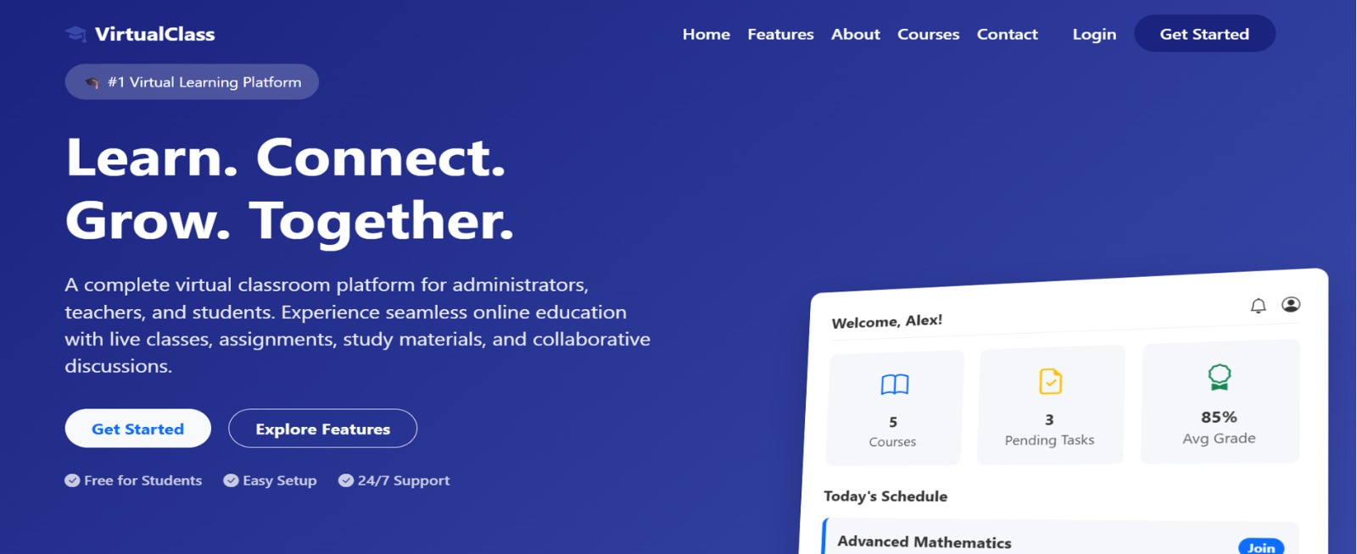
Fig 2 Dashboard
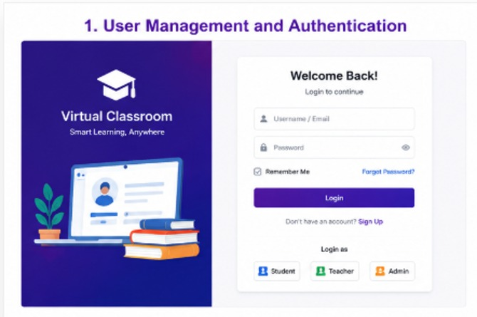
Fig 3 User Management and Autentication
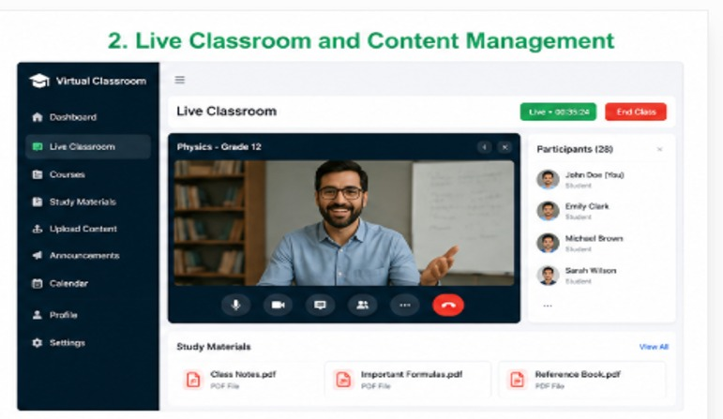
Fig 4: Live Classroom and Content Management
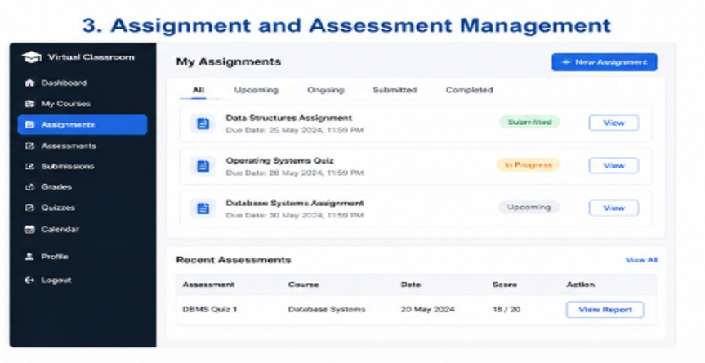
Fig 5: Assignments and Assessments Management

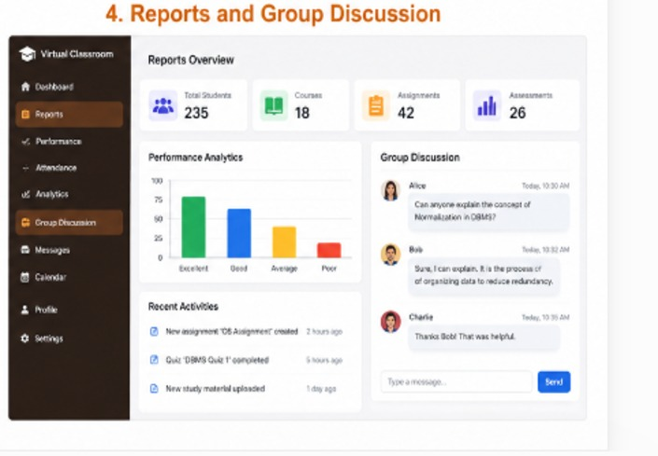
Fig 6 Reports and Discussion

