A PROJECT REPORT ON
IMAGE CAPTION GENERATOR USING NLP

A project report submitted to
MALLA REDDY UNIVERSITY
in partial fulfillment of the requirements for the award of degree of

BACHELOR OF TECHNOLGY
in
COMPUTER SCIENCE & ENGINEERING (AI & ML)

Submitted by:
N.Mamatha : 2211CS020357
N.GangadharReddy : 2211CS020358
N.Harini : 2211CS020359
N.VigneshVarma : 2211CS020360
N.Prasanna : 2211CS020361

Under the Guidance of
Prof.T.Ranga
Assistant Professor , Department of AIML.



DEPARTMENT OF COMPUTER SCIENCE & ENGINEERING (AI & ML)
MALLA REDDY UNIVERSITY
2025

I

COLLEGE CERTIFICATE

This is to certify that this is the bonafide record of the application development entitled“IMAGE CAPTION GENERATOR” Submitted N.Mamatha(2211CS020357)by,N.GangadharReddy(2211CS020358),N.Harini(2211CS020359),N.VigneshVarma(2211CS020360),N.Prasanna(2211CS020361)B.Tech III year I semester, Department of CSE (AI&ML) during the year 2023-24. The results embodied in the report have not been submitted to any other university or institute for the award of any degree or diploma.

PROJECT GUIDE HEAD OF THE DEPARTMENT
Prof Thanish Kumar Dr.R.Nagaraju

DEAN CSE(AI&ML)

Dr. Gifta Jerith

II

ACKNOWLEDGEMENT
We have been truly blessed to have a wonderful internal guide T.Ranga, Asst.Professor, Department of AI&ML, Mallareddy University for guiding us to explore the ramification of our work and we express our sincere gratitude towards her for leading me through the completion of Application Development.

We would like to say our sincere thanks to Dr.Adam Baba, Asst.Professor, Department of AI&ML, App Development Coordinator, for providing seamless support and right suggestions are given in the development of the APP.

We would like to say our sincere thanks to Dr.R.Nagaraju Head of Department of AI&ML SOE, Mallareddy University for providing seamless support and right suggestions are given in the development of the APP.

We wish to express our sincere thanks to Dr. Gifta Jerith Dean AI&ML SOE, Mallareddy University for providing us with the conducive environment for carrying through our academic schedules and Project with ease.

We wish to express our sincere thanks to Vice Chancellor sir and The Management of Mallareddy University for providing excellent infrastructure and their visionary thoughts to prepare ourselves industry ready by focusing on new technologies.

III
CONTENTS

CHAPTER NO. TITLE PAGE NO.

- INTRODUCTION:
  - Project Identification / Problem Definition
  - Objective of project
  - Scope of the project
  - Literature survey
- ANALYSIS:
  - Project Planning and Research
  - Software requirement specification
    - Software requirement
    - Hardware requirement
  - Model Selection and Architecture

- DESIGN:
  - Introduction
  - DFD/ER/UML diagram(any other project diagram)
  - Data Set Descriptions
  - Data Preprocessing Techniques
  - Methods & Algorithms

- DEPLOYMENT AND RESULTS:
  - Introduction
  - Source Code
  - Model Implementation and Training
  - Model Deployment: Testing and Validation
  - Web GUI’s Development
  - Results

5. CONCLUSION:
5.1 Project conclusion
5.2 Future Scope

iv

CHAPTER 1.INTRODUCTION
  - PROBLEM IDENTIFICATION
With the increasing use of digital media, automated image captioning has become essential for image indexing, accessibility for visually impaired users, and digital media management. This project leverages deep learning techniques to bridge the gap between visual perception and natural language understanding. This project is to develop an image caption generator capable of automatically producing descriptive captions for a wide range of images, including photographs, illustrations, and complex scenes. The system must analyze the visual content, identifying key elements such as objects, scenes, actions, and their relationships, and then generate a coherent, grammatically correct sentence that accurately describes the image. The captions should be natural-sounding, concise (typically one or two sentences), and provide a clear understanding of the image’s content . This task involves significant challenges in both computer vision and natural language processing (NLP). In computer vision, the system needs to perform object detection, scene recognition, and activity recognition to understand the image’s context. In NLP, it must leverage language modeling and text generation to produce fluent and meaningful descriptions.

  - OBJECTIVE OF THE PROJECT
The main goal of this project is to create a computer program that can look at any picture and write a short sentence or two about what it sees. We call this program an image caption generator. The idea is to make a program that’s smart enough to understand pictures and describe them in a way that makes sense to people. The project has two big jobs:
- Seeing the Picture: It needs to look at the picture and figure out what’s there. This means spotting things like people, animals, objects (like a ball or a car), and what’s happening (like running or eating).
- Writing a Sentence: After figuring out what’s in the picture, it has to turn that into words. It can’t just say random stuff it needs to make a sentence that sounds natural, like how a person would talk.

  - SCOPE OF THE PROJECT
The scope of this project is to develop an image caption generator that automatically produces accurate, fluent captions for diverse images, including photographs and illustrations. The system will leverage computer vision to detect objects, scenes, and actions, and natural language processing to generate concise, grammatically correct descriptions. It must handle a wide range of images and be evaluated on caption accuracy and fluency using human or automated metrics.

  - LITERATURE SURVEY
1.Title: A Survey on Automatic Image Caption Generation
Author: Shunan Zhao et al.
Description:Surveys image captioning methods categorizing them into retrieval based,template-based, and neural network-based techniques.
Methodology: Literature review and categorization of existing methods.
Limitations: May not cover the latest advancements or niche applications.
2.Title: From Vision to Text: A Comprehensive Review of Natural Image Captioning in Medical Diagnosis and Radiology Report Generation
Author:Alessandro Bruno et al.
Description: Reviews image captioning in medical contexts, focusing on radiology and deep learning applications.
Methodology: Literature review on medical image captioning, particularly in radiology.
Limitations: Limited to medical applications, may not generalize to other domains.
3. Title: Image Captioning: Bridging Computer Vision and Natural Language Processing
Author: Ujjwal Upadhyay
Description: Explores the integration of computer vision and NLP in image captioning, highlighting attention mechanisms.
Methodology: Overview of integrating vision and language, focusing on attention
Limitations: Lacks detailed technical analysis or performance comparisons.
4. Title: A Thorough Review of Models, Evaluation Metrics, and Datasets on Image Captioning
Author:Sandeep Kaur et al.
Description: Analyzes models, metrics, and datasets in image captioning, comparing leading methods.
Methodology: Compilation and evaluation of existing research on models and metrics.
Limitations: Lacks new experimental results or novel methods.

5. Title: A Survey on Automatic Image Caption Generation
Author: Marc Tanti et al.
Description: Categorizes image captioning methods, tracing their evolution to neural networks.
Methodology: Systematic review and classification of captioning techniques.
Limitations: May exclude recent advancements post-publication.
6.Title: Image Captioning by Diffusion Models: A Survey
Author: Rongjie Huang et al.
Description: Examines diffusion models for generating coherent captions.
Methodology: Survey of diffusion model applications in image captioning.
Limitations: Limited by the nascent state of diffusion models in this area.
7. Title: An Overview of Image Caption Generation Methods
Author: Zhixin Li et al.
Description: Summarizes image captioning methods, focusing on attention mechanisms.
Methodology: Review of techniques, datasets, and evaluation criteria.
Limitations: May lack in-depth technical details and recent advancements.

2.ANALYSIS
2.1 PROJECT PLANNING AND RESEARCH
The Image Caption Generator project is designed to generate text descriptions for images using deep learning. The planning phase involved selecting the right dataset, model, and technology to ensure accurate and efficient caption generation. Many images on the internet lack proper descriptions, making it difficult for visually impaired users to understand them. Automatic caption generation helps in various applications, such as social media, e-commerce, and accessibility tools.For this project, we used the Flickr8k dataset, which contains 8,000 images with five captions each. This dataset was chosen because it provides diverse captions for training and testing the model. The model used for caption generation is ViT-GPT2 (Vision Transformer + GPT-2). The Vision Transformer (ViT) extracts image features, and GPT-2 generates text descriptions, offering better accuracy than traditional CNN-RNN methods.
Traditional methods relied on CNN and RNN models, but modern approaches like transformer models significantly improve accuracy. We chose ViT-GPT2 because it is faster and provides better descriptions. Alongside model selection, the project also included the development of a web application using Flask. The backend was built using Flask to handle image processing and caption generation, while the frontend was developed using HTML, CSS, and JavaScript for a simple and user-friendly interface. Users can upload an image, and the system generates an appropriate caption as output.
  - SOFTWARE REQUIREMENT AND RESEARCH
2.2.1 Software Requirements
- Python Programming: Python, which serves as the primary programming for developing the application.
- Flask: Flask is used as the backend framework to handle web-based interactions and API development.
- Transformers Library: The Transformers Library is essential for integrating the ViT-GPT2 model, enabling accurate image caption generation.
- Python Imaging Library(PIL): PIL is used for image processing tasks such as resizing, format conversion, and preprocessing before feeding images into the model.

    - Hardware Requirements
- GPU : GPU is highly recommended for faster inference and efficient model processing. Using a GPU significantly reduces the computational load when processing large datasets or generating captions in real time.
- Minimum 8GB RAM: The system should have a minimum of 8GB RAM to ensure smooth execution of the Flask application, image processing tasks, and deep learning model inference without performance bottlenecks.
  - MODEL SELECTION AND ARCHITECTURE
The ViT-GPT2 model was chosen because it can both understand images and generate meaningful captions. It consists of two key parts:
- Vision Transformer (ViT): This part looks at the image and understands its contents. Instead of using traditional methods like CNNs (which scan images in a structured way), ViT splits the image into smaller patches and processes them like words in a sentence. This helps it get a better overall understanding of the image.
- GPT-2: Once ViT understands the image, it sends the information to GPT-2, which is a language model trained to create human-like text. GPT-2 then forms a caption based on what it learned .
ARCHITECTURE:
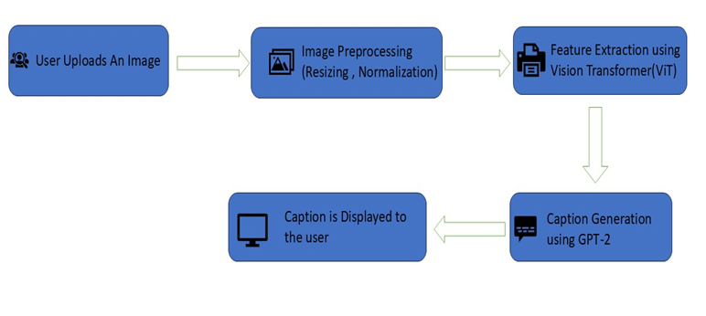

The architecture of the Image Caption Generator follows a structured pipeline to process images and generate meaningful captions. The flow consists of the following steps:
- User Uploads an Image
  - The user provides an image either by uploading it from their device or providing a URL.
- Image Preprocessing (Resizing & Normalization)
  - The uploaded image is resized to a fixed dimension (e.g., 224x224 pixels) to maintain uniformity.
  - Pixel values are normalized to improve model performance and ensure consistency in input processing.
- Feature Extraction using Vision Transformer (ViT)
  - The processed image is passed through the ViT (Vision Transformer) model, which extracts meaningful features from the image.
  - Instead of traditional CNNs, ViT splits the image into patches and analyzes them like words in a sentence, capturing spatial information effectively.
- Caption Generation using GPT-2
  - The extracted features are passed to GPT-2, a powerful natural language processing (NLP) model.
  - GPT-2 processes the visual information and generates a descriptive text caption that best represents the image.
- Caption is Displayed to the User
  - The generated caption is displayed on the user interface.
  - Users can view the description and download or use the caption as needed.
This architecture leverages deep learning by combining computer vision (ViT) and natural language processing (GPT-2) to create a seamless and accurate image captioning system.

3.DESIGN
3.1 INTRODUCTION
The design phase of the Image Caption Generator project focuses on structuring the system for efficient image processing and caption generation. This phase is crucial because it ensures that all components work together seamlessly, leading to accurate and meaningful caption generation.
3.2 DATAFLOW DIAGRAM
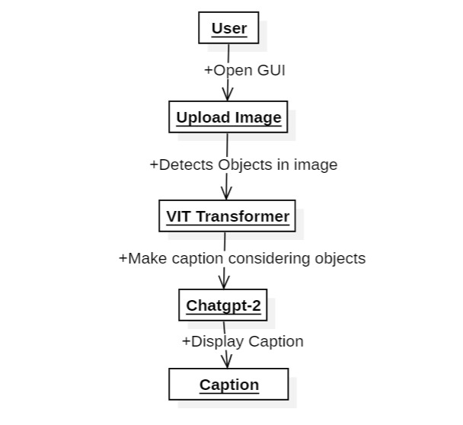

3.3 DATA SET DESCRIPTIONS
The Flickr8k dataset is used for training and testing the ViT-GPT2 image captioning model. It is a widely used dataset in computer vision and NLP for generating image descriptions.
Key Features of Flickr8k Dataset
- Number of Images: 8,000 real-world images collected from Flickr.
- Captions: Each image has five manually written captions describing the scene.
- Diversity: The dataset contains images of people, animals, objects, and activities, ensuring the model learns various contexts.
- Annotations: Captions are provided in a text file, mapping each image to its descriptions.
Dataset Structure
- Images Folder: Contains 8,000 JPEG images.
- Captions File (Flickr8k.token.txt): A text file where each line has an image name followed by a caption.
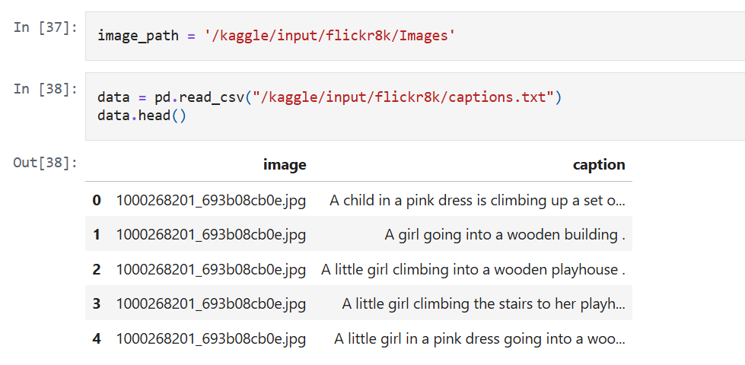

3.4 DATA PROCESSING TECHNIQUES
Data preprocessing is necessary to make the raw data (images and captions) clean, structured, and understandable for the model. Without proper preprocessing, the model may struggle to learn, leading to poor accuracy and incorrect captions.
Converting to lowercase: x.lower() ensures uniformity in text.
Removing special characters: x.replace("[^A-Za-z]","") attempts to remove non-alphabetic characters (but this regex is incorrectly applied inside replace(), as it needs re.sub()).
Removing extra spaces: x.replace("\s+"," ") (though incorrect syntax, should use re.sub()).
Removing short words: " ".join([word for word in x.split() if len(word)>1]) removes words with only one letter.
Adding start and end tokens: "startseq "+data['caption']+" endseq" is done to mark sentence boundaries for the model.
Word to Number Conversion: Convert words into numbers so the model can process them.
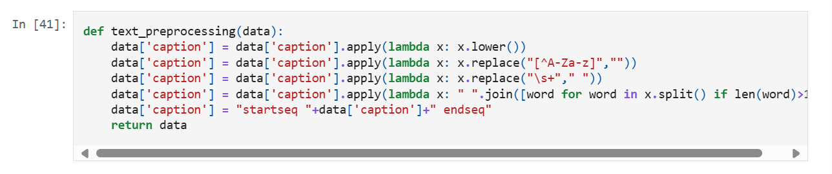
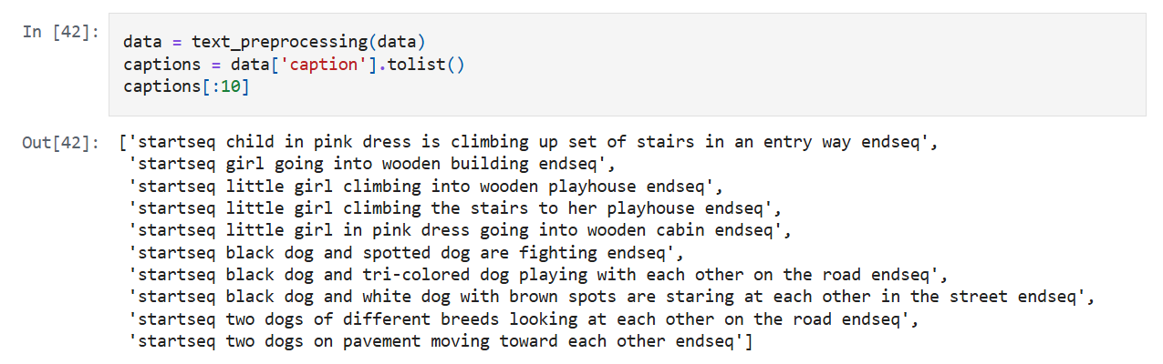

3.5 METHODS & ALGORITHMS
The Image Caption Generator system uses deep learning techniques, combining computer vision and natural language processing (NLP). The key methods and algorithms used in the project are:
1. Vision Transformer (ViT) for Feature Extraction
ViT is efficient and accurate in understanding images without using traditional convolutional layers. This diagram explains how Vision Transformer (ViT) processes an image to classify it:
1.Image Splitting – The input image is divided into small patches instead of scanning the entire image at once.
2.Linear Projection – Each patch is converted into numerical data (embeddings) so the model can understand it.
3.Patch + Position Embedding – Position information is added to maintain the spatial structure of the image.
4.Transformer Encoder – The processed patches are passed through a Transformer model, which learns the important patterns and relationships in the image.
5.MLP Head (Classification Layer) – The final output is a label (e.g., "Car,""Bird,""Ball") based on what the model learned from the image.
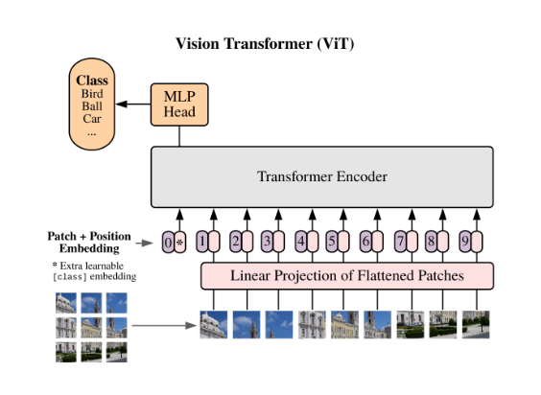

Why is ViT Important?
- It avoids convolutional layers, making it different from traditional CNNs.
- Uses self-attention mechanisms to capture global relationships between patches.
- Achieves high accuracy in image recognition and caption generation tasks.
2. GPT-2 for Caption Generation
- GPT-2 is a pre-trained AI model that generates human-like text.
- It receives image details from ViT and predicts the best words to describe the image.
- It uses a special mechanism called self-attention to ensure the generated caption makes sense.
3. Using Transformers for Faster Processing
- Unlike older models that process data step by step, Transformers handle all input at once, making them much faster and more accurate.
- This ensures better captions with fewer mistakes.

4.DEPLOYMENT AND RESULTS
4.1 INTRODUCTION
The Deployment and Results section provides a comprehensive overview of how the Image Caption Generator system is transformed from a conceptual model into a fully functional application. The system integrates multiple components, including the backend powered by Flask API, a user-friendly web-based frontend, and a deep learning model utilizing ViT-GPT2 for image-to-text conversion. Each of these components plays a crucial role in ensuring the system operates efficiently, delivering accurate and meaningful captions for uploaded images.
The deployment process involves setting up a server environment where the Flask API processes incoming image data and communicates with the ViT-GPT2 model to generate captions. The frontend interface allows users to interact with the system by uploading images or providing image URLs, after which the backend processes the input and returns a descriptive caption. This integration ensures a seamless user experience, where captions are generated in real time, making the system practical for various applications such as automated image annotation, accessibility tools, and content organization.
Performance evaluation is a key aspect of this section, as the model's efficiency and accuracy in generating captions are tested using real-world datasets.
4.2 SOURCE CODE
App.py
from flask import Flask, render_template, request, jsonify
from transformers import pipeline
from PIL import Image
import requests
from io import BytesIO
app = Flask(__name__)
# Load pretrained model
captioner = pipeline("image-to-text", model="nlpconnect/vit-gpt2-image-captioning")
@app.route('/')
def index():
return render_template('index.html')
@app.route('/caption', methods=['POST'])
def generate_caption():
# Handle file upload
if 'file' in request.files:
file = request.files['file']
if file.filename == '':
return jsonify({'error': 'Empty filename'}), 400
try:
image = Image.open(file.stream)
if image.mode != 'RGB':
image = image.convert('RGB')
except Exception as e:
return jsonify({'error': f'Invalid image file: {str(e)}'}), 400
# Handle URL input
elif 'url' in request.form:
url = request.form['url']
if not url.startswith(('http://', 'https://')):
return jsonify({'error': 'Invalid URL format'}), 400
try:
response = requests.get(url, stream=True, timeout=10)
if response.status_code != 200:
return jsonify({'error': f'Failed to download image (HTTP {response.status_code})'}), 400
image = Image.open(BytesIO(response.content))
if image.mode != 'RGB':
image = image.convert('RGB')
except Exception as e:
return jsonify({'error': f'URL processing failed: {str(e)}'}), 400
else:
return jsonify({'error': 'No image provided'}), 400
try:
result = captioner(image)
caption = result[0]['generated_text']
return jsonify({'caption': caption})
except Exception as e:
return jsonify({'error': str(e)}), 500
if __name__ == '__main__':
app.run(debug=True)
Index.html
<!DOCTYPE html>
<html lang="en">
<head>
<meta charset="UTF-8">
<meta name="viewport" content="width=device-width, initial-scale=1.0">
<title>Image Caption Generator</title>
<link rel="stylesheet" href="https://cdnjs.cloudflare.com/ajax/libs/animate.css/4.1.1/animate.min.css">
<style>
:root {
--primary: #4CAF50;
--primary-dark: #45a049;
--secondary: #2196F3;
--light-bg: #f8f9fa;
--dark-bg: #343a40;
--text: #212529;
--light-text: #f8f9fa;
}

body {
font-family: 'Segoe UI', Tahoma, Geneva, Verdana, sans-serif;
max-width: 900px;
margin: 0 auto;
padding: 20px;
text-align: center;
background-color: var(--light-bg);
color: var(--text);
transition: all 0.3s ease;
}

h1 {
font-size: 2.5em;
margin-bottom: 30px;
position: relative;
display: inline-block;
}

h1::after {
content: '';
position: absolute;
width: 50%;
height: 3px;
bottom: -10px;
left: 25%;
background-color: var(--primary);
border-radius: 5px;
}

.input-container {
display: flex;
flex-direction: column;
gap: 20px;
margin: 30px 0;
}

.tab-container {
display: flex;
justify-content: center;
margin-bottom: 20px;
}

.tab {
padding: 10px 20px;
cursor: pointer;
border: none;
background-color: #e9ecef;
font-weight: bold;
border-radius: 5px 5px 0 0;
transition: all 0.3s ease;
}

.tab.active {
background-color: var(--primary);
color: white;
}

.tab-content {
display: none;
animation: fadeIn 0.5s;
}

.tab-content.active {
display: block;
}

.upload-box {
border: 2px dashed #ccc;
padding: 50px;
margin: 20px 0;
cursor: pointer;
border-radius: 10px;
transition: all 0.3s ease;
position: relative;
overflow: hidden;
background-color: white;
}

.upload-box:hover {
border-color: var(--primary);
transform: translateY(-5px);
box-shadow: 0 10px 20px rgba(0, 0, 0, 0.1);
}

.upload-box p {
font-size: 1.2em;
margin-bottom: 10px;
}

.upload-box i {
font-size: 3em;
color: var(--primary);
margin-bottom: 15px;
}

.url-input {
padding: 15px;
width: 80%;
margin: 20px auto;
font-size: 1em;
border: 2px solid #ccc;
border-radius: 5px;
transition: all 0.3s ease;
}

.url-input:focus {
outline: none;
border-color: var(--primary);
box-shadow: 0 0 10px rgba(76, 175, 80, 0.3);
}

.preview-container {
position: relative;
margin: 30px auto;
max-width: 500px;
overflow: hidden;
border-radius: 10px;
box-shadow: 0 5px 15px rgba(0, 0, 0, 0.1);
opacity: 0;
transform: translateY(20px);
transition: all 0.5s ease;
}

.preview-container.show {
opacity: 1;
transform: translateY(0);
}

#preview {
width: 100%;
height: auto;
display: block;
}

.caption-container {
margin: 30px auto;
position: relative;
opacity: 0;
transform: translateY(20px);
transition: all 0.5s ease;
}

.caption-container.show {
opacity: 1;
transform: translateY(0);
}

#caption {
font-size: 1.3em;
margin: 20px auto;
padding: 20px;
background-color: white;
border-radius: 10px;
box-shadow: 0 5px 15px rgba(0, 0, 0, 0.1);
line-height: 1.6;
min-height: 60px;
}

.caption-word {
display: inline-block;
opacity: 0;
transform: translateY(10px);
}

.caption-word.show {
opacity: 1;
transform: translateY(0);
transition: all 0.2s ease;
}

button {
background-color: var(--primary);
color: white;
padding: 12px 25px;
border: none;
border-radius: 50px;
cursor: pointer;
font-size: 1em;
font-weight: bold;
transition: all 0.3s ease;
box-shadow: 0 5px 15px rgba(76, 175, 80, 0.4);
margin: 20px 10px;
}

button:hover {
background-color: var(--primary-dark);
transform: translateY(-3px);
box-shadow: 0 7px 20px rgba(76, 175, 80, 0.6);
}

button:active {
transform: translateY(0);
box-shadow: 0 5px 15px rgba(76, 175, 80, 0.4);
}

.loader {
border: 5px solid #f3f3f3;
border-top: 5px solid var(--primary);
border-radius: 50%;
width: 40px;
height: 40px;
animation: spin 1s linear infinite;
margin: 20px auto;
display: none;
}

@keyframes spin {
0% {
transform: rotate(0deg);
}

100% {
transform: rotate(360deg);
}
}

@keyframes fadeIn {
from {
opacity: 0;
}

to {
opacity: 1;
}
}

.progress-bar {
width: 0%;
height: 4px;
background-color: var(--primary);
position: fixed;
top: 0;
left: 0;
z-index: 1000;
transition: width 0.3s ease;
}

.notification {
position: fixed;
top: 20px;
right: 20px;
padding: 15px 20px;
background-color: var(--primary);
color: white;
border-radius: 5px;
box-shadow: 0 5px 15px rgba(0, 0, 0, 0.2);
transform: translateX(150%);
transition: transform 0.5s ease;
z-index: 1000;
}

.notification.show {
transform: translateX(0);
}

/* Dark mode toggle */
.mode-toggle {
position: fixed;
top: 20px;
right: 20px;
background-color: var(--dark-bg);
color: white;
border: none;
border-radius: 50%;
width: 50px;
height: 50px;
font-size: 1.5em;
cursor: pointer;
box-shadow: 0 5px 15px rgba(0, 0, 0, 0.2);
transition: all 0.3s ease;
}

.dark-mode {
background-color: var(--dark-bg);
color: var(--light-text);
}

.dark-mode .upload-box,
.dark-mode #caption,
.dark-mode .url-input {
background-color: #495057;
color: white;
border-color: #6c757d;
}

.dark-mode .tab {
background-color: #495057;
color: white;
}

.dark-mode .tab.active {
background-color: var(--primary);
}

@media (max-width: 768px) {
body {
padding: 10px;
}

.upload-box {
padding: 30px;
}

h1 {
font-size: 2em;
}

button {
padding: 10px 20px;
}
}
</style>
<script src="https://cdnjs.cloudflare.com/ajax/libs/font-awesome/6.0.0/js/all.min.js"></script>
</head>

<body>
<div class="progress-bar" id="progress-bar"></div>
<div class="notification" id="notification">Image uploaded successfully!</div>
<button class="mode-toggle" id="mode-toggle"><i class="fas fa-moon"></i></button>

<h1 class="animate__animated animate__fadeInDown">Image Caption Generator</h1>
<p class="animate__animated animate__fadeIn animate__delay-1s">Upload an image or enter a URL to generate a smart
caption</p>

<div class="tab-container animate__animated animate__fadeIn animate__delay-1s">
<button class="tab active" onclick="openTab('upload')">Upload Image</button>
<button class="tab" onclick="openTab('url')">Image URL</button>
</div>

<div class="input-container">
<div id="upload" class="tab-content active animate__animated animate__fadeIn">
<div class="upload-box" onclick="document.getElementById('file-input').click()">
<i class="fas fa-cloud-upload-alt"></i>
<p>Click or drag to upload an image</p>
<p class="small">Supports JPG, PNG, GIF</p>
<input type="file" id="file-input" accept="image/*" hidden>
</div>
</div>

<div id="url" class="tab-content animate__animated animate__fadeIn">
<input type="text" id="url-input" class="url-input" placeholder="Enter image URL (https://...)">
<button onclick="loadImageFromURL()">Load Image</button>
</div>
</div>

<div class="preview-container" id="preview-container">
<img id="preview" alt="Image preview">
</div>

<div class="caption-container" id="caption-container">
<div id="caption"></div>
</div>

<div class="loader" id="loader"></div>

<button onclick="generateCaption()" class="animate__animated animate__fadeIn animate__delay-2s">
<i class="fas fa-magic"></i> Generate Caption
</button>

<script>
const fileInput = document.getElementById('file-input');
const urlInput = document.getElementById('url-input');
const preview = document.getElementById('preview');
const previewContainer = document.getElementById('preview-container');
const captionDiv = document.getElementById('caption');
const captionContainer = document.getElementById('caption-container');
const loader = document.getElementById('loader');
const progressBar = document.getElementById('progress-bar');
const notification = document.getElementById('notification');
const modeToggle = document.getElementById('mode-toggle');

let imageFile = null;
let imageUrl = null;

// Dark mode toggle
modeToggle.addEventListener('click', function () {
document.body.classList.toggle('dark-mode');
if (document.body.classList.contains('dark-mode')) {
modeToggle.innerHTML = '<i class="fas fa-sun"></i>';
} else {
modeToggle.innerHTML = '<i class="fas fa-moon"></i>';
}
});

// Tab functionality
function openTab(tabName) {
const tabs = document.getElementsByClassName('tab');
const tabContents = document.getElementsByClassName('tab-content');

for (let i = 0; i < tabs.length; i++) {
tabs[i].classList.remove('active');
}

for (let i = 0; i < tabContents.length; i++) {
tabContents[i].classList.remove('active');
}

document.getElementById(tabName).classList.add('active');
document.querySelector(`.tab[onclick="openTab('${tabName}')"]`).classList.add('active');
}

// File upload functionality
fileInput.addEventListener('change', function (e) {
const file = e.target.files[0];
if (file) {
imageFile = file;
imageUrl = null;
loadImage(URL.createObjectURL(file));
showNotification('Image uploaded successfully!');
}
});
// load image from url
function loadImageFromURL() {
const url = urlInput.value.trim();
if (!url) {
showNotification('Please enter a valid URL!', 'error');
return;
}

const img = new Image();
img.onload = function () {
preview.src = url; // Set preview image
previewContainer.classList.add('show');
captionContainer.classList.remove('show');
captionDiv.innerHTML = '';
imageUrl = url; // Store the URL for caption generation
showNotification('Image loaded successfully!');
};
img.onerror = function () {
showNotification('Failed to load image. Check the URL.', 'error');
};

img.src = url; // Try loading the image
}

// Load image function
function loadImage(src) {
preview.onload = function () {
previewContainer.classList.add('show');
captionContainer.classList.remove('show');
captionDiv.innerHTML = '';
};
preview.onerror = function () {
showNotification('Failed to load image!', 'error');
};
preview.src = src;
}

// Progress bar animation
function animateProgressBar() {
progressBar.style.width = '0%';
let width = 0;
const interval = setInterval(() => {
if (width >= 100) {
clearInterval(interval);
progressBar.style.width = '0%';
} else {
width += 1;
progressBar.style.width = width + '%';
}
}, 10);
}

// Show notification
function showNotification(message, type = 'success') {
notification.textContent = message;
notification.style.backgroundColor = type === 'success' ? '#4CAF50' : '#f44336';
notification.classList.add('show');

setTimeout(() => {
notification.classList.remove('show')
}, 3000);
}

async function generateCaption() {
if (!imageFile && !imageUrl) {
showNotification('Please upload an image or enter a URL first!', 'error');
return;
}

const formData = new FormData();

if (imageFile) {
formData.append('file', imageFile);
} else {
formData.append('url', imageUrl);
}

try {
loader.style.display = 'block';
animateProgressBar();

const response = await fetch('/caption', {
method: 'POST',
body: formData
});

const data = await response.json();
if (data.error) {
throw new Error(data.error);
}
displayCaptionWithAnimation(data.caption);
} catch (error) {
showNotification(`Error: ${error.message}`, 'error');
} finally {
loader.style.display = 'none';
}
}

function displayCaptionWithAnimation(caption) {
captionDiv.innerHTML = '';
captionContainer.classList.add('show');

const words = caption.split(' ');
words.forEach((word, index) => {
const wordSpan = document.createElement('span');
wordSpan.textContent = word;
wordSpan.classList.add('caption-word');
captionDiv.appendChild(wordSpan);

// Add a space after each word
captionDiv.appendChild(document.createTextNode(' '));

setTimeout(() => {
wordSpan.classList.add('show');
}, 100 * index);
});
}

// Allow drag and drop for images
const uploadBox = document.querySelector('.upload-box');

['dragenter', 'dragover', 'dragleave', 'drop'].forEach(eventName => {
uploadBox.addEventListener(eventName, preventDefaults, false);
});

function preventDefaults(e) {
e.preventDefault();
e.stopPropagation();
}

['dragenter', 'dragover'].forEach(eventName => {
uploadBox.addEventListener(eventName, highlight, false);
});

['dragleave', 'drop'].forEach(eventName => {
uploadBox.addEventListener(eventName, unhighlight, false);
});

function highlight() {
uploadBox.style.borderColor = '#4CAF50';
uploadBox.style.backgroundColor = '#f0f9f0';
}

function unhighlight() {
uploadBox.style.borderColor = '#ccc';
uploadBox.style.backgroundColor = 'white';
}

uploadBox.addEventListener('drop', handleDrop, false);

function handleDrop(e) {
const dt = e.dataTransfer;
const file = dt.files[0];

if (file && file.type.startsWith('image/')) {
fileInput.files = dt.files;
imageFile = file;
imageUrl = null;
loadImage(URL.createObjectURL(file));
showNotification('Image uploaded successfully!');
} else {
showNotification('Please upload an image file!', 'error');
}
}
</script>
</body>
</html>
Image.ipynb
import numpy as np
import pandas as pd
import os
import torch
from transformers import VisionEncoderDecoderModel, ViTFeatureExtractor, GPT2TokenizerFast
from PIL import Image
import matplotlib.pyplot as plt
from torch.utils.data import DataLoader, Dataset

# Define dataset paths
dataset_path = r"C:\Users\nalla\Desktop\AD\dataset"
image_folder = os.path.join(dataset_path, "Images")
captions_file = os.path.join(dataset_path, "captions.csv") # Ensure correct filename

# Load dataset
df = pd.read_csv(captions_file)
df.columns = ["image", "caption"]

# Preprocess text captions
def preprocess_text(text):
text = text.lower().strip()
text = "".join([char if char.isalnum() or char.isspace() else "" for char in text]) # Remove special characters
text = "startseq " + text + " endseq"
return text

df["caption"] = df["caption"].apply(preprocess_text)

# Load Pretrained ViT-GPT2 Model
model = VisionEncoderDecoderModel.from_pretrained("nlpconnect/vit-gpt2-image-captioning")
feature_extractor = ViTFeatureExtractor.from_pretrained("google/vit-base-patch16-224-in21k")
tokenizer = GPT2TokenizerFast.from_pretrained("gpt2")
tokenizer.pad_token = tokenizer.eos_token

# Function to generate captions
def generate_caption(image_name):
image_path = os.path.join(image_folder, image_name) # Get full image path
image = Image.open(image_path).convert("RGB")
pixel_values = feature_extractor(images=image, return_tensors="pt").pixel_values

with torch.no_grad():
output = model.generate(pixel_values)
caption = tokenizer.decode(output[0], skip_special_tokens=True)

return caption

# Test with a sample image
sample_image_name = "10815824_2997e03d76.jpg"
predicted_caption = generate_caption(sample_image_name)
print("Generated Caption:", predicted_caption)

# Model Evaluation
def evaluate_model(sample_size=100):
total_samples = min(sample_size, len(df)) # Ensure we don't exceed dataset size
for i in range(total_samples):
image_name = df.iloc[i]["image"]
actual_caption = df.iloc[i]["caption"]
predicted_caption = generate_caption(image_name)
print(f"Actual: {actual_caption}\nPredicted: {predicted_caption}\n")
print("Evaluation complete.")

evaluate_model()

4.3 MODEL IMPLEMENTATION AND TRAINING
The implementation of the Image Caption Generator involves combining computer vision and natural language processing (NLP) techniques to generate meaningful textual descriptions for images. The model is based on ViT (Vision Transformer) for image feature extraction and GPT-2 for text generation, forming a deep learning pipeline that efficiently processes images and produces captions. The implementation consists of several stages, including data preprocessing, model architecture setup, training, and evaluation.
The first step in model implementation involves image processing, where input images are resized, normalized, and converted into a suitable format for the ViT model. ViT processes the images by dividing them into small patches, embedding them, and passing them through a transformer-based architecture to extract meaningful visual features. These extracted features are then used as input for the GPT-2 model, which is responsible for generating captions based on the image context.
The training process begins with preparing the dataset, where images are paired with corresponding captions. The dataset used for training, such as Flickr8k, Flickr30k, or MS-COCO, contains thousands of images, each annotated with multiple human-written descriptions. During training, the model learns to associate visual patterns with textual descriptions through supervised learning. The captions are tokenized, and the model is trained to predict the next word in a sequence given the previous words and the image features.

4.4 MODEL DEPLOYMENT:TESTING AND VALIDATION
Model deployment involves integrating the trained ViT-GPT2 model with a Flask-based API and a user-friendly web interface for real-time image captioning. The deployment process ensures seamless interaction, allowing users to upload images or provide URLs to receive accurate captions instantly.
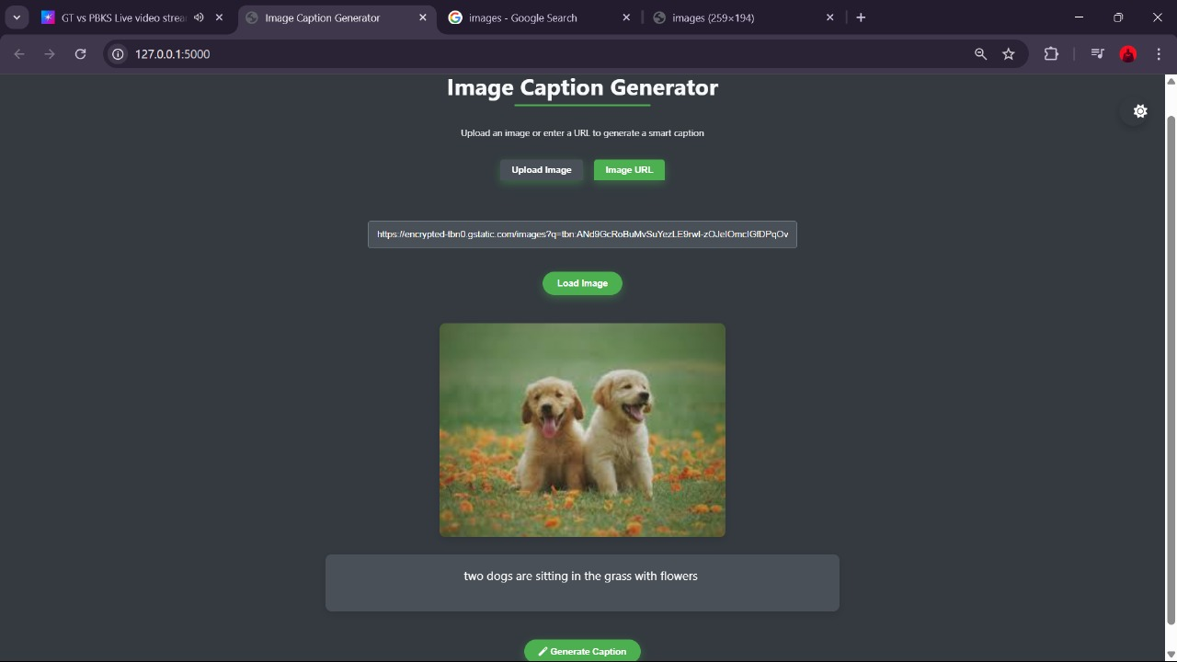
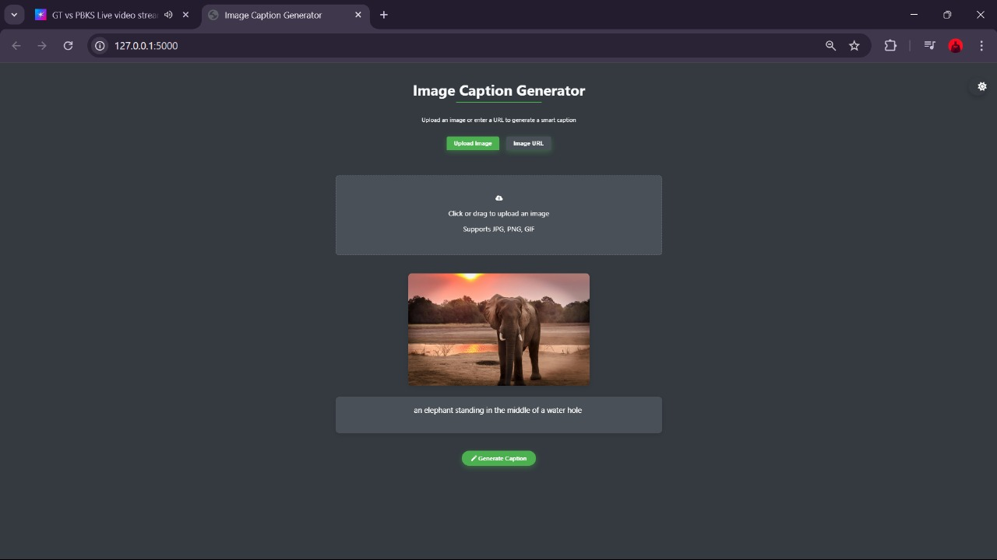

4.6 WEB GUI’SDEVELOPMENT

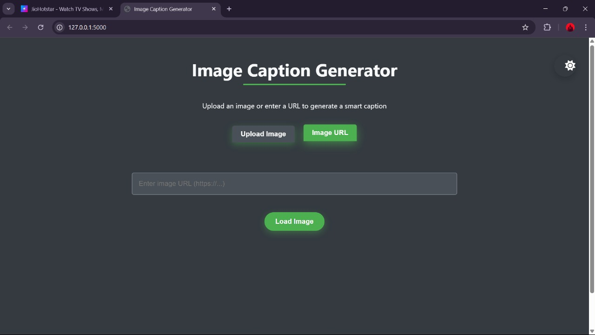

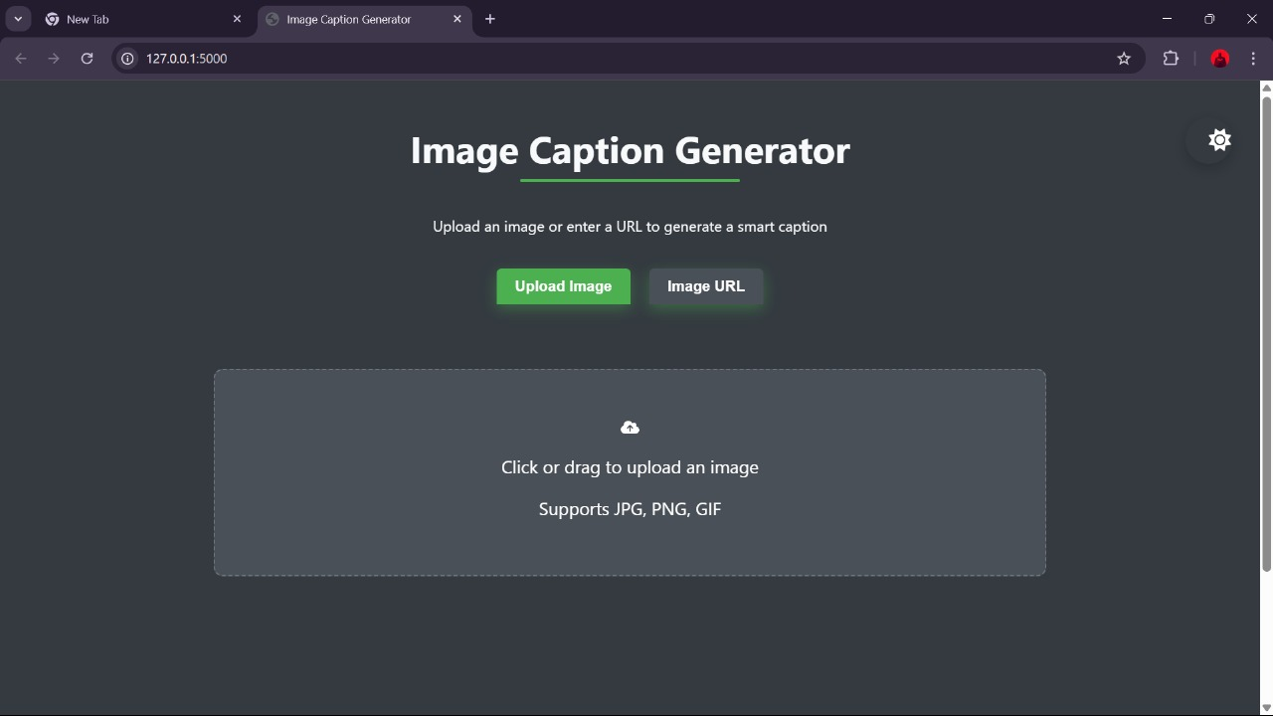

4.7 RESULTS

5.CONCLUSION
5.1 PROJECT CONCLUSION
The Image Caption Generator project successfully demonstrates the integration of computer vision and natural language processing (NLP) to generate meaningful captions for images. By utilizing the ViT-GPT2 model, the system effectively extracts visual features and converts them into coherent textual descriptions.The project achieves real-time image captioning through a Flask-based API and a user-friendly web interface, making it accessible and easy to use. Overall, this system has practical applications in automated image tagging, accessibility support for visually impaired users, and digital content organization.
5.2 FUTURE SCOPE
The future scope of the Image Caption Generator project includes several enhancements to improve accuracy, efficiency, and usability.
- Improving Model Performance – Fine-tuning the ViT-GPT2 model with larger and more diverse datasets, such as MS COCO and Conceptual Captions, can enhance the quality of generated captions.
- Multilingual Captioning – Extending support for multiple languages will make the system accessible to a global audience, enabling users to receive captions in their preferred language.
- Real-Time Processing – Optimizing the model for faster inference can help generate captions instantly, improving usability in applications like video captioning and live content analysis.
- Integration with Voice Assistants – Enhancing the system to work with voice assistants can enable audio-based image descriptions, benefiting visually impaired users.
- Mobile and Cloud Deployment – Developing a mobile application or deploying the system on the cloud will provide users with greater accessibility and scalability, allowing them to generate captions on-the-go.
- Improved Context Understanding – Implementing transformer-based architectures like GPT-4 or LLaVA can enhance contextual awareness, leading to more accurate and meaningful captions.

