S.No | Topics
1 | OSI
2 | TCP header | IMP
3 | IP header | IMP
4 | ARP (types of ARP)
5 | About ping, traceroute, Telnet
6 | DHCP | IMP
7 | DNS | IMP
8 | TCP three-way handshake | IMP
9 | SSL handshake (cert validation, intermediate cert, root cert) | IMP
10 | GRE
11 | IPSEC (main mode 6 Packets with payloads, aggressive mode 4 packet with payloads, quick mode with payloads)
12 | SAML (IDP initiated flow SP initiated flow)
13 | Zero Trust Architecture,
14 | Overview of Zscaler products ZIA and ZPA,
15 | Authentication - SAML how it works,
16 | GRE vs IPSEC,
17 | What are Browser Header Traces
18 | What is SCIM,
19 | HTTP and HTTPS difference,
20 | HTTP request Methods, | IMP
21 | HTTP Response codes, | IMP
22 | TLS Handshake,
23 | How client verifies the server certificate,
24 | IPSEC IKev1- main mode and Aggressive mode, quick mode,
25 | NAT Traversal,
26 | DNS over HTTP,
27 | TCP options,
28 | TCP flags,
29 | Ping and Traceroute How they work,
30 | SNI and Subject Alternative Name,
31 | In detail TLS1.2 handshake and 1.3 handshake,
32 | How do you troubleshoot latency issues using wireshark
33 | Difference between a Proxy and a firewall,
34 | TCP Timers

Please focus on TLS and IPSEC more
Please prepare on these questions

S. No | Topics | Comments
1 | TCP completely - timers, flags, diff between push and urgent, left edge and right edge with a scenario, Sack
2 | ⁠TLS and difference between 1.2 and 1.3
3 | ⁠FTP diff difference between active and passive
4 | ⁠DNS over http
5 | SNI and encrypted SNI

- What is OSI Model?
The OSI (Open Systems Interconnection) Model is a 7-layer conceptual framework developed by the International Organization for Standardization (ISO). It explains how data travels from one computer to another over a network and how different computer systems communicate with each other. Each layer has specific functions and responsibilities, which helps standardize communication and allows different devices and technologies to work together
Layers of OSI Model

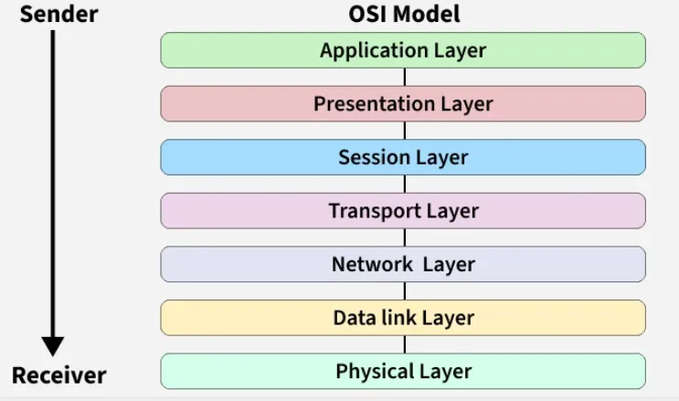

Layer 1: Physical Layer
The lowest layer of the OSI reference model is the Physical Layer. It is responsible for the actual physical connection between the devices. The physical layer contains information in the form of bits.
- Physical Layer is responsible for transmitting individual bits from one node to the next.
- When receiving data, this layer will get the signal received and convert it into 0s and 1s and send them to the Data Link layer, which will put the frame back together.
- Common physical layer devices are Hub, Repeater, Modem, and Cables.
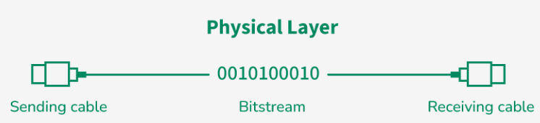

Layer 2: Data Link Layer (DLL)
The data link layer is responsible for the node-to-node delivery of the message. The main function of this layer is to make sure data transfer is error-free from one node to another, over the physical layer.
- When a packet arrives in a network, it is the responsibility of the DLL to transmit it to the Host using its MAC address.
- Packet in the Data Link layer is referred to as Frame. Switches and Bridges are common Data Link Layer devices.
- The packet received from the Network layer is further divided into frames depending on the frame size of the NIC (Network Interface Card). DLL also encapsulates Sender and Receiver’s MAC address in the header.
- The Receiver’s MAC address is obtained by placing an ARP (Address Resolution Protocol) request onto the wire asking, "Who has that IP address?" and the destination host will reply with its MAC address.

Layer 3: Network Layer
The Network Layer works for the transmission of data from one host to the other located in different networks. It also takes care of packet routing i.e. selection of the shortest path to transmit the packet, from the number of routes available.
- The sender and receiver's IP address are placed in the header by the network layer. Segment in the Network layer is referred to as Packet.
- Network layer is implemented by networking devices such as routers and switches.

Layer 4: Transport Layer
The Transport Layer provides services to the application layer and takes services from the network layer. The data in the transport layer is referred to as Segments. It is responsible for the end-to-end delivery of the complete message.
- The transport layer also provides the acknowledgment of the successful data transmission and re-transmits the data if an error is found.
- Protocols used in Transport Layer are TCP, UDP NetBIOS, PPTP.
- At the sender's side, the transport layer receives the formatted data from the upper layers, performs Segmentation, and also implements Flow and error control to ensure proper data transmission.
- It also adds Source and Destination port number in its header and forwards the segmented data to the Network Layer.
- Generally, this destination port number is configured, either by default or manually.

Example: when a web application requests a web server, it typically uses port number 80, because this is the default port assigned to web applications. Many applications have default ports assigned. At the Receiver’s side, Transport Layer reads the port number from its header and forwards the Data which it has received to the respective application. It also performs sequencing and reassembling of the segmented data.

Layer 5: Session Layer
Session Layer in the OSI Model is responsible for the establishment of connections, management of connections, terminations of sessions between two devices. It also provides authentication and security. Protocols used in the Session Layer are NetBIOS, PPTP.
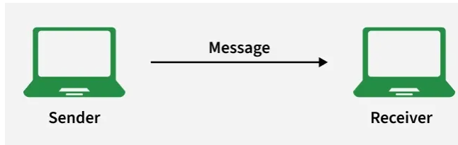

Layer 6: Presentation Layer
The Presentation Layer is also called the Translation layer. The data from the application layer is extracted here and manipulated as per the required format to transmit over the network. Protocols used in the Presentation Layer are TLS/SSL (Transport Layer Security / Secure Sockets Layer).JPEG, MPEG, GIF, are standards or formats used for encoding data, which is part of the presentation layer’s role

Layer 7: Application Layer
At the very top of the OSI Reference Model stack of layers, we find the Application Layer which is implemented by the network applications. These applications produce the data to be transferred over the network.
- This layer also serves as a window for the application services to access the network and for displaying the received information to the user.
- Protocols used in the Application layer are SMTP, FTP, DNS, etc

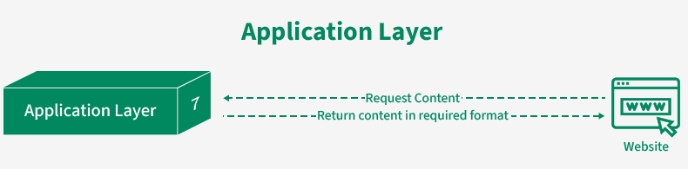

How Data Flows in the OSI Model?
When we transfer information from one device to another, it travels through 7 layers of OSI model. First data travels down through 7 layers from the sender's end and then climbs back 7 layers on the receiver's end. Data flows through the OSI model in a step-by-step process
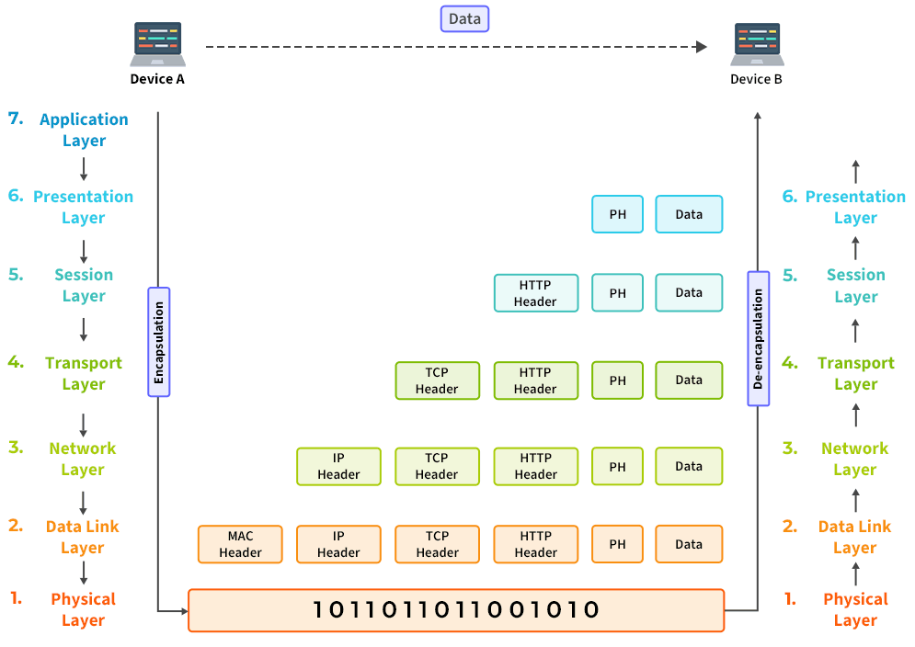

Layer | Working | Protocol Data Unit | Protocols
Physical  Layer | Establishing Physical Connections between Devices. | Bits | USB, SONET/SDH, etc.
Data Link  Layer | Node to Node Delivery of Message. | Frames | Ethernet, PPP, etc.
Network  Layer | Transmission of data from one host to another, located in different networks. | Packets | IP, ICMP, IGMP, OSPF, etc.
Transport  Layer | Take Service from Network Layer and provide it to the Application Layer. | Segments (for TCP) or Datagrams (for UDP) | TCP, UDP, SCTP, etc.
Session  Layer | Establishes Connection, Maintenance, Ensures Authentication and Ensures security. | Data | NetBIOS, RPC, PPTP, etc.
Presentation Layer | Data from the application layer is extracted and manipulated in the required format for transmission. | Data | TLS/SSL, MIME, etc.
Application Layer | Helps in identifying the client and synchronizing communication. | Data | FTP, SMTP, DNS, DHCP, etc.

- Transmission Control Protocol (TCP) header
TCP (Transmission Control Protocol) is a reliable transport protocol as it establishes a connection before sending any data and everything that it sends is acknowledged by the receiver

When computers send data over the internet, they don’t send it as one big file. They break it into small pieces called TCP segments. Each segment has two parts:
- Header → Control information (like instructions)
- Data → The actual message
👉 TCP Header = A small block of information attached before the data so the receiver knows how to handle it.

Real Life Example:
Imagine you send 5 pages of a document by courier in 5 separate envelopes. On each envelope you write
- From address
- To address
- Page number (1/5, 2/5…)
- Special instructions
That label = TCP Header
The papers inside = Actual Data
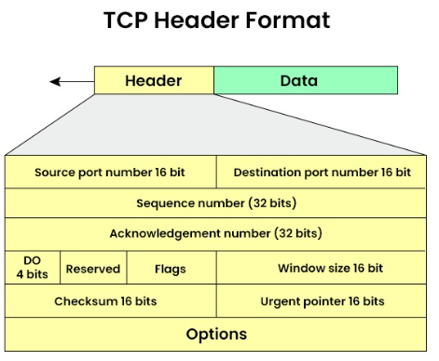

TCP HEADER STRUCTURE (20–60 Bytes)
Field | Size | Purpose | Related TCP Feature
Source Port | 16 bits | Sender application port | Process-to-process delivery
Destination Port | 16 bits | Receiver application port | Process-to-process delivery
Sequence Number | 32 bits | Order of bytes sent | Reliable & Ordered delivery
Acknowledgment Number | 32 bits | Next expected byte | Reliability (ACK)
Header Length | 4 bits | Size of TCP header | Proper data parsing
Reserved | 6 bits | Future use | —
Flags (URG, ACK, PSH, RST, SYN, FIN) | 6 bits | Control connection | Connection setup & termination
Window Size | 16 bits | How much data receiver can accept | Flow Control
Checksum | 16 bits | Error checking | Error Control
Urgent Pointer | 16 bits | Urgent data position | Special data handling
Options (Optional) | 0–40 bytes | Extra features (MSS, scaling) | Performance & Congestion control

- IP header or IPv4 packet header
IPv4 stands for Internet Protocol version 4 is the addressing system which assigns unique labels to devices on the internet. You can think of IPv4 as the address label on a package you are sending in the mail. Just like the label includes information about the sender, receiver, and nature of the contents, the IPv4 Header also contains information regarding the data that is being sent over the internet.

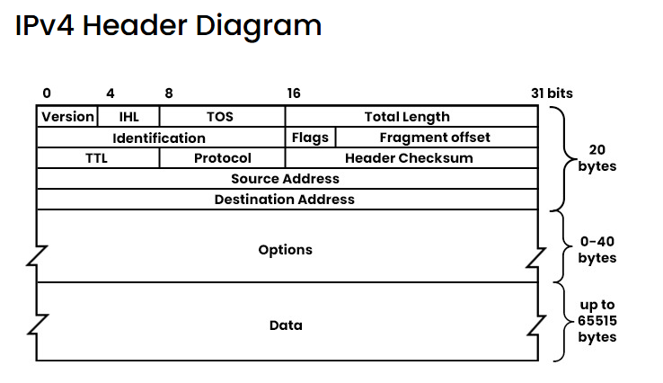
Field | Size | Purpose (Easy Meaning)
Version | 4 bits | Tells IP version. For IPv4, value is 4.
IHL (Internet Header Length) | 4 bits | Header length. Minimum is 20 bytes, can be more if options are used.
TOS (Type of Service) / DSCP | 8 bits | Tells network how to treat the packet (priority, delay, reliability). Used for QoS.
Total Length | 16 bits | Full packet size = Header + Data. Max = 65,535 bytes.
Identification | 16 bits | Used to identify fragments of the same original packet. Important during fragmentation.
Flags | 3 bits | Controls fragmentation.  • 1 bit unused  • DF = Don’t Fragment  • MF = More Fragments coming
Fragment Offset | 13 bits | Tells where this fragment belongs in the original packet.
TTL (Time to Live) | 8 bits | Limits how long packet can travel. Reduced by 1 at each router. If it reaches 0, packet is dropped. Prevents infinite looping.
Protocol | 8 bits | Tells which protocol is inside the data part.  Examples: 6 = TCP, 17 = UDP, 1 = ICMP
Header Checksum | 16 bits | Error-checking for the header only (not data). Recalculated at every router.
Source Address | 32 bits | Sender’s IPv4 address.
Destination Address | 32 bits | Receiver’s IPv4 address.
Options (Optional) | 0–40 bytes | Extra features like security, timestamp, routing. Rarely used today. Makes header longer than 20 bytes.
Data (Payload) | Variable | Actual data being carried (like TCP segment, UDP data, etc.).

- ARP
ARP stands for Address Resolution Protocol, it is used to find the MAC address of a device when we already know its IP address.

What is a MAC Address?
MAC address stands for Media Access Control address. It is a unique physical address given to every network device.

Think of it like this:
You know your friend’s name (IP address), but to call them, you need their phone number (MAC address). ARP helps you get that number.

Why ARP is needed?
Computers talk inside a local network using MAC addresses, not IP addresses. So, when one device wants to send data to another device in the same network
- It knows the destination IP
- But it needs the destination MAC
- ARP helps to find that MAC address

How ARP Works (Simple Steps)
- A device wants to send data and knows the destination IP address, but it needs the MAC address to deliver the data in the local network.
- It first checks its ARP cache to see if the MAC address for that IP is already saved.
- If the MAC address is not found, the device sends an ARP request as a broadcast to all devices in the network asking, “Who has this IP address?”
- All devices receive the request, but only the device with the matching IP address replies.
- The target device sends an ARP reply directly back, telling its MAC address.
- The sender stores this IP–MAC mapping in its ARP cache for future communication.
- Now the sender can send the actual data using the destination device’s MAC address.

Types of ARP

S.No | Type of ARP | What It Does / How It Works | When It’s Used / Purpose | Simple Meaning
1 | Normal ARP | Finds the MAC address of a device when its IP is known. Standard ARP request & reply. | Regular communication inside a local network. | “I know the IP, tell me the MAC.”
2 | Proxy ARP | A router replies to an ARP request for another device with its own MAC, tricking sender. | When devices are in different networks but appear local. | Router acts like a middleman.
3 | Gratuitous ARP | A device sends an ARP request for its own IP to check for duplicates or update tables. | To check duplicate IPs or update ARP tables. | “Hey everyone, this IP belongs to me.”
4 | Reverse ARP (RARP) | Finds IP address from a MAC address using a gateway/router table. | Used by old diskless systems at startup. | “I know my MAC, what’s my IP?”
5 | Inverse ARP | Finds IP address when the device’s MAC (link layer address) is known. | Used in Frame Relay / ATM networks where virtual circuits exist. | “I know the connection, what’s your IP?”

- Ping, Traceroute and Telnet

5.1 What is Ping?
Ping is a basic yet powerful network utility that helps you check the reachability of a server or IP address and measures the round-trip time for messages sent from your computer to the destination and back.
It is primarily used to verify whether a device or server is active and responsive over a network.

How Ping Works
When you run a Ping command, it sends Internet Control Message Protocol (ICMP) echo requests to the target IP address or domain. The recipient responds with an echo reply, and Ping calculates the time it took for the packet to travel to the destination and back. The result is displayed in terms of round-trip time (RTT), usually measured in milliseconds (ms).

Example
If you ping the IP address 127.0.0.1 (which is the localhost address), you will get a reply, even if you're not connected to the internet
- Pinging 127.0.0.1 with 32 bytes of data:
- Reply from 127.0.0.1: bytes=32 time<10ms TTL=32
- Reply from 127.0.0.1: bytes=32 time<10ms TTL=32
- Reply from 127.0.0.1: bytes=32 time<10ms TTL=32
- Reply from 127.0.0.1: bytes=32 time<10ms TTL=32

Explanation
- 127.0.0.1 = your own computer (localhost)
- Ping to this IP never goes to the internet
- Your PC sends a message to itself
- Getting a reply means network software (TCP/IP) is working
- bytes=32 → size of the test message
- time<10ms → very fast because it stays inside your PC
- TTL=32 → packet life limit (not very important here)
- No reply means network stack, drivers, or firewall issue

Common Uses of Ping
- Testing local network connectivity: By pinging the localhost address (127.0.0.1), you can verify that your computer's network stack is functional.
- Checking server availability: Ping helps to check whether a remote server is accessible and responsive.
- Diagnosing slow network connections: By monitoring RTT, you can identify whether latency is an issue

  - What is Traceroute
Traceroute is a tool that shows the full path your data takes to reach a destination (like a website or server).

While Ping only says “Yes, it’s reachable”,
Traceroute says 👉 “Here’s every step it took to get there.”

How Traceroute Works
Traceroute uses something called TTL (Time To Live).
Don’t worry about the big name — here’s the idea:

1️. Traceroute sends a packet with TTL = 1
➡️ First router receives it
➡️ TTL becomes 0
➡️ Router stops it and replies back
✅ Traceroute now knows Hop 1

2️. Then it sends another packet with TTL = 2
➡️ Passes router 1
➡️ Stops at router 2
✅ Now it knows Hop 2

Example:
Running Traceroute to google.com may produce the following output. Tracing route to google.com [142.250.190.78] over a maximum of 30 hops:
- <1 ms <1 ms <1 ms 192.168.1.1
- 10 ms 8 ms 9 ms 10.0.0.1
- 15 ms 12 ms 13 ms 72.14.194.1
- 20 ms 18 ms 17 ms 108.170.250.1
- 25 ms 23 ms 22 ms 142.250.190.78

Common Uses of Traceroute
- Identifying network bottlenecks: If a certain hop has a high RTT, it may indicate congestion or issues at that specific router.
- Diagnosing routing issues: Traceroute can help pinpoint where network issues are occurring by revealing where packets are delayed or dropped.
- Detecting routing loops: If the packet endlessly circulates between routers, Traceroute will display Time to Live (TTL) exceeded messages, indicating a routing loop.

- Dynamic Host Configuration Protocol (DHCP)
DHCP is a network protocol that automatically gives devices an IP address and other network settings so they can connect and communicate on a network without manual configuration.
- Assigns a unique IP address to each device.
- Provides the subnet mask to define the local network range.
- Configures the default gateway for communication outside the local network.
- Supplies DNS server addresses for domain name resolution

Example: Laptop Connecting to Wi-Fi
- Laptop joins Wi-Fi → It doesn’t have an IP yet.
- Laptop asks for IP → Sends a request (Discover).
- Router replies → Offers an IP address and settings (Offer).
- Laptop accepts → Requests that IP (Request).
- Router confirms → Assigns the IP for a set time (Acknowledge).
- Laptop is ready → Can now browse the internet.

Role of DCHP in this example
- Automatically assigns a unique IP address to the laptop.
- Provides network settings like subnet mask, default gateway, and DNS servers.
- Manages the lease time so IPs are reused efficiently.
- Removes manual setup — you don’t have to type in IP details yourself.

Components of DCHP
S. No | Component Name | Purpose / Why It’s Used
1 | DHCP Server | Provides IP addresses and network settings to devices.
2 | DHCP Relay | Forwards DHCP messages between clients and servers across different networks.
3 | DHCP Client | The device (like a laptop or phone) that requests an IP address to join the network.
4 | IP Address Pool | A collection of available IP addresses that the server can assign to clients.
5 | Lease | Defines how long a client can use an assigned IP before renewal is needed.
6 | Options | Extra configuration details like subnet mask, gateway, and DNS.
7 | Default Gateway | Provides the path for devices to communicate outside their local network (e.g., to the internet).
8 | DNS Servers | Translate domain names (like example.com) into IP addresses so devices can access websites.

- Domain Name System (DNS)
The Domain Name System (DNS) is a hierarchical (level based) and distributed naming system that translates human-readable domain names into IP addresses, enabling users to access websites easily.
- Converts domain names (e.g., www.geeksforgeeks.org) into IP addresses.
- Eliminates the need to remember numerical IP addresses.
- Works using a hierarchical structure of servers.
- Uses root, TLD, and authoritative DNS servers for resolution.
- Supports caching to improve speed and reduce network traffic.

Working of DNS
- User Input
You type a domain name into your browser (e.g., www.geeksforgeeks.org).
- Local Cache Check
Browser/OS checks if it already knows the IP address from a previous visit.
- Recursive Resolver
If not cached, the request goes to a DNS resolver (often provided by your ISP or a public DNS like Google’s 8.8.8.8).
- Root Server
Resolver asks a root DNS server where to find info about the domain’s extension (.com, .org, etc.).
- TLD Server
The root directs it to a Top-Level Domain (TLD) server (e.g., .org server).
- Authoritative Server
The TLD server points to the authoritative DNS server that knows the exact IP for the domain.
- Response
The resolver returns the IP address to your browser, which then connects to the website.

Example of DNS
- You open your browser and type www.google.com
- But computers don’t understand names like this. They understand only IP addresses (like 142.250.183.206).

Role of DNS in this example: When you type www.google.com this happens:
- Your computer asks: “What is the IP address of www.google.com?”
- DNS searches in its hierarchical structure:
- Root server
- .com server
- google.com server
- DNS finds the correct IP address.
- DNS sends back the IP address to your computer.
- Your browser connects to that IP address and loads the website.

- TCP three – way handshake
The TCP 3-way handshake is the process used to establish a reliable connection between a client and a server in the Transmission Control Protocol (TCP). It ensures that both sides are ready to communicate and agree on initial parameters such as sequence numbers.

Steps in the TCP 3-Way Handshake
- SYN (Synchronize)
- The client sends a TCP packet with the SYN flag set.
- It includes an Initial Sequence Number (ISN).
- Purpose: "I want to start a connection. Here's my sequence number."
- SYN-ACK (Synchronize-Acknowledge)
- The server responds with a packet that has both SYN and ACK flags set.
- It acknowledges the client’s ISN and sends its own ISN.
- Purpose: "Got your request. Here's my sequence number too."
- ACK (Acknowledge)
- The client sends a final packet with the ACK flag set.
- It acknowledges the server’s ISN.
- Purpose: "Acknowledged. Let’s start communicating."

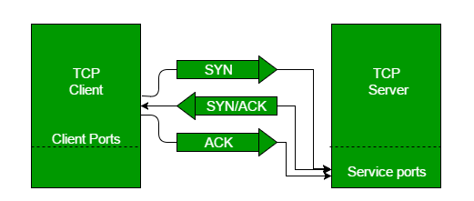

Why It Matters
- Ensures reliable communication by synchronizing sequence numbers.
- Prevents data loss and connection errors.
- Forms the basis for secure and ordered data transfer in TCP/IP networks.

- SSL handshake (cert validation, intermediate cert, root cert)

- Generic Routing Encapsulation (GRE) Tunnel
- Generic Routing Encapsulation (GRE) is a tunneling protocol developed by Cisco that wraps one network protocol inside another.
- It is primarily used to transport packets from one network to another securely and efficiently.
- It GRE creates a virtual point-to-point connection between routers, allowing different network segments or protocols to communicate as if they were directly connected

How GRE Works?
- Encapsulation Process
- The original IP packet is wrapped with: GRE Header: Identifies tunnel information.
- Delivery Header: Contains source and destination IP addresses of tunnel endpoints.
- This hides the original packet during transit.
- Routing Behavior:
- The new IP header allows GRE packets to be routed between tunnel endpoints.
- The original payload (e.g., IPv6, multicast, or routing protocols like OSPF/EIGRP) remains untouched inside.

Key Use Cases
- Transporting IPv6 traffic over IPv4-only networks.
- Carrying multicast traffic across networks that don’t support it.
- Tunneling routing protocols (RIP, OSPF, EIGRP) between branch and HQ sites.
- Simplifying connections between separate networks

14. Zscaler Overview
Zscaler is a cloud-native security platform that delivers secure access to applications and services without relying on traditional network-based security (like firewalls or VPNs). It’s built on Zero Trust principles, meaning no user or device is trusted by default—every connection is verified.

Core Components
- Zscaler Internet Access:
(ZIA) Protects users by securely connecting them to the internet and SaaS apps. It inspects traffic inline for threats, enforces compliance, and prevents data leaks.
- Zscaler Private Access (ZPA)
Provides secure, identity-based access to internal applications without exposing the corporate network. Unlike VPNs, users connect only to the specific apps they need.
- Zscaler Digital Experience (ZDX)
Monitors and improves user experience by analyzing performance issues across devices, networks, and applications.

19. Hypertext Transfer Protocol (HTTP) & Hypertext Transfer Protocol Secure (HTTPS)

What is HTTP?
HTTP stands for HyperText Transfer Protocol. It is a communication protocol used to transfer data between a web browser (like Google Chrome or Firefox) and a web server on the internet.

Simple Meaning:
When you open a website like Google, your browser sends an HTTP request to the server, and the server sends back an HTTP response (like a webpage, image, or data).

Example: When you type: http://example.com your browser
- Sends a request to the server.
- The server responds with the webpage.
- Your browser displays it.

Important Points:
- HTTP works on Port 80
- It is not secure
- Data is sent in plain text
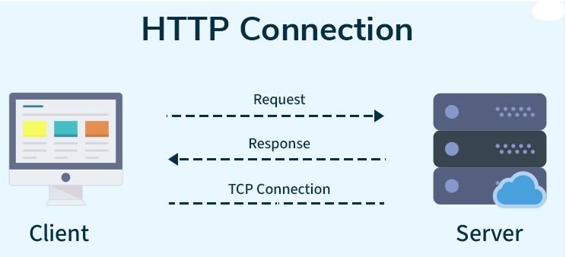
How HTTP Works: Step-by-Step Process
Here’s how HTTP works when you visit a website:
- Open Web Browser: First, you open your web browser and type a website URL (e.g., www.example.com).
- DNS Lookup: Your browser asks a Domain Name System (DNS) server to find out the IP address associated with that URL. Think of this as looking up the phone number of the website.
- Send HTTP Request: Once the browser has the website’s IP address, it sends an HTTP request to the server. The request asks the server for the resources needed to display the page (like text, images, and videos).
- Server Response: The server processes your request and sends back an HTTP response. This response contains the requested resources (like HTML, CSS, JavaScript) needed to load the page.
- Rendering the Web Page: Your browser receives the data from the server and displays the webpage on your screen.

What is HTTPS?
HTTPS stands for HyperText Transfer Protocol Secure. It’s the secure version of HTTP, the protocol used for communication between your web browser and a website.

One-line meaning:

HTTPS = Secure communication between browser and server

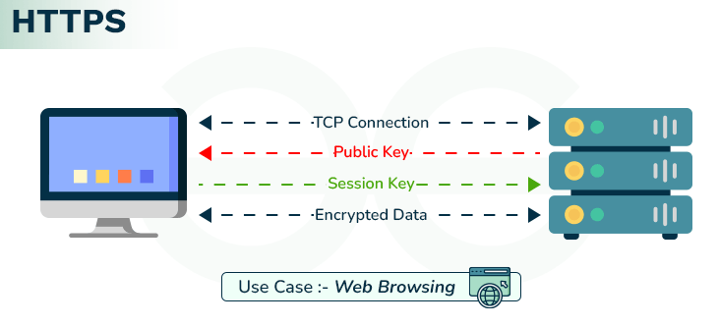
Example:
When you open https://google.com the data is Encrypted, Secure, Safe for passwords & banking

How HTTPS Works?
- You type a website starting with https://google.com
- The browser connects to the server (A powerful computer that stores and sends the website.)
The server is:
- A powerful computer owned by Google
- Located inside Google data centers
- Running Google’s website
- The server sends its SSL certificate (proof of identity).
- The browser checks if the certificate is valid
- If valid, both create a secret encryption key.
- All data is now encrypted (locked).
- The browser shows the secure webpage 🔒

Difference between HTTP & HTTPS
Feature | HTTP | HTTPS
Security | Data is sent as plain text — easy to intercept. | Data is encrypted — safer from hackers.
Port | Uses port 80 by default. | Uses port 443 by default.
Trust | Browsers may label it “Not Secure.” | Shows a padlock in the address bar.
Speed | Slightly slower on old systems. | Often faster due to newer protocols and optimizations.
Use case | Suitable for public or non-sensitive info. | Best for sensitive data like payments, logins, personal info.

