DESIGNING A RESUME CV

INTRODUCTION

* 1. Overview of the Resume CV

An effective resume summary typically follows the following structure:

Your experience summary ( many years, doing what, etc.) Your general experience (more specific skills, what’s your focus) your top achievements (career highlights, including quantifiable change and data).

* 1. Purpose of the Resume CV

A resume is to give your potential employer a feel for your past experience and skills. Remember you are trying to sell yourself, so emphasize your strengths. Most employers look for a steady job history and positive patterns of progression (i.e. increased responsibility, promotions).

2. PROBLEM DEFINITION AND DESIGN THINKING

2.1 Empathy map

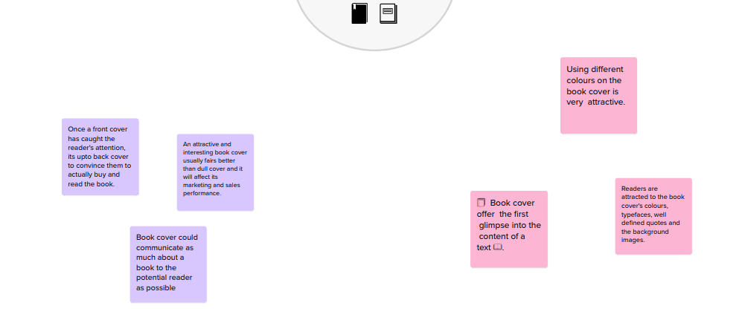

2.2 Ideation and Brainstorming Map

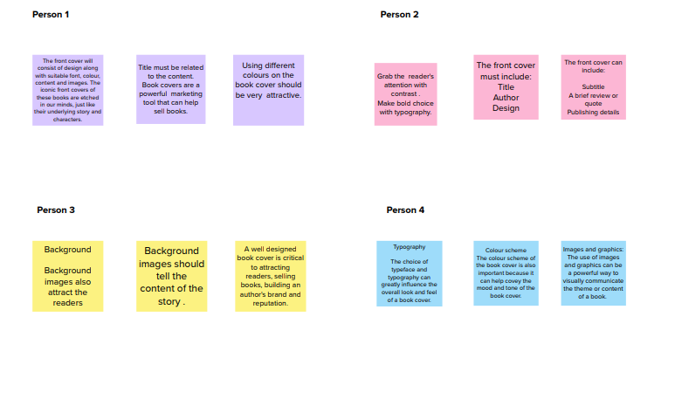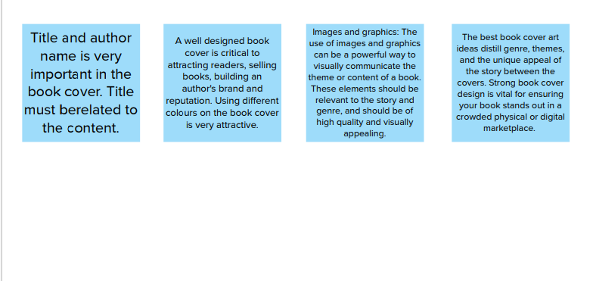

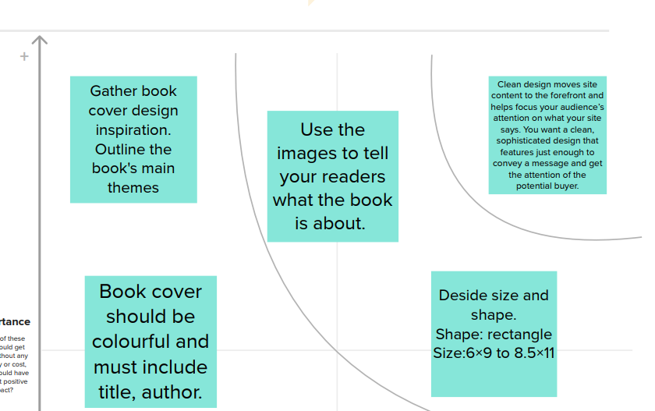

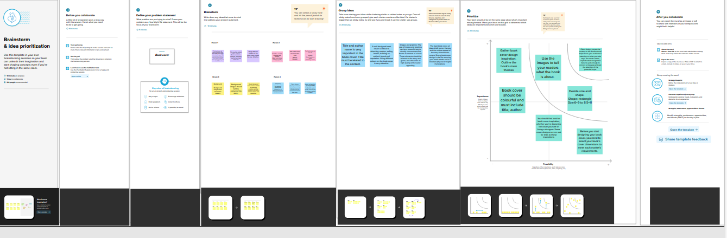

RESULT

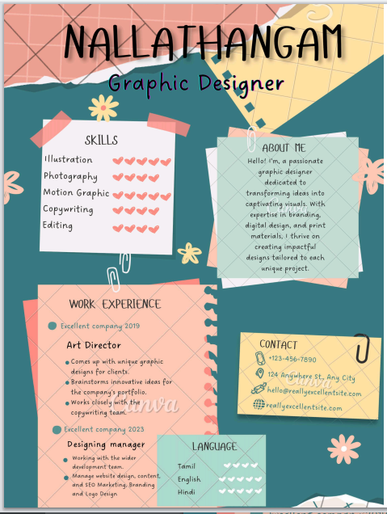

ADVANTAGES AND DISADVANTAGES :

Advantages:

A CV is important because it serves as an attention grabbing bridge between you today and the more successful future of living your dream career. The curriculum vitae is the most important doctument that you’ll ever write to snatch the job opportunity .It will be your first impression, and it should leave people wanting more. It should show the best angle of your image to your future employers.

Similarly it makes it easy for an applicant to emphasize the skills and capabilities they have that are actually relevant to a specific role. Because the general format of a CV is one that employers are familiar with, it is easy for them to look for the require skill set in a candidate. In other applications, might take a lot more effort and time.

It is possible to get an idea if someone’s personality form CV. It is becoming more common for candidates to include small section in their CV about their CV with a specific design, color scheme, or layout. Additionally, people could be memorable by submitting their CV for clarity.

Disadvantages

* They create Bias.
* Doesn’t Reflect Worker’s Skills.
* Create Hurdles for Otherwise Qualified Applicants.
* A major problem with functional resumes is their immidiately regognisable formet. Functional resumes are different in layout than traditional chronological resumes and as such, it takes just a glance from a hiring profesional to notice that you did not supply your information in the standard format.

APPLICATIONS

Remember that a potential employer’s first impression of you will be based solely on this intial application letter and resume. If the application letter and resume are sloppy, the employer may conclude that you do not care, you do not look after details, and you are not focussed.

CONCLUSION

Our resume design is creative design features an incredible pattern and clean typeface.

FUTURE SCOPE

For example, if you’re looking for a new job, consider your experience in various fields and industries and than highlight the relevant experience.