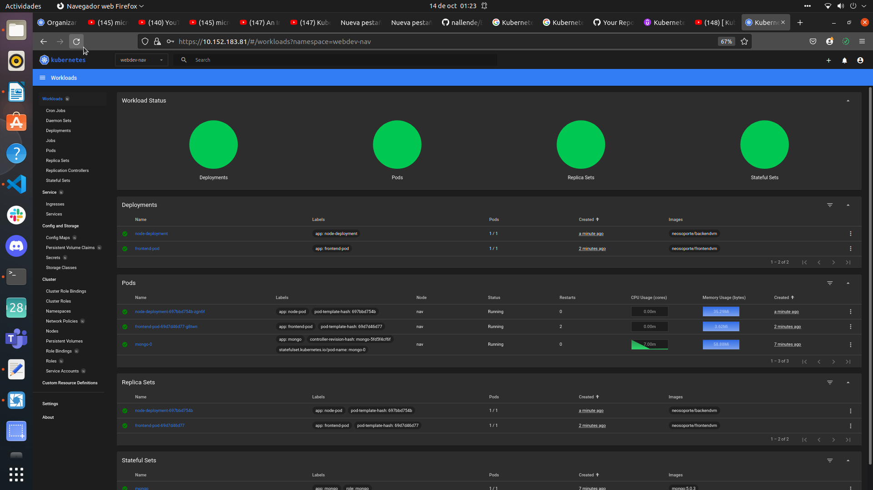
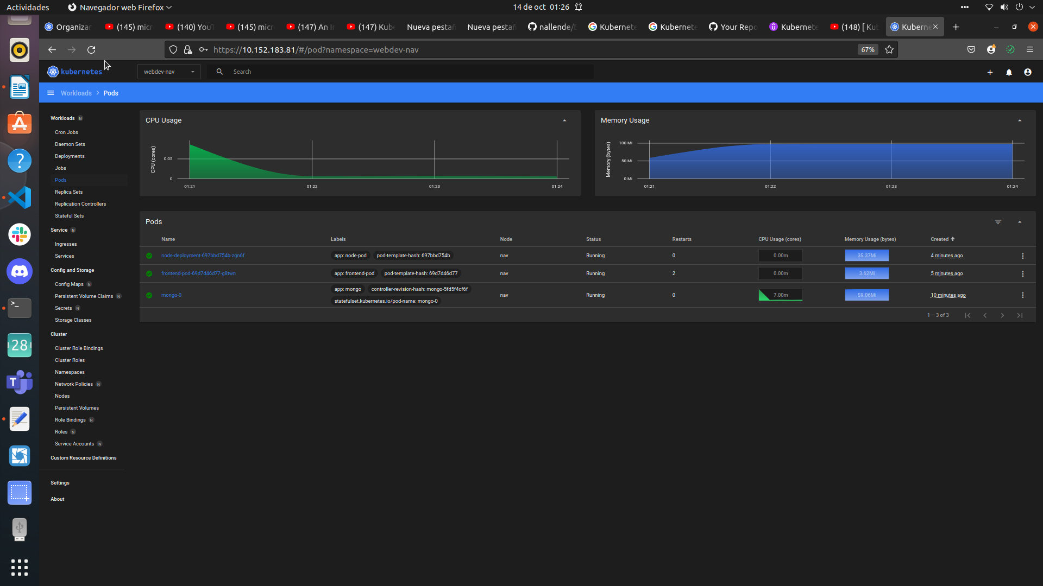
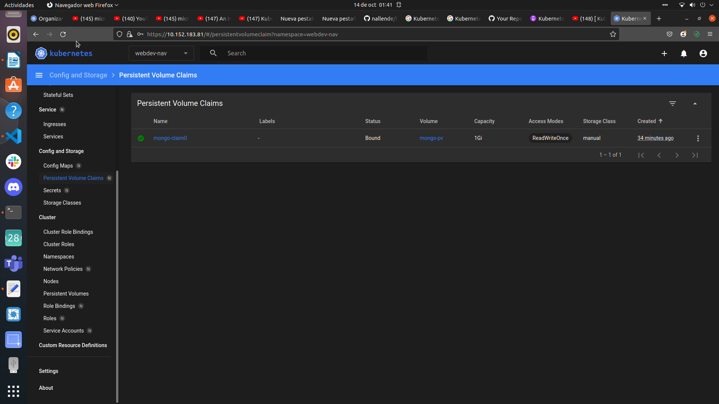
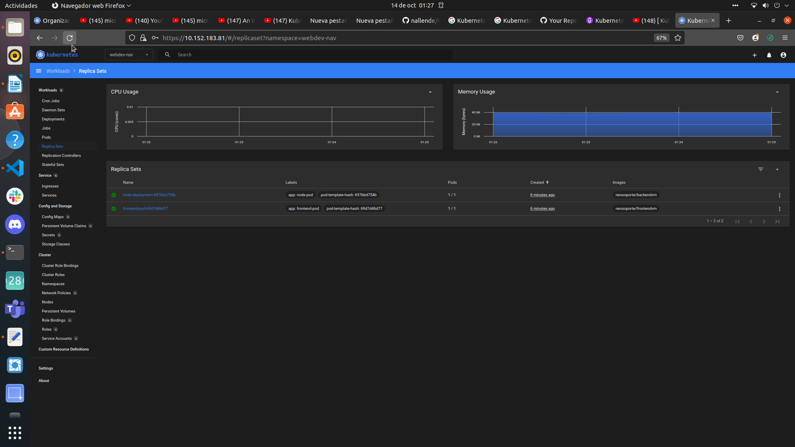
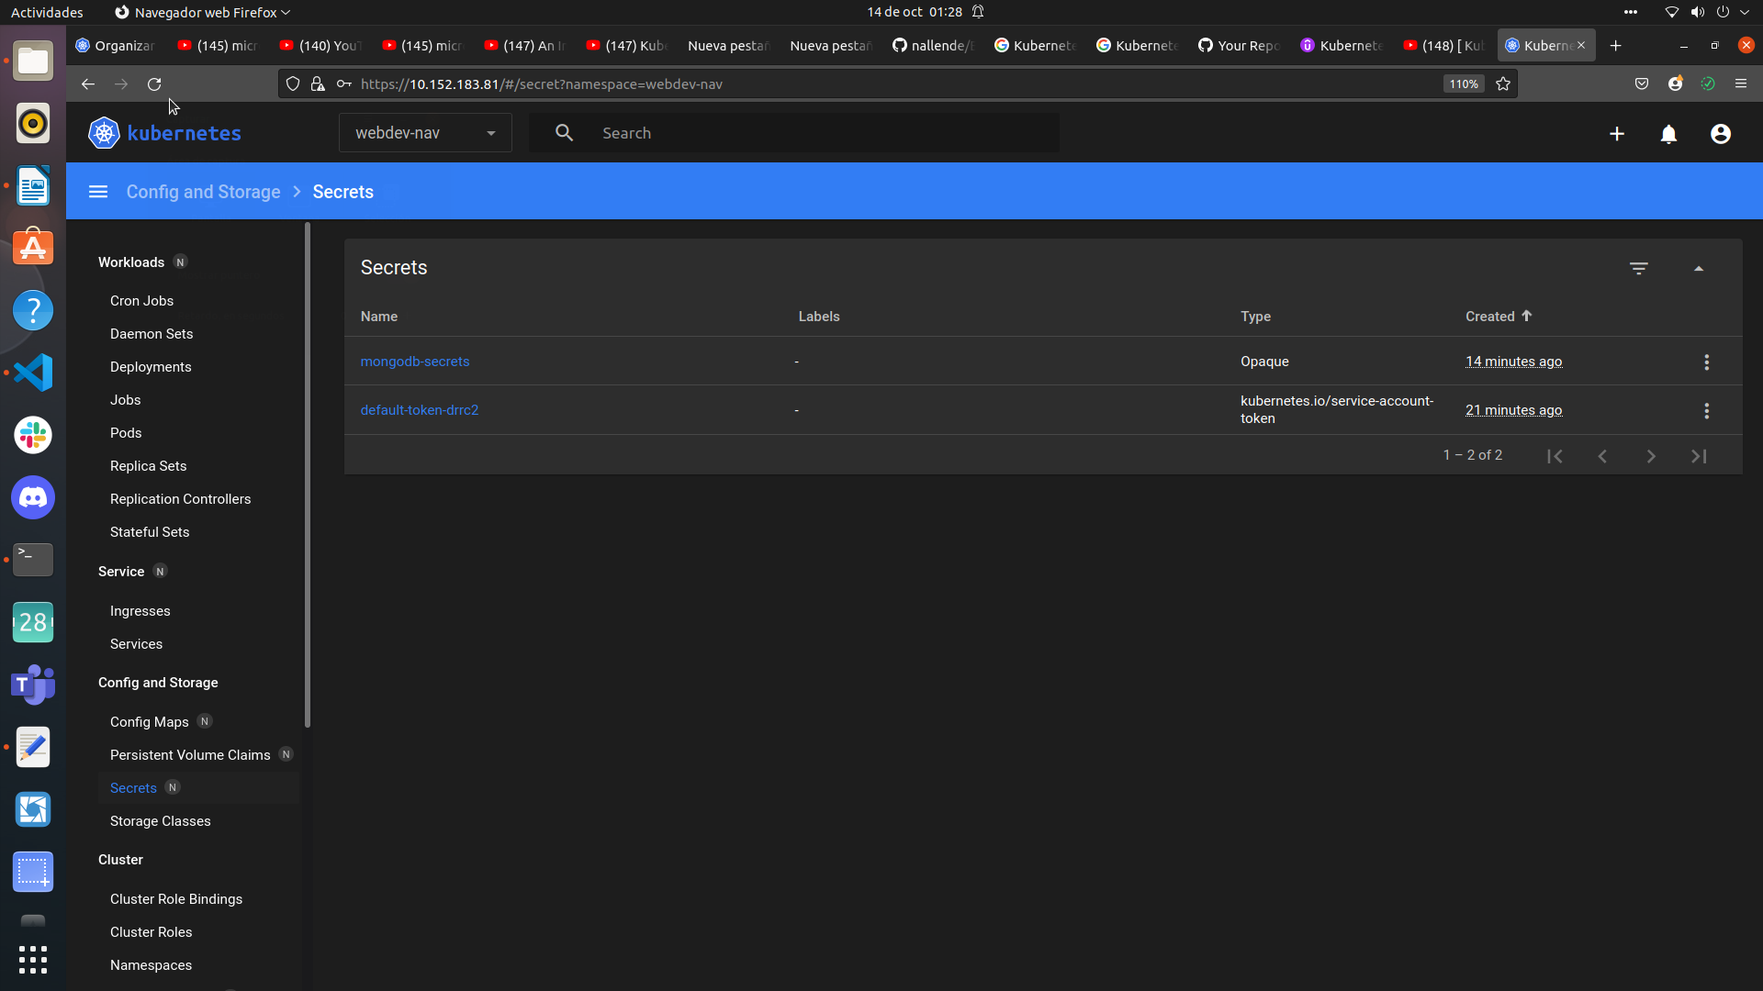

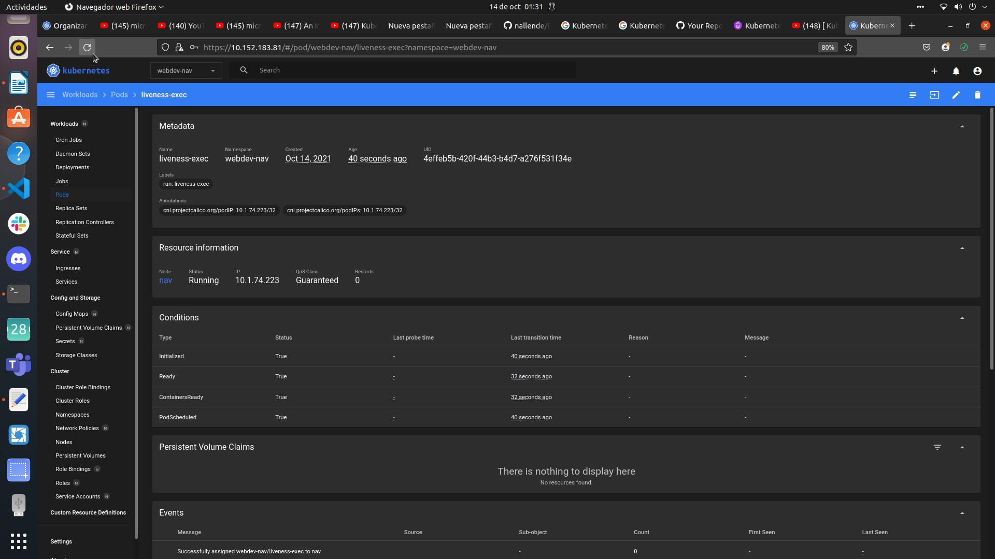

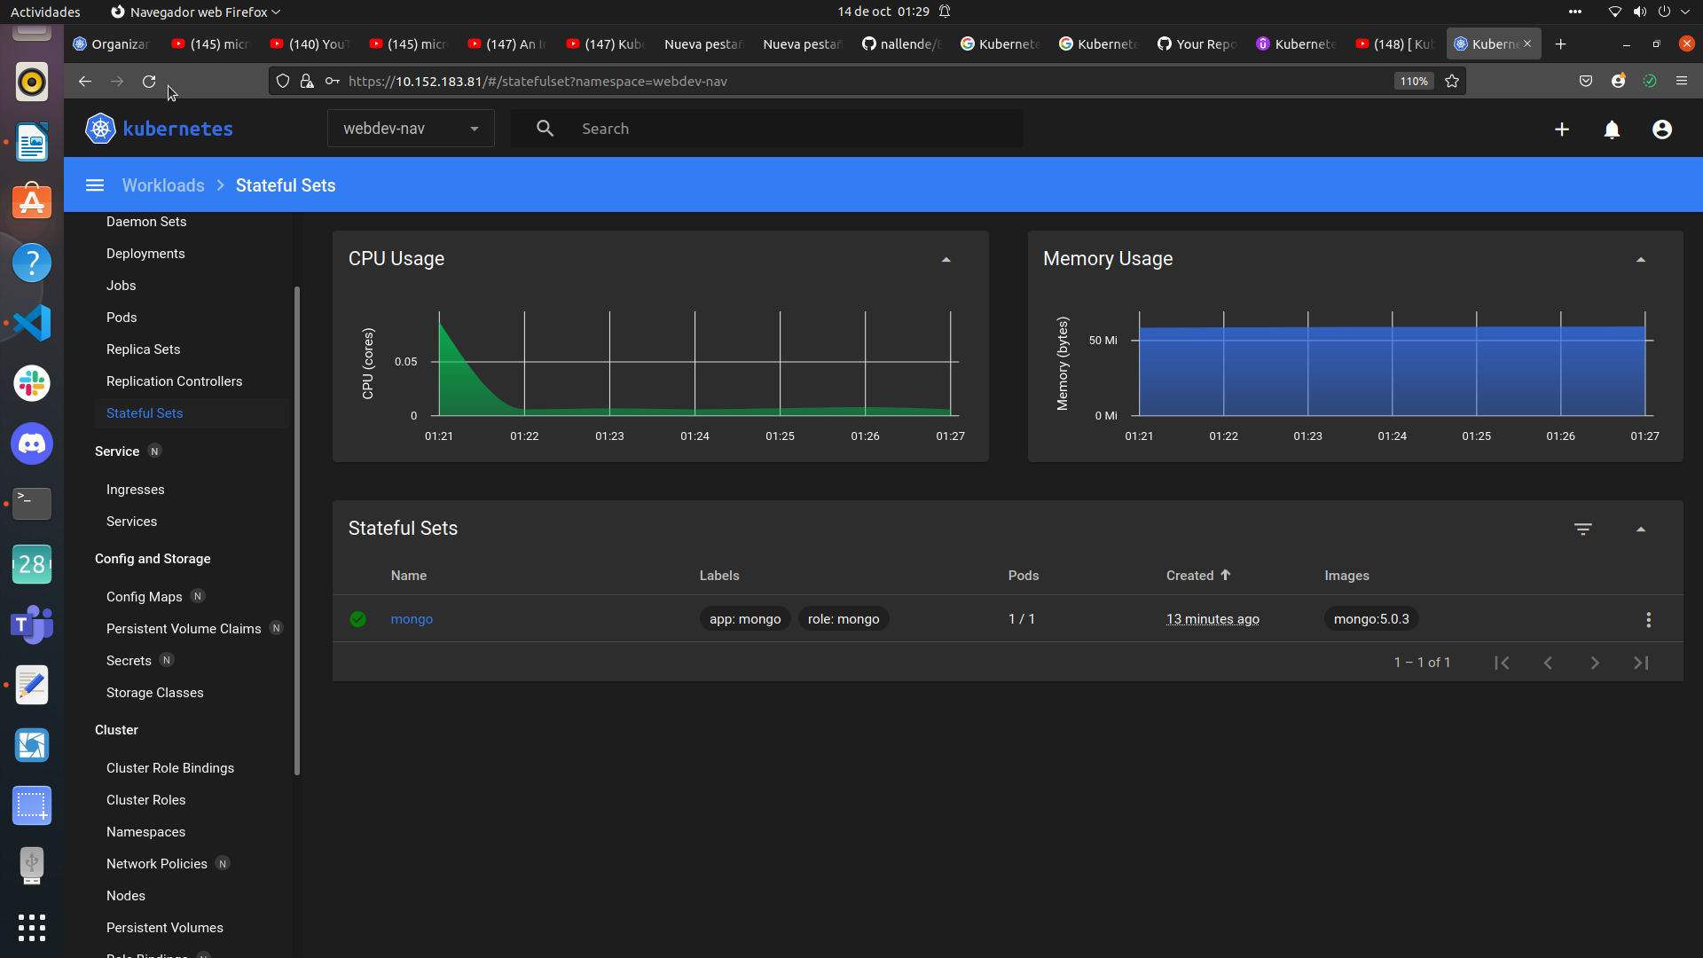
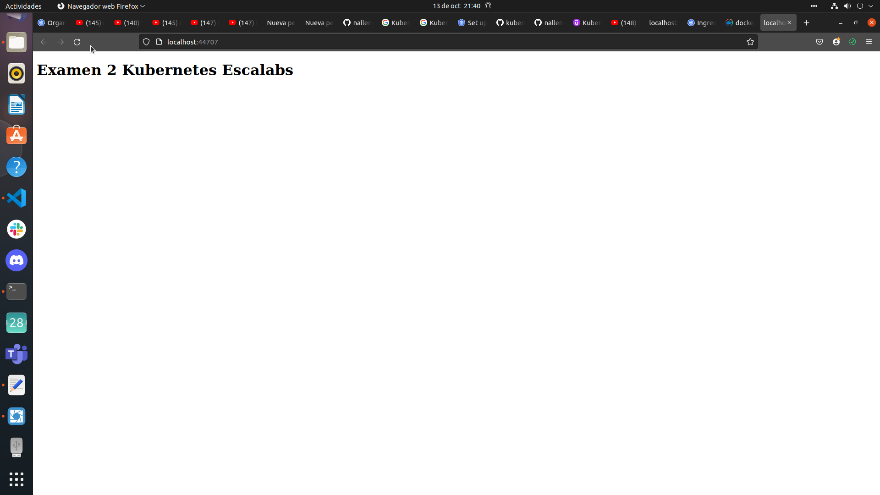

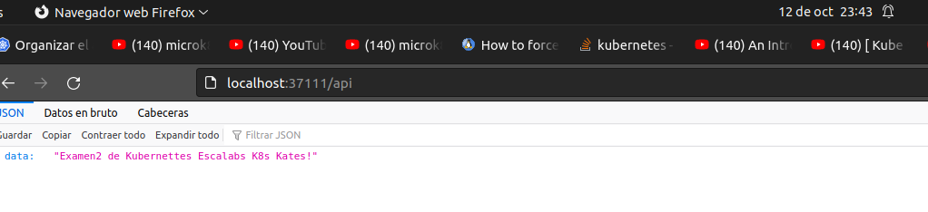

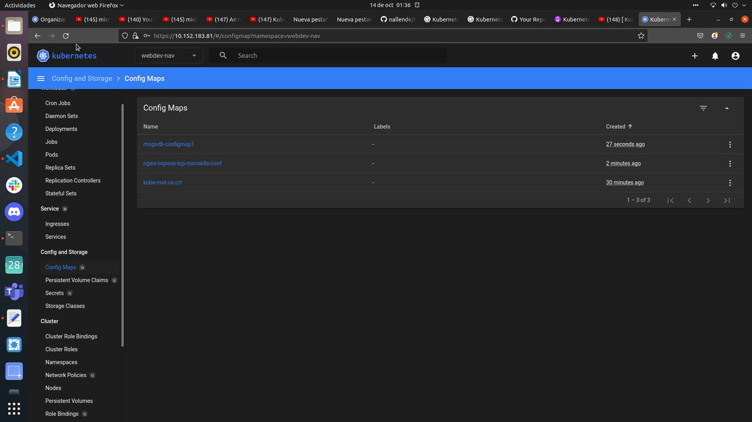
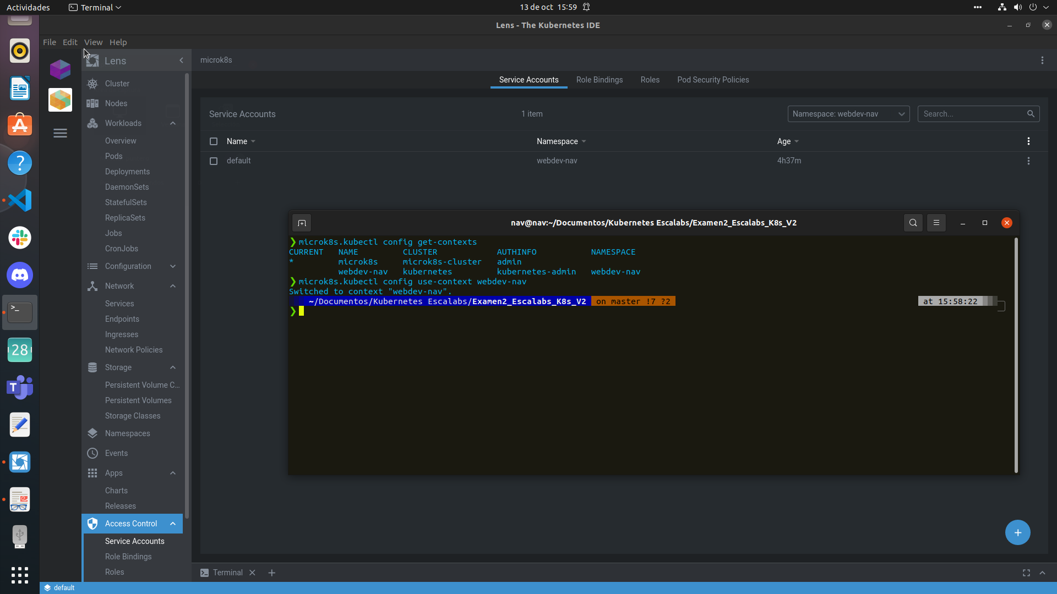

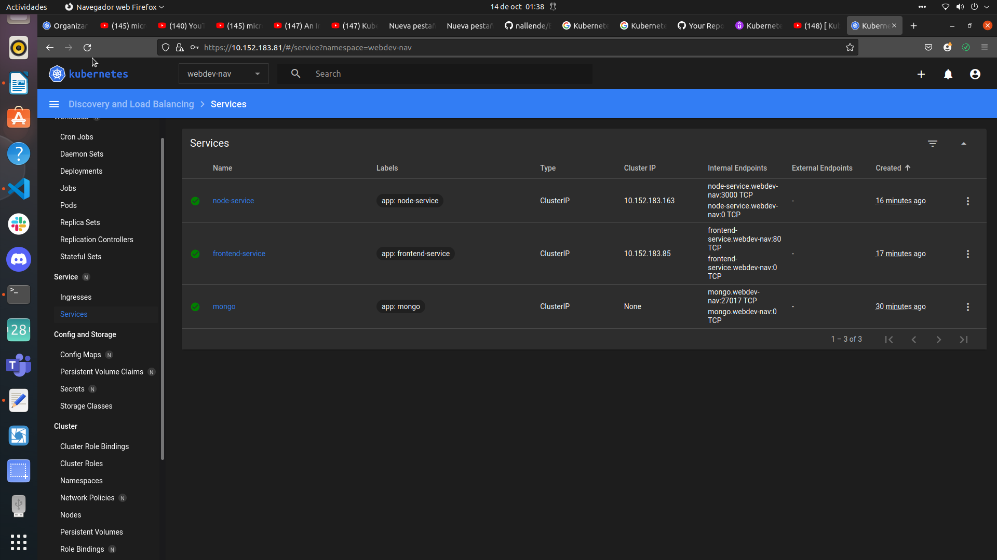
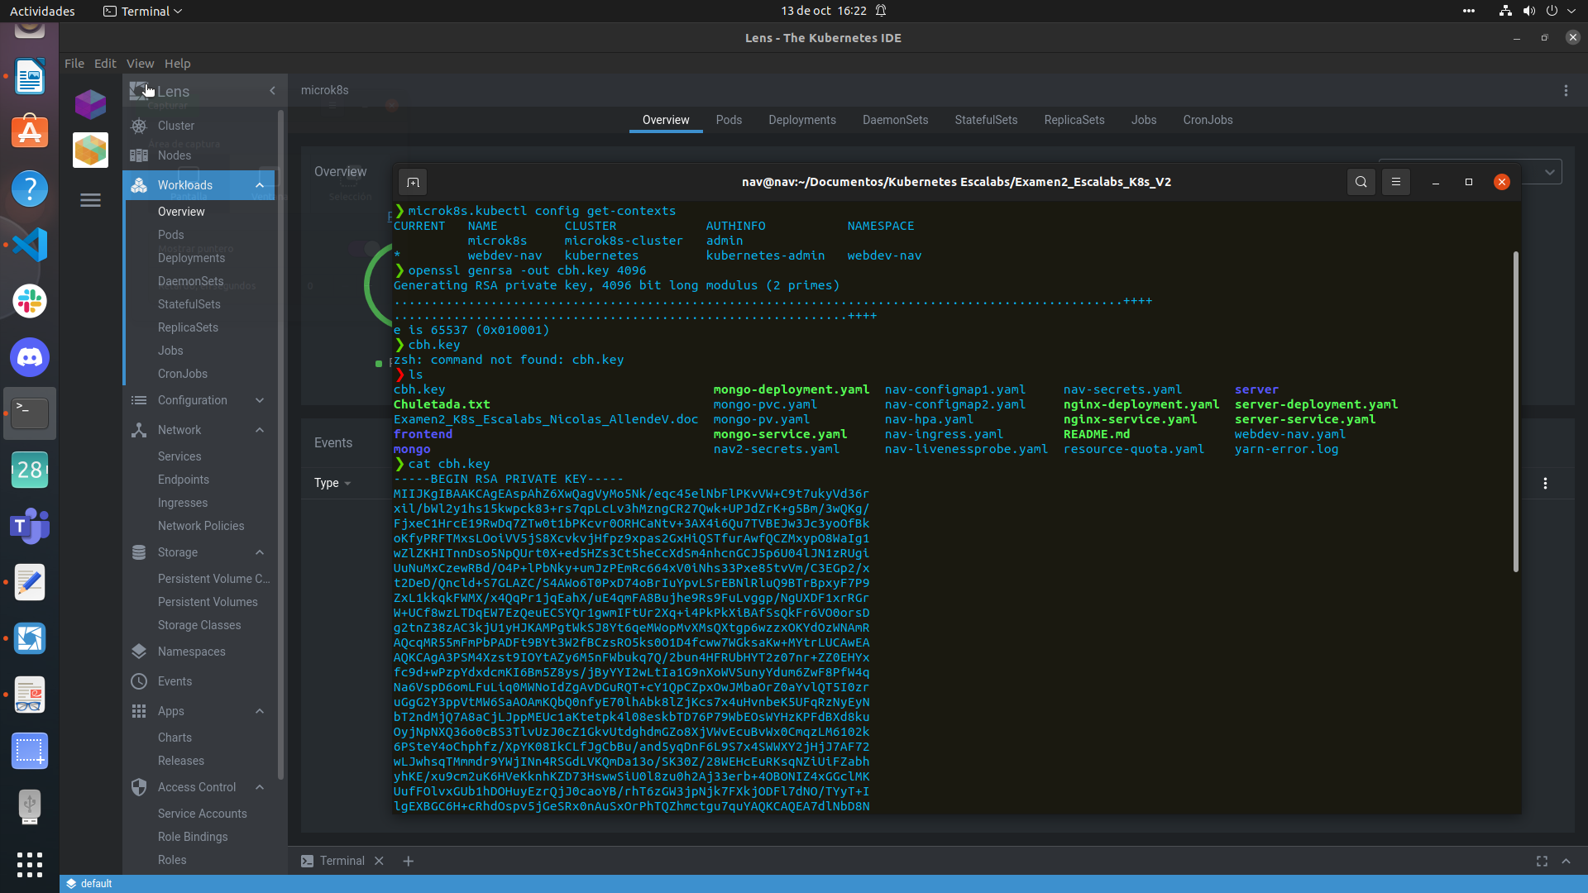

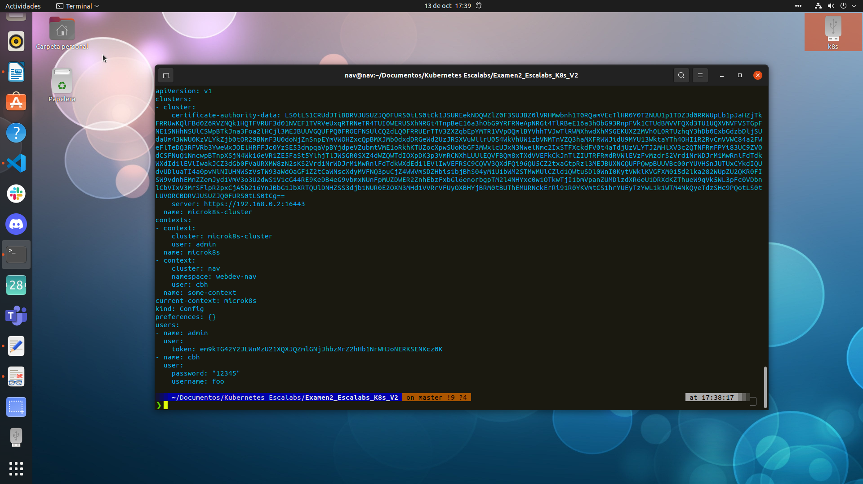

microk8s.kubectl create -f webdev-nav.yaml
microk8s.kubectl create -f mongo-pv.yaml
microk8s.kubectl create -f mongo-pvc.yaml

microk8s.kubectl create -f nav-secrets.yaml
microk8s.kubectl create -f nav-secrets.yaml

microk8s.kubectl create -f resource-quota.yaml

microk8s.kubectl create -f server-deployment.yaml
microk8s.kubectl create -f server-service.yaml

microk8s.kubectl create -f mongo-deployment.yaml
microk8s.kubectl create -f mongo-service.yaml

microk8s.kubectl create -f nginx-deployment.yaml
microk8s.kubectl create -f nginx-service.yaml

microk8s.kubectl create -f nav-hpa.yaml

microk8s kubectl -n kube-system get secret | grep default-token
microk8s kubectl -n kube-system describe secret default-token-s4znc

microk8s.kubectl get all --all-namespaces

microk8s.kubectl delete deploy server-deployment
microk8s.kubectl stop server-service

microk8s.kubectl delete deploy nginx-deployment
microk8s.kubectl stop nginx-service

microk8s.kubectl delete deploy mongo-deployment
microk8s.kubectl stop mongo-service

microk8s.kubectl delete deploy server-deployment
microk8s.kubectl delete deploy server-service

microk8s.kubectl delete deploy node-deployment

microk8s.kubectl delete ns webdev-nav

echo -n 'user' | base64
echo -n 'password' | base64

kubectl config delete-context

