

University of Hertfordshire

IMPROVING CLASSIFICATION WITH SEMI-SUPERVISED LEARNING: A COMPARATIVE STUDY OF SELF-TRAINING AND SUPERVISED MODELS

Submitted by - Meghana chandrika nallola

Student ID - 24160148

Table of Contents
Introducing Semi-Supervised Learning 4
Why Do We Need Semi-Supervised Learning? 4
What Happens When Labels Are Limited? 4
How Self-Training Works (Step-by-Step) 5
Let’s Try It on Real Data (Breast Cancer Dataset) 5
Setting Up the Experiment 6
Baseline: Training a Supervised Model 6
Applying Self-Training (Semi-Supervised) 8
Comparing the Results 10
What Happens When We Reduce Labels Further? 11
Choosing the Right Confidence Threshold 11
What Did We Learn? 12
Limitations and Things to Watch Out For 12
Final Thoughts and Real-World Applications 12
References 13

Executive Summary
This paper provides a comparison between supervised and semi-supervised learning in the case of limited labelled data availability. Self-training shown to be of higher accuracy using the Breast Cancer dataset utilizes unlabelled data with the help of pseudo-labelling. Findings reveal that semi-supervised models perform better compared to supervised models particularly at low percentages of labels, which is a cost-effective tool in real-world practices where limited labelled data exists.

Introducing Semi-Supervised Learning
Semi-supervised learning is a learning method which incorporates a small quantity of labelled data with a high quantity of unlabeled data to enhance the performance of the model. The model does not use labelled examples when learning data, but also uses the underlying structure associated with unlabelled data (Aleksić, 2025). As an example, when working with 1000 samples and only 100 of them labelled, semi-supervised learning allows us to utilise the remaining 900 unlabelled samples to augment learning and result in superior generalisation and more precise predictions.
Formally, let the labelled dataset be $D_{L}=\{\left(x_{i},y_{i}\right)\}_{i=1}^{n}$ and the unlabelled dataset be $D_{U}=\{x_{i}\}^{m}j=1$ where typically m≫n. The objective is to learn a function f(x) that minimises a combined loss.

Why Do We Need Semi-Supervised Learning?
- In real-world problems, labelled data is often costly to acquire, time-intensive or requires expert knowledge (e.g. medical diagnosis or legal documents).
- Nevertheless, big data that is not labelled can be readily accessible.
- Conventional supervised learning is highly dependent on labelled data, which becomes ineffective in cases where the labels are few (Kumar et al. 2022).
- This poses a discrepancy between the data available and the data usable.
- Semi-supervised learning is one approach to this problem in which a small volume of labelled data is used with a large volume of unlabeled data (Gomes et al. 2022).
- This allows models to learn better with the existing data and reduce the need to perform as much manual labeling.
- $L=L_{supervised}(X_{l},y_{l})+λ⋅L_{unsupervised}(X_{u})$

What Happens When Labels Are Limited?
- Supervised models with limited data labelling can fail to grasp correct patterns.
- Overfitting potentially occurs because specifically labelled data is used to develop the model, but the model is not well generalised to novel data.
- Significant patterns in the raw data are totally neglected.
- Consequently, the accuracy of predictions is reduced, and performance declines dramatically (Shamsabadi et al. 2024).
- The problem is more intense with the reduction of the share of labelled data.
- This, in practice, results in poor decision-making, and hence, there is a need to have methods through which both labelled and unlabelled data can be put to good use.

How Self-Training Works (Step-by-Step)
The most common and simplest form of semi-supervised learning technique is self-training. It does this by progressively increasing the labelled data with the task of the model itself.
- Step 1: Train on labelled data
Begin by training a model on the available labelled data. This makes a first-order classifier.
- Step 2: Predict unlabelled data
Predict on the unlabelled data using the trained model.
- Step 3: Select confident predictions
Select predictions with which the model is highly certain (e.g. probability >= 0.8).
- Step 4: Add pseudo-labels
Regarding these high-confidence predictions as the new pseudolabels and appending them to the labelled dataset.
- Step 5: Repeat
Re-train the model using the larger dataset, and continue until performance is consistent.
Model predicts probability:
$P(y∣x)$
Confidence threshold condition:
$maxP(y∣x)≥τ$

Let’s Try It on Real Data (Breast Cancer Dataset)
The “Breast Cancer Wisconsin (Diagnostic) dataset” is one of the most common datasets in binary classification work. It includes features that are calculated on digitised samples of breast masses, and each sample is identified as being benign or malignant (Tusher et al. 2026). The dataset consists of 569 samples and 30 numerical variables used to explain such characteristics as radius, texture, and smoothness. This tutorial is helpful due to its purity, order, and appropriateness concerning the display of performance in classification; therefore, it will best compare the supervised and semi-supervised methods of learning.
Dataset Link: https://archive.ics.uci.edu/dataset/17/breast+cancer+wisconsin+diagnostic

Setting Up the Experiment
- Train/Test Split: This is where we split the dataset into training and test sets. The model is constructed on the training set, whereas the test set is held aside to fairly test performance.
- Simulating Limited Labels: We now pretend we are in the real world and take all the labelled training data away (e.g. keep only 10, 20, or 50 of it). The rest of the data is considered to be unlabeled (Bhowmick and Narvekar, 2022).
- Why This Matters: This configuration enables us to have insight into the behaviour of models in the case of scanty labelled data.

Baseline: Training a Supervised Model
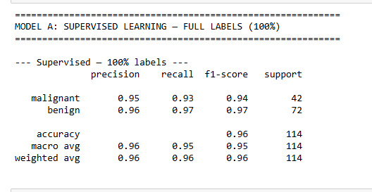
Figure 3: Supervised learning on full labels
The model is trained in this baseline condition on 100 per cent of the labelled data. We see that both classes have high levels of precision, recall and F1-scores, resulting in an overall accuracy of approximately 96%. This means that it is capable of learning a good decision boundary and generalising well when enough labelled data exists. This is our benchmark when performance is compared in the context of limited labels.
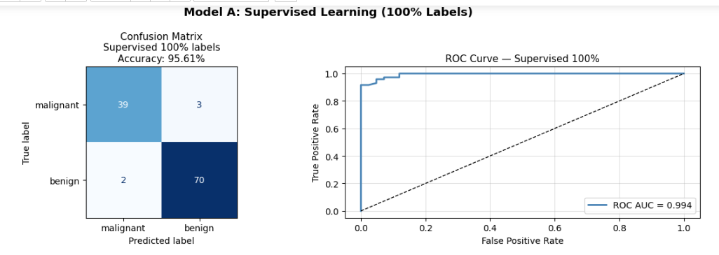
Figure 4: Supervised learning results visualization
According to the confusion matrix, the majority of the samples are correctly identified, where misclassifications are minimal in cases of benign and malignant. The ROC curve also shows that the model has good overall performance and the AUC is near 1. This is to show that using complete labels, the model proves to be very trustworthy and it is able to differentiate between classes efficiently.
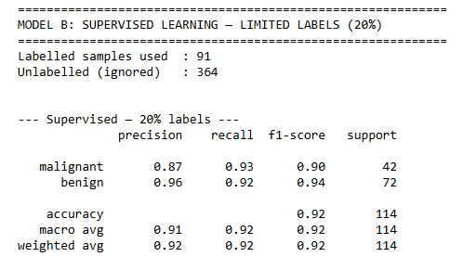
Figure 5: Supervised learning on limited labels
In this case, the model is trained on only 20 per cent of the labelled data, the rest being overlooked. It is evident that there is a reduction in the performance, especially in precision and general accuracy, as compared to the full-label scenario. This underscores the effect of minimisation of labelled data on the capacity of the model to acquire meaningful patterns.
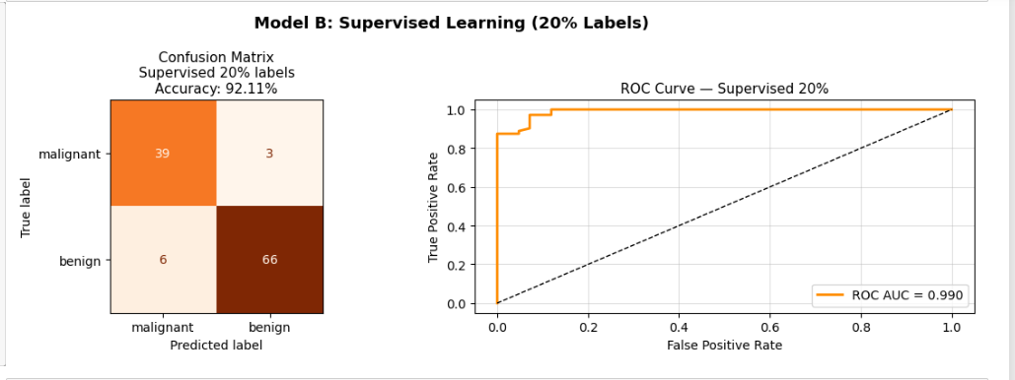
Figure 6: Supervised learning on limited labels results visualization
The confusion matrix indicates that there have been more misclassifications and the benign class has been affected the most. The ROC curve is again quite functional and yet slightly worse than under full label. It shows that although the model remains operable, the reliability of the model suffers due to limited labelled data training, which preconditions the application of semi-supervised learning. This reduction in performance caused by limited labels can be explained by the decrease in sample diversity and a lack of ability to learn a strong decision boundary by the model, as well as the higher probability of overfitting.

Applying Self-Training (Semi-Supervised)
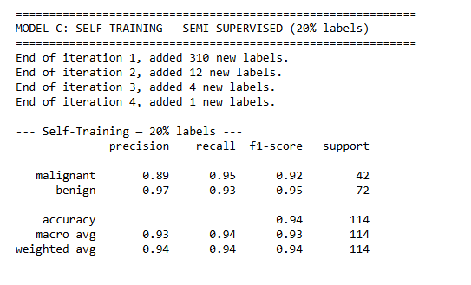
Figure 7: Self-training
This step involves self-training on labelled and unlabelled data (20% labelled). This model adds high-confidence predictions as pseudo-labels, which are added in the first stage (nature of more than 300 labels). This greatly increases the training set. Consequently, the model attains an accuracy rate of 94%, which is better compared to the supervised model set on a few labels (~92%).
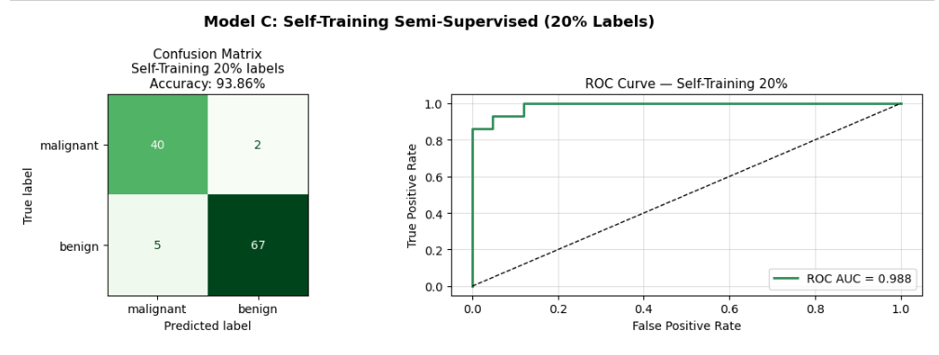
Figure 8: Self-training results visualization
There are fewer misclassifications than with the supervised model, as indicated by the confusion matrix, especially with the benign class. The ROC curve is robust and the AUC of the ROC is near to 0.99, which shows good separation of classes. The overall accuracy is 93.86%, which shows that mixed data in terms of labels assists the model in restoring the accuracy lost because of a few labels.
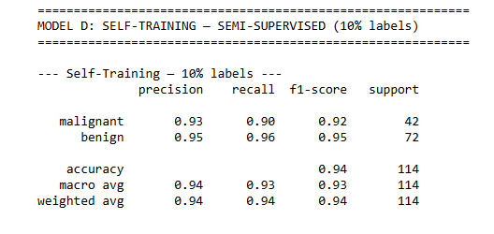
Figure 9: Self-training on reduced labels
Although the number of data labelled is 10 per cent, the self-training model with 10 per cent labelling still has a great accuracy of approximately 94%. The precision and recall values are also very high in both classes, indicating that the model is also able to learn adequately even when labelled data is extremely limited.
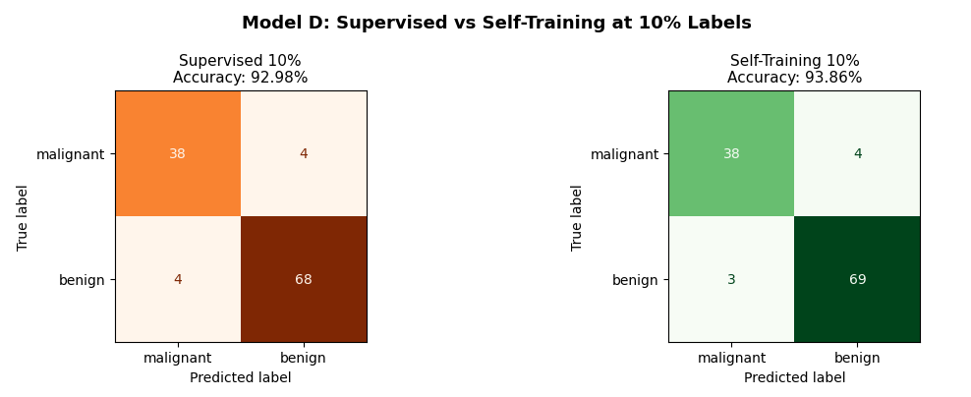
Figure 10: Supervised vs Self-Training at 10% Labels
This comparison highlights the obvious benefit of semi-supervised learning. Accurate results of the supervised model are approximately 92.98%, whereas self-training is 93.86. Lower errors in the self-training model, as indicated in the confusion matrices, indicate that the application of unlabeled data will achieve better predictions in situations where there are few labels. The enhancement is due to the fact that pseudo-labeling is able to expand the training set making the model more able to model the data distribution.

Comparing the Results
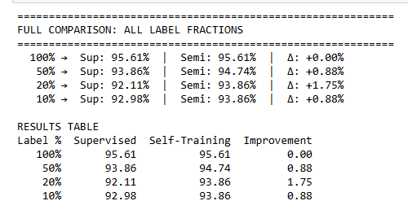
Figure 11: Comparison with all label fractions
The following table summarises the performance at varying label percentages. With 100% labelled data, both models are equally effective (95.61%), which is anticipated. Nevertheless, in cases where the quantity of labelled data is lower, the semi-supervised model is always better than the supervised one. The largest positive gain is at 20% labels with a positive contribution of +1.75%, indicating that self-training works best with limited labelled data.
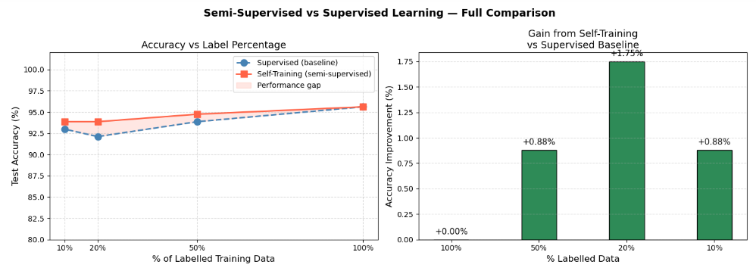
Figure 12: Comparison Graph
The graph indicates clearly that the supervised performance declines in the case of a reduction in labels, but the self-training model is more stable. The difference between the two models increases with lower label percentages, especially at 20 per cent and 10 percent where semi-supervised learning is higher in its degree of accuracy. This increase is due to the fact that this model makes use of the unlabelled data to learn more about the underlying structure and the results of the model in making predictions using fewer labels. The variation in performance among lower label fractions is higher, due to the fact that the supervised models are only trained on labelled data, but self training uses the structure of unlabelled data to regularise training.

What Happens When We Reduce Labels Further?
- The performance of the supervised model increasingly declines as the proportion of labelled data reduces (50% to 20% to 10%).
- This is due to the fact that the model does not have as many labelled instances to be learnt to acquire meaningful patterns (Long et al. 2023).
- However, the semi-supervised model is more stable in all cases.
- The difference between performance is more pronounced at low label percentages, particularly at 20 percent and 10 percent.
- This tendency provides evidence that semi-supervised learning models are most effective when there is limited labelled data and numerous unlabelled ones.

Choosing the Right Confidence Threshold
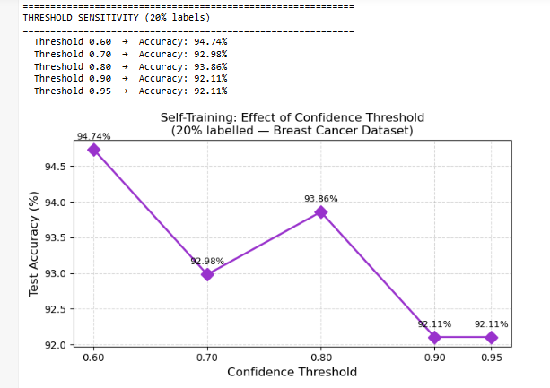
Figure 13: Threshold sensitivity
The confidence threshold determines the degree of certainty that the model needs to have before the pseudo-labels are added. A smaller threshold (e.g., 0.60) has more labels but it will be noisier, whereas a larger threshold (e.g., 0.90+) is tighter but has fewer samples. In our findings, 0.60 was the most accurate (approximately 94.7%), and extremely high thresholds decreased it, indicating that a balance is required. Less threshold amplifies the amount of sample size at the expense of label noise, whereas larger threshold amplifies sample size at the expense of less training samples, presenting a bias-variance trade-off.

What Did We Learn?
- The semi-supervised learning technique is useful when there are very few labelled data but large volumes of unlabelled data (Dastageer et al. 2025).
- It uses the unlabelled data to make the models perform better using some latent patterns.
- It performs best under low levels of label percentages (e.g., 10%- 20%), where monitored models do not work.
- In case sufficient labelled data is available, the enhancement is small (Roy and Etemad, 2024).
- Label combination with unlabeled data results in stronger and more stable models, particularly when the data is limited.

Limitations and Things to Watch Out For
Self-training has its shortcomings, even though it does have benefits. One can also compound the mistakes by adding incorrect pseudo-labels at the beginning, thus resulting in biased models. The process also relies most on the goodness of the original model. Besides, it is important to select the appropriate confidence threshold since a smaller threshold brings in noise and a higher threshold inhibits learning. Error propagation takes place when false pseudo-labels are reinforced repeatedly creating confirmation bias in the model. These difficulties indicate that special attention should be paid to tuning and assessment in case of semi-supervised techniques.

Final Thoughts and Real-World Applications
Semi-supervised learning is popular in fields where data labelling is also costly, e.g., medical imaging, fraud detection and natural language processing (Shan et al. 2025). It enables organisations to take advantage of large unlabelled datasets better and this saves money at the expense of enhancing performance. This renders it a strong as well as an effective method of machine learning in modern settings where the data is ample, whereas labels are frequently scarce.

References
Aleksić, V., 2025. Unsupervised and Semi-Supervised Learning Techniques in Contemporary Educational Application. In Sinteza 2025-International Scientific Conference on Information Technology, Computer Science, and Data Science (pp. 259-266). Singidunum University.
Bhowmick, K. and Narvekar, M., 2022. A semi-supervised clustering-based classification model for classifying imbalanced data streams in the presence of scarcely labelled data. International Journal of Business Intelligence and Data Mining, 20(2), pp.170-191.
Dastageer, K.B., Chinnasamy, P. and Deepalakshmi, P., 2025, November. Enhancing Cyber Attack Detection: A Comparative Analysis of Labeled and Unlabeled Data in Machine Learning Models. In 2025 International Conference on Intelligent Computing, Information and Control Systems (ICOIICS) (pp. 1755-1762). IEEE.
Gomes, H.M., Grzenda, M., Mello, R., Read, J., Le Nguyen, M.H. and Bifet, A., 2022. A survey on semi-supervised learning for delayed partially labelled data streams. ACM Computing Surveys, 55(4), pp.1-42.
Kumar, A., Ghosh, S. and Verma, J., 2022, November. Guided self-training based semi-supervised learning for fraud detection. In Proceedings of the third acm international conference on ai in finance (pp. 148-155).
Long, J., Chen, Y., Yang, Z., Huang, Y. and Li, C., 2023. A novel self-training semi-supervised deep learning approach for machinery fault diagnosis. International Journal of Production Research, 61(23), pp.8238-8251.
Roy, S. and Etemad, A., 2024, March. Scaling up semi-supervised learning with unconstrained unlabelled data. In Proceedings of the AAAI Conference on Artificial Intelligence (Vol. 38, No. 13, pp. 14847-14856).
Shamsabadi, E.A., Erfani, S.M.H., Xu, C. and Dias-da-Costa, D., 2024. Efficient semi-supervised surface crack segmentation with small datasets based on consistency regularisation and pseudo-labelling. Automation in Construction, 158, p.105181.
Shan, F., Dai, S. and Xiong, H., 2025. Semi-supervised learning for rock mass classification with limited labeled data in TBM tunnelling. In Tunnelling into a Sustainable Future–Methods and Technologies (pp. 3200-3206). CRC Press.
Tusher, E.H., Ismail, M.A., Khan, F., Raffei, A.M., Uddin, J. and Akbar, M., 2026. Semi-supervised learning: Assisted cardiovascular disease forecasting using self-learning approaches. Journal of Advanced Research in Applied Sciences and Engineering Technology, pp.136-150.

