The Resolution of Reality
  - A Primer on Quantum Computing
"There is no need to build a labyrinth when the entire universe is one." - Jorge Luis Borges, from The Aleph
July 6th, 2026
Nick Alonso

I. The Problem of Scale: The Lock on the World
Every time you send a credit card number or a private message across the internet, you are relying on a mathematical lock known as RSA Encryption [Appendix A: The Mathematics of RSA]. [1]
The security of this lock rests on a single, widely believed assumption: that factoring large integers is computationally infeasible for classical computers. To create a lock, a computer takes two huge prime numbers and multiplies them together to create a massive "Public Key." To break the code, a hacker must work backward, taking that massive number and splitting it back into its two original factors.
Without knowing the prime numbers, the hacker is working blind. There is no efficient mathematical map to guide them toward the answer; even the most advanced classical methods amount to a search far too long to ever finish.
While the solution is simple, the difficulty lies in the scale. Modern RSA keys are typically 2048 bits long. Written out, this is a number roughly 617 digits long.
- The number of atoms in the observable universe is roughly${10}^{80}$.
- The total pool of numbers to check for a 2048-bit key is roughly ${10}^{617}$.
This represents a hard physical limit on computation. As the classic analogy goes: even if you turned every atom in the observable universe into a supercomputer and let them run for the entire age of the cosmos, they would still fail to make a dent in the problem.
[Note: Strictly speaking, a hacker only needs to search up to the square root of the number. However, even with that reduction, the search space remains exponentially larger than the physical resources of the universe.]

II. The Classical Reality: The Physical Cost
Why is this problem so hard for a classical computer? Because each classical bit can hold only one definite value at a time, the machine must check potential answers sequentially. Even though it is fast at a single operation, there are so many potential answers (${10}^{617})$that there is not enough time to check them all.
The Physical Cost: We often think of software as abstract, but in a classical computer, information is physical. A number is stored in bits, and a bit is implemented using a transistor. You can think of a transistor as a microscopic bucket for electrons.
- To represent a 1, the computer pushes electrons into the bucket.
- To represent a 0, it drains the bucket.
To check just one guess, the computer must physically fill its transistors with electrons to represent that specific number, run the division calculation, and then drain the buckets to reset them for the next number.
To find the answer, the computer must repeat this "fill and drain" process for a massive fraction of the possibilities until it finds the one that works. It is like looking for a particular grain of sand in a desert when the solution sets are so large.
Note: This laborious guessing process is actually the same mechanism used in Blockchain Mining (Proof of Work). Bitcoin secures its network by forcing computers to expend energy filling and draining these "buckets" to find a random number (Hash). In cryptocurrency, this difficulty is the main feature, as the blockchain is secured by a chain of these hashed puzzles.

III. The Quantum Shift: Physics Solving Physics
Quantum computing approaches this problem in a fundamentally different way: it uses the laws of physics to solve the problems of physics.
If the classical approach is like looking for a specific grain of sand by checking each one, the quantum approach is like placing that sand on a metal plate (Chladni plate) and vibrating it.
You don't need to touch the sand. Through the application of specific frequencies, you can get the sand to naturally move away from the "wrong" spots, revealing the "right" spots where the answer lies.
A quantum computer does not examine solutions individually. Instead, it represents many possibilities at once and manipulates them as a single physical system to reveal the right answer.
The Qubit: The quantum equivalent to the classical bit is called a qubit. Like a classical bit, the qubit is a physical object and ultimately produces a 0 or a 1 when finally measured. However, before measurement, the qubit's physical state exists in a combination of possibilities between 0 and 1. In simple terms, the qubit is not committed to being a 0 or a 1 yet; both outcomes remain physically possible until the act of measurement forces a choice.
Because each qubit is suspended in this state of possibility, we can manipulate them using physical laws. By applying specific forces (the algorithm), we coerce the system to resolve into the exact sequence of 0s and 1s that represents the correct answer.
To understand how this works in more detail, we need to look more closely at the physics involved. In the next sections, we will introduce three key concepts that form the foundation of quantum computing: superposition, entanglement, and coherence.

IV. Superposition: Reality, Not Theory
The idea that a qubit can exist in a "combination of possibilities" has a name: superposition.
Superposition sounds abstract, but it describes a real physical behavior. Before a quantum system is measured, it does not need to commit to a single outcome. Multiple outcomes remain physically possible at the same time.
This behavior has been observed and tested repeatedly in experiments, the most famous of which is the Double-Slit Experiment. [2]
Young’s Double Slit Experiment: Imagine you are firing individual particles (like electrons) at a barrier with two narrow slits. Behind the barrier is a detector wall that records where each particle lands.
- The Classical Expectation: If particles acted like tiny bullets, they would pass through either the left slit or the right slit. You would expect to see two simple piles of hits on the back wall, directly behind the openings.
- The Quantum Reality: That is not what happens. Instead of two piles, the particles land all over the back wall in a series of alternating bright and dark stripes known as an interference pattern.
This pattern is identical to what happens when water waves pass through two openings. The waves ripple out, overlap, and interfere with each other, sometimes combining to make a bigger wave (bright stripe), sometimes canceling out (dark stripe).
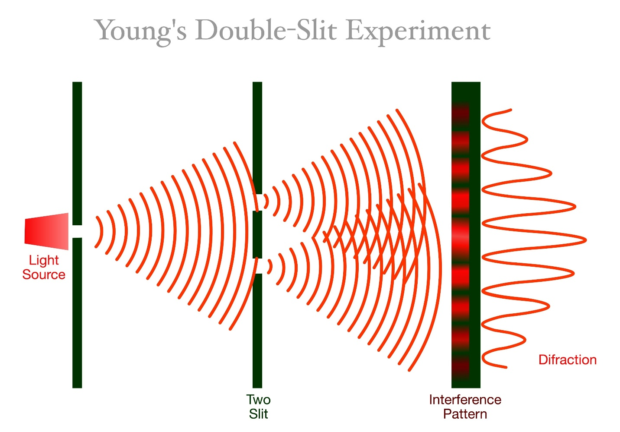
Figure 1 Expectation vs. Reality. On the left, classical objects (like bullets or sand) pass through slits and form two distinct piles. On the right, quantum particles (like electrons) behave as waves, passing through both slits simultaneously to create an interference pattern of alternating bright and dark stripes on the back wall.
The Role of Measurement: However, this wave-like behavior is fragile. The key lesson from the experiment is that measurement, or interaction, changes the result. If you place a sensor at the slits to see which path the particle actually took, the wave collapses. The interference pattern disappears, and you are left with two simple piles of particles. In this sense, the detector forces the quantum particle, which was in a superposition of "left" and "right", to strictly become one or the other.
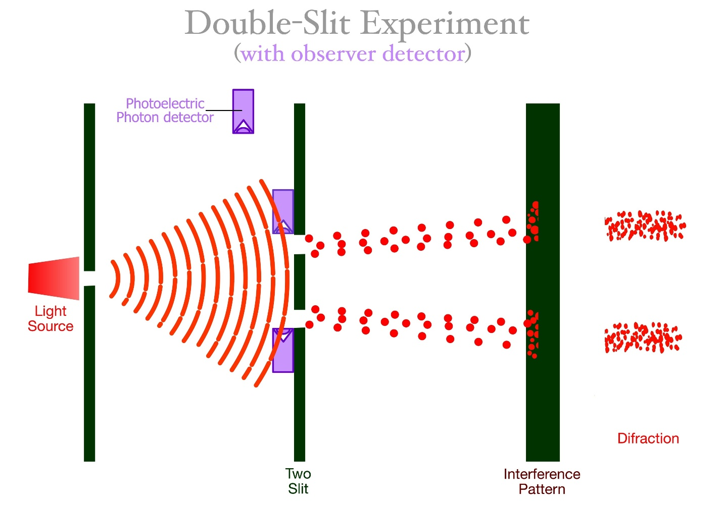
Figure 2 The Cost of Peeking. When a detector is placed at the slits to measure which path the particle takes, the quantum behavior collapses. The interference pattern vanishes, and the particles revert to behaving like classical objects, forming two simple piles. This demonstrates that the act of measurement fundamentally alters the system.
Connection to Computing: A classical bit must choose one path. But a qubit in superposition is the wave passing through both. It explores the pathway of 0 and the pathway of 1 at the same time.
We can think of the back wall as the landscape of all possible answers.
- The slits represent the qubits.
- The interference pattern on the wall represents the probability of finding the answer in a specific spot.
The more qubits we have, the more 'slits' we open, and the more of the wall gets exposed. As long as we have enough slits (qubits), we can see the entire 'wall' of possible answers. In our RSA encryption example, the slits represent the qubits that will eventually reveal the 0s and 1s of the correct encryption key
The next step is to make sure that all of these qubits are aware of each other, so that they can work together to represent the complex pattern of the solution as a single, unified system that encompasses all possible answers. This is called entanglement.

V. Entanglement: When Systems Stop Being Separate
Superposition allows a single qubit to explore two possibilities at once. But meaningful problems require checking trillions of possibilities. To do this, we need multiple qubits working together as a single team. This linking is called entanglement. [Appendix B: Entanglement & Breaking the Logic Barrier]
The "Single Entity": When qubits are entangled, they stop acting as independent objects and behave as a single physical system. This is much more than a simple physical connection. Entanglement is measured by correlations, and in quantum mechanics, the correlation among entangled objects is significantly stronger than any classical interpretation would allow. In fact, these correlations are so strong that, assuming the objects stay in superposition, they will continue to influence each other regardless of the distance between them, even if separated by the physical expanse of the universe. (Importantly, this link cannot be used to send messages faster than light; it reveals itself only in the correlations between measurements.) This is where Einstein's famous objection about "spooky action at a distance" came from.
Returning to the Double Slit: How does this help us solve the encryption problem? We can visualize the power of entanglement by returning to our Double Slit Experiment.
- 1 Qubit = 2 Slits: A single qubit in superposition is like a barrier with two slits. The wave passes through both (representing 0 and 1) simultaneously.
- Entanglement = Adding Slits: When we entangle qubits, we are mathematically adding more "slits" to the barrier.
  - Two entangled qubits create 4 possible paths (00, 01, 10, 11).
  - Three entangled qubits create 8 paths.
  - With roughly 2,000 entangled qubits, we create a barrier with ${10}^{617}$ slits. (In practice, Shor’s algorithm uses roughly double that, about 4,000 logical qubits, to read the pattern reliably [Appendix D].)
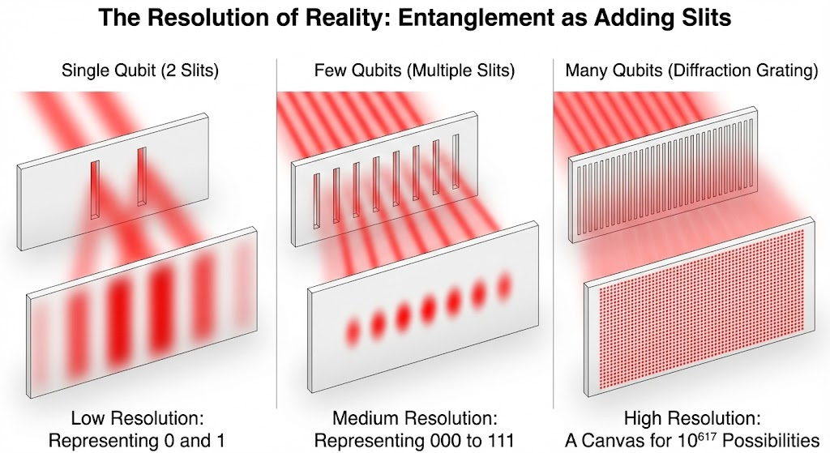
Figure 3: The Resolution of Reality. Entanglement acts like adding more slits to the barrier. Left (Low Resolution): A single qubit creates a blurry, simple pattern that can only distinguish between basic states (0 and 1). Center (Medium Resolution): As we entangle more qubits, the interference pattern sharpens, revealing more distinct possibilities. Right (High Resolution): With thousands of entangled qubits, the system behaves like a massive diffraction grating. The "back wall" becomes a high-definition canvas capable of distinguishing the single correct answer among ${10}^{617}$ possibilities.
The Massive Wave: The quantum computer acts as a single, massive wave passing through all of these slits simultaneously. This is why entanglement is the engine of quantum computing. It expands the "solution space" (the back wall) from a simple pattern of black-and-white stripes into a canvas complex enough to reveal the prime factors we are looking for.
The Challenge - Fragility: However, maintaining such a system in a delicate state of superposition is extremely hard. The more qubits that are added, the more complex and fragile the system becomes. If any other physical object - air molecules, heat, stray magnetic fields, interacts with the system in this delicate state, the synchronization breaks, the wave collapses, and the complex interference pattern dissolves into noise. This challenge of maintaining the system is known as Coherence.
Note on "Logical" Qubits: Throughout this paper, when we discuss the number of qubits required (e.g., 4,000 for encryption), we are referring to Logical Qubits. In the real world, physical qubits are prone to error. To create one perfect "Logical Qubit" that can hold a value without breaking, engineers often need to tie together thousands of "Physical Qubits" to correct for noise. Building a machine with enough physical qubits to create these logical units is the primary engineering challenge of the next decade.

VI. Coherence: The Challenge
For superposition, entanglement, and probability shaping to work, the qubits must remain in a delicate state where their quantum properties are not forced to choose a definite value. This fragile condition is known as Coherence. [3]
The Environment is a Detector: The problem is that the universe is hostile to these states. Recall from the Double Slit experiment that if a detector "peeks" at the particle, the wave collapses. In a real quantum computer, you don't need a deliberate detector to ruin the experiment.
- Heat (vibrating atoms)
- Electromagnetic radiation (WiFi signals)
- Stray particles (Cosmic rays)
All of these act like unintended measurements. Even a single interaction with a stray heat photon effectively asks the qubit, "Are you a 0 or a 1?"
When that happens, the qubit is forced to decide. Superposition collapses, entanglement breaks, and the coordinated quantum wave falls apart. The result on our "back wall" is no longer a sharp, high-resolution solution; it reverts to random noise.
This loss of quantum behavior is called Decoherence. It is not a theoretical limitation, but a physical one. It is the primary engineering challenge standing between today’s experimental devices and the quantum machines of the future.
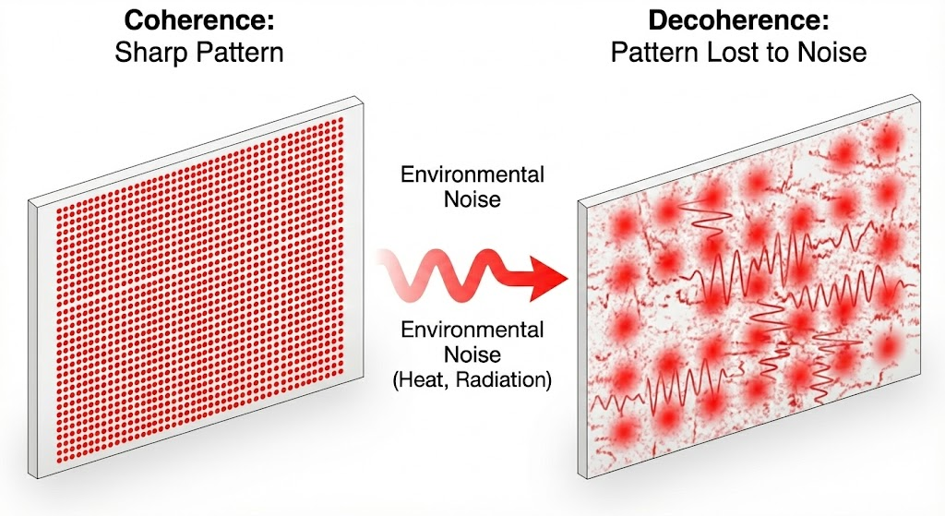
Figure 4 The Fight Against Noise. Coherence is the ability to maintain the sharp, high-resolution pattern (Left). Decoherence occurs when the environment interacts with the system, introducing noise that blurs the pattern and scrambles the information (Right), making the answer impossible to read.

VII. The Solution: Shaping Probabilities
At this point, thanks to entanglement, our quantum computer is holding a vast landscape of possibilities, a "back wall" covered in ${10}^{617}$ potential answers. But right now, the wave is spread equally. Every answer looks the same. If we measured the system now, we would just get random noise.
How do we guide the system toward the one right answer?
The Algorithm as a Lens: A quantum computer does not search sequentially. Instead, it uses interference, a controlled method of reshaping the likelihood of different outcomes.
To visualize this, we return to the Double Slit Experiment. Imagine placing a series of optical lenses between the slits (the qubits) and the back wall.
We haven't looked at the answer yet; we are simply applying these lenses to "bend" the waves passing through the system, adjusting their phases so they focus on a single bright point on the wall.
Note: What is the "Lens" made of? In the actual hardware, there are no glass lenses. Instead, engineers use Quantum Gates. These are precise pulses of energy (microwaves or lasers) applied to the qubits. By hitting a qubit with a specific pulse, we rotate its state, mathematically shifting its wave phase. A quantum algorithm is simply a sequence of these pulses designed to create the interference pattern we want.
How Do We Shape the Lenses? And how do we know where to place the lenses if we don't know the answer? We use the rules of the problem itself.
To understand this, consider the challenge of designing a new drug molecule. We may not know the final, stable shape of the molecule, but we do know the physics that govern it. We know that two atoms cannot occupy the same space, and we know that like charges repel, etc. We build these physical constraints into the algorithm. These rules act as the lenses.
- Destructive Interference (High Energy): Consider a configuration where the molecule is folded so that atoms are crashing into each other. This is physically "impossible" or high-energy. The algorithm uses this physical constraint to shift the wave phases so that these answers cancel out.
- Constructive Interference (Low Energy): Now consider the configuration where the atoms fit together perfectly, the stable, low-energy shape. The algorithm aligns the waves for this outcome.
The Result: Nature Finds a Way - Nothing is removed explicitly. No configuration is deleted. Instead, the system mimics nature's own tendency to settle into a stable state. When we finally measure the system, we don't find a random result. Because the "stable" wave (the low-energy solution) has been amplified by our lenses, it dominates the probability distribution.
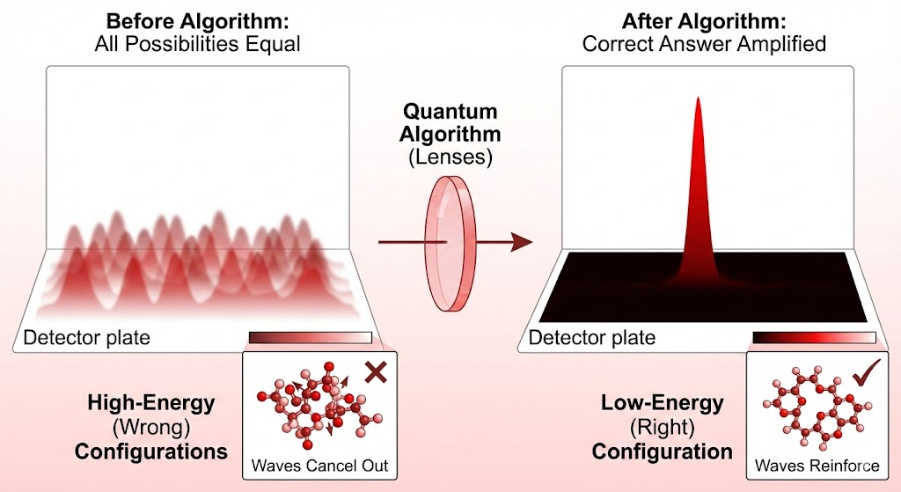
Figure 5: The Algorithm as a Lens. Just as an optical lens focuses scattered light into a single bright point, a quantum algorithm acts on probability waves. By applying specific logic gates, the algorithm shifts the phases of the data, causing incorrect answers to cancel out (Destructive Interference) and the correct answer to reinforce itself (Constructive Interference). The result is a single "bright spot" of high probability that reveals the solution.

VIII. Limits and Opportunities: What Quantum Computing Can, and Cannot, Do
Quantum computing is powerful, but it is not a magic oracle. It does not work by checking every possible answer simultaneously. For a quantum algorithm to work, the problem must have a hidden mathematical structure, or "Codable Laws", that we can exploit to create interference.
You cannot build a lens for a problem that has no shape.
- Structured Problems: In the RSA encryption example, the system is defined by exact mathematical relationships (prime factors). In the drug discovery example, the system is defined by the forces of physics. We can code these rules into the algorithm to focus the wave on the correct solution
- Unstructured Problems: If a problem is truly random (like finding a specific name in an unsorted pile of paperwork), there is no mathematical structure to "focus" on. The wave cannot be focused in a single stroke, and the best a quantum computer can offer is the modest quadratic speedup of Grover’s algorithm [Appendix D], useful but far from exponential.
Because of this, quantum computing is not a universal replacement for classical machines, but a specialized tool for specific domains:
- Nature’s Home Court: Chemistry and Medicine: The most transformative opportunity lies in drug discovery and materials science. At the molecular level, chemistry is quantum mechanical. A classical computer struggles to simulate a drug molecule because it has to approximate the complex quantum behavior using rigid math. A quantum computer doesn't have to approximate. It simulates the molecule by becoming the molecule. [4] It uses its own physics to mirror the physics of the drug. This could accelerate the design of targeted therapies, enabling patient-specific treatments tailored to an individual’s molecular profile.
"Nature isn't classical, dammit, and if you want to make a simulation of nature, you'd better make it quantum mechanical, and by golly it's a wonderful problem, because it doesn't look so easy." — Richard Feynman [7]
- Imposing Structure: Logistics and Optimization: Beyond physics, quantum computers are also adept at solving problems like global logistics or financial portfolio optimization. While these problems aren't "physical" in the literal sense, they have mathematical structures (constraints, costs, dependencies) that can sometimes be mapped onto quantum states.

IX. Conclusion: The Hybrid Architecture
Ultimately, the goal of quantum computing is not to replace classical computers, but to complete them.
The emerging model is a Hybrid Architecture where the quantum computer functions as a Specialized Accelerator, similar to a modern GPU (Graphics Processing Unit). [5] Just as a standard CPU offloads heavy graphics or AI tasks to a GPU, future supercomputers will offload specific problems of scale to a QPU (Quantum Processing Unit). [Appendix C: The Hardware Race (Types of Physical Qubits)]
In this workflow, the classical computer retains control over logic, operating systems, and data storage. It only triggers the QPU when it hits a barrier of scale, such as factoring a massive number or simulating a complex molecule. The QPU applies the "lenses" of interference to isolate the solution and returns the result to the classical system. [Appendix D: The Software (Key Quantum Algorithms)]
This approach leverages the best of both physical regimes: the rock-solid reliability of classical bits for general computing, and the probabilistic power of qubits for the problems that are simply too big to count.
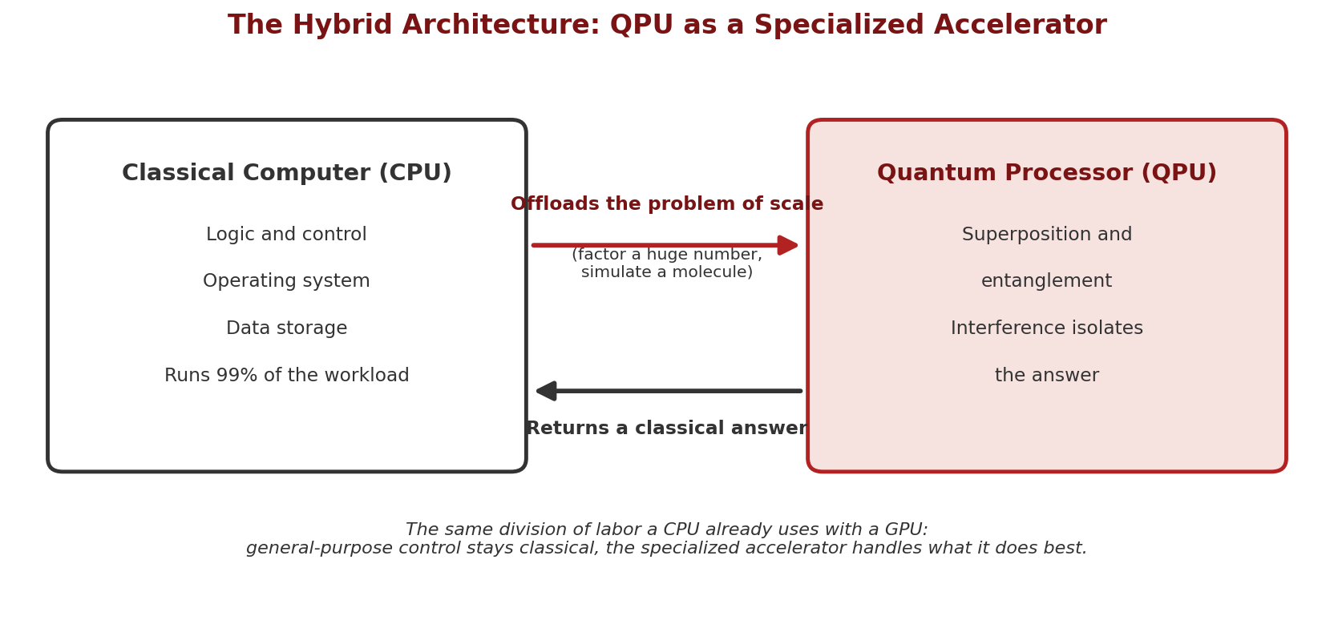
Figure 6 The Hybrid Architecture. The classical computer keeps control of logic, storage, and the operating system. When it hits a problem of scale, it offloads that single step to the QPU, just as it already offloads graphics and AI workloads to a GPU. The QPU applies interference to isolate the answer and hands back a classical result.

Appendices
Appendix A: The Mathematics of RSA
RSA security relies on the difficulty of factoring large integers. While the public key is constructed using simple multiplication, reversing the process to find the private key requires solving a "Hidden Subgroup Problem", specifically, finding the period of a modular function.
- The Setup (Key Generation) RSA begins with the selection of two large prime numbers, p and q.
  - The Modulus (N): The primes are multiplied to create the modulus: N = p x q
  - Euler’s Totient ($ϕ$): We calculate the number of integers less than (N) that are coprime to N:
$$ϕ\left(N\right)=(p-1)(q-1)$$
  - The Keys:
    - Public Key ($e$): Chosen such that it is coprime to $ϕ(N)$.
    - Private Key ($d$): Calculated such that $d×e≡1(mod(ϕ\left(N\right))$
- The One-Way Function: Modular Exponentiation Encryption and decryption are performed using Modular Exponentiation. This operation wraps numbers around a circle of size N.
  - Encryption: $C=M^{e} (mod N)$
  - Decryption: $M=C^{d} (mod N)$
For a classical computer, finding d (the private key) without knowing $ϕ\left(N\right)$ (which requires knowing p and q) is computationally intractable because the "wrapping" obscures the original values.
- The Hidden Structure: The Looping Property: The weakness of RSA lies in the fact that modular exponentiation is periodic. If we take a number a and repeatedly multiply it by itself modulo N, the sequence eventually repeats. The function is:
$$f\left(x\right)=a^{x} (mod N)$$
This function creates a looping sequence:
$$a^{1},a^{2},a^{3},…,a^{r}≡1 (mod N)$$
The length of this loop, the number of steps it takes to get back to 1, is called the Period (r).

- The Quantum Attack (Period Finding) Mathematically, if you can find the period r, you can easily factor N and break the encryption.
  - Classical Difficulty: The period r is typically a massive number, comparable in scale to N itself (hundreds of digits long for a 2048-bit key). A classical computer has to calculate the sequence one by one to find where it repeats, which takes exponential time.
  - Quantum Solution: The quantum computer does not check the sequence step-by-step.
    - It creates a superposition of all possible inputs x
    - It applies the function $f\left(x\right)=a^{x} (mod N)$
    - Because the function is periodic, the output states interfere with each other. The wrong periods cancel out (destructive interference), and the correct period r amplifies (constructive interference).
Shor's Algorithm is essentially a method for finding this "loop length" r. [6] Once r is known, a simple classical calculation reveals the factors p and q.
- A Concrete Example: Encrypting "A" To visualize this, let’s use small numbers to encrypt the letter "A".
  - Step 1: Create the Lock $(N)$: We pick two small prime numbers: p = 3 and q = 11. The Public Modulus N = 3 X 11 = 33. The “Totient” $ϕ\left(N\right)=\left(2\right)\left(10\right)=20$
  - Step 2: Create the Keys
    - Public Exponent (e): We choose 7
    - Private Exponent (d): We need a number where 7 X d leaves a remainder of 1 when divided by 20. We choose 3. (Because 7 X 3 = 21, and 21 is 1 more than 20).
  - Step 3: Encrypt "A" Let's convert "A" into the number 2 (to avoid the trivial math of using 1)
$$2^{7} \left(mod 33\right)=128 (mod 33)$$
128 divided by 33 is 3 with a remainder of 29. So, we send the encrypted number: 29.
  - Step 4: Decrypt with the Private Key: The receiver takes 29 and uses the private key (d=3).
$${29}^{3} \left(mod 33\right)=24,389 (mod 33)$$
24,389 divided by 33 leaves a remainder of 2. We get our original message back: "A".

Appendix B: Entanglement & Breaking the Logic Barrier
Quantum mechanics predicts that entangled particles share a harmony that is mathematically stronger than any two independent classical objects could ever achieve. To prove this, physicists use a logical "stress test" known as Bell's Theorem.
1. The Classical Limit (The Logic Trap)
Imagine testing two separated partners, Alice and Bob. We put them in a "Game Show" scenario to test their coordination.
The Setup: In each round, the Host separates Alice and Bob. He has two cards, Card A and Card B. He flips a coin to decide which card to show Alice, and which card to show Bob.
The Four Scenarios: This creates four possible combinations of questions. The rules for winning depend on which combination comes up:
- Host shows (A) and (A): They must give the SAME answer.
- Host shows (A) and (B): They must give the SAME answer.
- Host shows (B) and (A): They must give the SAME answer.
- Host shows (B) and (B): They must give DIFFERENT answers.
The Trap (Why You Can't Win 100%): Since they can't talk during the game, their only strategy is to agree on a "Hidden Script" beforehand (e.g., "Always say Yes" or "If you see Card A, say Yes"). But logic guarantees they will lose at least one case.
Look at the chain of logic required to win the first three:
- If Alice(A) matches Bob(A)...
- And Bob(A) matches Alice(B)...
- And Alice(B) matches Bob(B)...
Then logic dictates: Alice(A) must match Bob(B).
But the rule for that last scenario (Rule 4) is to DISAGREE. By ensuring a win in the first three, their own logic forces a loss in the last one.
The Result (The 75% Limit): Because of this conflict, the absolute best "Win Rate" any classical system can achieve is 3 out of 4 (75%). [8]
2. The Quantum Violation (The Smoking Gun)
When actual experiments are run using entangled photons, they break this limit, winning roughly 85% of the time. Physicists usually express this as a correlation score: classical logic caps the score at 2, while entangled photons reach approximately 2.8 (the quantum maximum of 2√2).
This number proves that the particles cannot be carrying pre-written scripts. If they were, they would be trapped by the logic above. Since they beat the limit, they must be generating their reality on the fly in a coordinated way.
3. The Intuitive Proof: The "State Reset"
How can a physical object "cheat" logic? The best way to visualize this mechanism is the Three Polarizer Paradox, which demonstrates how measurement changes reality.
The Setup (The Block): Imagine sending light through a Vertical filter followed by a Horizontal filter.
- The Physics: These two states are "Orthogonal" (90° apart). Vertical light contains absolutely zero "Horizontal-ness." There is no overlap in their states.
- The Result: Because there is no common state to grab onto, 100% of the light is blocked. The screen is dark.
The Twist (The Quantum Bridge): If you insert a third filter oriented Diagonally (45°) in between them, light suddenly passes through to the end.
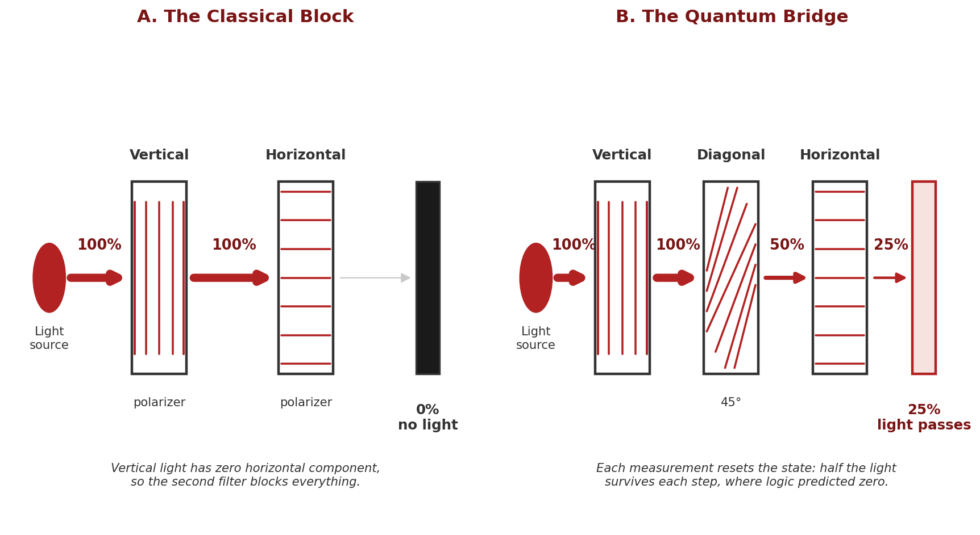
Figure 7 The Quantum State Reset. (Left) Vertical light is strictly orthogonal to Horizontal, so it is blocked. (Right) The Diagonal filter bridges the gap. Vertical light contains a diagonal component, so it passes and becomes Diagonal. Diagonal light contains a horizontal component, so it passes the final filter. The measurement changes the reality of the photon mid-flight. Each successive filter passes half the light, so roughly 25% emerges where classical logic predicted zero.
Why this happens (The Chain of Superposition): In the classical world, adding an obstacle should only block more light. In the quantum world, the middle filter acts as a bridge by resetting the state.
- Vertical to Diagonal: Light leaves the first filter as Vertical. While Vertical has no Horizontal component, it is a superposition of "Diagonal Left" and "Diagonal Right."
- The Reset: When it hits the middle filter, the measurement forces the light to snap into the Diagonal state. It has now "forgotten" it was ever Vertical.
- Diagonal to Horizontal: Now that the light is Diagonal, it holds a new superposition: it is a mix of Vertical and Horizontal. Because it now possesses a "Horizontal component," it can successfully pass through the final gate.
Conclusion: By putting another filter in the middle, we changed its fundamental nature. We used the "Diagonal Bridge" to rotate the probability wave, allowing it to bypass a barrier that logic said was impassable. Entangled particles use this same "wave geometry" to achieve their impossible correlations, showing that quantum objects do not carry fixed, pre-written properties waiting to be revealed [9]
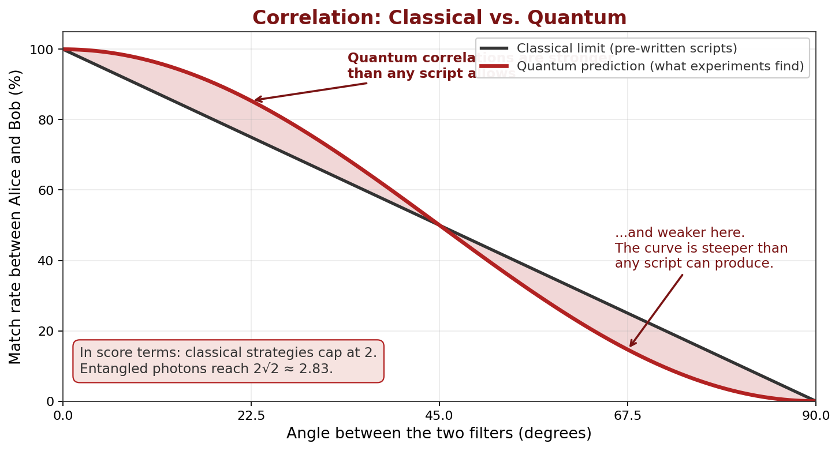
Figure 8 The Logic Gap. The straight line is the strongest correlation any pre-written script (hidden variables) can produce. The curve is the quantum prediction, which bends away from that line at intermediate angles. Experiments follow the curve; in score terms, classical strategies cap out at 2 while entangled photons reach roughly 2.8, the quantum maximum of 2√2.

Appendix C: The Hardware Race (Types of Physical Qubits)
In classical computing, the "bit" has been standardized for 50 years: it is a silicon transistor. In quantum computing, there is no standard yet. A "qubit" is a concept, a two-state quantum system. Engineers are currently betting on completely different physical objects to act as those qubits.
Here are the five leading approaches currently in the race:
1. Superconducting Qubits (The Current Leader)
- What it is: A tiny loop of wire made of superconducting material (usually aluminum) broken by a non-conducting gap (Josephson Junction). It acts like an "artificial atom."
- How it works: When cooled to near absolute zero, electrons flow through the loop without resistance. The current can flow clockwise (0), counter-clockwise (1), or both at once.
- Pros: Fast calculation speeds; leverages existing chip-manufacturing techniques.
- Cons: Extremely fragile; requires massive "chandeliers" of dilution refrigerators to keep them cold; short coherence times (they forget information quickly).
- Companies: IBM, Google, Rigetti.
2. Trapped Ions (The Perfectionist)
- What it is: Actual individual atoms (usually Ytterbium or Calcium) that have had an electron removed (ionized).
- How it works: The atoms are suspended in a vacuum chamber using electromagnetic fields (levitation). Lasers are zapped at them to change their electron states between 0 and 1.
- Pros: Incredibly stable (long coherence times); the qubits are identical by nature (every atom is perfect).
- Cons: Slower operation speeds than superconducting chips; hard to scale up (it's hard to hold millions of atoms in a vacuum trap).
- Companies: IonQ, Quantinuum (Honeywell).

3. Photonic Qubits (The Speedster)
- What it is: Particles of light (photons).
- How it works: Information is encoded in the properties of the light (like polarization or arrival time). The light travels through a maze of mirrors and beam splitters on a silicon chip.
- Pros: Can operate at room temperature (mostly); extremely fast; easy to network (light travels through fiber optic cables).
- Cons: Light is hard to store (it wants to fly away); if you lose a photon, you lose the information.
- Companies: PsiQuantum, Xanadu.
4. Silicon Spin Qubits (The Traditionalist)
- What it is: A single electron trapped inside a standard silicon semiconductor.
- How it works: It uses the "spin" of the electron (up or down) to represent 0 and 1.
- Pros: Tiny size (millions can fit on a chip); can be manufactured using the same factories (fabs) that make Intel/AMD processors today.
- Cons: extremely sensitive to material defects; currently lagging behind in qubit counts.
- Companies: Intel.
5. Topological Qubits (The "Holy Grail")
- What it is: A theoretical particle (Majorana fermion) that essentially "braids" the quantum information into a knot.
- How it works: Instead of holding the state in a fragile particle, the information is stored in the relationship (the knot) between particles.
- Pros: Theoretically immune to noise. You can shake the knot, but the information stays safe. This would eliminate the need for massive error correction.
- Cons: Extremely difficult to create. Physicists are still proving the physics works.
- Companies: Microsoft.

Summary Table
Approach | The "Object" | The Trade-off | Key Players
Superconducting | Circuits | Fast but Fragile | IBM, Google
Trapped Ions | Atoms | Stable but Slow | IonQ, Quantinuum
Photonic | Light | Room Temp but Lossy | PsiQuantum
Silicon Spin | Electrons | Tiny but Sensitive | Intel
Topological | Knots | Robust but Unproven | Microsoft

Appendix D: The Software (Key Quantum Algorithms)
Just as a GPU is great for graphics but bad at Excel, quantum computers are not faster at everything. They are only faster when running specific algorithms designed to exploit quantum mechanics.
There are three main "killer apps" for quantum algorithms:
- The "Magic Key" (Exponential Speedup)
  - The Algorithm: Shor’s Algorithm (1994) [6]
  - The Problem: Factoring massive numbers (Breaking Encryption).
  - The Speedup: Exponential. A problem that takes a classical computer billions of years might take a quantum computer hours.
  - Why it works: It exploits a hidden structure (periodicity). As we discussed with RSA, the answer repeats like a wave. Shor’s algorithm uses the "Quantum Fourier Transform" to find the frequency of that wave instantly.
  - Resource Requirement: Shor proved that to factor a number of size n (e.g., 2048 bits), the quantum computer requires roughly 2n logical qubits to hold the superposition. This is why a 2048-bit key requires a ~4,100 qubit machine.
    - This is essentially because you are looking for repeating patterns (waves). To strictly pinpoint the frequency of a wave, you cannot just look at a single loop; the computer needs a sampling window large enough to observe the wave repeating many times to distinguish the true signal from the noise. Doubling the qubits provides the massive "squared" capacity needed to capture this full picture.
- The "Turbo Boost" (Quadratic Speedup)
  - The Algorithm: Grover’s Algorithm (1996) [10]
  - The Problem: Unstructured Search. Imagine trying to find a specific name in a phone book that is completely randomized.
  - The Speedup: Quadratic (Square Root).
    - Classical Computer: Must check 50% of the book on average (N/2).
    - Quantum Computer: Only needs to check the square root of the book ($\sqrt{N}$).
  - Why it works: It uses "Amplitude Amplification." It doesn't find the answer in one shot, but it statistically boosts the probability of the right answer with every step, allowing you to find the needle in the haystack much faster. Variants of this approach can also speed up brute-force searches in optimization problems like the Traveling Salesperson Problem, though the boost remains quadratic rather than exponential.
- The "Simulator" (Feynman’s Dream) [7]
  - The Algorithm: Quantum Simulation
  - The Problem: Simulating nature (Chemistry and Materials).
  - The Speedup: Massive (often Exponential).
  - Why it works: Instead of using math to calculate physics, the computer becomes the physics. You map the electrons of a drug molecule directly onto the qubits. The quantum computer doesn't "compute" the reaction; it essentially acts it out, allowing us to discover new drugs and battery materials without a lab.
Summary table
Algorithm | Best For... | Speed Advantage
Shor's | Breaking Encryption | Exponential (The "Holy Grail")
Grover's | Searching Databases | Quadratic (A nice boost, but not magic)
Simulation | Chemistry / Physics | Natural (Perfect fit)

References
[1] Rivest, R. L., Shamir, A., & Adleman, L. (1978). "A Method for Obtaining Digital Signatures and Public-Key Cryptosystems." Communications of the ACM
[2] Feynman, R. P., Leighton, R. B., & Sands, M. (1965). "Quantum Behavior." In The Feynman Lectures on Physics, Vol. III. Addison-Wesley.
[3] Zurek, W. H. (2003). "Decoherence, einselection, and the quantum origins of the classical." Reviews of Modern Physics, 75, 715.
[4] Cao, Y., et al. (2019). "Quantum Chemistry in the Age of Quantum Computing." Chemical Reviews, 119(19), 10856–10915.
[5] Gambetta, J. (2020). "IBM’s Roadmap for Scaling Quantum Technology." IBM Quantum Computing Blog, September 2020.
[6] Shor, P. W. (1994). "Algorithms for quantum computation: discrete logarithms and factoring." Proceedings of the 35th Annual Symposium on Foundations of Computer Science, 124–134.
[7] Feynman, R. P. (1982). "Simulating Physics with Computers." International Journal of Theoretical Physics, 21, 467–488.
[8] Bell, J. S. (1964). "On the Einstein Podolsky Rosen paradox." Physics Physique Fizika, 1(3), 195–200.
[9] Dirac, P. A. M. (1930). The Principles of Quantum Mechanics. Oxford University Press.
[10] Grover, L. K. (1996). "A fast quantum mechanical algorithm for database search." Proceedings of the 28th Annual ACM Symposium on Theory of Computing, 212–219.

