Module 4.2 – MySQL Install
Name: Noor Al Salihi
Assignment: Module 4.2 – MySQL Install
Date: 11/12/2025

Screenshot 1: MySQL Login
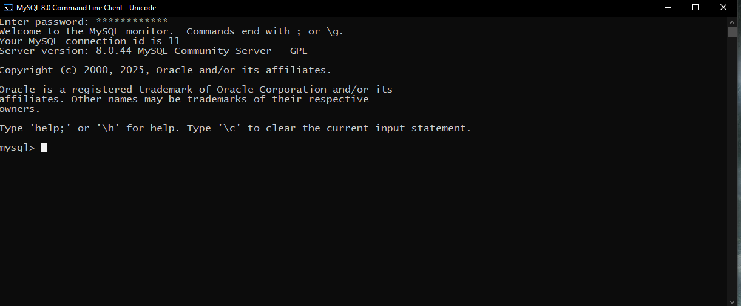

Screenshot 2: SHOW DATABASES Output
