Module 7.2 – Movies Table Queries
Name: Noor Al Salihi
CSD 310
11/27/2025

Screenshot 1 – Python Code (movies_queries.py)
This screenshot displays the entire Python code for the assignment. It accesses the MySQL 'movies' database with MySQL. The connector executes all four queries, cleanly prints the output in a readable format, the database is correctly set up and queried, and the results are formatted correctly.
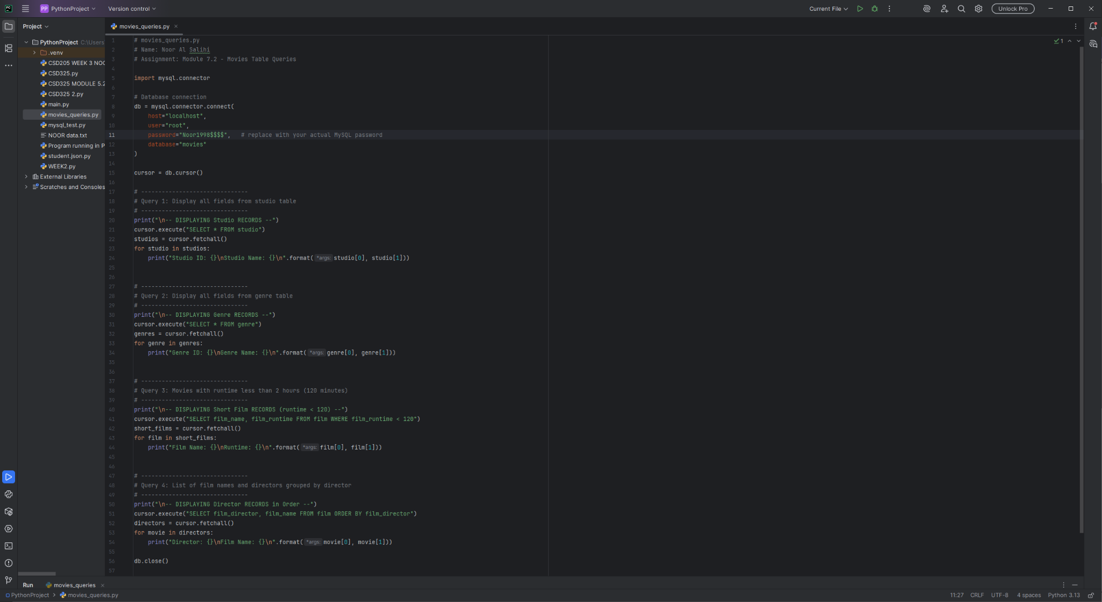

Screenshot 2 – Program Output
Screenshot for all the expected output from running movies_queries.py:
- list all studio table records
- list all genre table records
- list all movies with a runtime less than 120 minutes
- list all directors and their movies in alphabetical order
Since the above is outputted to the screen, we can see the Python script connected to the movies database on MySQL and gave us the expected results.