Module 5.2 – MySQL Functions
Name: Noor Al Salihi
Assignment: Module 5 – MySQL Functions
Date: 11/12/2025

Function 1: CURRENT_DATE()
Used to retrieve today's date. Useful for timestamping logs, reports, and daily records.
SQL Statement:
SELECT CURRENT_DATE() AS 'Today\'s_Date';
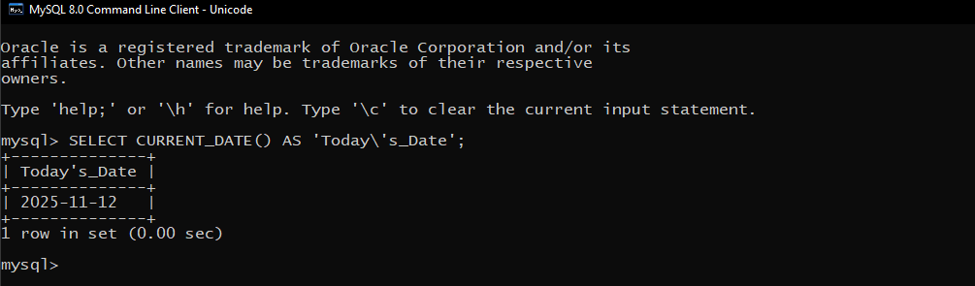

Function 2: UPPER()
Used to convert text to uppercase. Useful for standardizing formatting in names, titles, or codes.
SQL Statement:
SELECT UPPER('noor al salihi') AS Uppercase_Name;
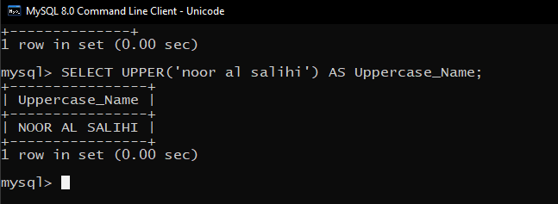

Function 3: LENGTH()
Used to return the length of a string. Helpful for validating password length or checking text size.
SQL Statement:
SELECT LENGTH('Cybersecurity') AS Word_Length;
