Module 6.2 Assignment – Noor Al Salihi
Name: Noor Al Salihi
Course: CSD-310
Assignment: Module 6.2 – Movies: Setup
Date: November 20, 2025

Screenshot #1 – Running SQL Script
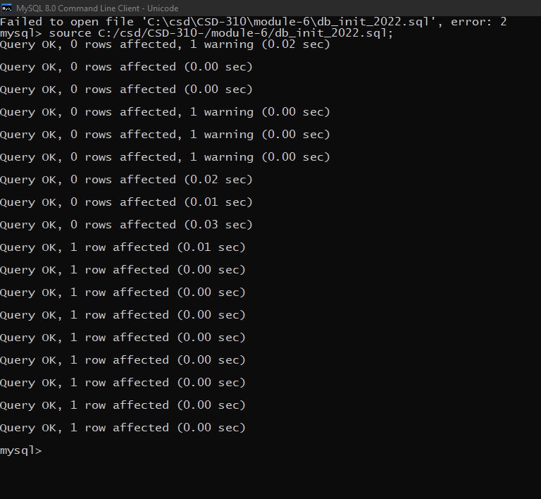

Screenshot #2 – SHOW TABLES Output
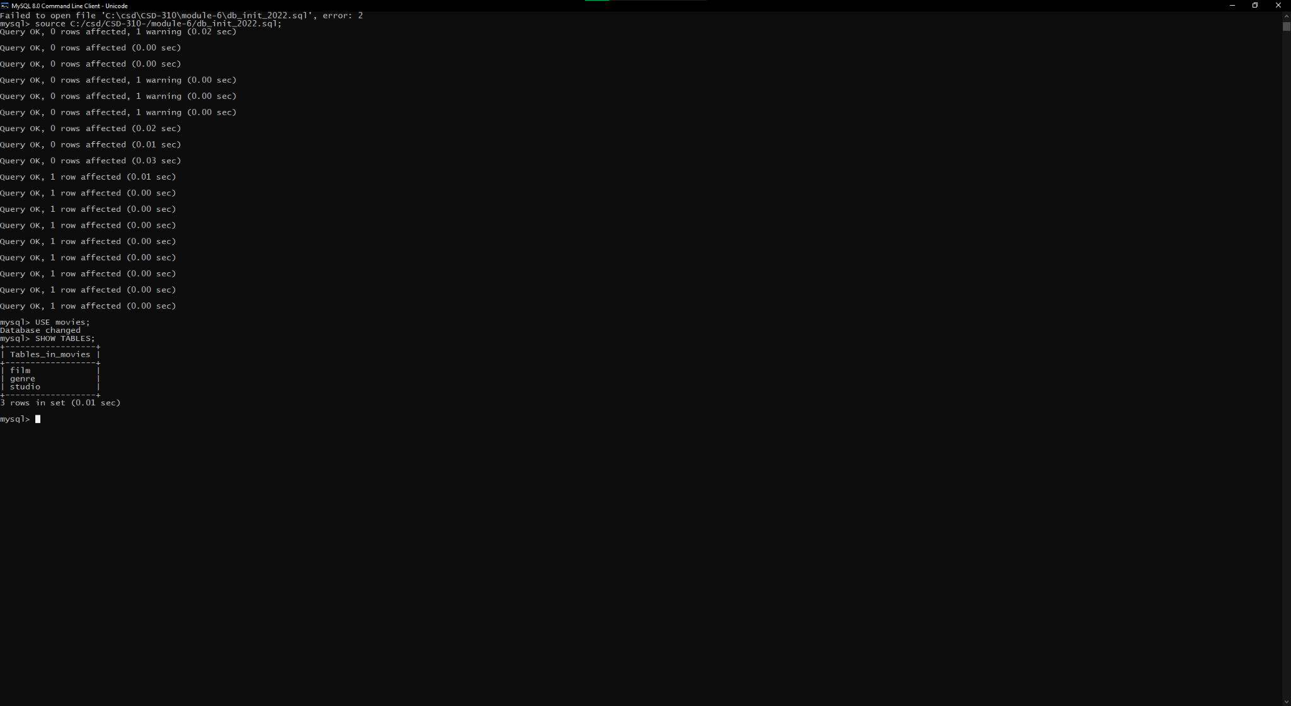

Screenshot #3 – mysql_test.py Successful Connection
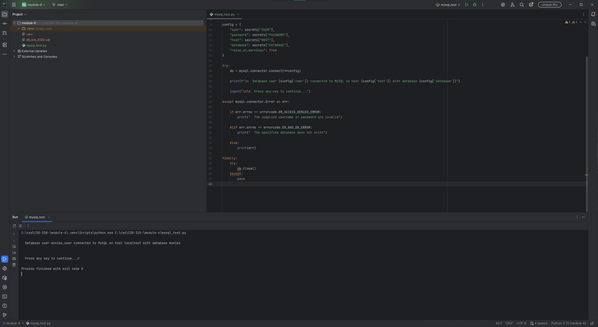

GitHub Repository Link
https://github.com/nalsali98/CSD-310-.git

