# Noor Al Salihi

Module 2.2 – Visual Paradigm ERD  
CSD-310

10/30/2025

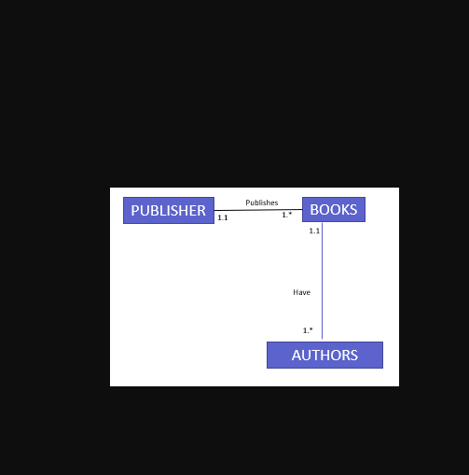

Figure 1. Entity-Relationship Diagram (ERD) showing relationships among Publisher, Books, and Authors.