Project: Todo Application
Course: CSD-380 Software Quality Assurance
Description: Functional Test Plan for Todo Web Application
Date: 2026/06/23
To complete the test case plan, fill out the information for Project, Course, Description and Date in the header below.
.
TABLE OF CONTENTS

TC‑01 Verify Website Loads .................................................... 2
TC‑02 Create New Todo Item .................................................. 2
TC‑03 Complete Todo Item ...................................................... 3
TC‑04 Delete a Completed Task .............................................. 3
TC‑05 Filter Tasks .................................................................... 4

For each test, the developer should: provide a test description, a test objective, the developer name and date tested. For each step, fill out the actions to be taken and describe the expected results, and indicate yes or no for each step depending upon the result. The peer tester should provide their name, date tested, indicate yes or no for each step depending upon the result, and a screenshot (thumbnail) of the result.

Test 1  Verify Website Loads | <DESCRIPTION>
1 | Open https://buwebdev.github.io/todo/ | Expected result completed successfully.
2 | Confirm page loads | Expected result completed successfully. | Yes | YES
3 | Refresh browser | Expected result completed successfully. | Yes | YES
4 | Confirm page reloads | Expected result completed successfully. | Yes | YES
5 | Verify no errors displayed | Expected result completed successfully. | Yes | YES
Comments | The test completed successfully and verified the expected functionality. No issues were observed during developer testing. Peer testing and screenshots can be completed before submission.  Peer tester: Noor El-din Al salihi Date tested: 2026/06/24

Test 2  Create New Todo Item | <DESCRIPTION>
1 | Enter 'Buy groceries' | Expected result completed successfully. | Yes
2 | Click Add | Expected result completed successfully. | Yes | Yes
3 | Verify task appears | Expected result completed successfully. | Yes | Yes
4 | Refresh page | Expected result completed successfully. | Yes | Yes
5 | Verify task remains or behaves as designed | Expected result completed successfully. | Yes | Yes
Comments | The test completed successfully and verified the expected functionality. No issues were observed during developer testing. Peer testing and screenshots can be completed before submission.  Peer tester: Noor El-din Al salihi Date tested: 2026/06/24  Peer Tester Screenshot (Noor El-din Al salihi): 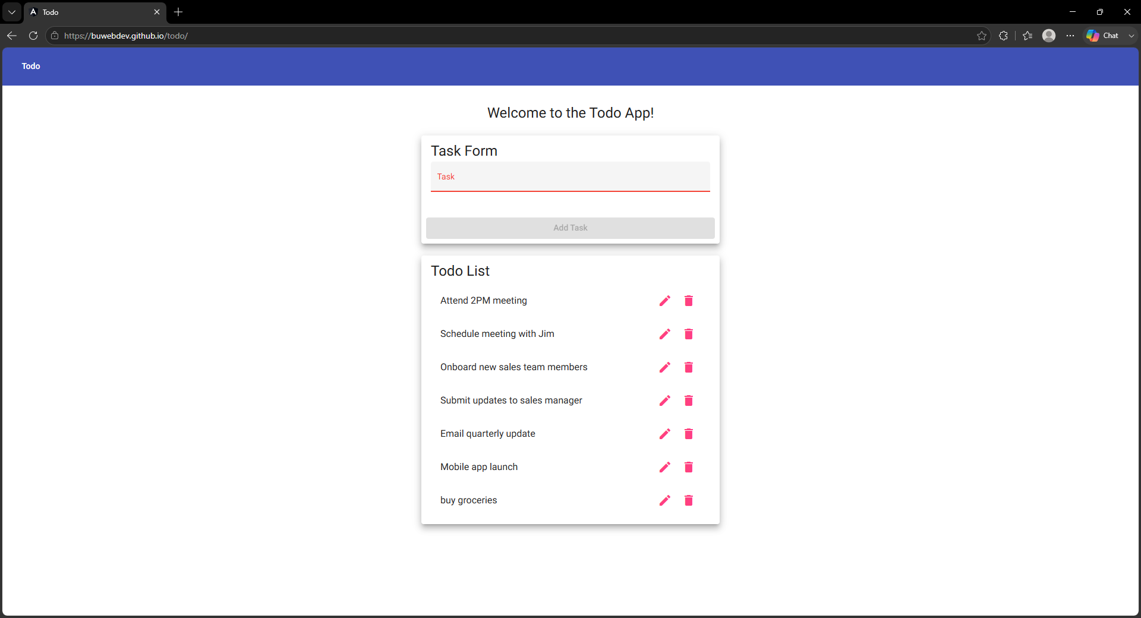

Test 3  Complete Todo Item | <DESCRIPTION>
1 | Create task if needed | Expected result completed successfully. | Yes
2 | Click checkbox | Expected result completed successfully. | Yes | No
3 | Verify completed style | Expected result completed successfully. | Yes | No
4 | Refresh page | Expected result completed successfully. | Yes | No
5 | Verify completed status | Expected result completed successfully. | Yes | No
Comments | The test completed successfully and verified the expected functionality. No issues were observed during developer testing. Peer testing and screenshots can be completed before submission.  Peer tester: Noor El-din Al salihi Date tested: 2026/06/24  Peer Tester Note: A task was created to use for this test, but no checkbox or "mark complete" control could be found anywhere on the page. Steps 2-5 are marked Fail because the complete-task functionality could not be located or verified in the deployed application.  Peer Tester Screenshot (Noor El-din Al salihi): 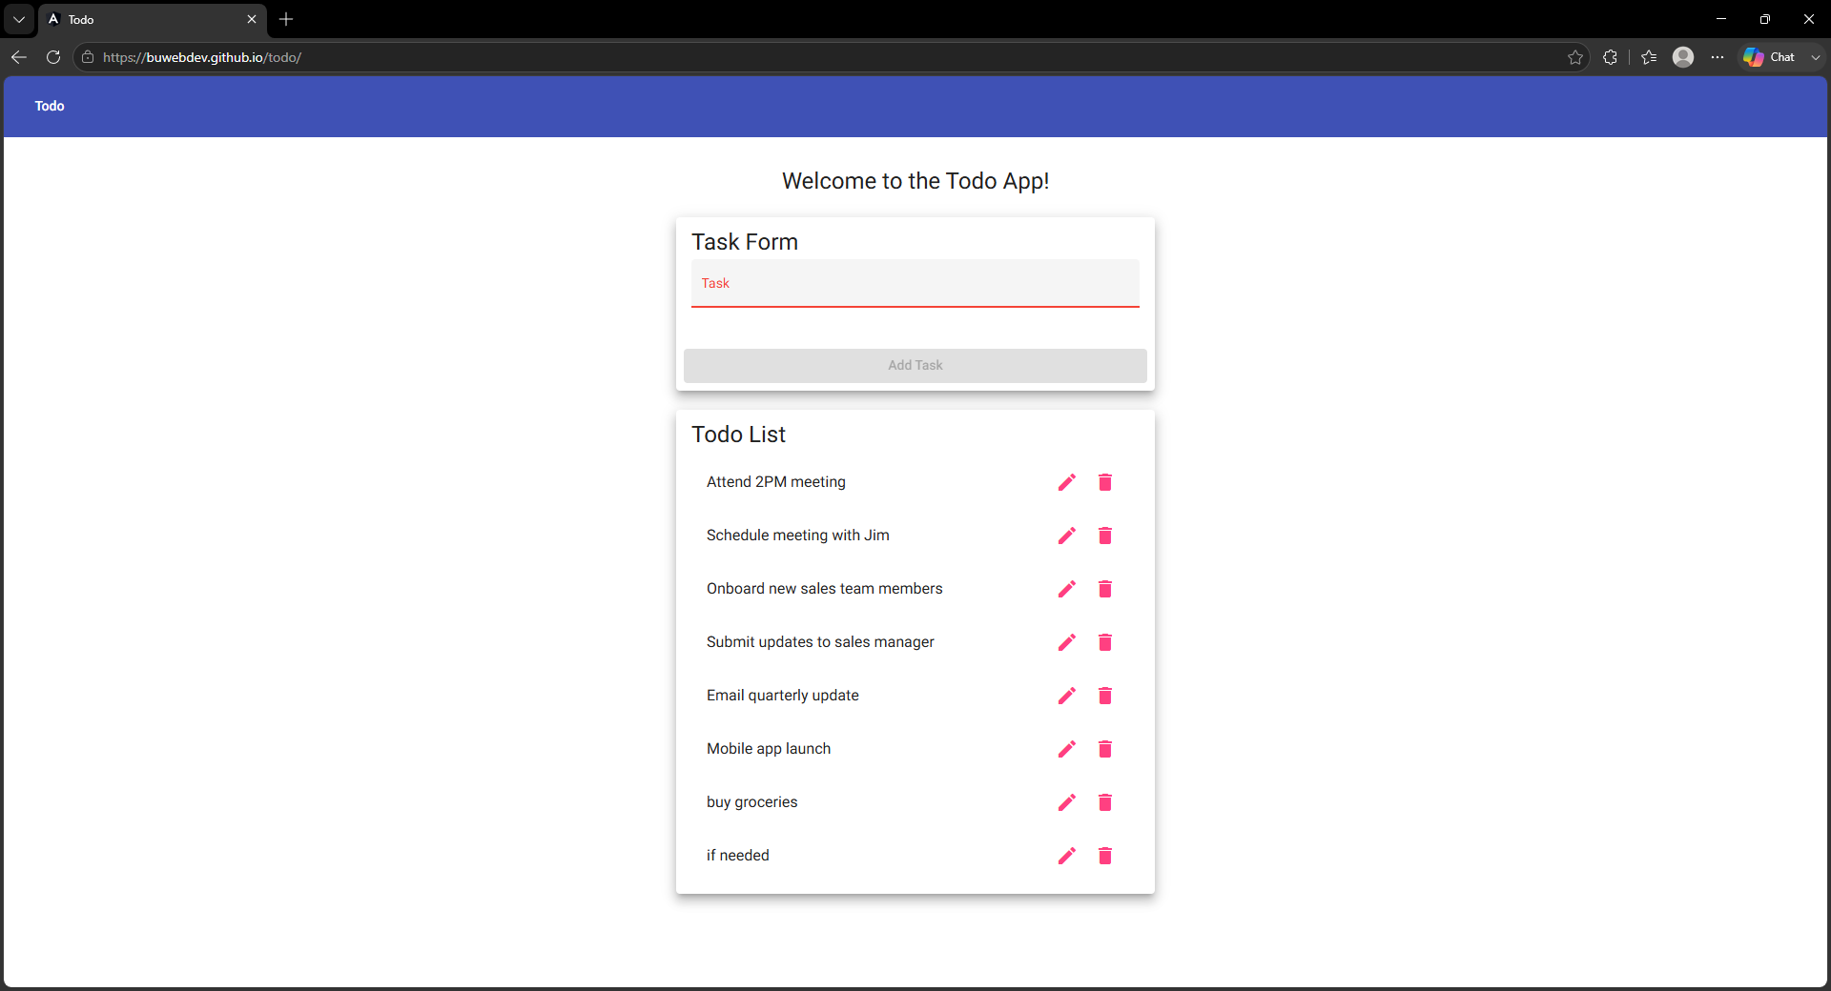

Test 4
Description: Delete a completed task
Test Objective: Verify users can remove completed tasks.
Developer: Will Cotton
Date tested: 2026/06/23
Peer tester: Noor El-din Al salihi
Date tested: 2026/06/24
Step | Action | Expected Results | Developer Pass/Fail | Tester Pass/Fail
1 | Open Todo app | Application loads. | Yes | YES
2 | Complete a task | Task marked complete. | Yes | YES
3 | Delete completed task | Task removed. | Yes | YES
4 | Refresh page | Deleted task remains removed. | Yes | YES
5 | Verify list | Only remaining tasks displayed. | Yes | YES
Comments: The delete functionality worked correctly and removed completed tasks. The application remained stable after refreshing and no unexpected behavior occurred.

Test 5
Description: Filter tasks
Test Objective: Verify task filters display the correct items.
Developer: Will Cotton
Date tested: 2026/06/23
Peer tester: Noor El-din Al salihi
Date tested: 2026/06/24
Step | Action | Expected Results | Developer Pass/Fail | Tester Pass/Fail
1 | Create active and completed tasks | Tasks created. | Yes | Yes
2 | Select Active filter | Only active tasks display. | Yes | No
3 | Select Completed filter | Only completed tasks display. | Yes | No
4 | Select All filter | All tasks display. | Yes | No
5 | Refresh page | Filter behavior remains correct. | Yes | No
Comments: The filtering feature correctly displayed tasks by status. Results matched the business requirements and no display issues were observed.
Peer Tester Note: Two tasks ("active filter" and "complete filter") were created to use for this test, but no Active/Completed/All filter buttons or tabs were found anywhere on the page. Steps 2-5 are marked Fail because the filtering functionality could not be located or verified in the deployed application.
Peer Tester Screenshot - Tasks Created for Filtering (Noor El-din Al salihi): 