Project: ToDo application Test Plan
Course: CSD380-340A - DevOps
Description: Five functional test cases covering ToDo application features
Date: 2026/06/24
To complete the test case plan, fill out the information for Project, Course, Description and Date in the header below.
.
TABLE OF CONTENTS
Website Access and Task List 2
Create Task 3
Edit Task 4
Delete Task 5
Invalid URL Page 6

Test 1 | Website Access and Task List
 | Test Objective: Verify that the standard URL opens the landing page and displays the existing Todo list. | Developer:  Date tested: 2026/06/24 | Peer tester: Noor El-din Al salihi  Date tested: 2026/06/24
Step | Action | Expected results: | Developer pass/fail | Tester pass/fail  + Screenshot
1 | Enter the web address https://buwebdev.github.io/todo/ in browser address bar | The ToDo Webapp loads in browser | Yes | Yes
2 | Confirm the landing page displays "Welcome to the Todo App!", the Task Form, and the Todo List. | All required landing-page sections and elements are visible and readable. | Yes | Yes
3 | Review the Todo List and the controls beside each item. | Existing task items appear, and each item has edit and delete controls. | Yes | Yes
4 | Refresh the browser window | The page reloads correctly, and the landing page and task list display again without errors. | Yes | Yes
Comments | Web application and all elements appear to load correctly. Browser refreshes correctly when refreshed. 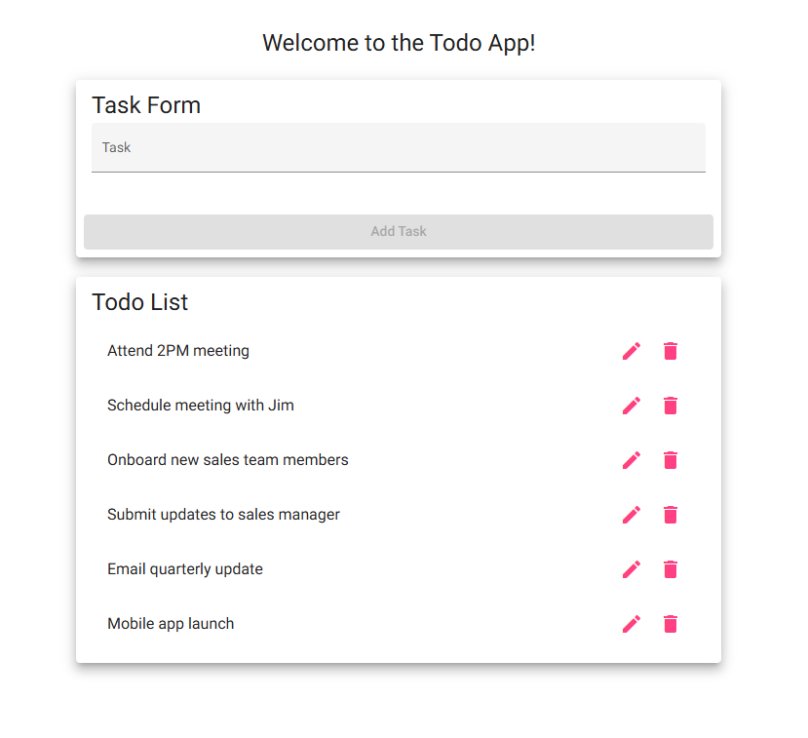  Peer Tester Screenshot (Noor El-din Al salihi): 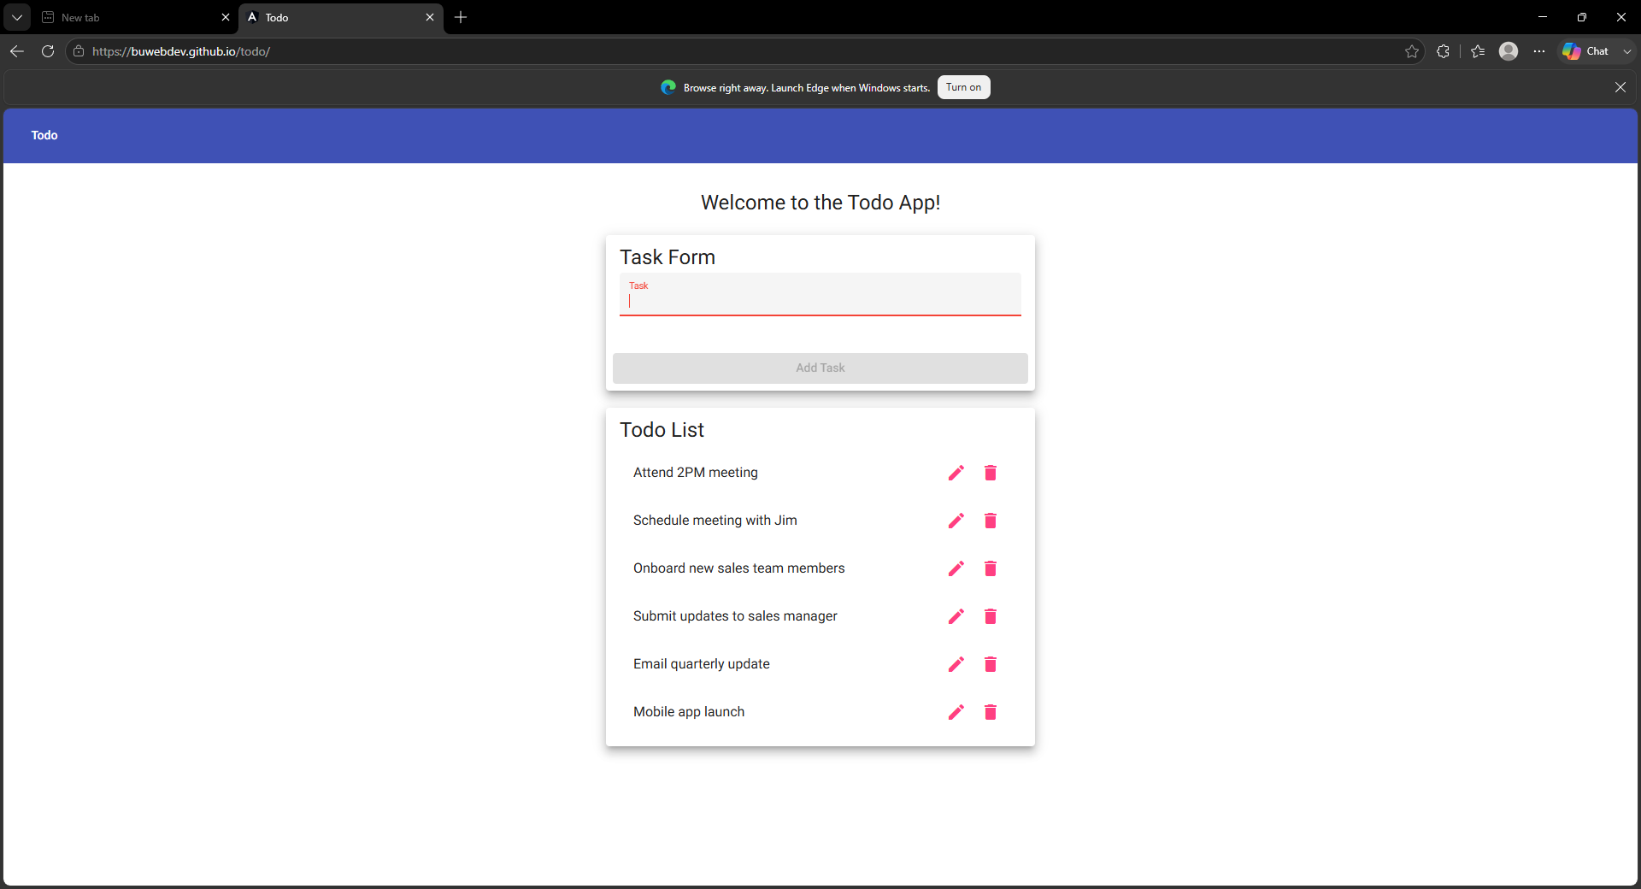

Test 2 | Create Task
 | Test Objective: Verify that a user can create a task and cannot submit the task form while it is blank. | Developer:  Date tested: 2026/06/24 | Peer tester: Noor El-din Al salihi  Date tested: 2026/06/24
Step | Action | Expected results: | Developer pass/fail | Tester pass/fail
1 | Open the Todo website and leave the Task field blank. | The Add Task button is disabled while the Task field is blank. | Yes | Yes
2 | Try to submit the blank Task form. | No blank item is added to the Todo List. | Yes | Yes
3 | Enter "Complete CSD 380 test plan" in the Task field. | The text appears in the field, and the Add Task button becomes enabled. | Yes | Yes
4 | Select Add Task. | A new Todo item named "Complete CSD 380 test plan" is added once to the list. | Yes | Yes
5 | Review the new item and the rest of the list. | The new item is visible, the input field is cleared, and the existing items remain unchanged. | Yes | Yes
Comments | The " Add Task button” remains blocked while a new task form is empty. Once a task is written, the add task button becomes interactive. The new task is correctly added to the list once the button is pressed.  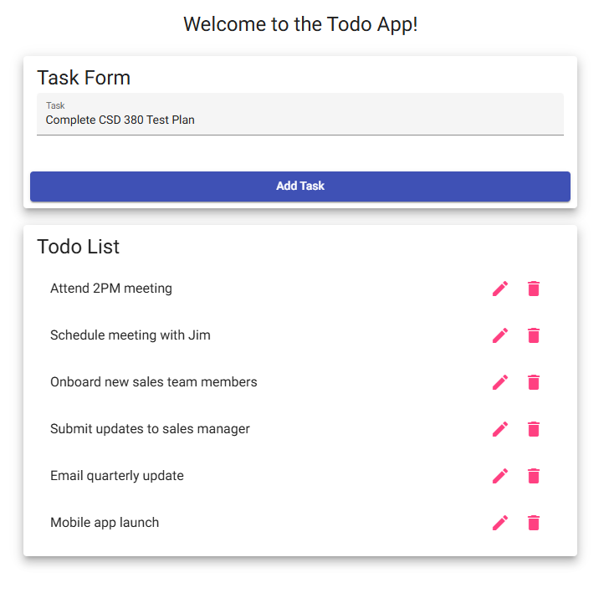  Peer Tester Screenshot (Noor El-din Al salihi): 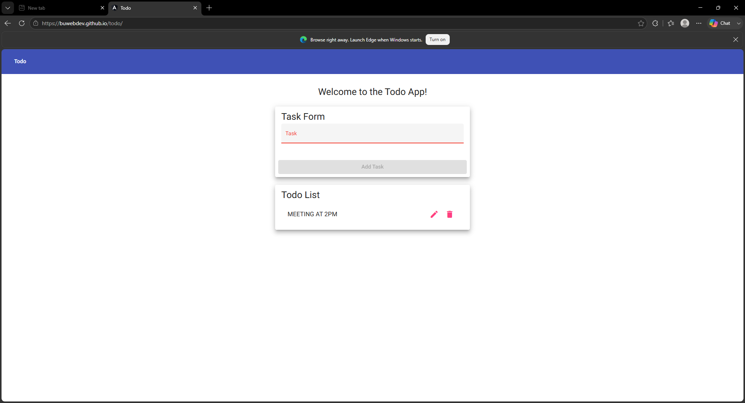  Peer Tester Screenshot - Task Added (Noor El-din Al salihi): 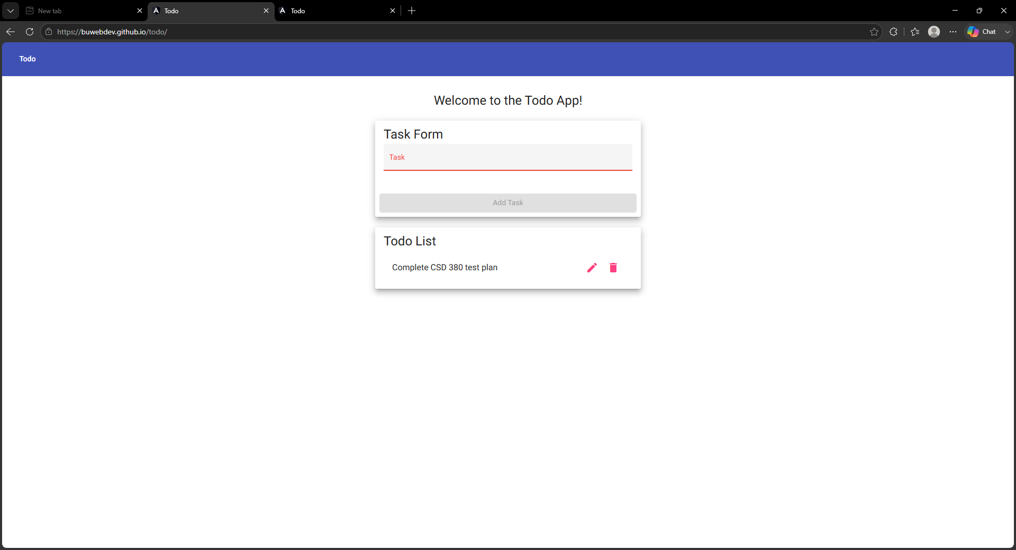

Test 3 | Edit Task
 | Test Objective: Verify that a user can edit a task and cannot save the edit form without task text. | Developer:  Date tested: 2026/06/24 | Peer tester: Noor El-din Al salihi  Date tested: 2026/06/24
Step | Action | Expected results: | Developer pass/fail | Tester pass/fail
1 | Select the edit icon beside "Complete CSD 380 test plan." | The Edit Form opens and displays the current task text. | Yes | Yes
2 | Delete all text from the edit field. | The field becomes blank, and the application should prevent a blank update. | No | No
3 | Select Save while the edit field is blank. | The blank value is not saved, and the original task remains unchanged. | No | No
4 | Enter "Complete and submit CSD 380 test plan" in the edit field. | The replacement text appears and is ready to save. | Yes | Yes
5 | Select Save and review the Todo List. | The Edit Form closes, the updated text appears, and the old text no longer appears. | Yes | Yes
Comments | The edit feature works as intended. However, the user can add and save blank text, resulting in a blank task appearing in the list. The save option should be disabled when no text is present.  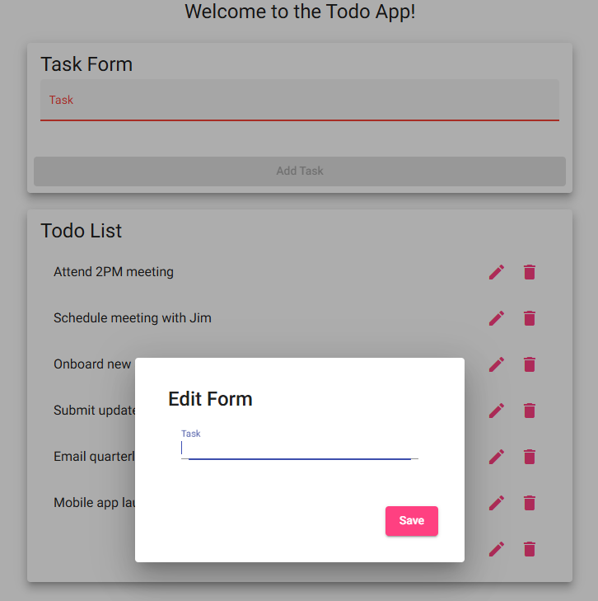  Peer Tester Screenshot (Noor El-din Al salihi): 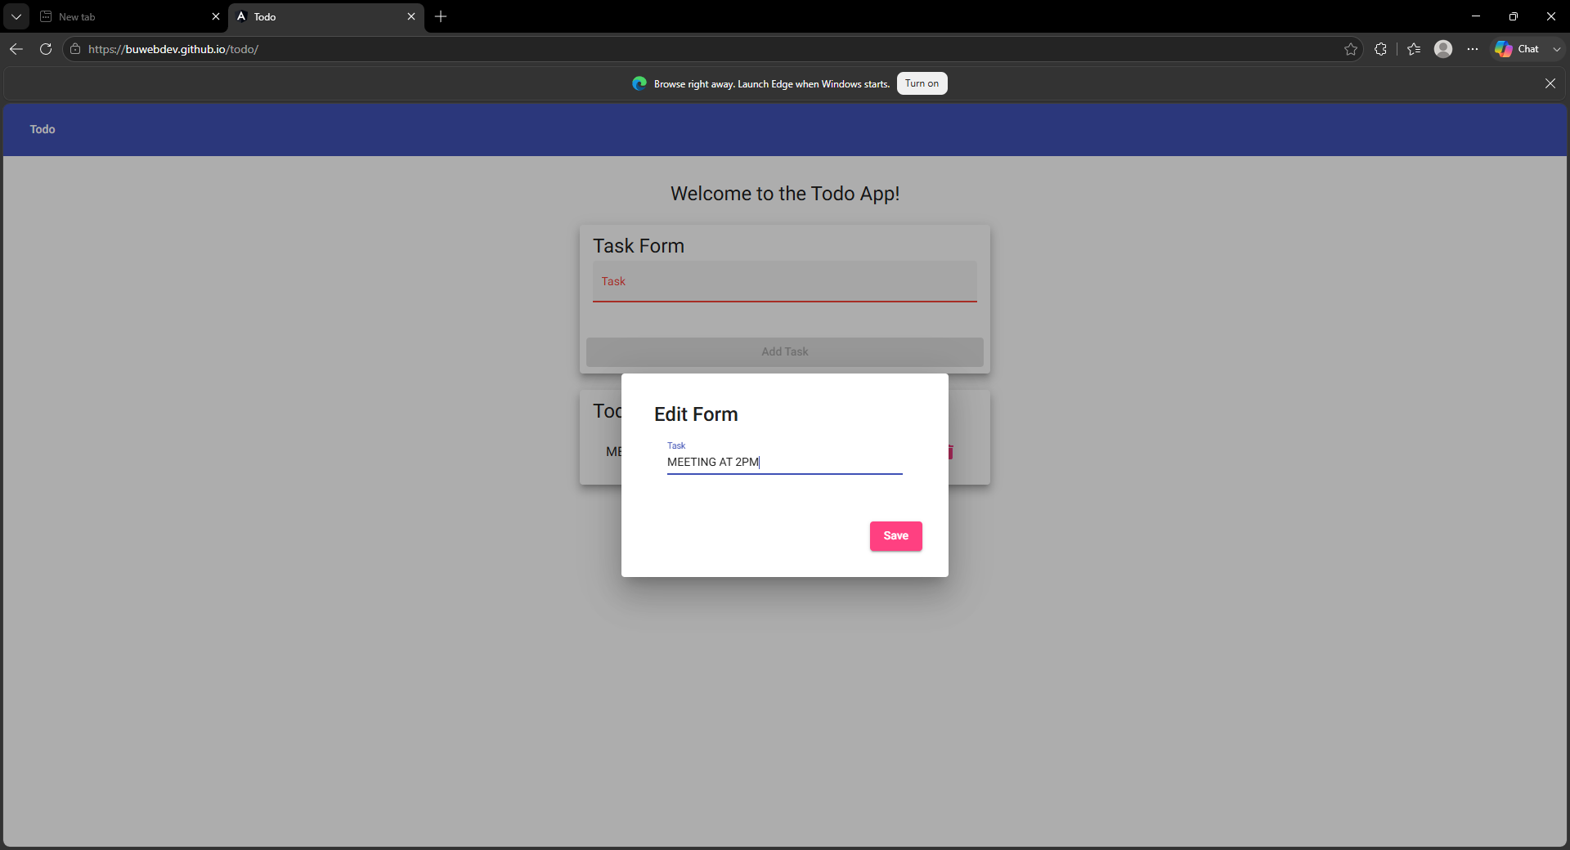  Peer Tester Note: Confirmed during peer testing — clearing the edit field and selecting Save does not block the blank update, and Save remains enabled with no text present. This matches the developer’s finding and should be addressed before the form validation is considered complete.  Peer Tester Screenshot - Edit Saved (Noor El-din Al salihi): 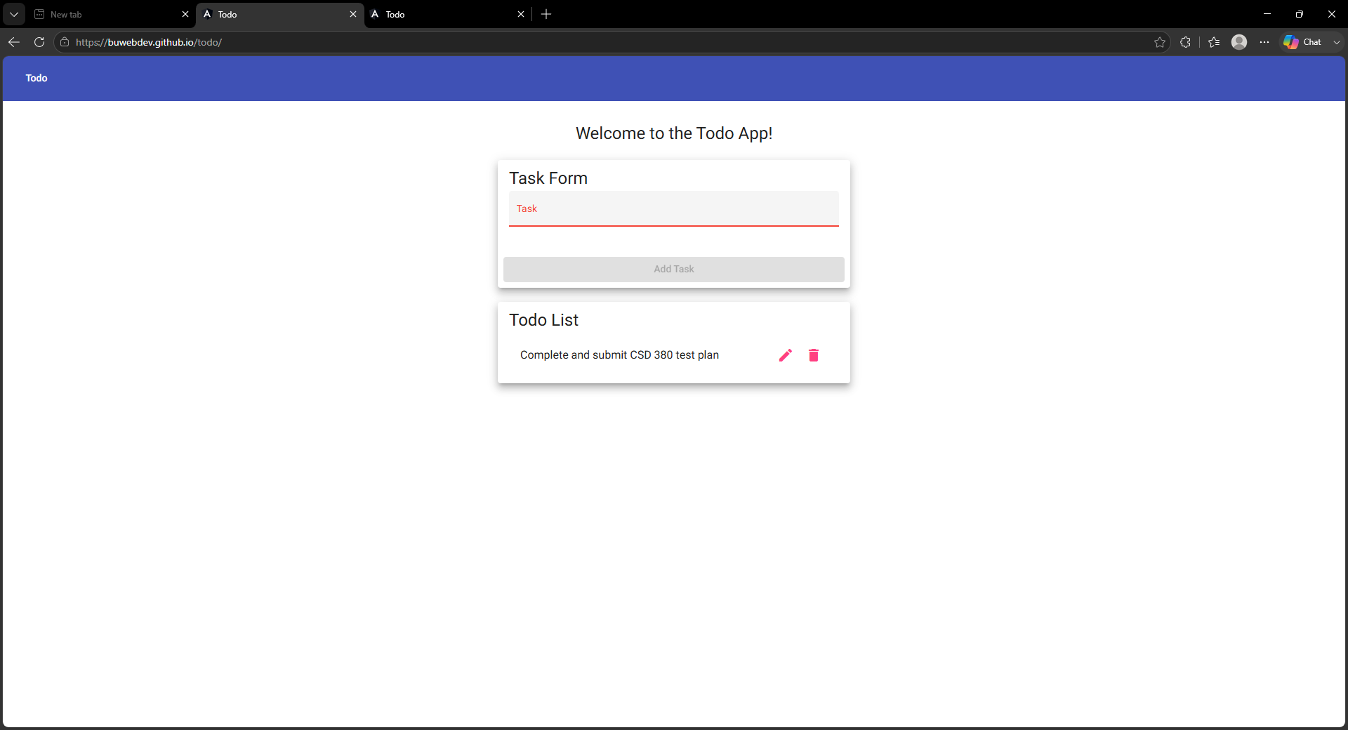

Test 4 | Delete Task
 | Test Objective: Verify that a user can delete a selected Todo item without changing other items. | Developer:  Date tested: 2026/06/24 | Peer tester: Noor El-din Al salihi  Date tested: 2026/06/24
Step | Action | Expected results: | Developer pass/fail | Tester pass/fail
1 | Locate "Complete and submit CSD 380 test plan" in the Todo List. | The edited task is visible with a delete control. | Yes | Yes
2 | Select the delete icon beside the edited task. | The selected delete action is processed. | Yes | Yes
3 | Review the Todo List for the deleted task. | The selected task no longer appears in the list. | Yes | Yes
Comments | The delete function works as intended, and all tasks in the list can be removed.  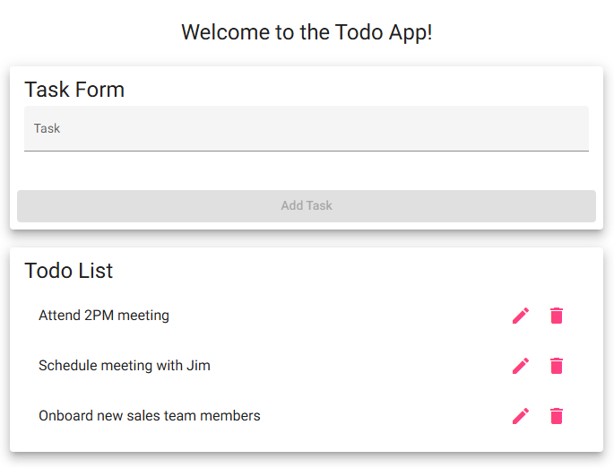  Peer Tester Screenshot (Noor El-din Al salihi): 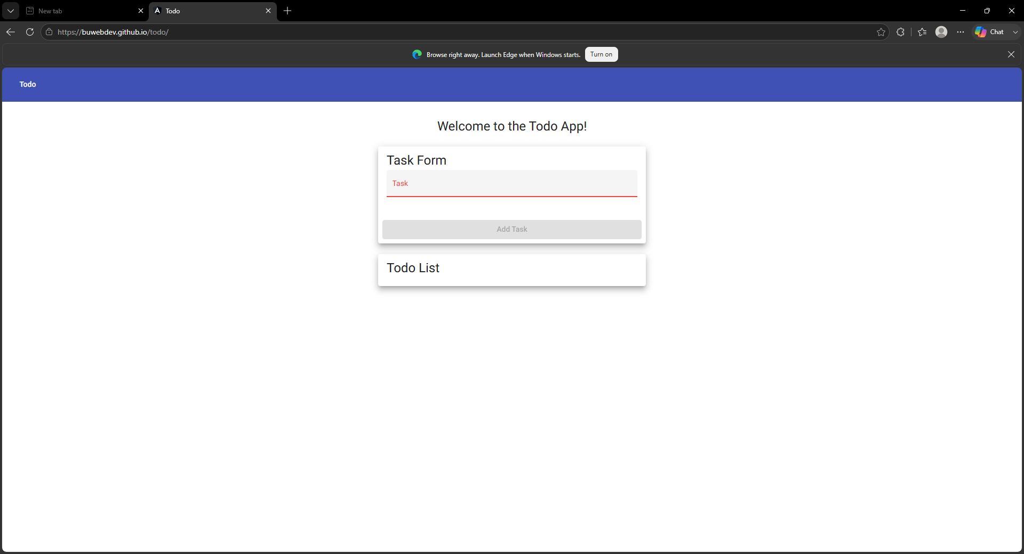

Test 5 | Invalid URL Page
 | Test Objective: Verify that an invalid application URL displays the custom not-found page and that the user can return to the application. | Developer:  Date tested: 2026/06/24 | Peer tester: Noor El-din Al salihi  Date tested: 2026/06/24
Step | Action | Expected results: | Developer pass/fail | Tester pass/fail
1 | Open a new browser tab. | A new blank tab opens without affecting the current Todo page. | Yes | Yes
2 | Enter https://buwebdev.github.io/todo/not-a-real-page and press Enter. | The invalid application URL is requested. | Yes | Yes
3 | Review the page displayed for the invalid URL. | A custom not-found message appears instead of the normal Todo landing page. | Yes | Yes
4 | Confirm the page does not display a blank screen or an unhandled application error. | The error state is understandable and presented as a page within the application experience. | Yes | Yes
5 | Return to https://buwebdev.github.io/todo/. | The standard Todo landing page loads correctly again. | Yes | Yes
Comments | Page with custom not found text is displayed correctly when an invalid URL is entered.  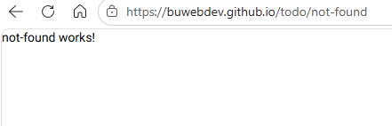  Peer Tester Screenshot (Noor El-din Al salihi): 