Noor El-din Al Salihi
CSD380-340A DevOps (2267-DD)
Module 5.2 Assignment
Value Stream Mapping (VSM)

Value Stream Mapping in Everyday Life
The New-Graduate Job Application Process
CSD380-340A DevOps (2267-DD) • Module 5.2 Assignment
Introduction and Example Selection
The article “3 Easy Steps for Using VSM in Everyday Life” proves that value stream mapping can be applied to any repeatable process, as long as the beginning, end, and customer can be defined. I chose to map the process of applying for a job as a software developer, something I will continually be doing as a new graduate. The value stream starts when I find a job posting and ends when a completed, customized application is verified as submitted to the employer’s ATS. The customer for this value stream would be the employer who will receive my application, and the value would be a completed, correct, customized application packet.

The span of time being mapped is one application cycle. For me, right now, this takes approximately four calendar days per application. I plan to send out several applications per week, so small flaws in this process add up quickly, making it perfect for lean mapping.

Step 1 — Identify the Value Stream

The second step in the article’s process instructed me to then list every task between trigger and delivery of value – completing and confirmed job application submission. There were five phases of the process:
• Find and review job posting – read requirements and determine worthiness of applying.
• Customize resume – rewrite resume bullets and rearrange skills to fit job posting, using a general resume as a starting point every time.
• Compose cover letter – written from scratch every time.
• Enter into ATS portal – manually enter work history, education, and contact information already compiled on resume.
• Submit application and verify – one last review, submit, and save confirmation email to coach’sSent folder.
Between each step, the application does nothing but wait. Posts get saved “for later,” my resume waits while I dilly-dally writing a cover letter, and completed materials sit until I decide to battle the portal again. These waiting periods are bureaucracy’s equivalent to work-in-process inventory.

Step 2 — Map the Current State
The current-state map below follows conventional VSM symbols: process boxes that store data (Process Time and Percent Complete & Accurate), inventory triangles indicating queued waiting, dashed lines represent information flows, and a timeline ladder with value-added process time on the bottom rail and non-value added wait time on the top rail.

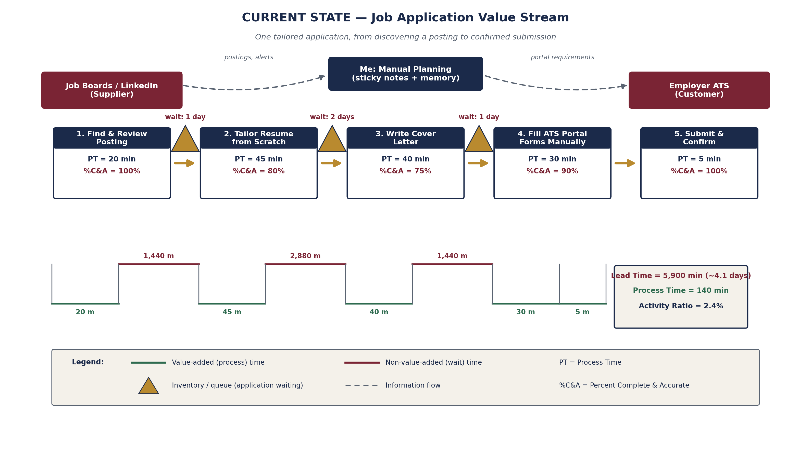
Figure 1. Current-state value stream map for one job application cycle.

Step 3 — Analyze the Lean Metrics
The following table decomposes the current state by step. PT stands for Process Time or hands-on working time; Wait Time is the queue time prior to the step starting; %C&A is the percentage of work that arrives at the next step Complete and Accurate (thus not requiring re-work). For example, if a resume were customized for a specific job (making it complete at that step) but then had to be re-edited because it didn't include a keyword, it would score less than 100% C&A.
Process Step | Process Time | Wait Time Before Step | %C&A | Value Type
1. Find and review the posting | 20 min | — | 100% | VA
2. Tailor a resume from scratch | 45 min | 1,440 min (1 day) | 80% | VA / NVA mix
3. Write a cover letter | 40 min | 2,880 min (2 days) | 75% | VA / NVA mix
4. Fill ATS portal forms manually | 30 min | 1,440 min (1 day) | 90% | NNVA
5. Submit and confirm | 5 min | — | 100% | VA
Totals | 140 min | 5,760 min | Rolled: 54%

Key Lean Calculations
- Total Lead Time (LT) = wait time + process time = 5,760 + 140 = 5,900 minutes (≈ 4.1 days).
- Total Process Time (PT) = 140 minutes (≈ 2.3 hours of actual work).
- Activity Ratio = PT ÷ LT = 140 ÷ 5,900 = 2.4%. Only 2.4% of the elapsed time adds value; the application spends 97.6% of its life waiting.
- Rolled %C&A = 100% × 80% × 75% × 90% × 100% ≈ 54%. Nearly half of all applications require some form of rework before submission.

Waste Identified (DOWNTIME)

• Waiting — 5760 minutes of queue time spent waiting is the largest block of time in the stream. The longest single wait is the two days between when I decided to apply and when I actually started writing the cover letter.
• Over-processing — creating the resume from scratch for each posting rather than building it from blocks I know work.
• Motion/transportation — retyping data into ATS resume portals that support data import.
• Defects — the 75–80% C&As for writing activities are rework. Whether typos caught late in the game, mismatched keywords, or using a stock sentence that mentioned the wrong company name from previous paste-uselessly spent time fixing mistakes.
• Inventory — job postings accumulate into my “saved jobs” queue with no WIP restriction, causing promising postings to expire before I can apply.

Optimizing the Process — Future State
The future-state design addresses the two biggest problems highlighted by the metrics: waiting (97.6% of lead time) and over-processing/ rework (rolled %C&A of 54%). Three kaizen opportunities, represented as improvement bursts on the map above, made these changes possible:
• Master resume with modular sections — instead of re-authoring my resume and cover letter for each application, I created a library of pre-written, proofread bullet points for every skill I might want to include. Tailoring came down to selection and light editing (30 minutes) vs. authoring from scratch (85 minutes across resume + letter), and re-using proven language raised %C&A to 95%.
• Browser autofill profile — saved work history, education, and contact data cut ATS form entry time from 30 minutes down to 10 and virtually eliminated re-typing defects (98% C&A).
• Daily one-hour application block with kanban pull system — a Trello board with WIP limit of three postings. Rather than stuffing postings into an unlimited “saved” queue, I pull one posting at a time and work it through all four steps in the same sitting. There are no more multi-day waits.
Changes to triage and submission also combine review steps that were previously duplicated, streamlining that portion from five steps down to four.
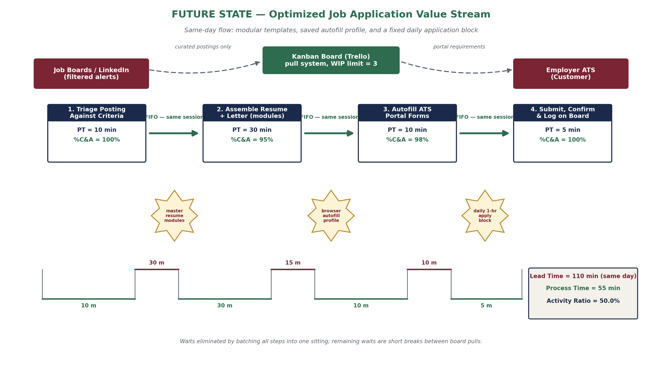
Figure 2. Future-state value stream map with kaizen bursts and same-day flow.

Results — Current vs. Future State
Lean Metric | Current State | Future State | Change
Lead Time (LT) | 5,900 min (~4.1 days) | 110 min (same day) | −98%
Process Time (PT) | 140 min | 55 min | −61%
Activity Ratio (PT/LT) | 2.4% | 50.0% | +47.6 pts
Rolled %C&A | 54% | 93% | +39 pts
Number of process steps | 5 | 4 | −1
Throughput (applications/week) | ~2 | 6–8 | 3–4×

Lead time decreases from approximately four days down to less than two hours (moving from multi session to single session work) and activity % increases from 2.4% to 50%. Even Process time decreases by 61% through reuse and automation—not by skimping—quality also increases with rolled %C&A increasing from 54% to 93%. Think about the benefits of the thought. For the same weekly effort, I went from producing about two apps to six to eight. That triples my exposure to opportunity, and each app arrives completer and more accurate than ever before..
Conclusion
Mapping something as simple as your everyday work uncovered a hidden issue: I thought applications take a long time because they’re difficult to work on, but the map showed me the work takes approximately two hours—the remaining four days consist of waiting and rework. This is analogous to what a VSM uncovers in typical DevOps value streams. Much of your code is waiting in queues (review, approvals, deployment windows) far longer than it’s being actively worked on. The same lean countermeasures we discussed—standardized components, automating manual data processes, limiting batch sizes, WIP-limited pull systems—are all techniques advocated by The DevOps Handbook to improve your technology value streams.
Reference
- Broadcom. (n.d.). 3 easy steps for using VSM in everyday life. ConnectALL. https://www.connectall.com/blog/3-easy-steps-for-using-vsm-in-everyday-life/

- Kim, G., Humble, J., Debois, P., & Willis, J. (2021). The DevOps handbook: How to create world-class agility, reliability, & security in technology organizations (2nd ed.). IT Revolution.

- Rother, M., & Shook, J. (2003). Learning to see: Value stream mapping to add value and eliminate muda (Version 1.4). Lean Enterprise Institute.

