Module 9 – API Assignment
Name: Noor Al Salihi
CSD-325
11/27/2025

1. Google API Connection Test
This program tests a simple HTTP connection using the requests library. A status code of 200 confirms a successful connection.
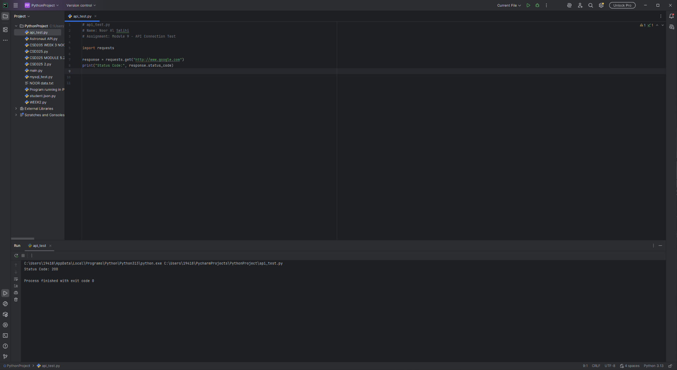

2. Astronaut API Program
This program retrieves current astronauts in space, shows the raw JSON response, and prints formatted output listing all astronauts.
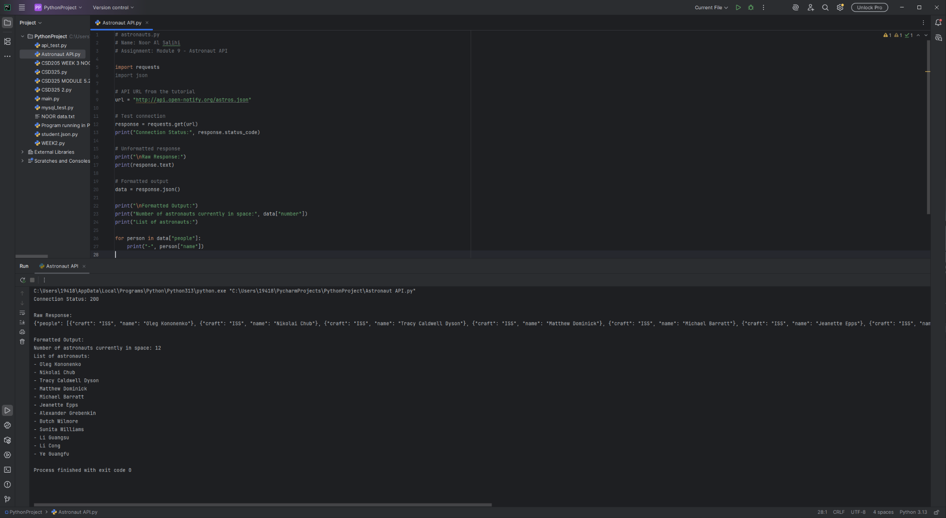

3. Custom API Program – Cat Facts API
This program uses the Cat Facts API to fetch a random fact. It prints the raw response and a formatted version of the fact.
