NOOR A AL
CSD 325 MODULE 7.2
11/20/2025

Final Code: city_functions.py
def city_country(city, country, population=None, language=None):
text = f"{city.title()}, {country.title()}"
if population:
text += f" - population {population}"
if language:
text += f", {language.title()}"
return text
# Final required calls (3 calls)
print(city_country("santiago", "chile"))
print(city_country("seattle", "united states", 750000))
print(city_country("dubai", "uae", 3300000, "arabic"))

Final Code: test_cities.py
import unittest
from city_functions import city_country
class CityTestCase(unittest.TestCase):
def test_city_country(self):
result = city_country("santiago", "chile")
self.assertEqual(result, "Santiago, Chile")
if __name__ == "__main__":
unittest.main()

Screenshots

Screenshot 1: First run of city_functions.py (City + Country only)
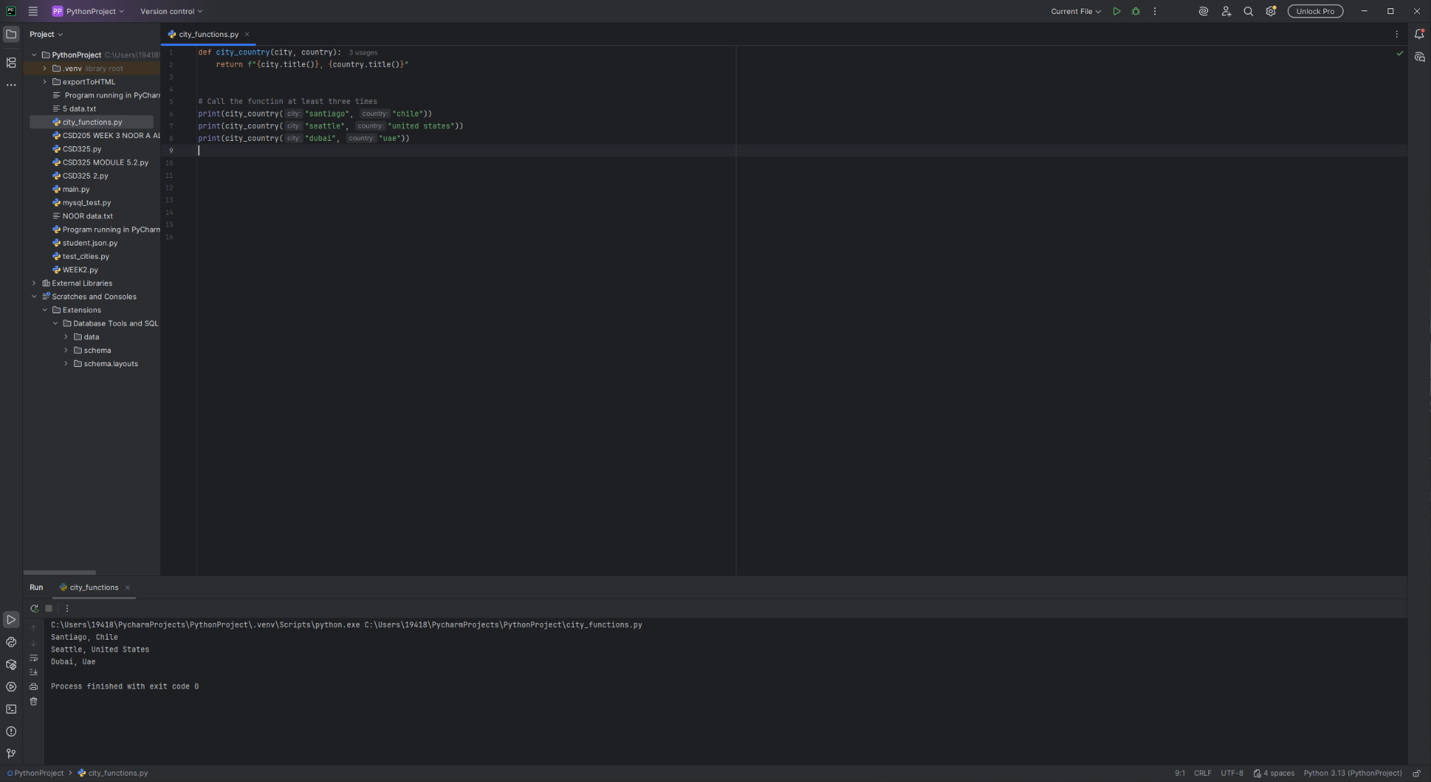

Screenshot 2: Test Passed (initial function)
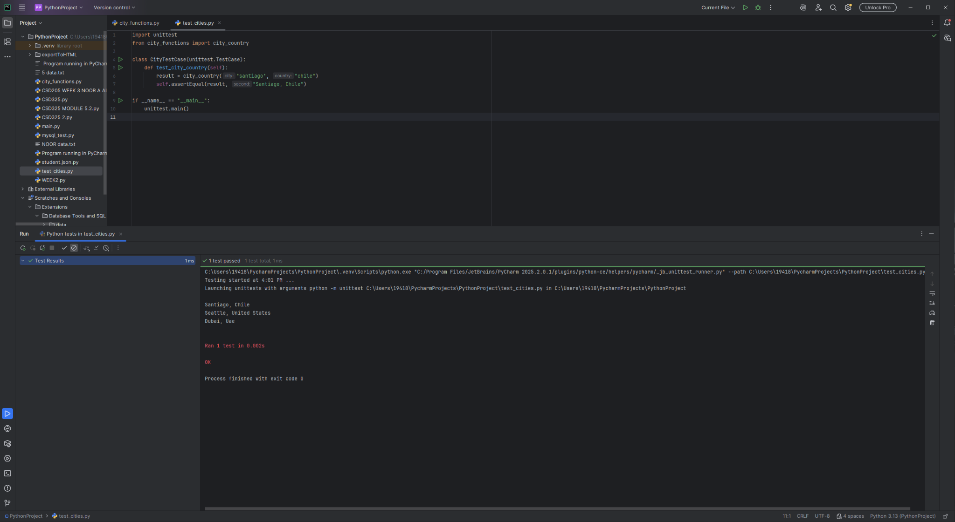

Screenshot 3: Test Failed (population required)
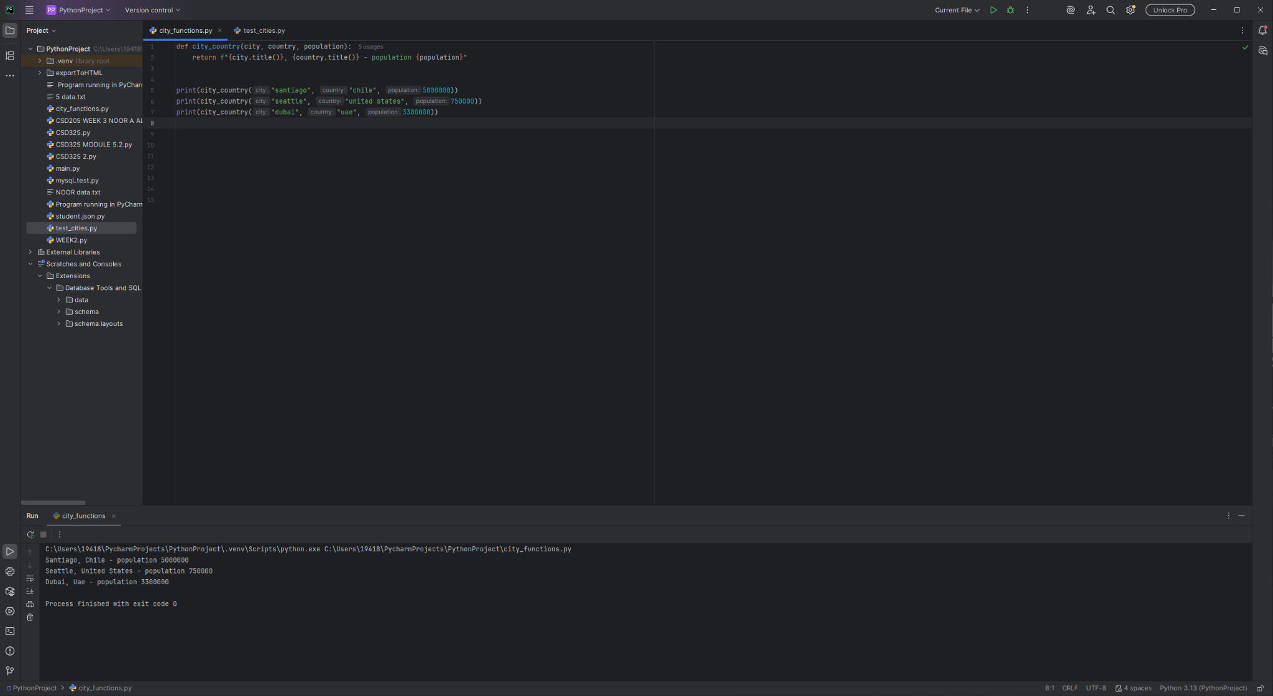

Screenshot 4: Test Passed (population optional)
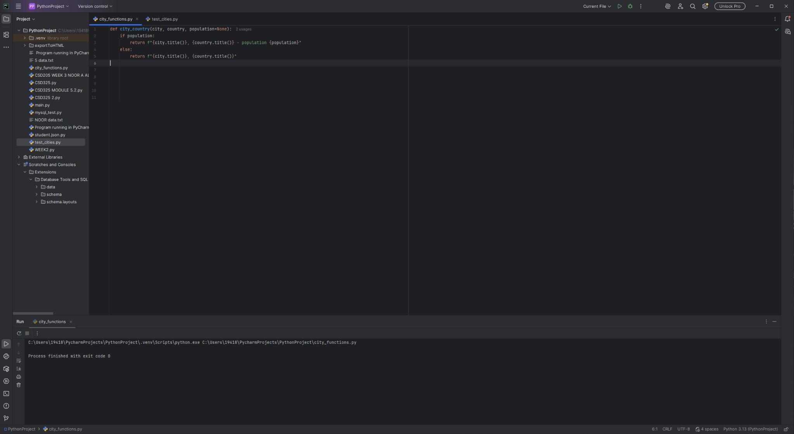

Screenshot 5: Test Failed (language required)
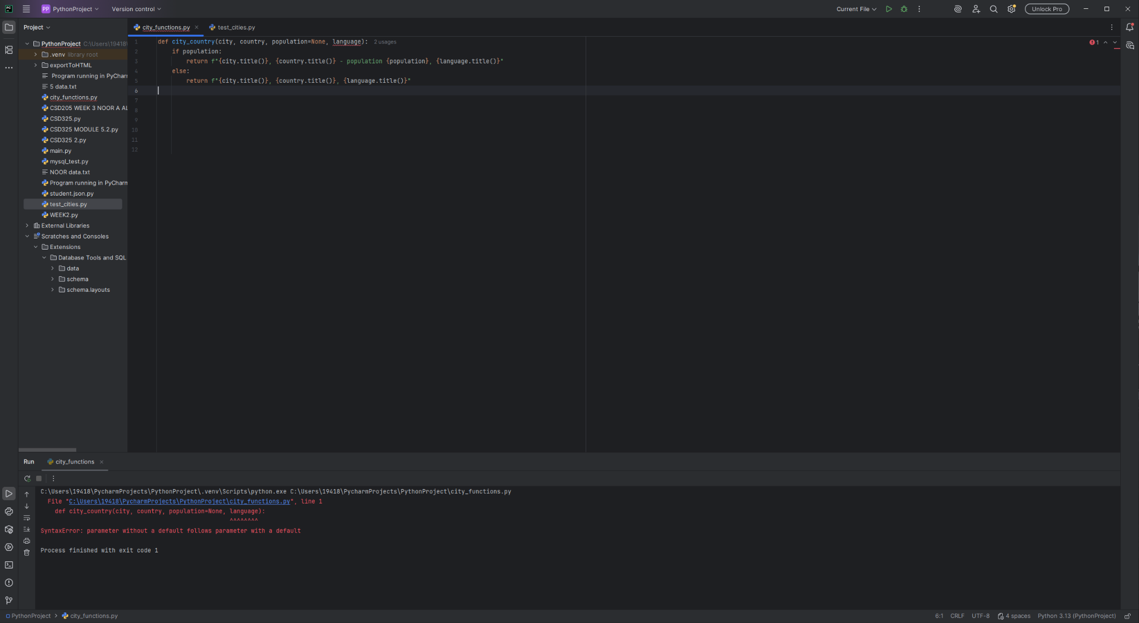

Screenshot 6: Final run with City, City+Population, City+Population+Language
