Module 8.2 Assignment: JSON Practice
Name: Noor Al Salihi
Assignment: Module 8.2 – JSON Practice
11/19/2025

Flowchart

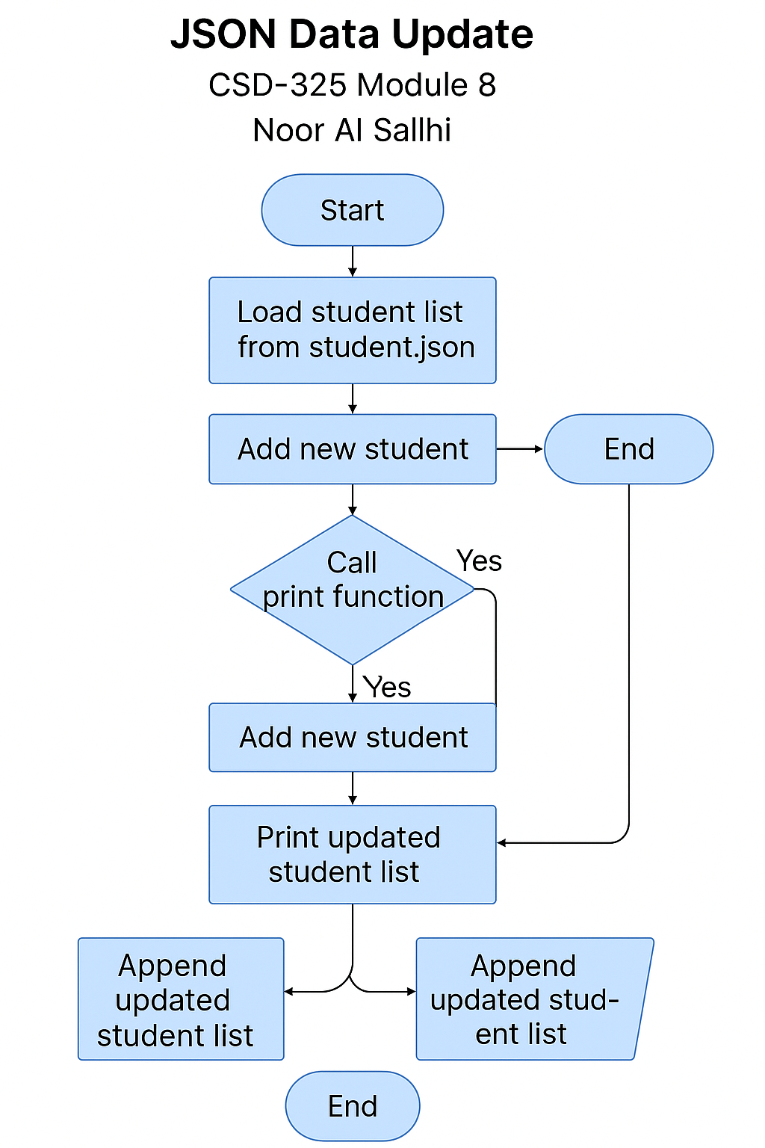

Program Output
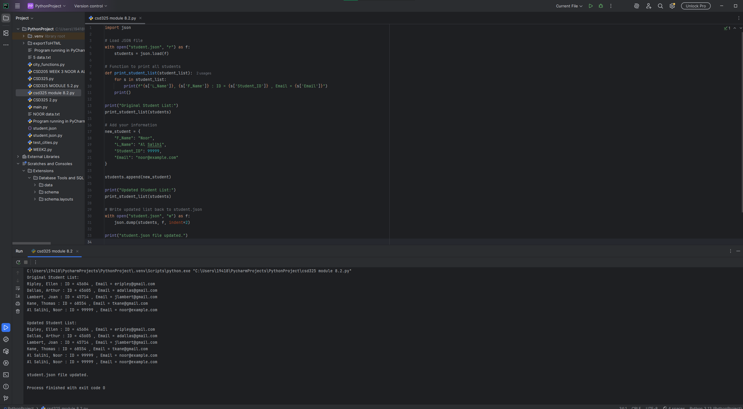

JSON File Change Notification

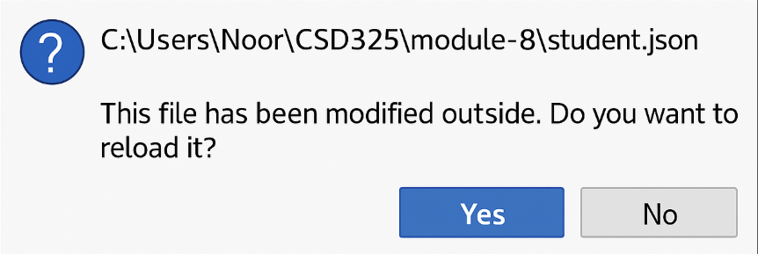

Final student.json File Contents
[
{
"F_Name": "Ellen",
"L_Name": "Ripley",
"Student_ID": 45604,
"Email": "eripley@gmail.com"
},
{
"F_Name": "Arthur",
"L_Name": "Dallas",
"Student_ID": 45605,
"Email": "adallas@gmail.com"
},
{
"F_Name": "Joan",
"L_Name": "Lambert",
"Student_ID": 45714,
"Email": "jlambert@gmail.com"
},
{
"F_Name": "Thomas",
"L_Name": "Kane",
"Student_ID": 68554,
"Email": "tkane@gmail.com"
},
{
"F_Name": "Noor",
"L_Name": "Al Salihi",
"Student_ID": 99999,
"Email": "noor@example.com"
}
]

