Noor A. Al-Salihi
CSD-325 Module 4 — High/Low Temperatures Assignment
Flowcharts: Original and Revised
11/05/2025

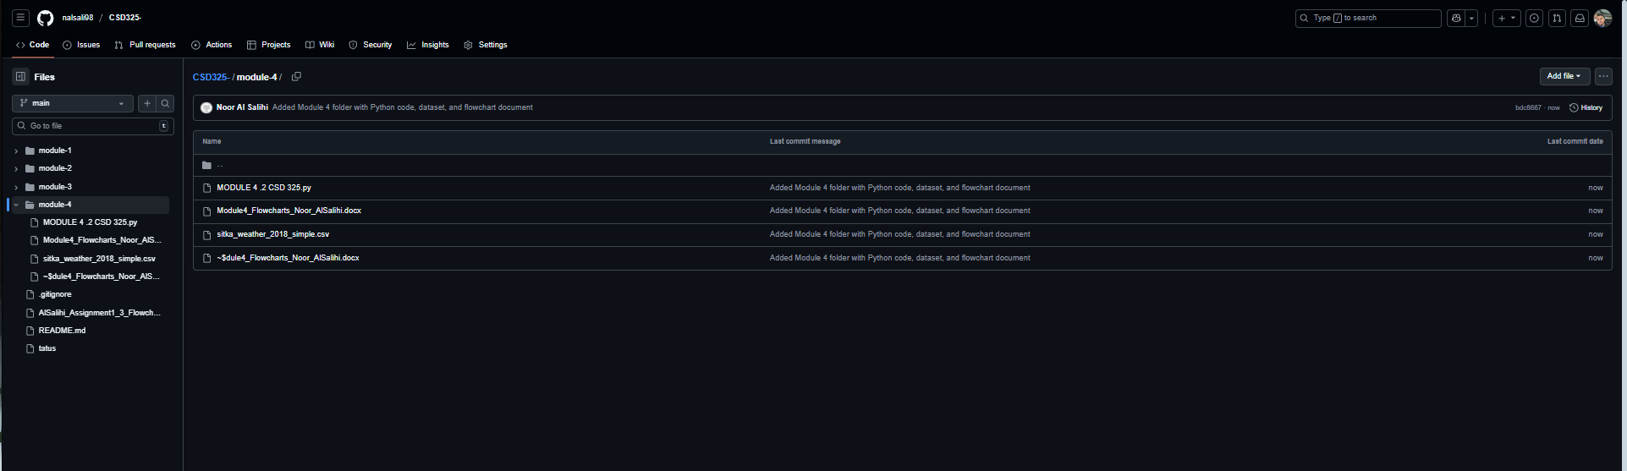

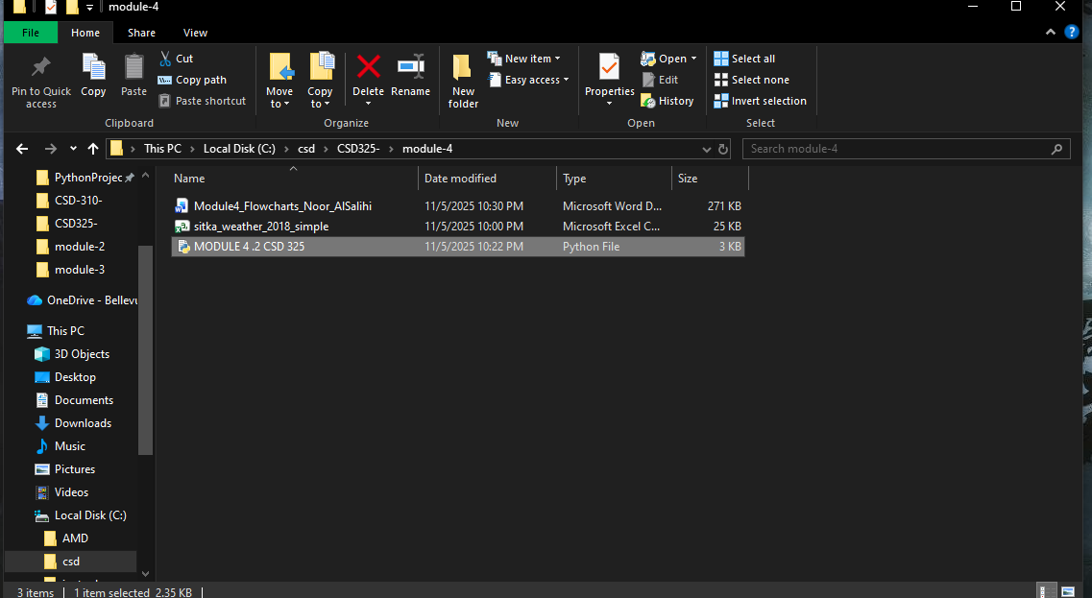

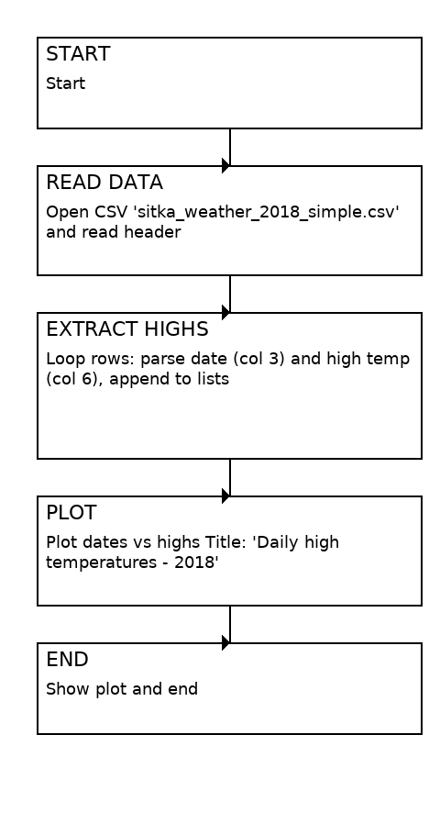
Figure 1: Original Flowchart

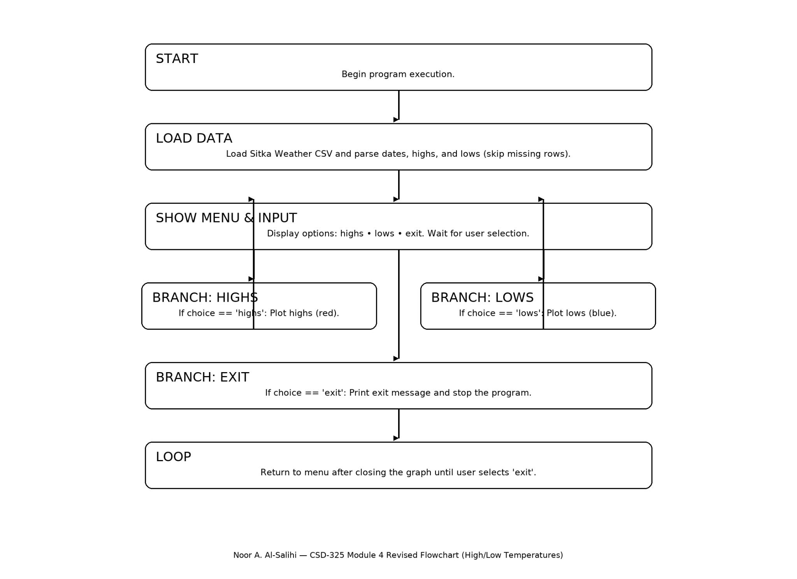
Figure 2: Revised Flowchart

