Assignment 1.3 – Building a Web Page Exercise, Part 1
Name: Noor Al Salihi
Date: January 16, 2026
Course: CSD 340 Web Development with HTML and CSS

https://github.com/nalsali98/csd-340.git

HTML Validation – Initial Errors
This screenshot shows the HTML validation results before fixing the errors.
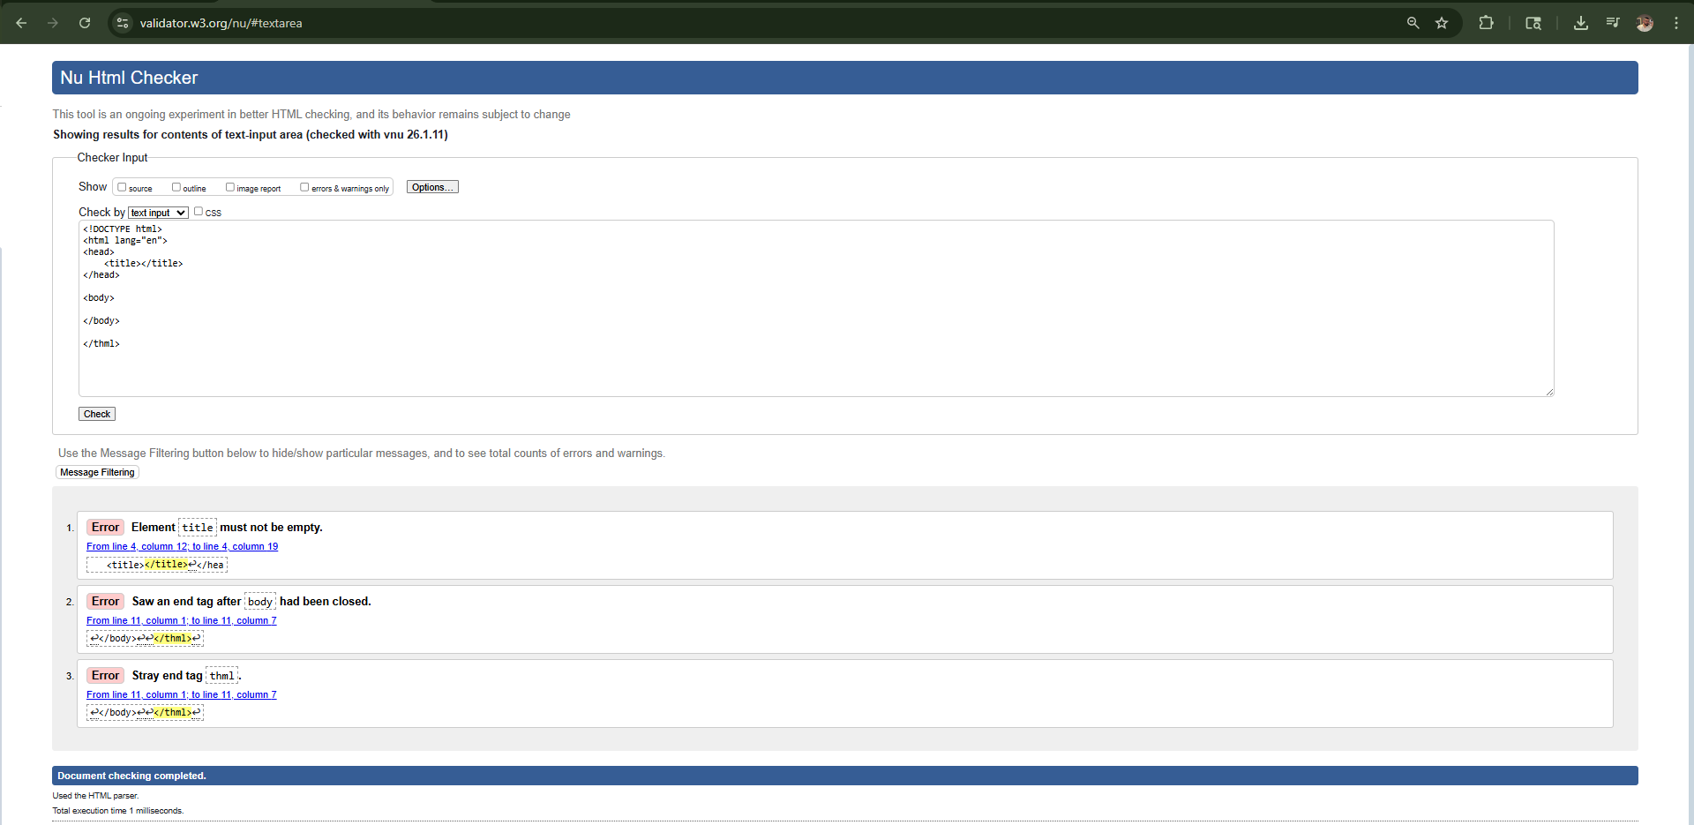

HTML Validation – No Errors
This screenshot shows the HTML validation results after all errors were corrected.
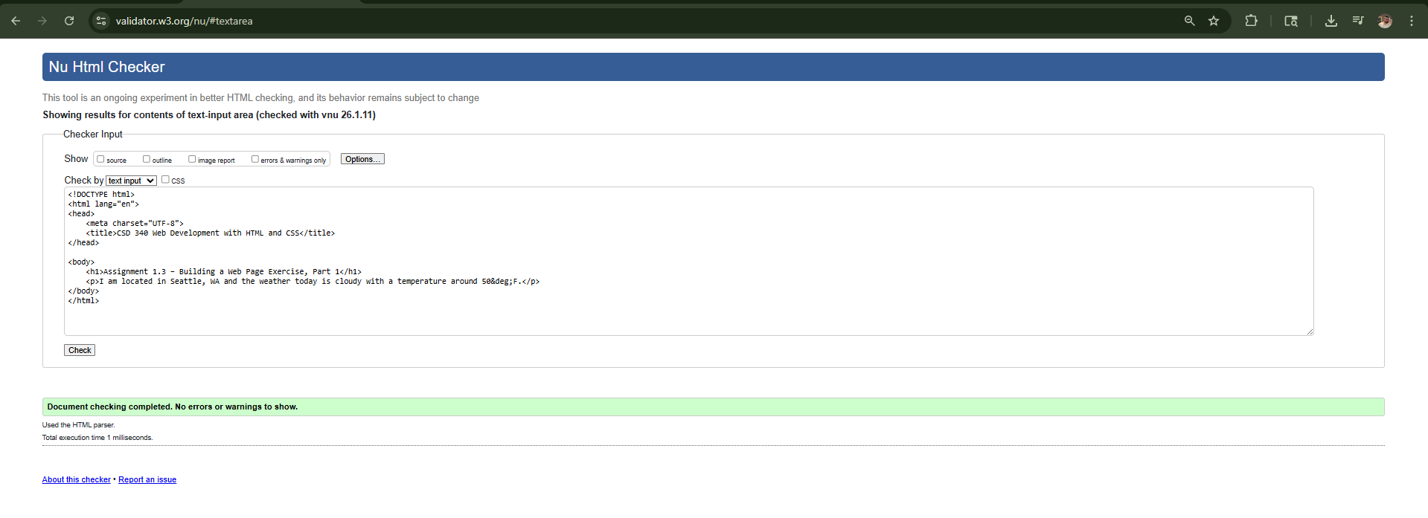

Browser Output
This screenshot shows the HTML page opened in a web browser.
