NOOR A AL
MODULE 2 ASSIGNMENT 2.2
CSD 340
CSD 340 – Module 2.2 Validation Proof
Included are screenshots of validation passes of the Module 2.2 Building a Web Page Exercise assignment. The HTML and CSS files both validated through W3C without error.

HTML Validation Result
The screenshot below shows the HTML validation result using the W3C Nu HTML Checker. The document validates with no errors or warnings.
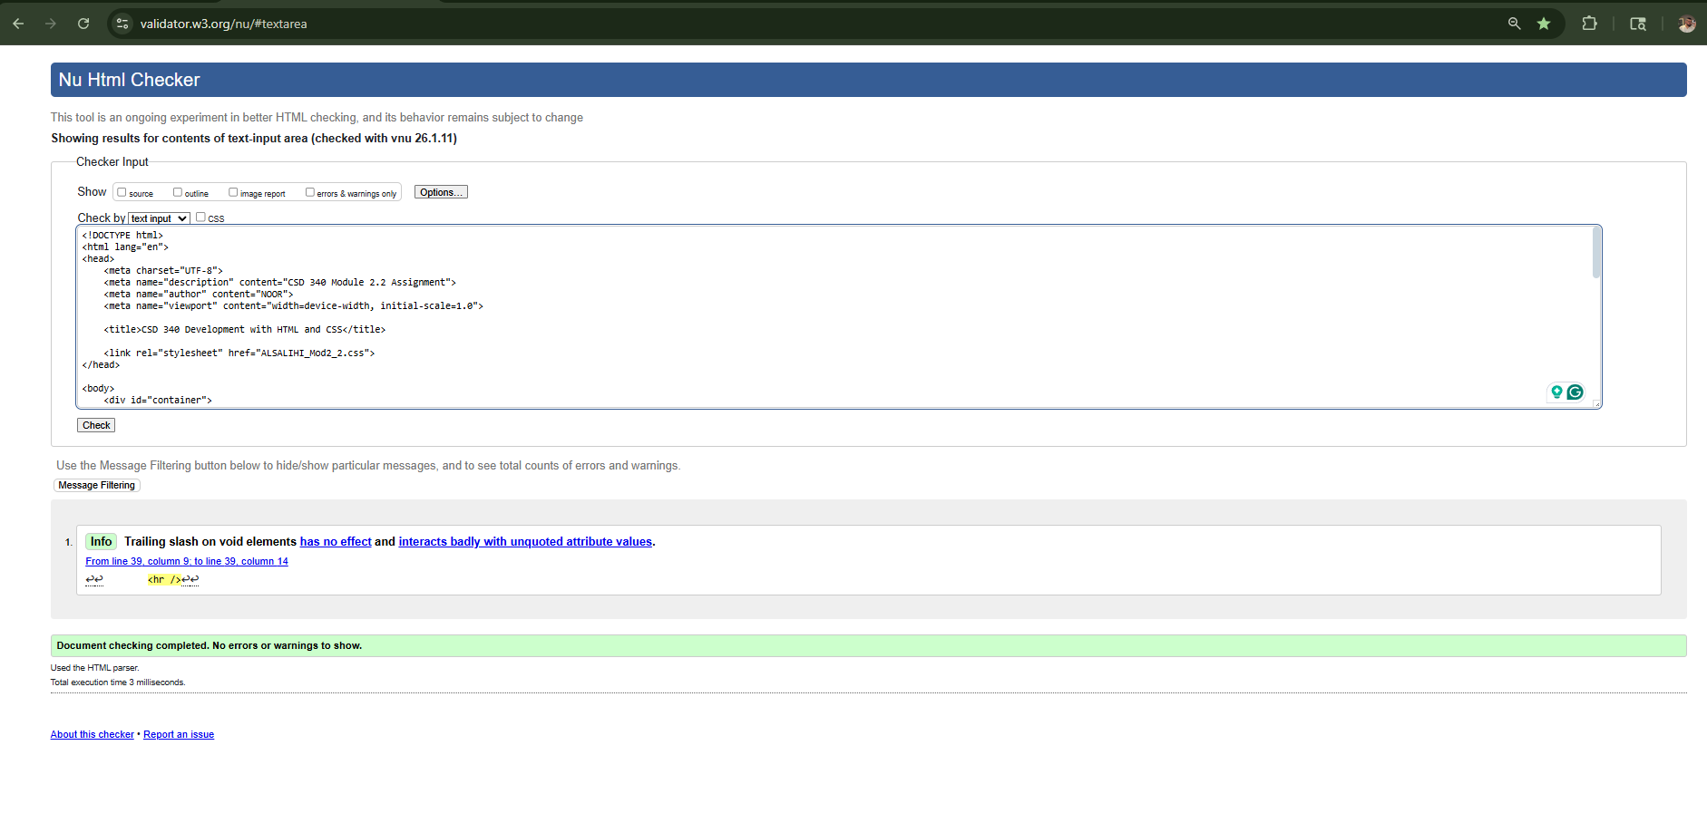

CSS Validation Result
The screenshot below shows the CSS validation result using the W3C CSS Validator. The stylesheet validates as CSS Level 3 with no errors found.
