CSD 402 – Energy Calculator Java Program
Student Name: Noor Al Salihi
Course: CSD 402
Assignment: Java Installation and Energy Calculator Program
Date: January 17, 2026

1. Java Installation and Configuration
The following screenshot confirms that Java has been successfully installed and configured in IntelliJ IDEA using OpenJDK 24.
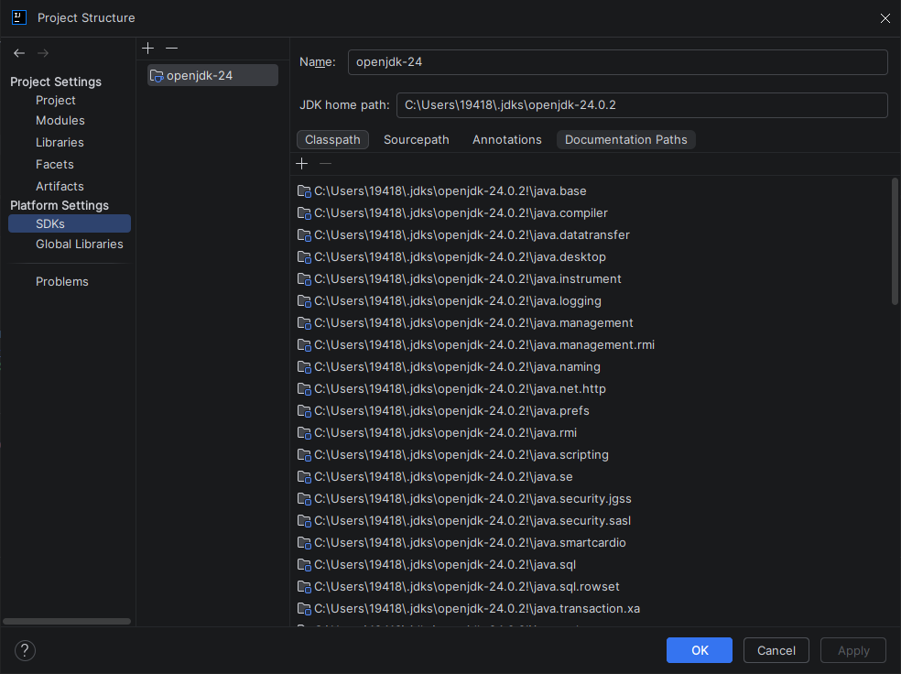

2. IntelliJ IDEA Setup and Source Code
This screenshot shows the EnergyCalculator.java file open in IntelliJ IDEA, demonstrating correct Java syntax and program structure.
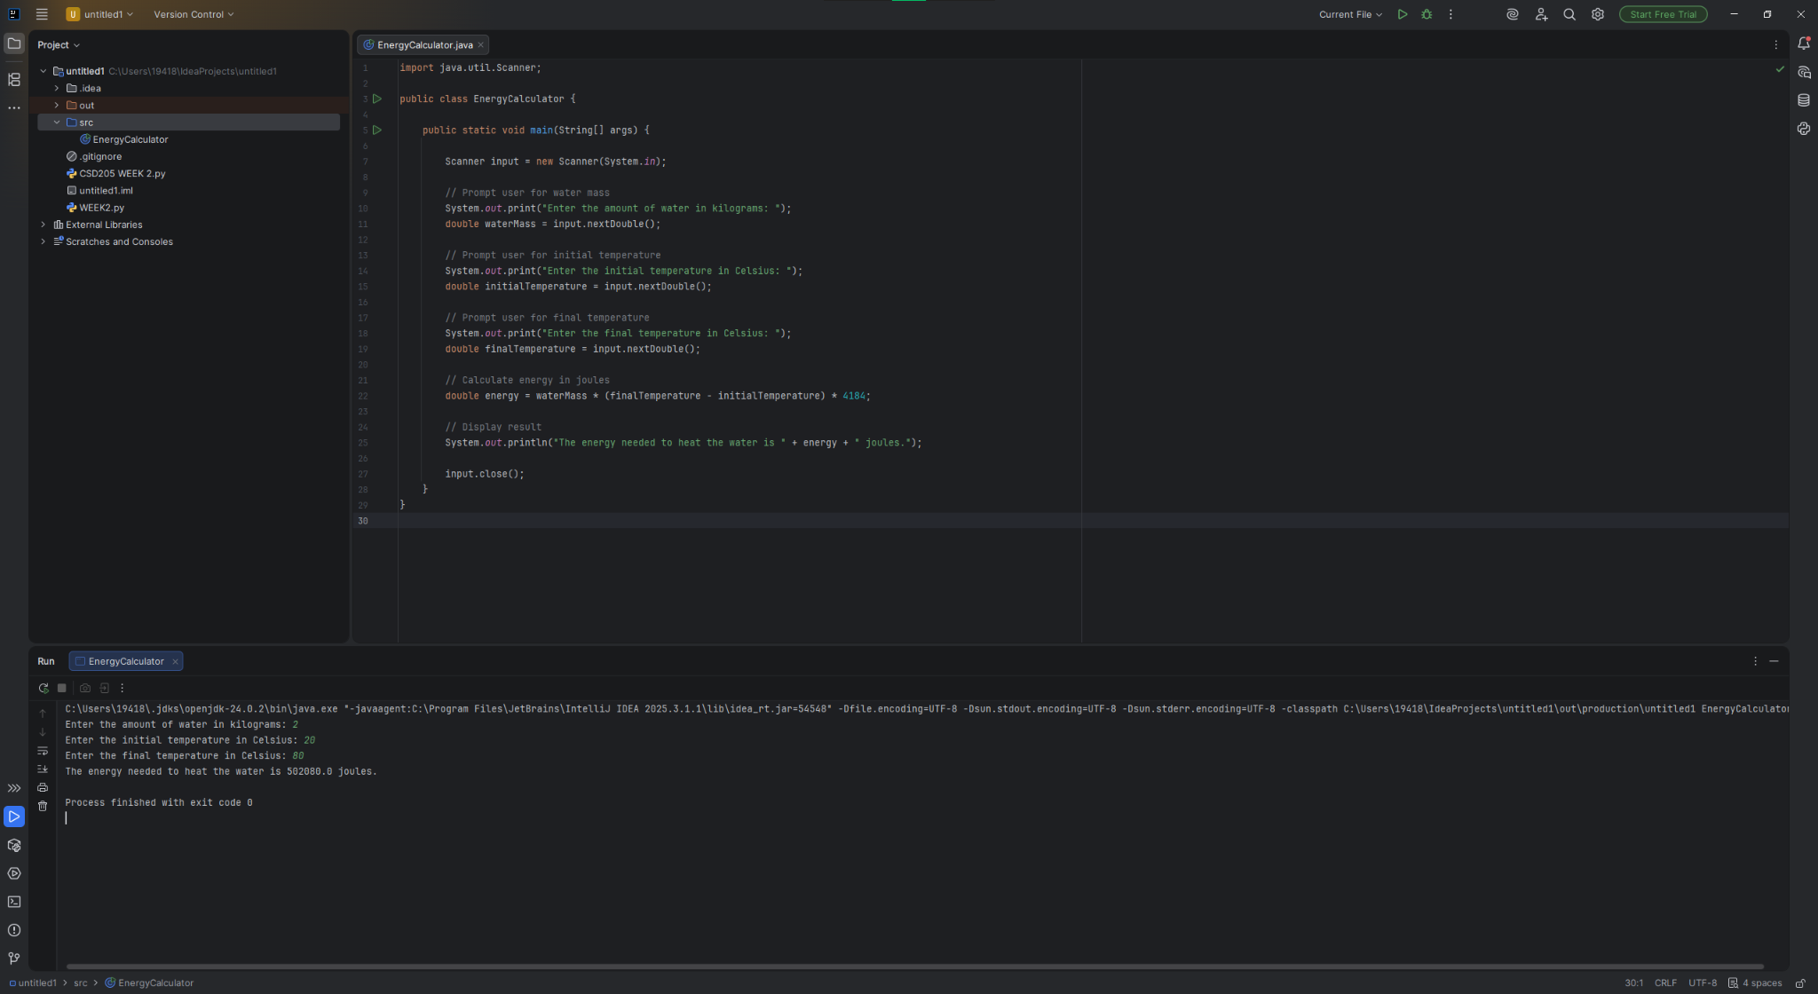

3. Program Execution Output
The program was executed successfully. The console output below shows user input and the correct energy calculation in joules.

