Module 10.2 Programming Assignment
Name: Noor Alsalihi
Course: CSD420-340A Advanced Java Programming
Date: May 15, 2026

In this assignment, you will see a JavaFX application linked to MySQL database by using JDBC. The JavaFX program lets the user display and update fan information in a database named db.
MySQL database and fans table setup.
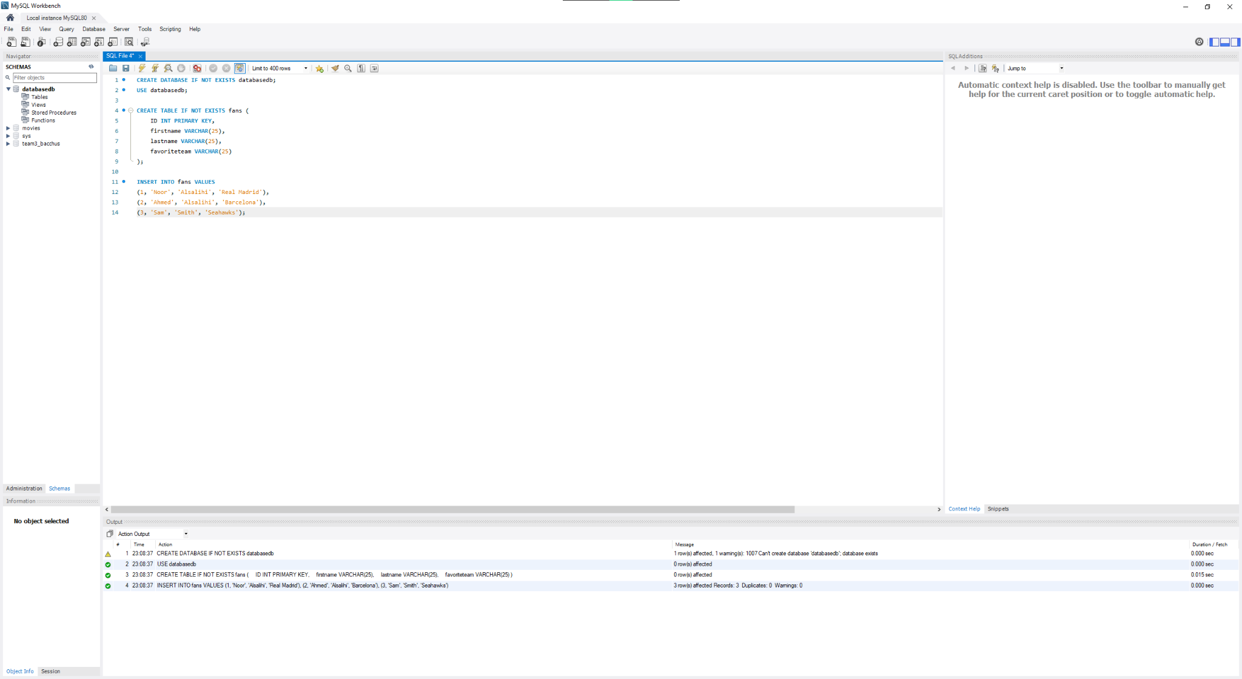

Maven pom.xml dependencies configuration.
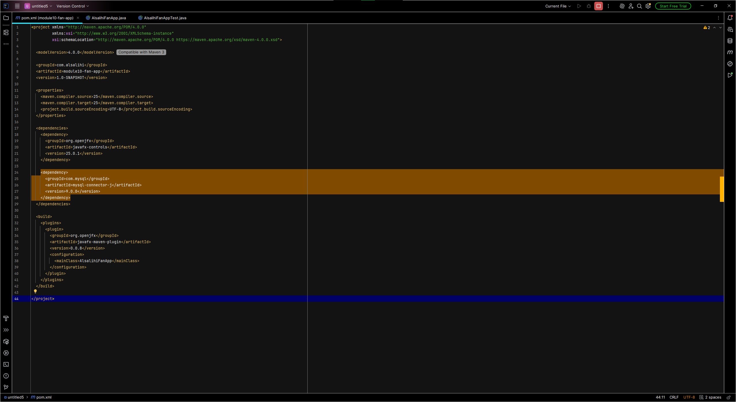

Main JavaFX application source code.
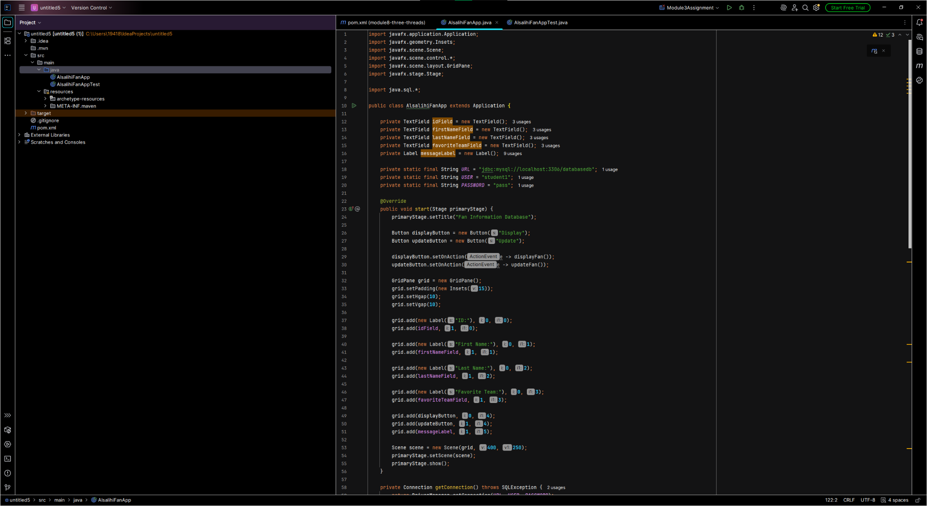

Test code implementation for the application.
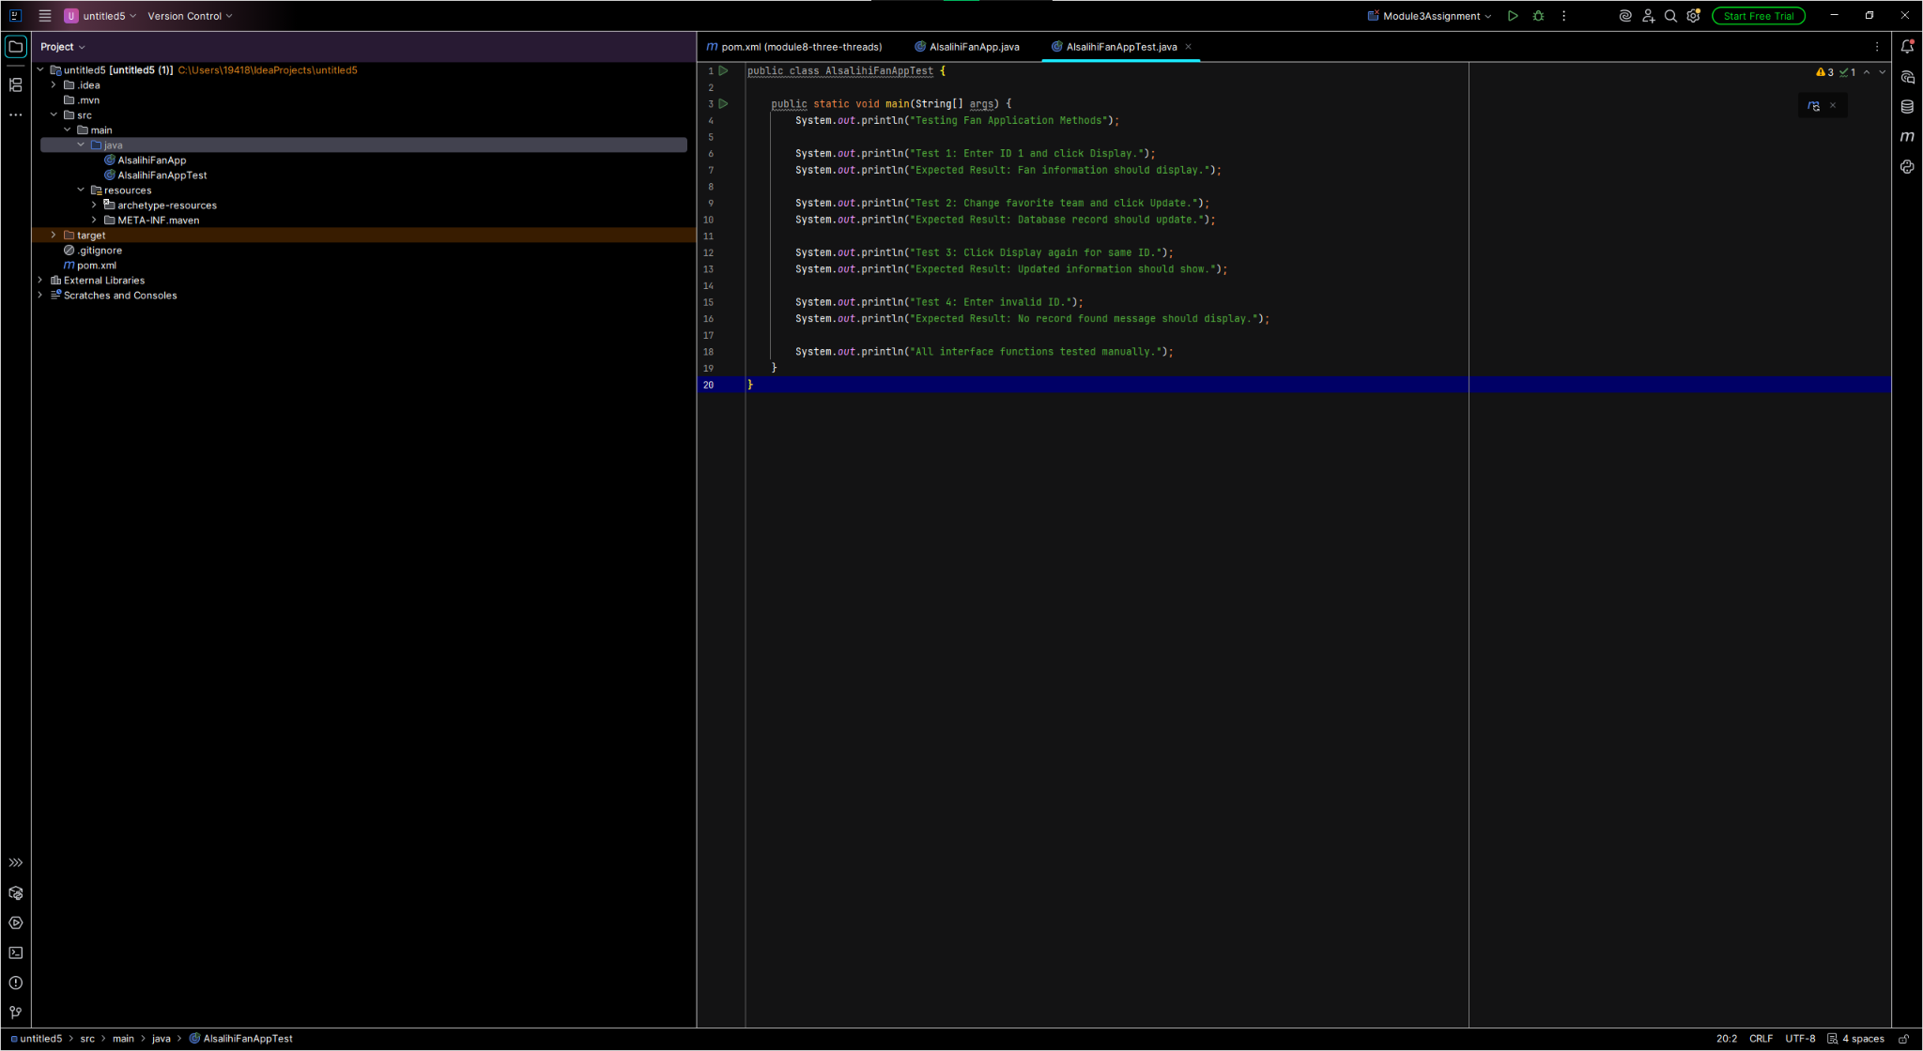

Successful test output execution.
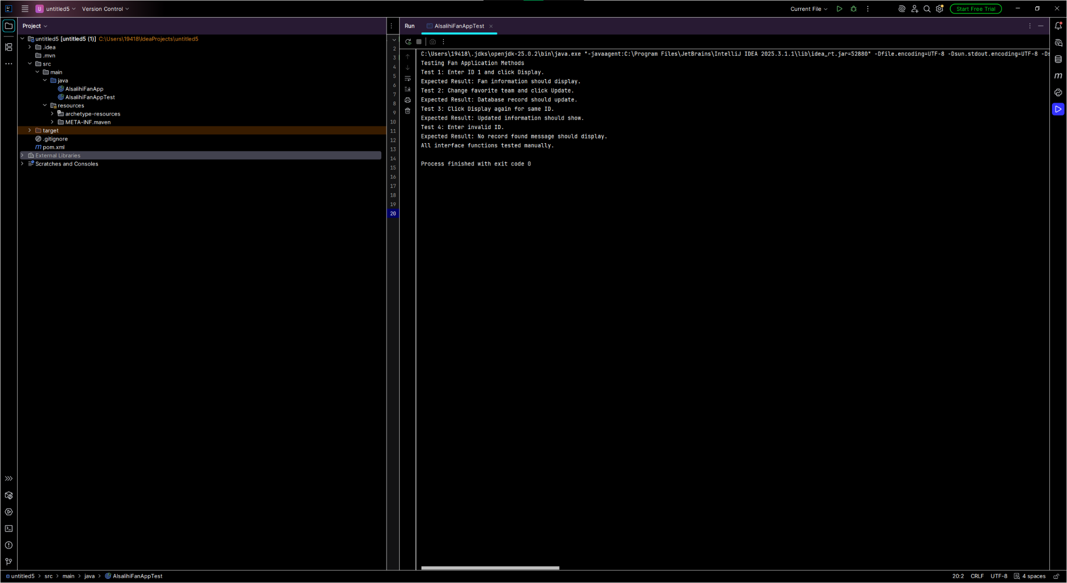

JavaFX application running successfully.
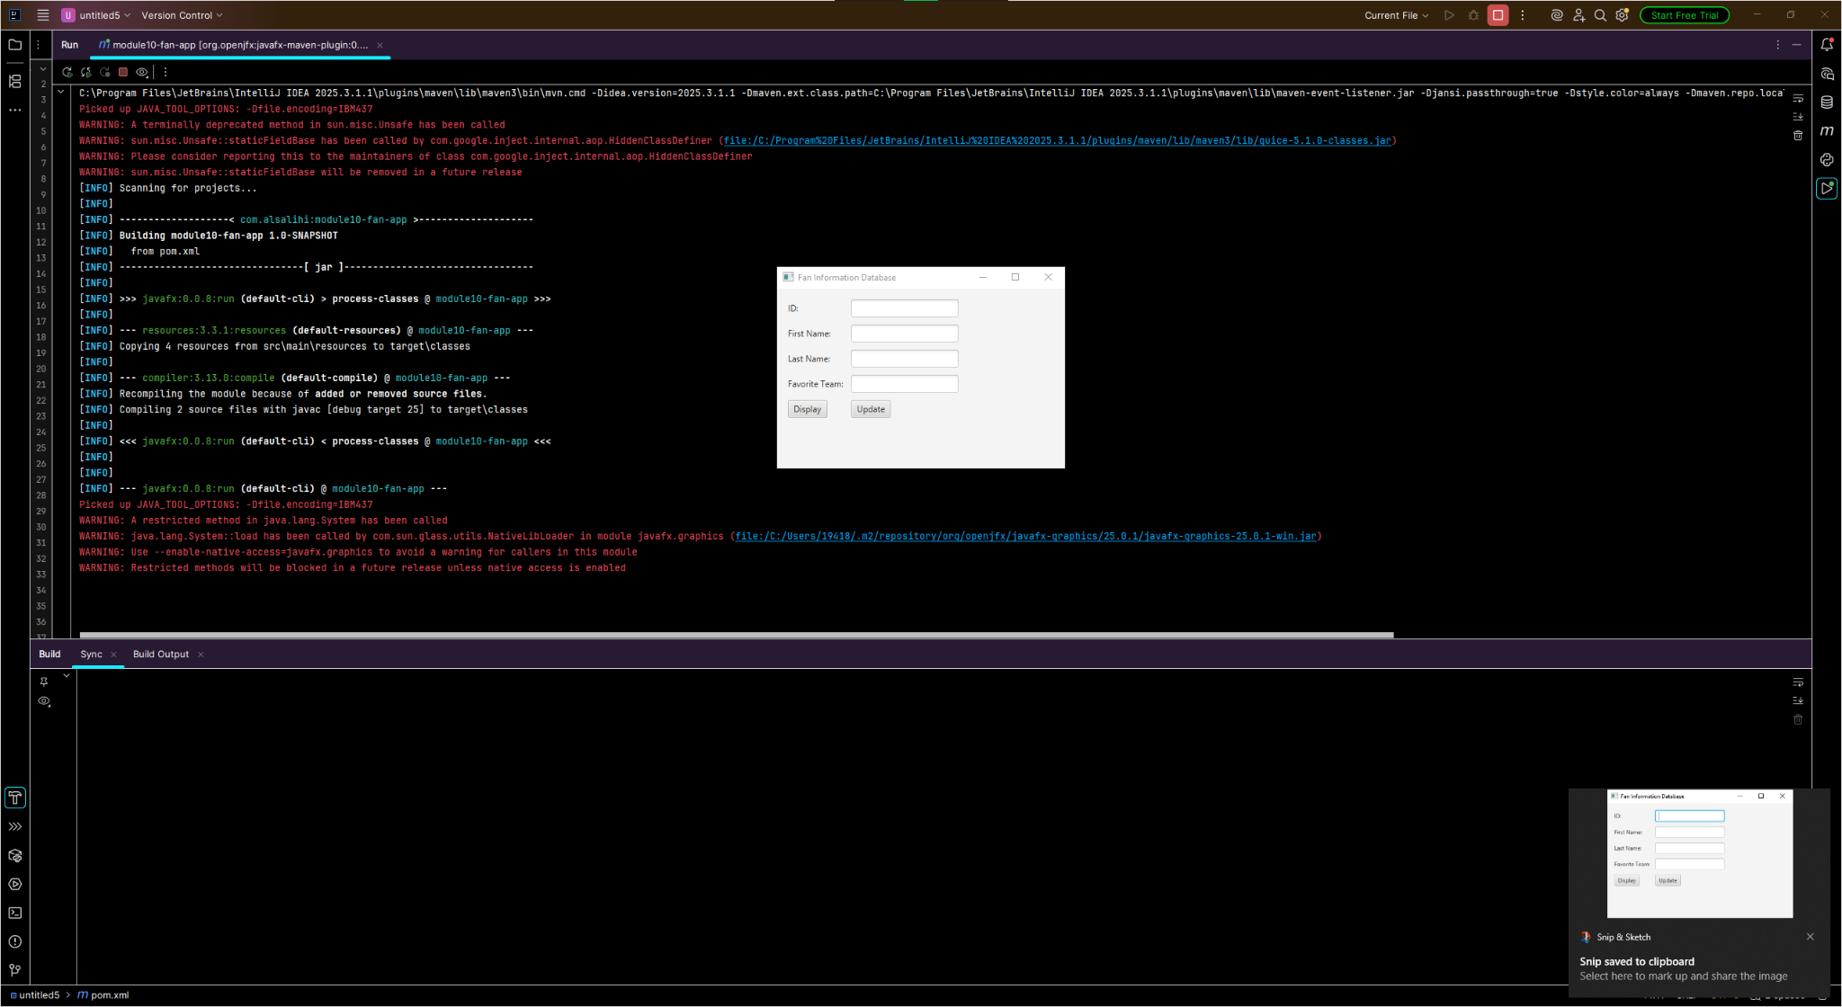

Update button successfully updating database records.
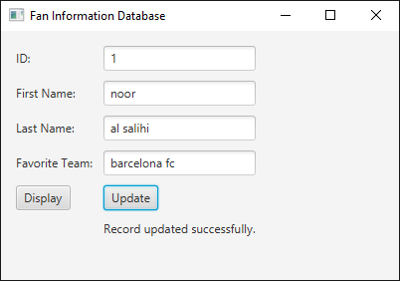

MySQL database showing updated fan information.
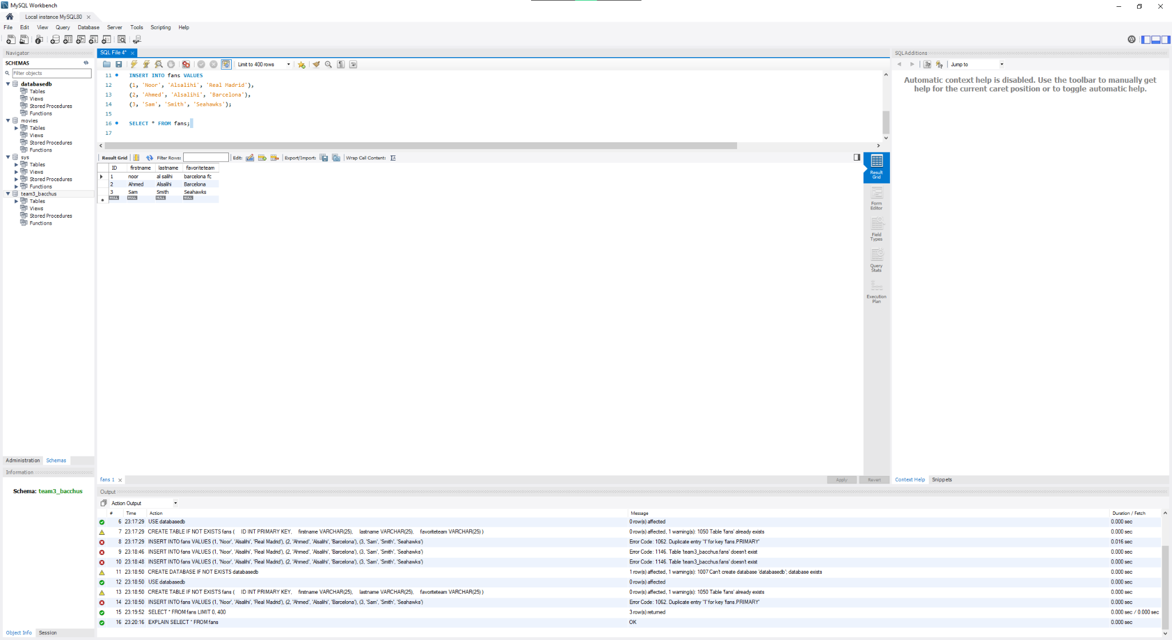

Conclusion
The JavaFX fan application ran and was connected to a MySQL database using JDBC. Records were displayed and updated properly from fans table and all requirements were met for the assignment.

