CSD420-340A Advanced Java Programming (2265-DD)
Module 9.2 Programming Assignment
Java and MySQL Database Connection Setup
Noor Alsalihi
Bellevue University
May 2026

Java Version Verification
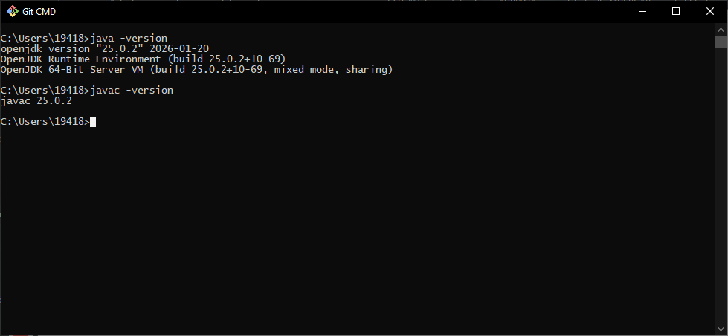
This screenshot demonstrates successful installation, configuration, or execution required for the assignment.

Apache NetBeans IDE Installed
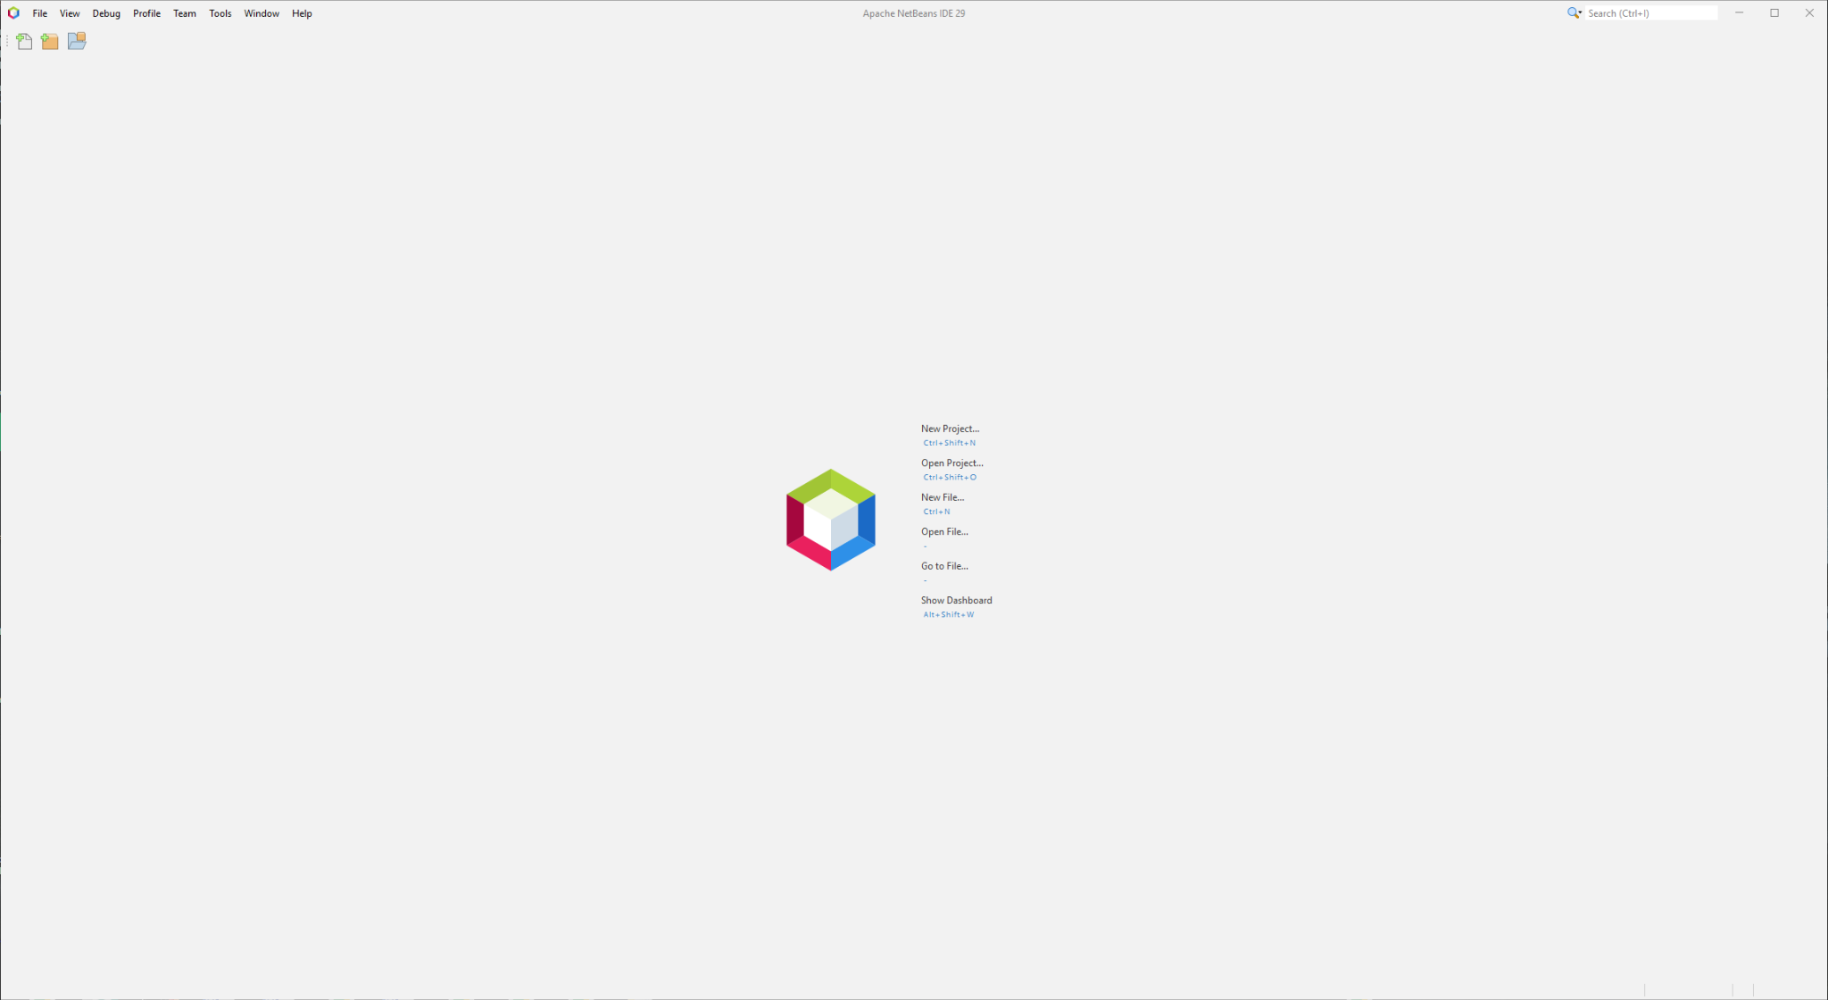
This screenshot demonstrates successful installation, configuration, or execution required for the assignment.

MySQL Database Configuration
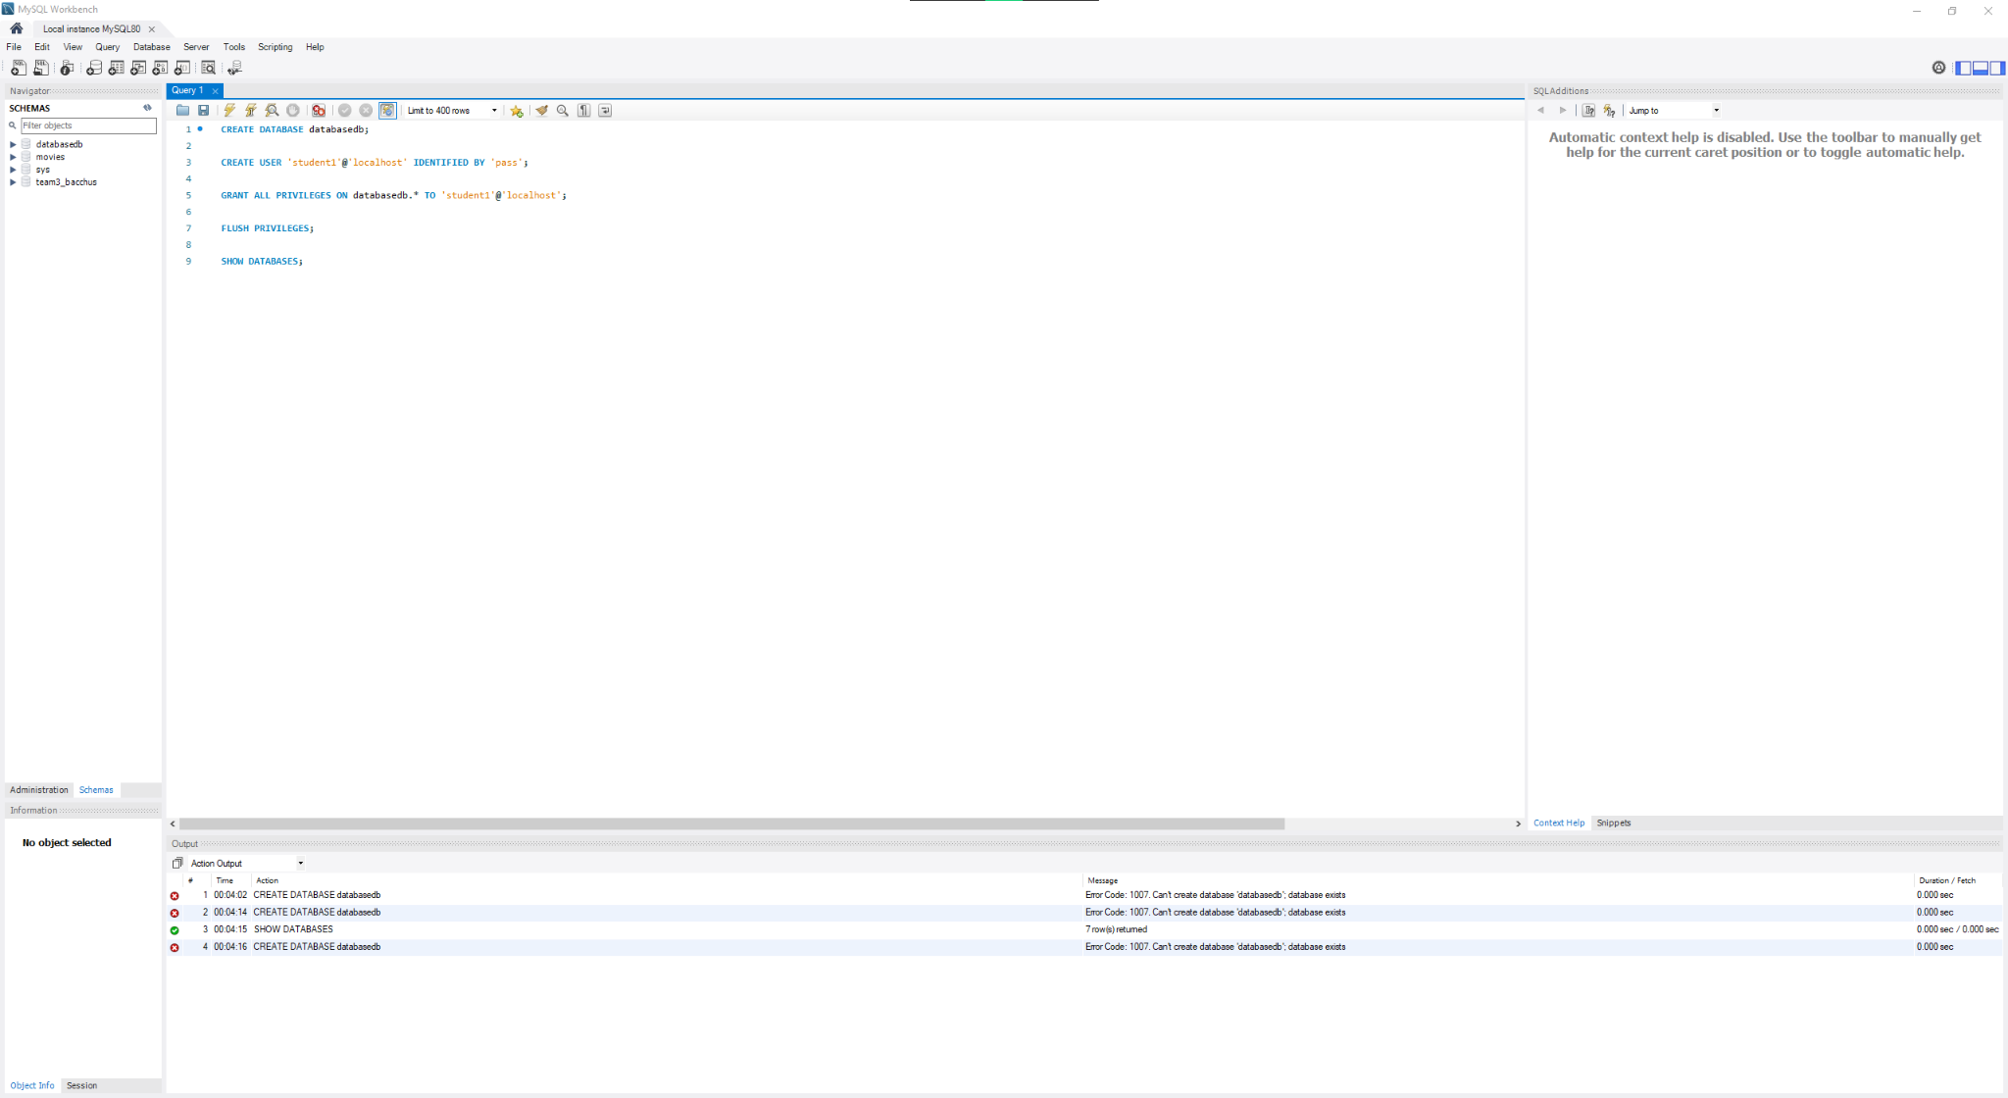
This screenshot demonstrates successful installation, configuration, or execution required for the assignment.

SHOW DATABASES Command
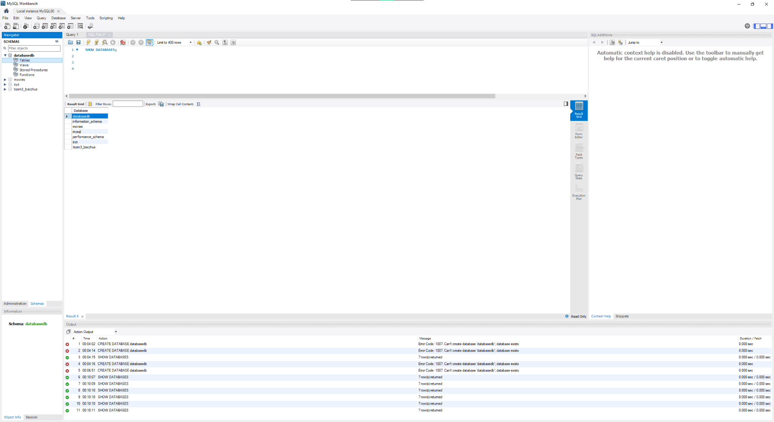
This screenshot demonstrates successful installation, configuration, or execution required for the assignment.

USE databasedb and SHOW TABLES
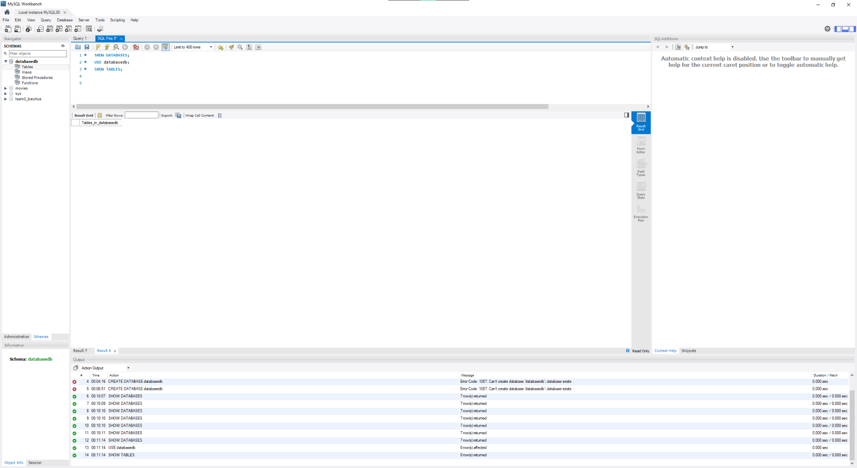
This screenshot demonstrates successful installation, configuration, or execution required for the assignment.

NetBeans Project Setup
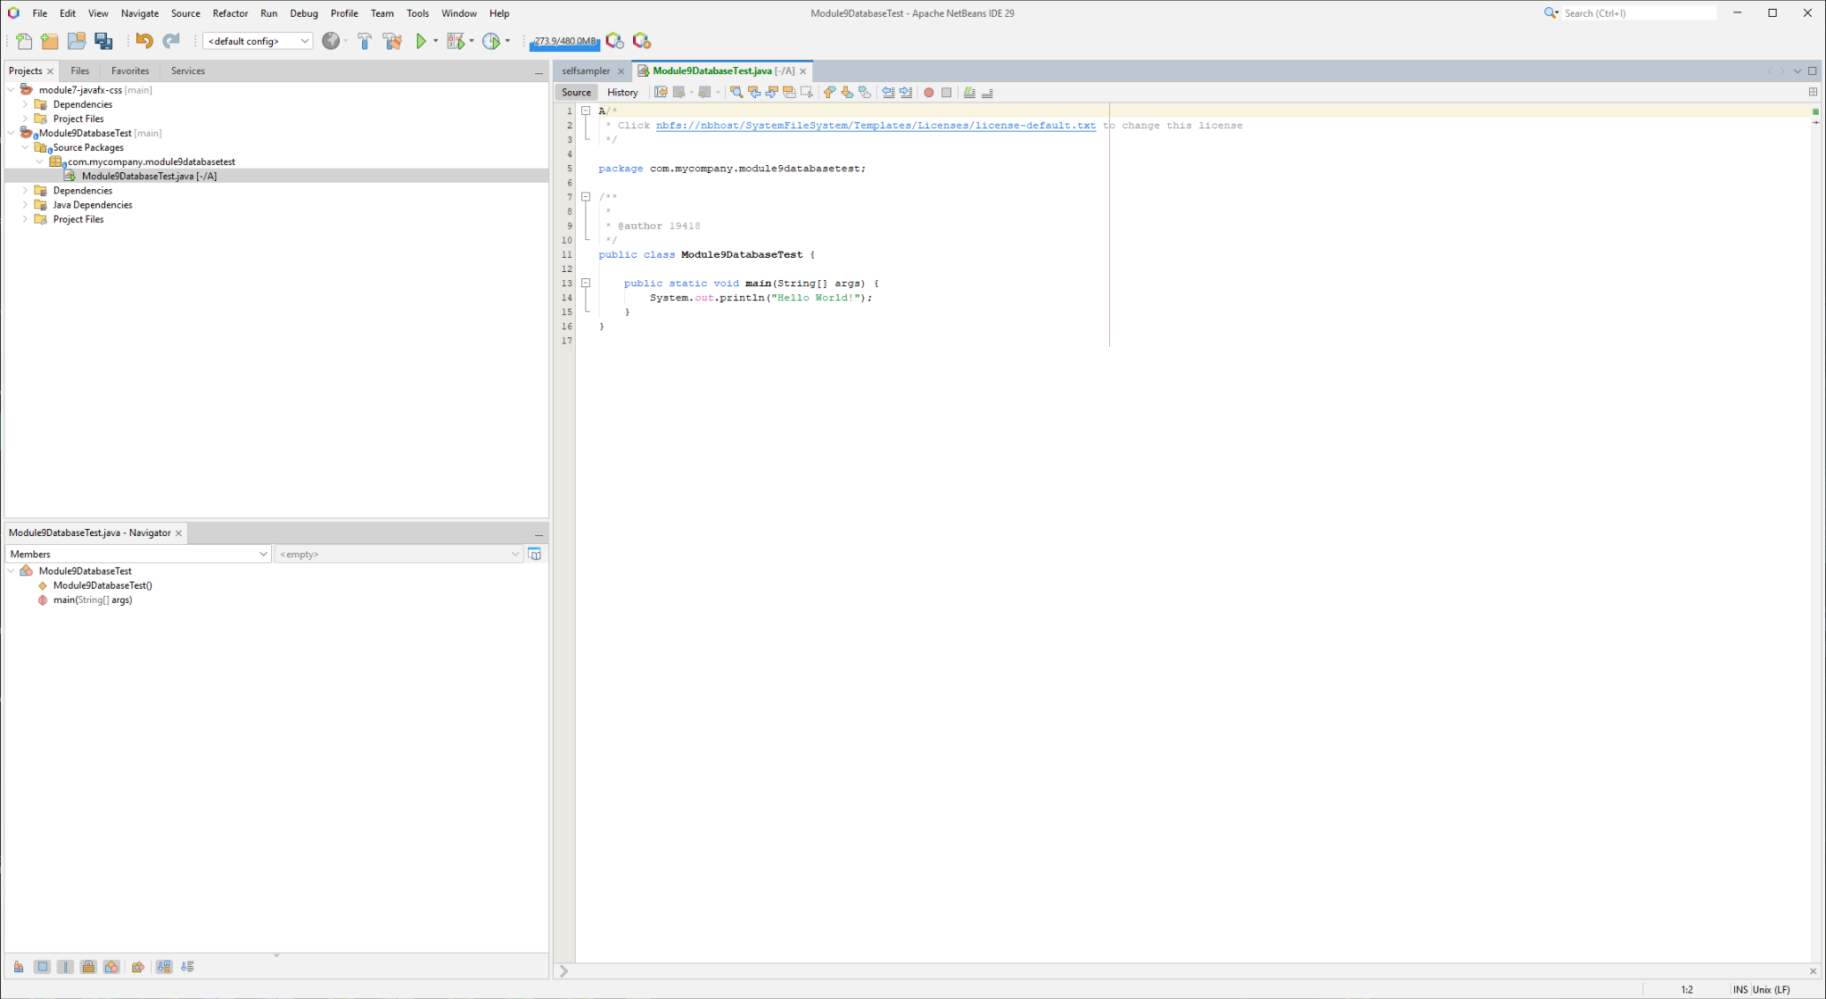
This screenshot demonstrates successful installation, configuration, or execution required for the assignment.

Maven Dependency Build Success
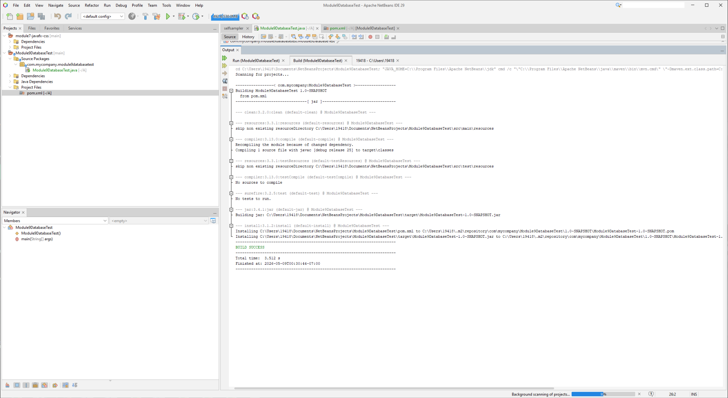
This screenshot demonstrates successful installation, configuration, or execution required for the assignment.

Successful Java and MySQL Connection
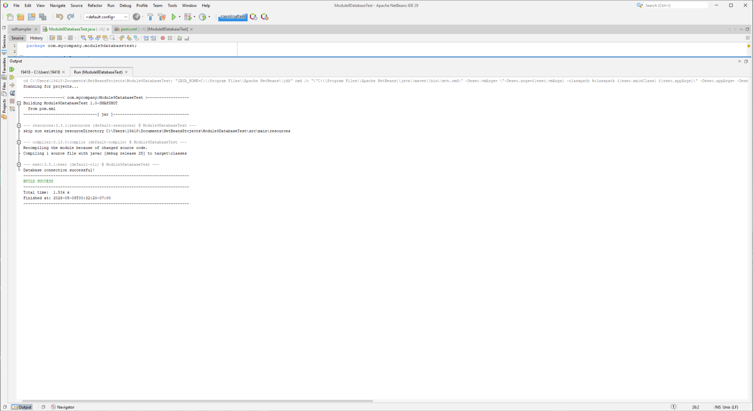
This screenshot demonstrates successful installation, configuration, or execution required for the assignment.

Summary
This assignment demonstrates the successful installation and configuration of Java, Apache NetBeans IDE, MySQL, and Java database connectivity using MySQL Connector/J.

