Google Gson Documentation Guide: Gson API Features for Java Developers Article
Noor Alsalihi
Bellevue University
CSD420-340A Advanced Java Programming (2265-DD)
Module 11.2 Programming Assignment
May 2026

Google Gson Documentation Guide: Gson API Features for Java Developers Article

Introduction
JSON stands for JavaScript Object Notation. JSON is one of the most popular formats to send and receive data today. Developers commonly use JSON when they need to transfer data between apps, APIs, databases, and web services. Java developers looking to work with JSON require tools that make it easier to handle and process JSON data. Google Gson is one of several Java JSON APIs programmers can use to work with JSON. Gson allows programmers to convert Java objects into JSON. Java programmers can also turn JSON into Java objects using Gson. Serialization is the term used to describe converting Java objects into JSON. Deserialization is the term used when programmers are converting JSON into Java objects. Gson is an open-source Java library that simplifies the processes involved in working with JSON. Gson supports modern Java coding practices and is easy to use.

History of the Google Gson API
Google Gson is a lightweight Java library for processing JSON data. Google developed Gson to give Java programmers an API that would simplify JSON coding and processing. Prior to using libraries like Gson, developers were required to write their own code in order to manually parse JSON objects in Java. Writing manual parsing logic was tedious and created more problems for developers down the line.
Google created Gson to be used as a library that Java developers could integrate into their applications. This would allow developers to clean up their JSON processing code and focus on other parts of their project. Gson became popular for this exact reason. Using Gson allowed developers to reduce their line of coding by hundreds when working with APIs and web services. Gson is lightweight and open-source. Developers can easily add Gson as a dependency to any Java project today.

Options Available in the Gson API
Google Gson API has many options that are available to Java programmers.

Serialization
Serialization is the process of converting a Java object into JSON. Serialization is used when a developer is looking to send information from Java to a web API or database.

Example
Employee emp = new Employee(”Noor”,”101”,”Developer”);
String json = gson. toJson(emp);
In the example above, the Java object will be serialized into JSON String format.

Deserialization
Deserialization is used to convert JSON into Java objects. Java programmers can use Gson to accept JSON data from an API or file, then convert that data into Java objects.

Example
Employee emp = gson. fromJson(json, Employee.class);

Json Parsing
Java developers can parse through well-formatted JSON. Gson supports parsing of:
- JSON objects
- JSON arrays
- Nested JSON
- Maps
- Collections
- Generic types

Pretty Printing
Java programmers can use JSON’s built-in print function to read and debug JSON data.

Example
Gson gson = new GsonBuilder()
. setPrettyPrinting()
. create();

Custom Serializers and Deserializers
Developers can create custom serializers and deserializers should they need more from the Gson library.

Null Handling and Field Policies
JSON provides null-value handling options if programmers need them. Programmers can also exclude fields, and they can customize field naming policies. Gson can be configured to support almost any programmer's needs.

Features and Supported Processes
Java programmers can use Gson to work with JSON in almost any scenario.

API and Web Service Communication
The majority of modern apps today connect to APIs. These application programming interfaces send and receive JSON data. Java applications can communicate with these APIs using Gson. Programmers can use Gson to send information to APIs and read data from APIs. Java objects can be converted into JSON Strings. JSON data can then be parsed into Java objects.

Object Mapping
Gson automatically maps JSON fields to Java objects. Programmers will not have to create variables and assign them to each JSON attribute.

Database and Cloud Application Integration
Many applications connect to databases or cloud-based services. Cloud databases typically use JSON strings to send and receive data to applications. Java developers can use Gson to easily work with data being sent to and from these applications.

Collection and Generic Data Type Support
Gson has support for developers who are working with collections and generic data types. Arrays, Lists, maps, and many other data types are supported by Gson. Developers will not have to write lines of code to parse these data types.

Gson is Lightweight and Easy to Implement
Developers love Gson because it is lightweight and quick to set up. Java developers can add gson into their project by downloading a JAR file or by adding gson as a dependency in Maven.

Conclusion
Google Gson API helps developers handle JSON processing with ease by providing powerful features that enable parsing, serialization, deserialization, as well as pretty printing from within Java applications. This Java JSON API gives options such as customizing collected data. Google Gson API lightweight framework and easy to use implementation have become very popular with Java developers who use APIs, web services, databases, and need to work with JSON in their cloud applications.
Java developers should become familiar with how APIs like Gson work. JSON is still a very popular data format that is used for data interchange in software development. Gson allows Java developers to save time by having an API that simplifies the process rather than writing things out by hand. It’s an easy to read and easy to implement option.

Download and JAR File Information
The Gson JAR file can be downloaded from the official Google Gson GitHub repository or from the Maven Repository. In this assignment, Gson was added to the Maven pom.xml file using the com. google.code.gson:gson dependency. Maven downloaded the Gson JAR and the required dependency files automatically. These files can be included together in the final ZIP submission as required by the assignment.
Official Gson repository: https://github.com/google/gson
Maven Repository download page: https://mvnrepository.com/artifact/com.google.code.gson/gson
Maven dependency used:
<dependency>
<groupId>com.google.code.gson</groupId>
<artifactId>gson</artifactId>
<version>2.13.1</version>
</dependency>

Additional Java JSON Example
The following example is a separate Java JSON example using the Gson API. The example demonstrates serialization by converting an Employee object into JSON and deserialization by converting JSON back into a Java Employee object.
import com.google.gson.Gson;

class Employee {

String name;
int id;
String position;

Employee(String name, int id, String position) {
this.name = name;
this.id = id;
this.position = position;
}
}

public class GsonExample {

public static void main(String[] args) {

Gson gson = new Gson();

Employee emp = new Employee("Noor", 101, "Developer");

String json = gson.toJson(emp);

System.out.println("Java Object to JSON:");
System.out.println(json);

Employee converted = gson.fromJson(json, Employee.class);

System.out.println("\nJSON to Java Object:");
System.out.println(converted.name + " " + converted.id + " " + converted.position);
}
}

References
Google. (n.d.). Gson GitHub repository. https://github.com/google/gson
Maven Repository. (n.d.). Gson. https://mvnrepository.com/artifact/com.google.code.gson/gson
Oracle. (n.d.). Java documentation. https://docs.oracle.com/
Google Developers. (n.d.). Gson user guide. https://github.com/google/gson/blob/main/UserGuide.md

The screenshots below document the Gson Maven dependency, successful Maven setup, Java source code, and successful program output.
Figure 1. pom.xml showing the Gson Maven dependency and External Libraries.
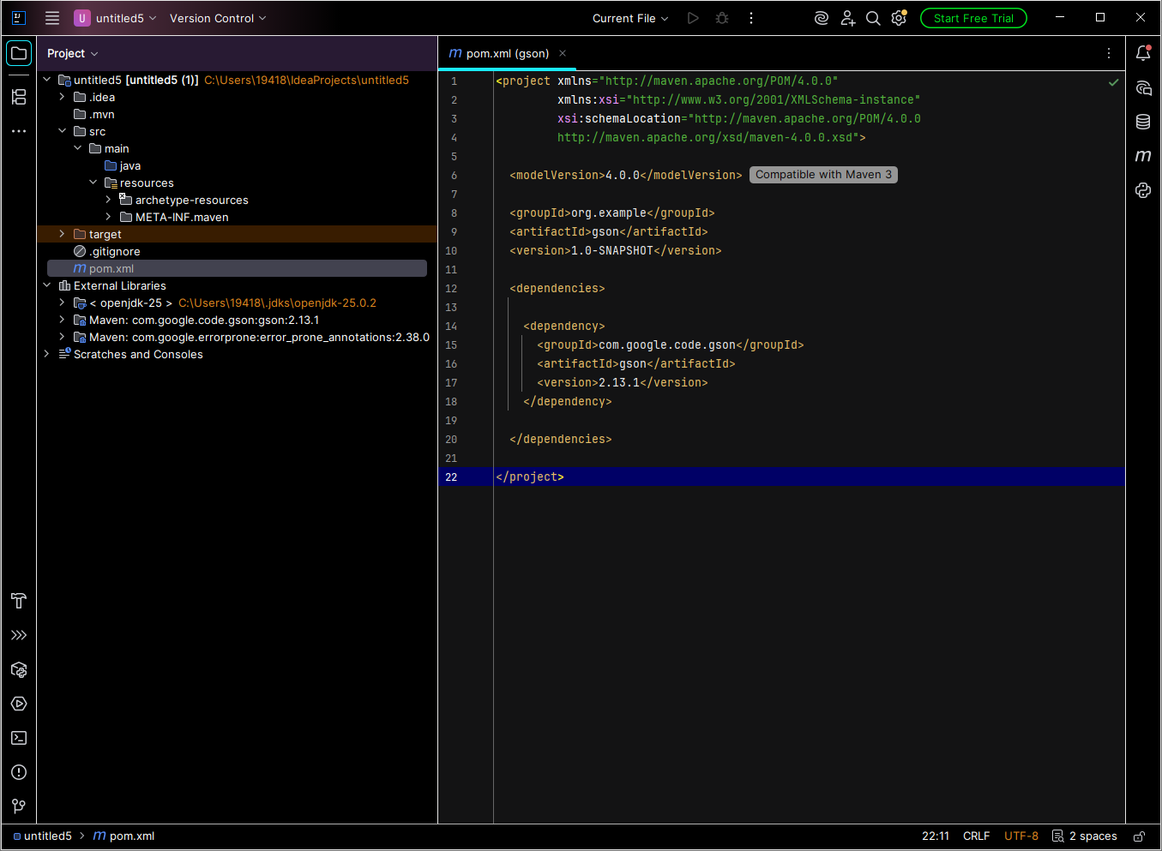

Figure 2. Maven panel after project refresh.
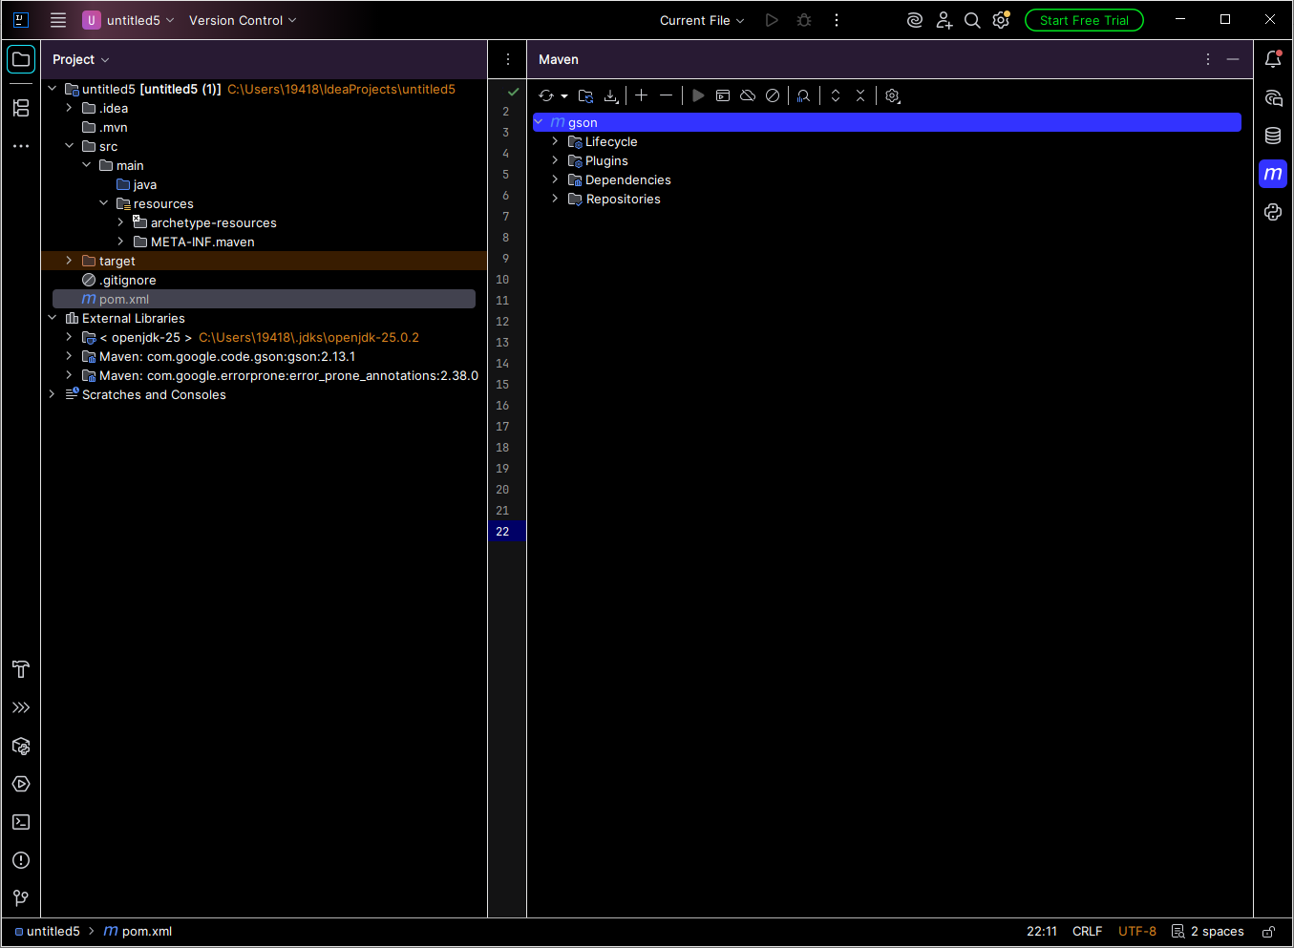

Figure 3. GsonExample.java source code with successful program output.
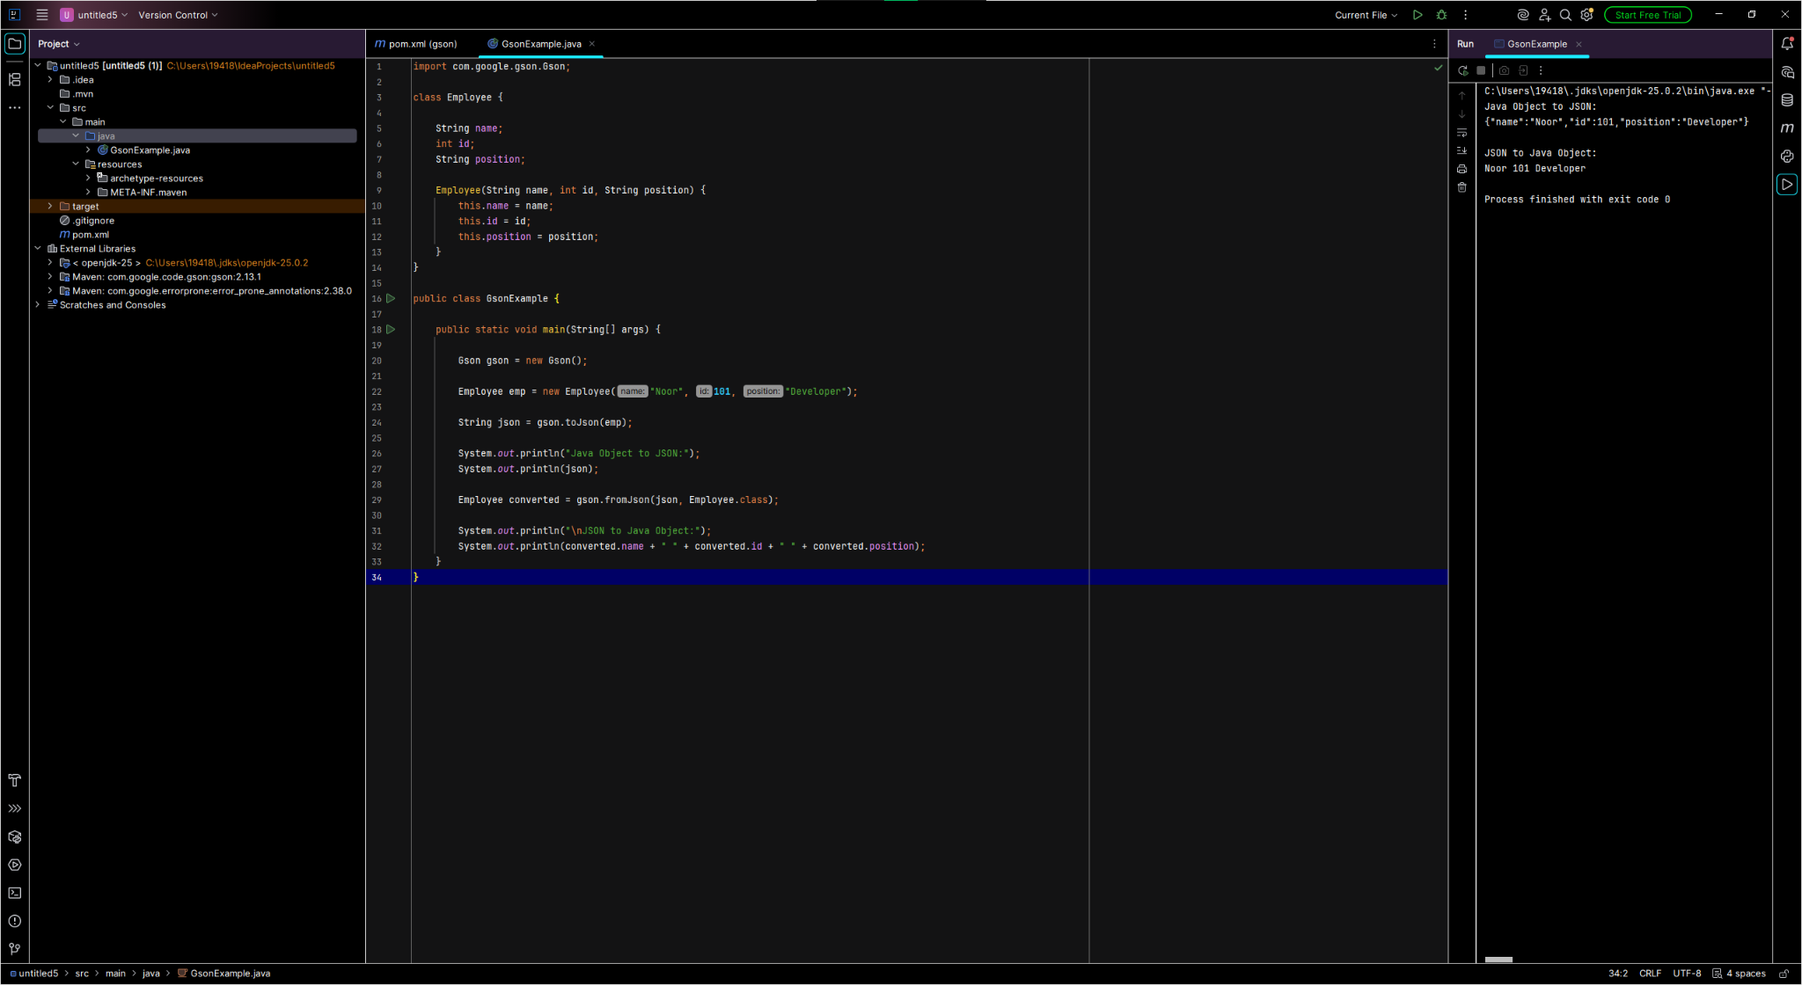

Figure 4. Program output showing Java object to JSON and JSON to Java object conversion.
