CSD420 Advanced Java Programming

Module 2.2 Programming Assignment
Name: Noor Al Salihi
Date: April 02, 2026
Assignment: Write and Read Data from a File

Description
This assignment contains two Java programs. One program writes random integer and double arrays to a file. If the file already exists then data will be appended. The other program reads the file and displays its contents. Both programs were tested successfully.

Screenshots
WriteDataFile Program Running
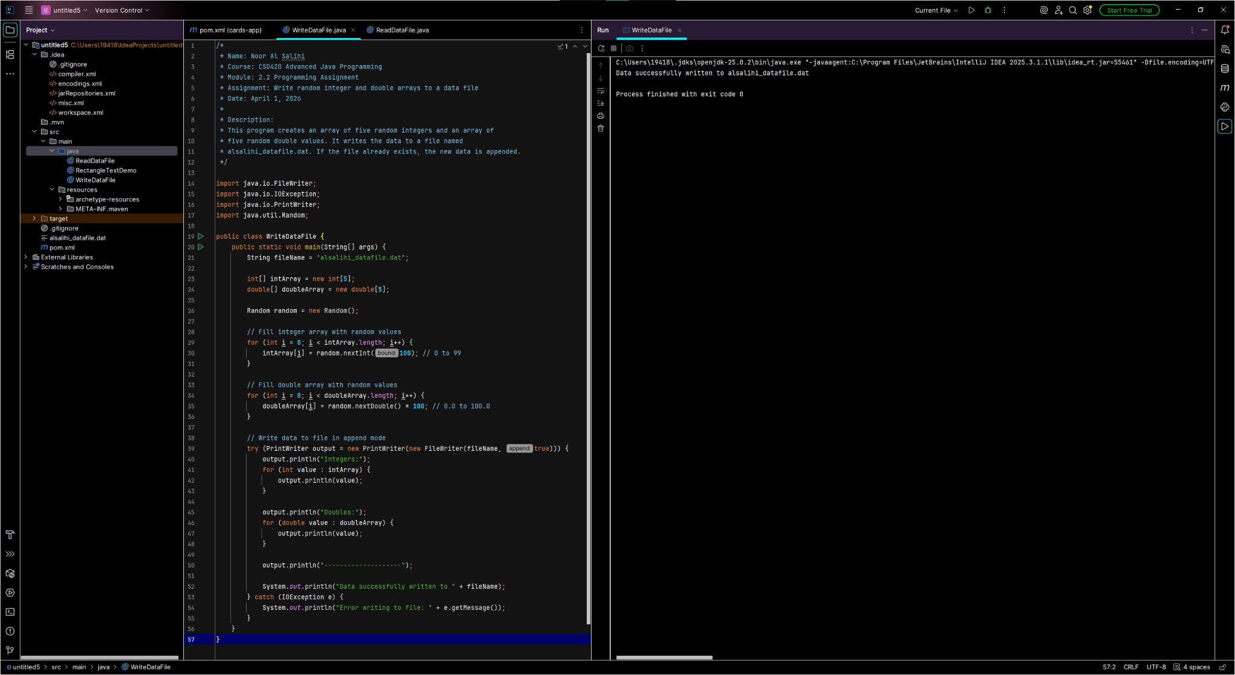
ReadDataFile Output
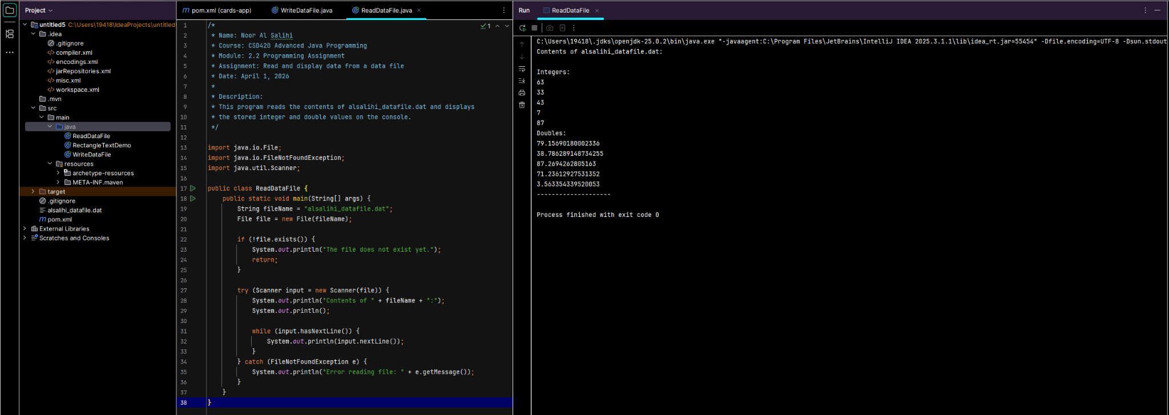
Project and Code View
