Module 8.2 Programming Assignment
ThreeThreads JavaFX Program
Name: | Noor Al Salihi
Class: | CSD420-340A Advanced Java Programming (2265-DD)
Assignment: | Module 8.2 Programming Assignment
Date: | April 30, 2026

Description: Screenshots of Module 8.2 JavaFX program, Maven setup, source code, test output, and successful run. Concurrently three threads that write random letters, digits, and special characters interleaved to a Text Area. Each thread writes at least 10,000 characters

. Screenshots
Figure 1: JavaFX application window cleared and ready to start threads.
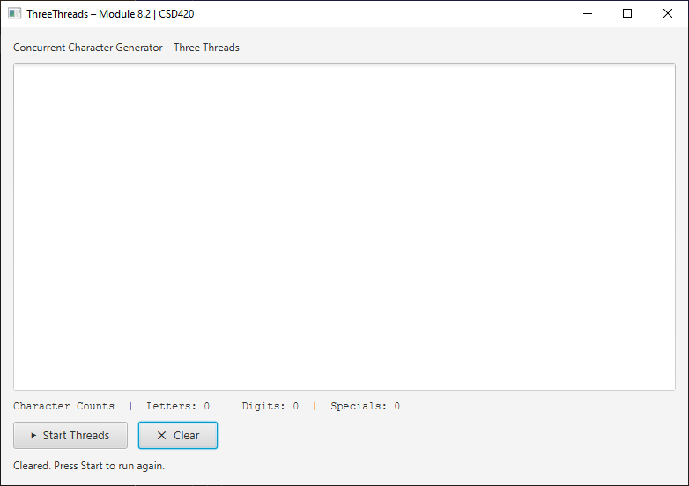

Figure 2: Running JavaFX application showing mixed letters, digits, and special characters with 10,000 counts for each thread.
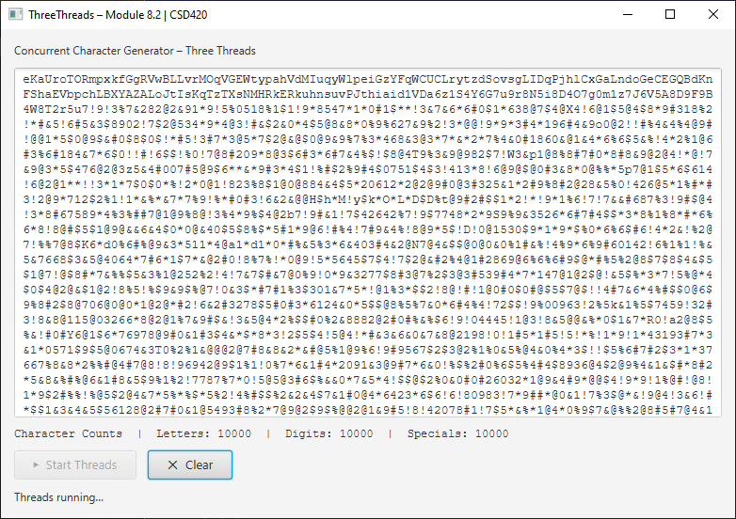

Figure 3: Maven pom.xml configuration for JavaFX and main class NoorThreeThreads.
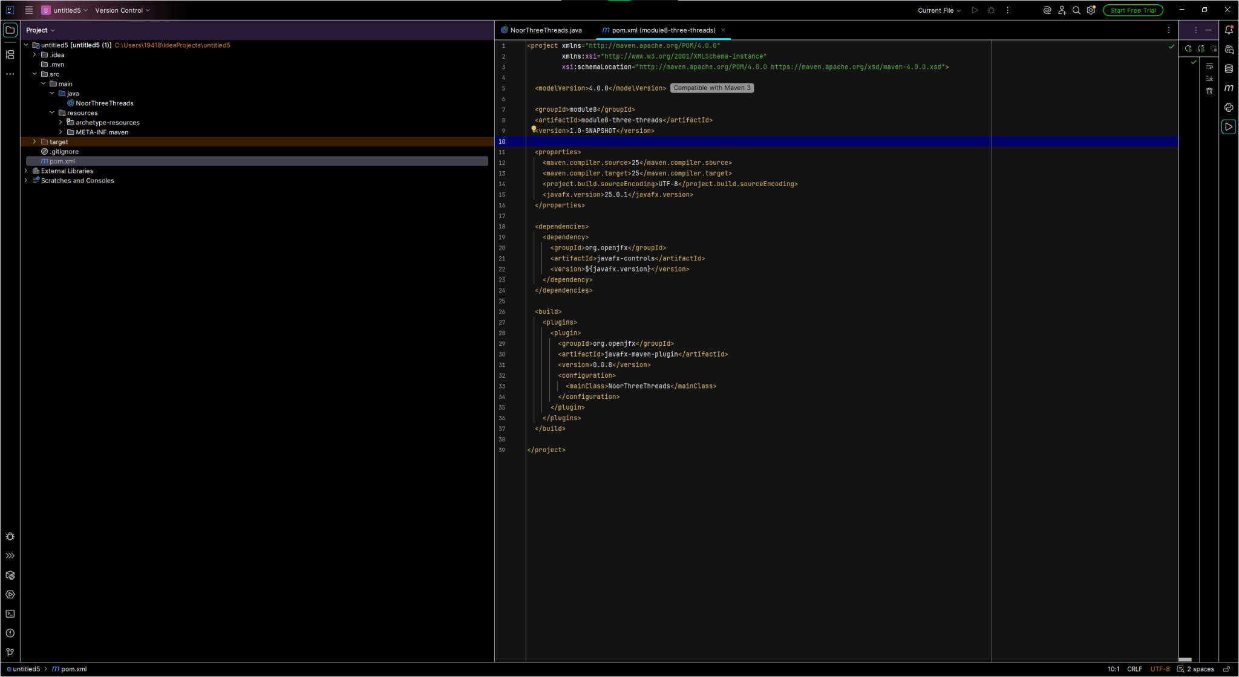

Figure 4: NoorThreeThreads.java documentation, imports, class declaration, and constants.
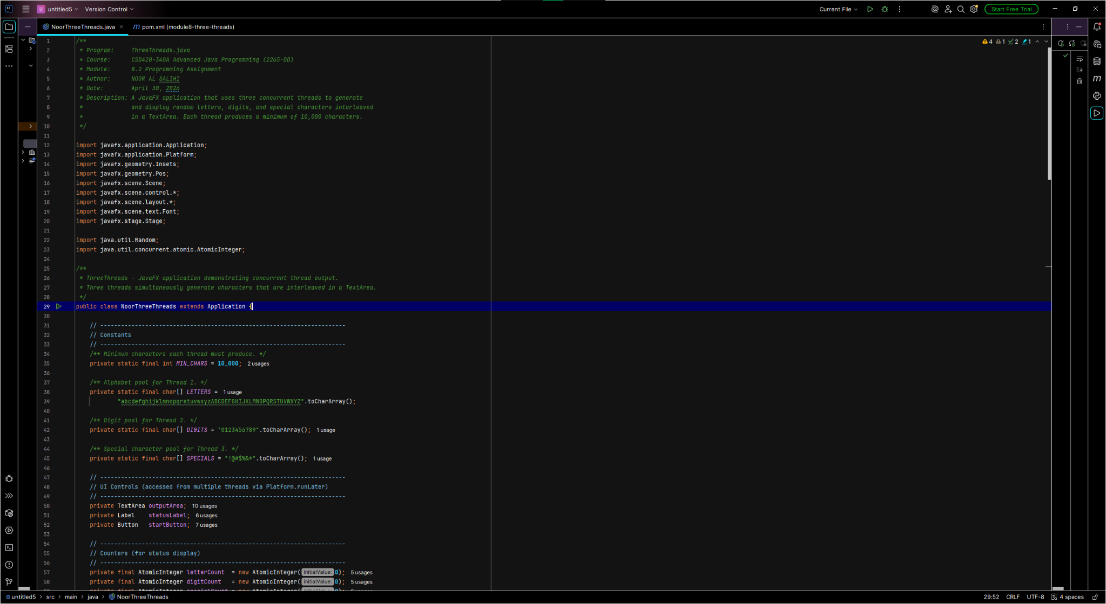

Figure 5: JavaFX user interface setup and clear button test code.
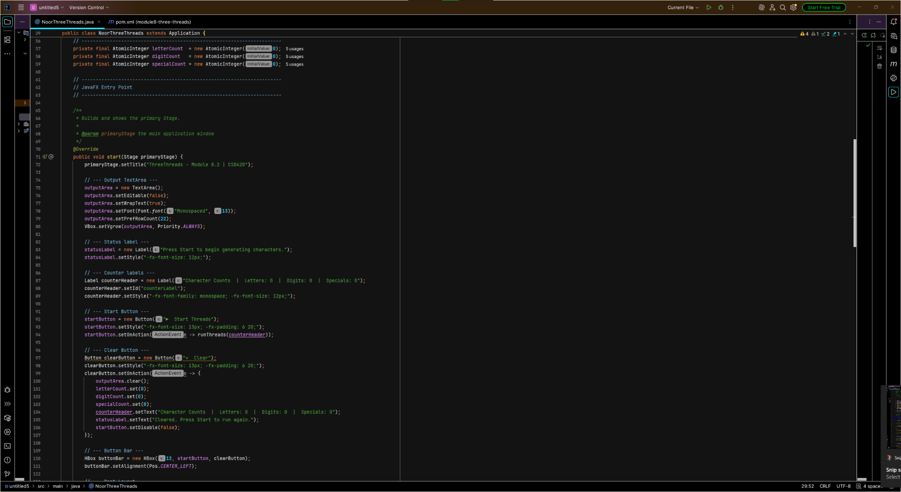

Figure 6: Thread orchestration code creating letter, digit, and special-character threads.
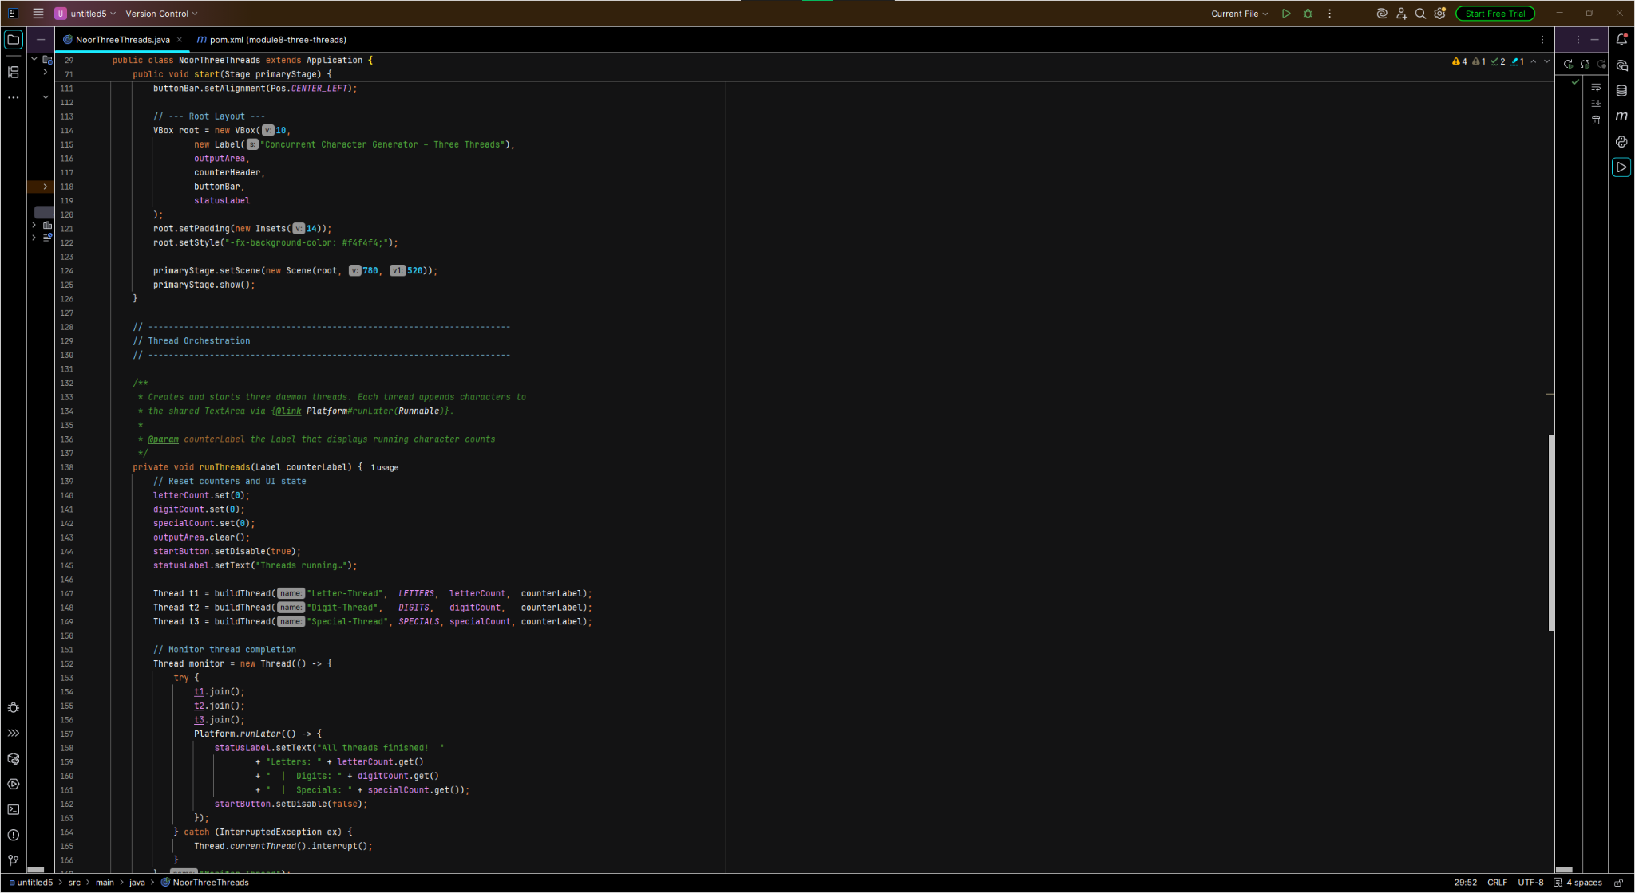

Figure 7: Thread start and monitor code verifying all three threads complete.
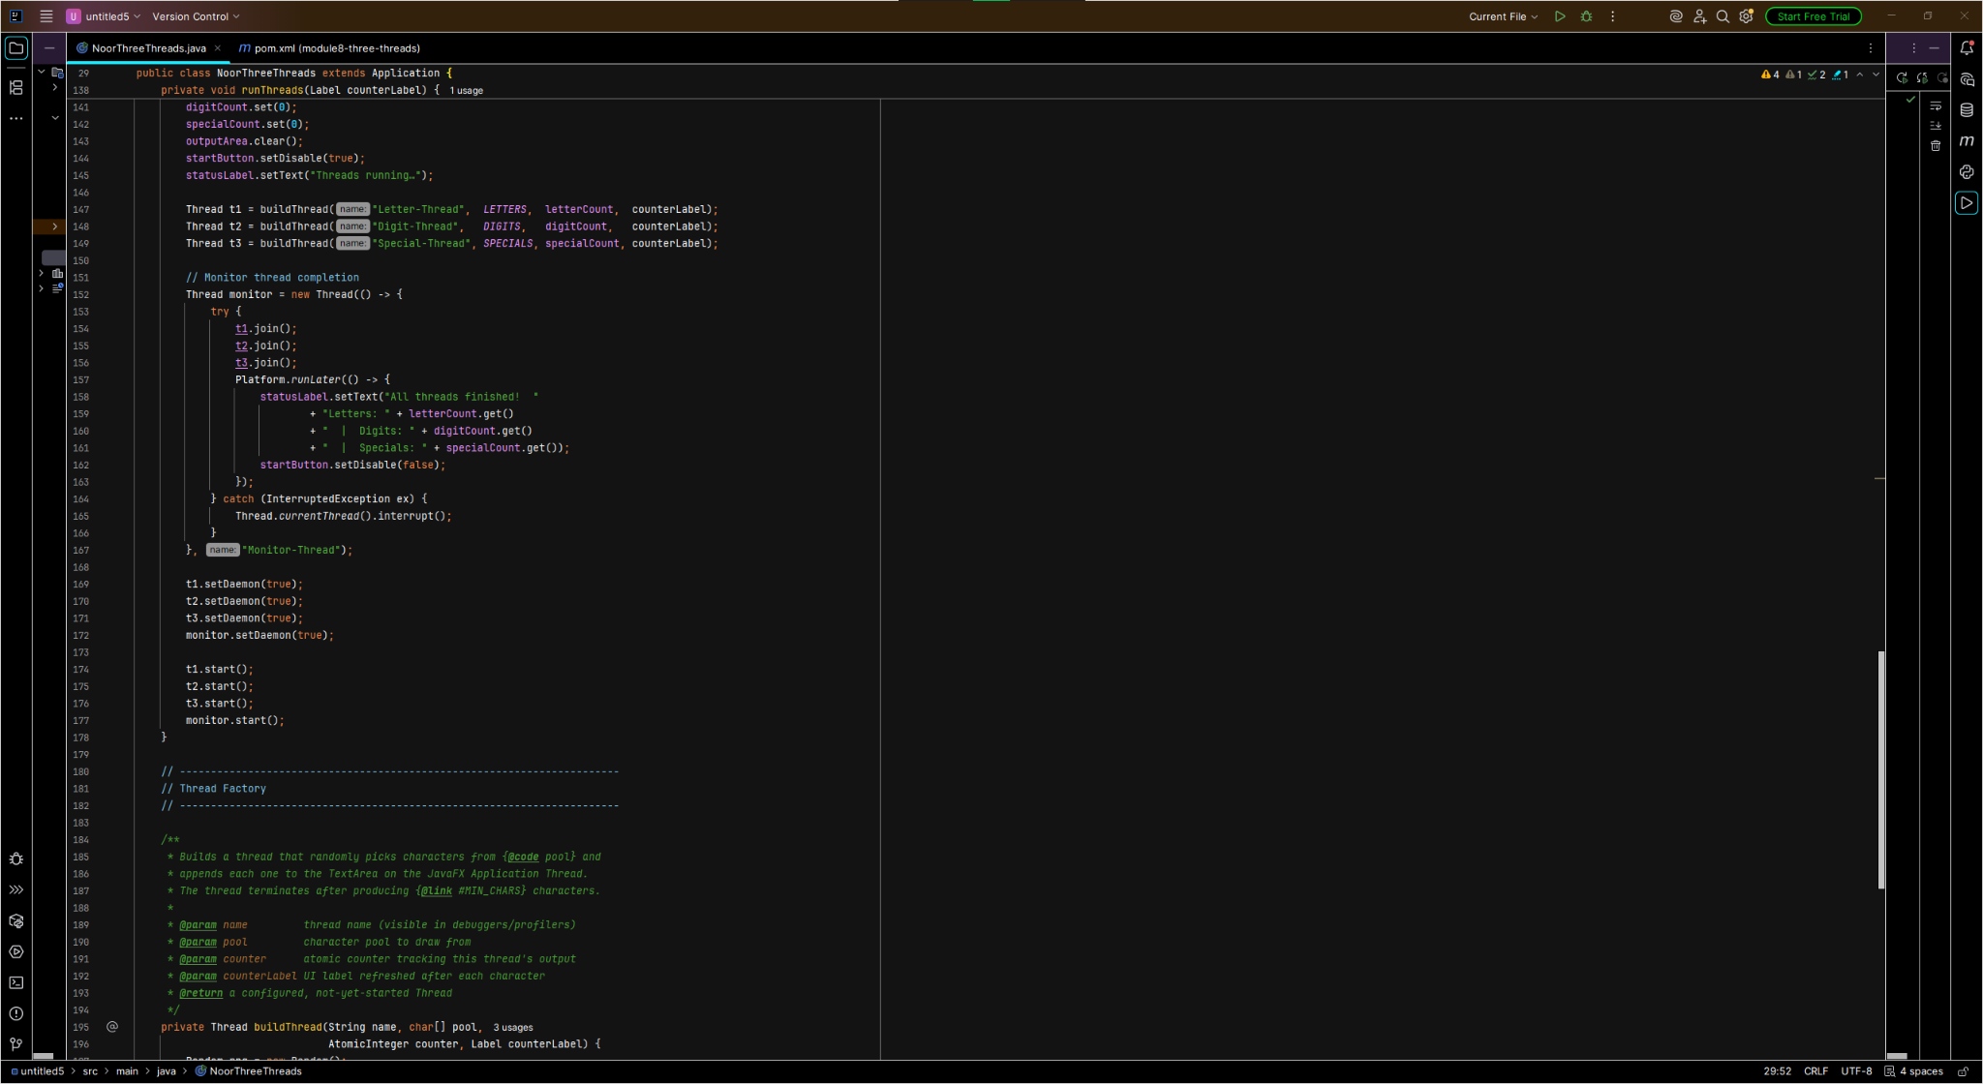

Figure 8: Thread factory logic that generates random characters and updates the JavaFX TextArea.
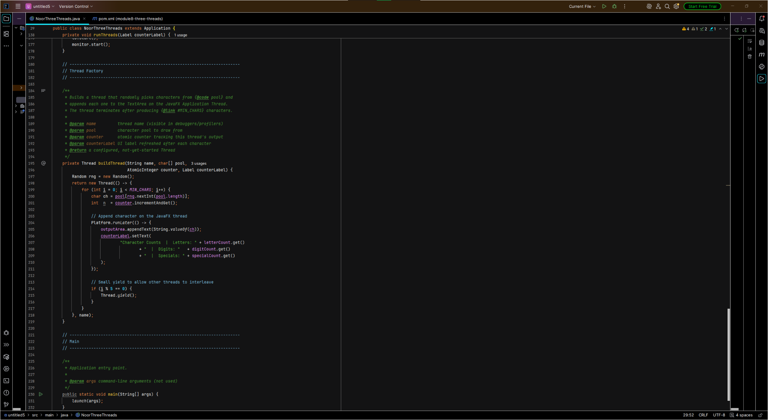

Figure 9: Maven run console showing successful build and JavaFX execution.
