CSD420-340A Advanced Java Programming
Module 6.2 Programming Assignment
Bubble Sort Using Comparable and Comparator

Name: Noor Alsalihi
Date: April 22, 2026
Assignment Number: Module 6.2
Course: CSD420-340A Advanced Java Programming

Description
These are the screenshots for Module 6.2. They are screenshots of my Bubble_Sort.java program, the successful run of the program output, Java runtime version installed, Java compiler version installed, and JavaFX installed in pom.xml. They prove that Java and JavaFX are installed and configured properly and that the program runs correctly.
Figure 1. Bubble_Sort.java code in IntelliJ
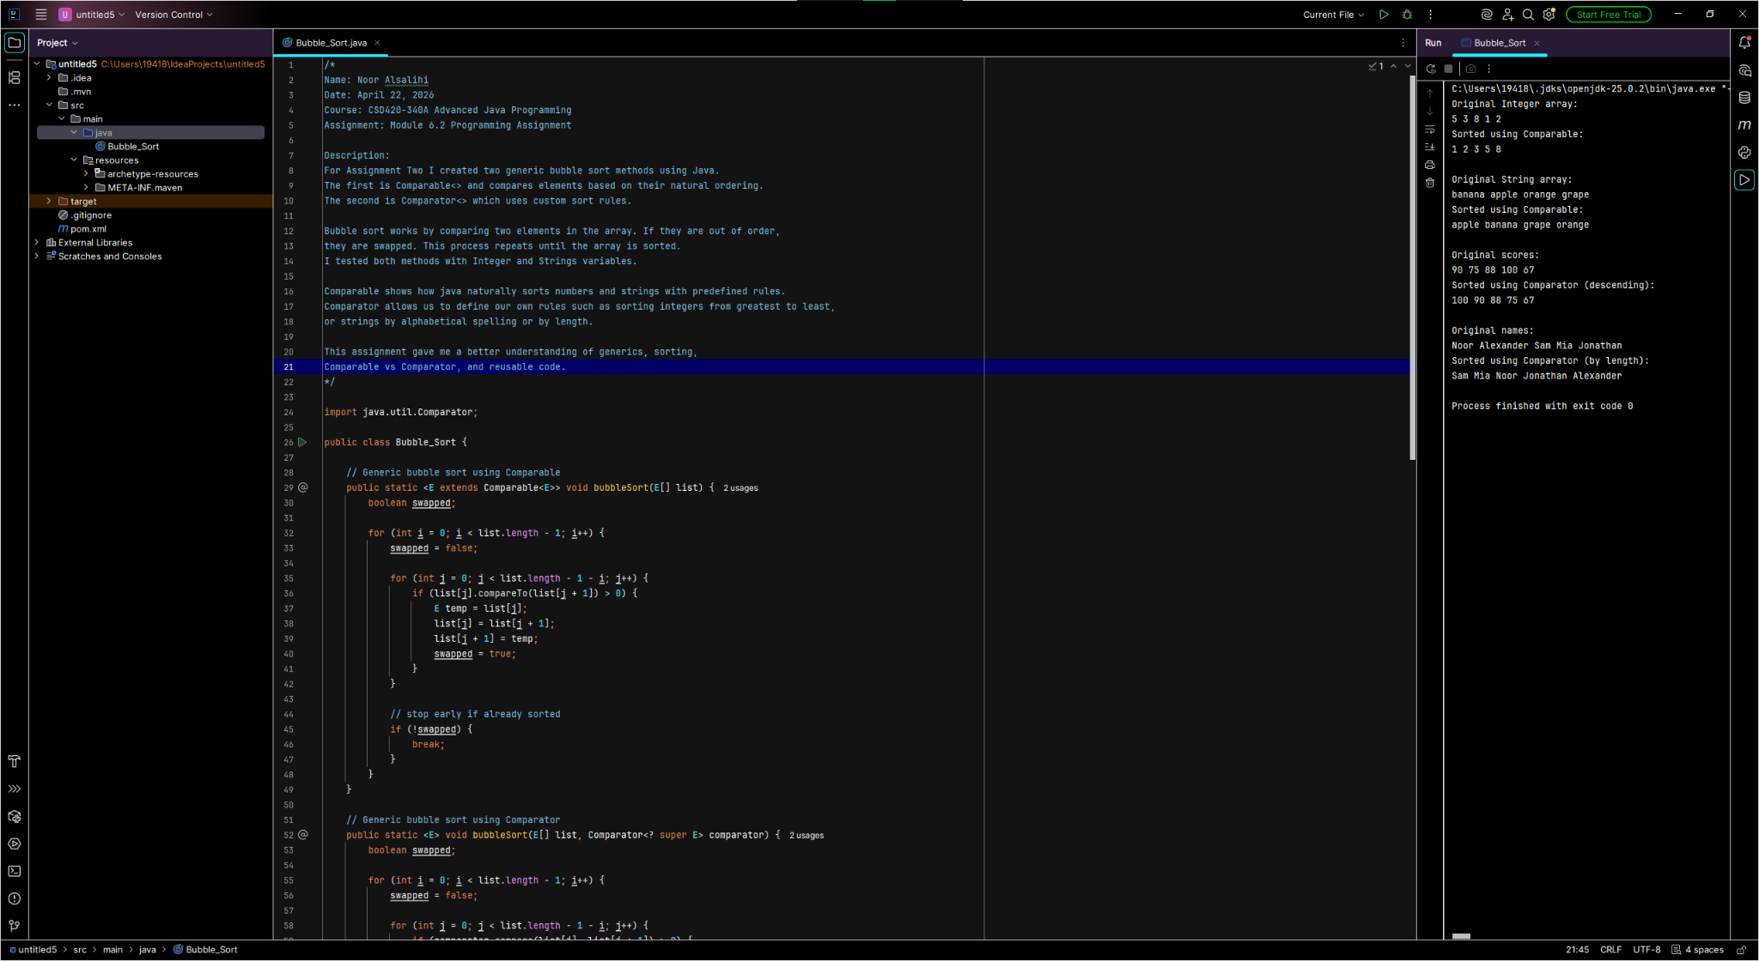

Figure 2. Program output from Bubble_Sort.java
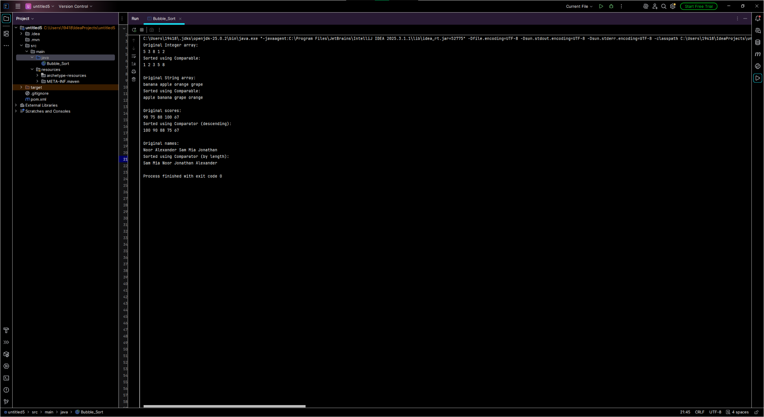

Figure 3. Java runtime version (java -version)
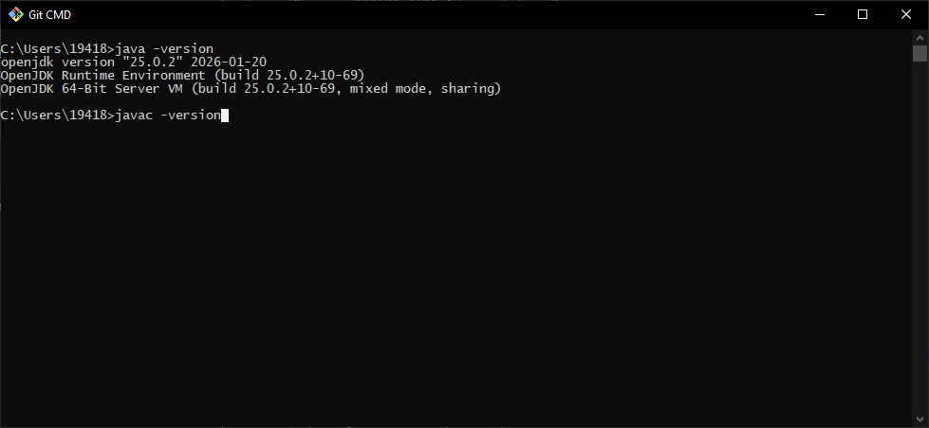

Figure 4. Java compiler version (javac -version)
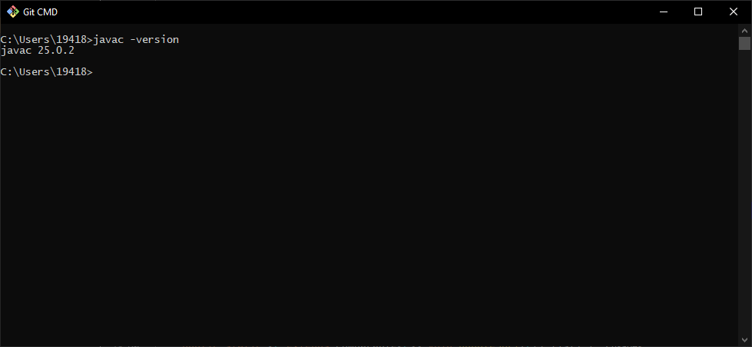

Figure 5. JavaFX configuration shown in pom.xml
