Module 3.2 Programming Assignment
Name: Noor Alsalihi
Course: CSD420-340A Advanced Java Programming
Assignment: Module 3.2 Programming Assignment
Date: 04/10/2026

Java Version (CMD)
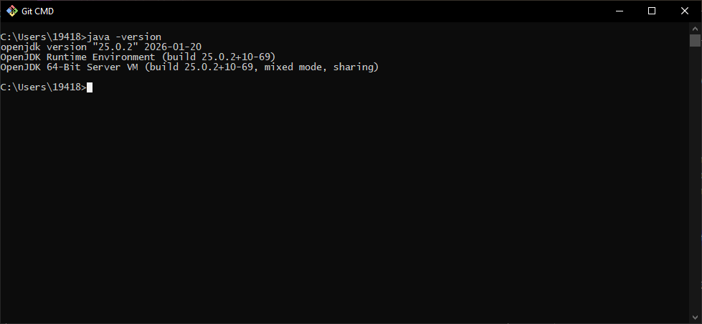

IntelliJ Project / Code
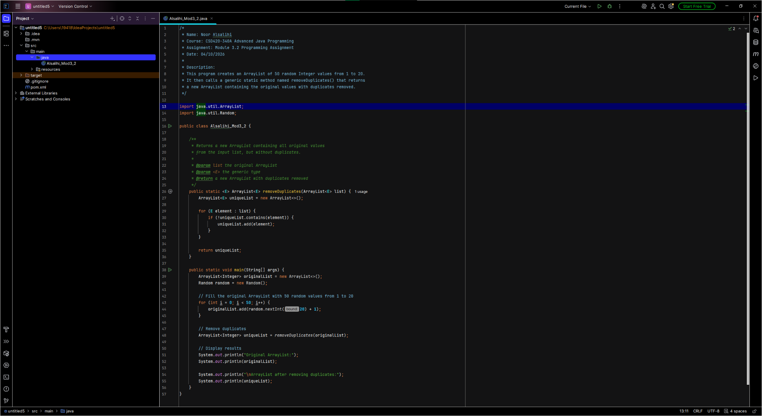

Program Output
