Name: Noor Al Salihi
Class: CSD420-340A Advanced Java Programming (2265-DD)
Assignment: Module 7.2 Programming Assignment
Date: May 01, 2026

Module 7.2 JavaFX CSS Assignment
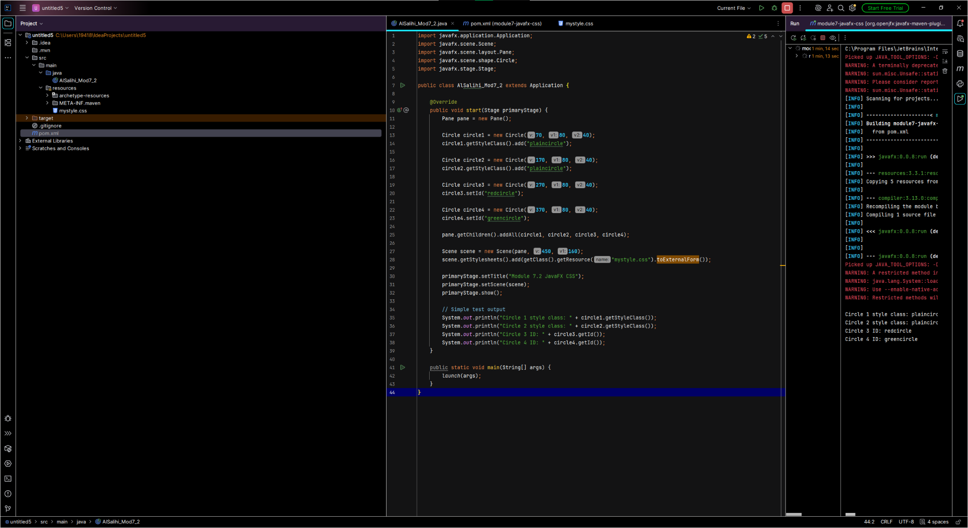
Figure 1: Java Code (AlSalihi_Mod7_2.java)

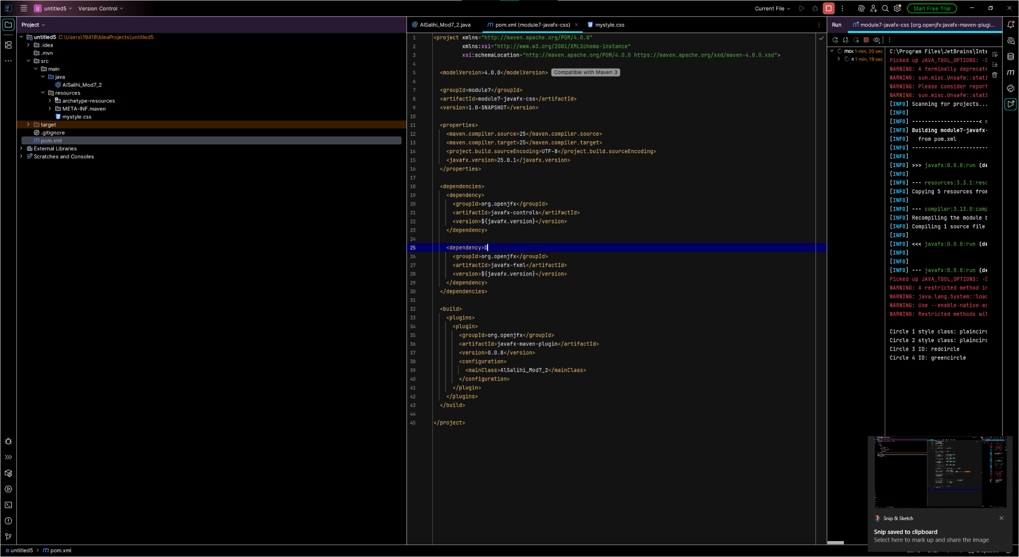
Figure 2: pom.xml Configuration

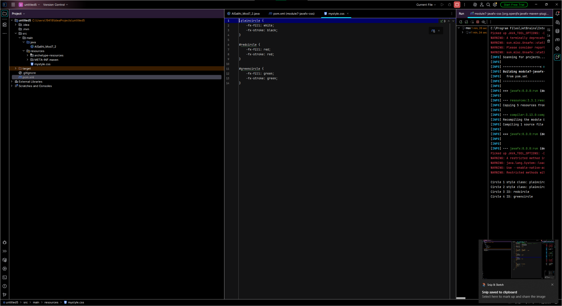
Figure 3: CSS File (mystyle.css)

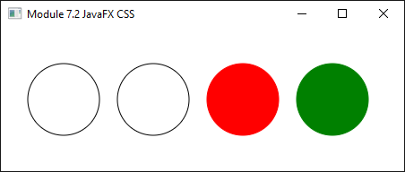
Figure 4: Running JavaFX Application Output

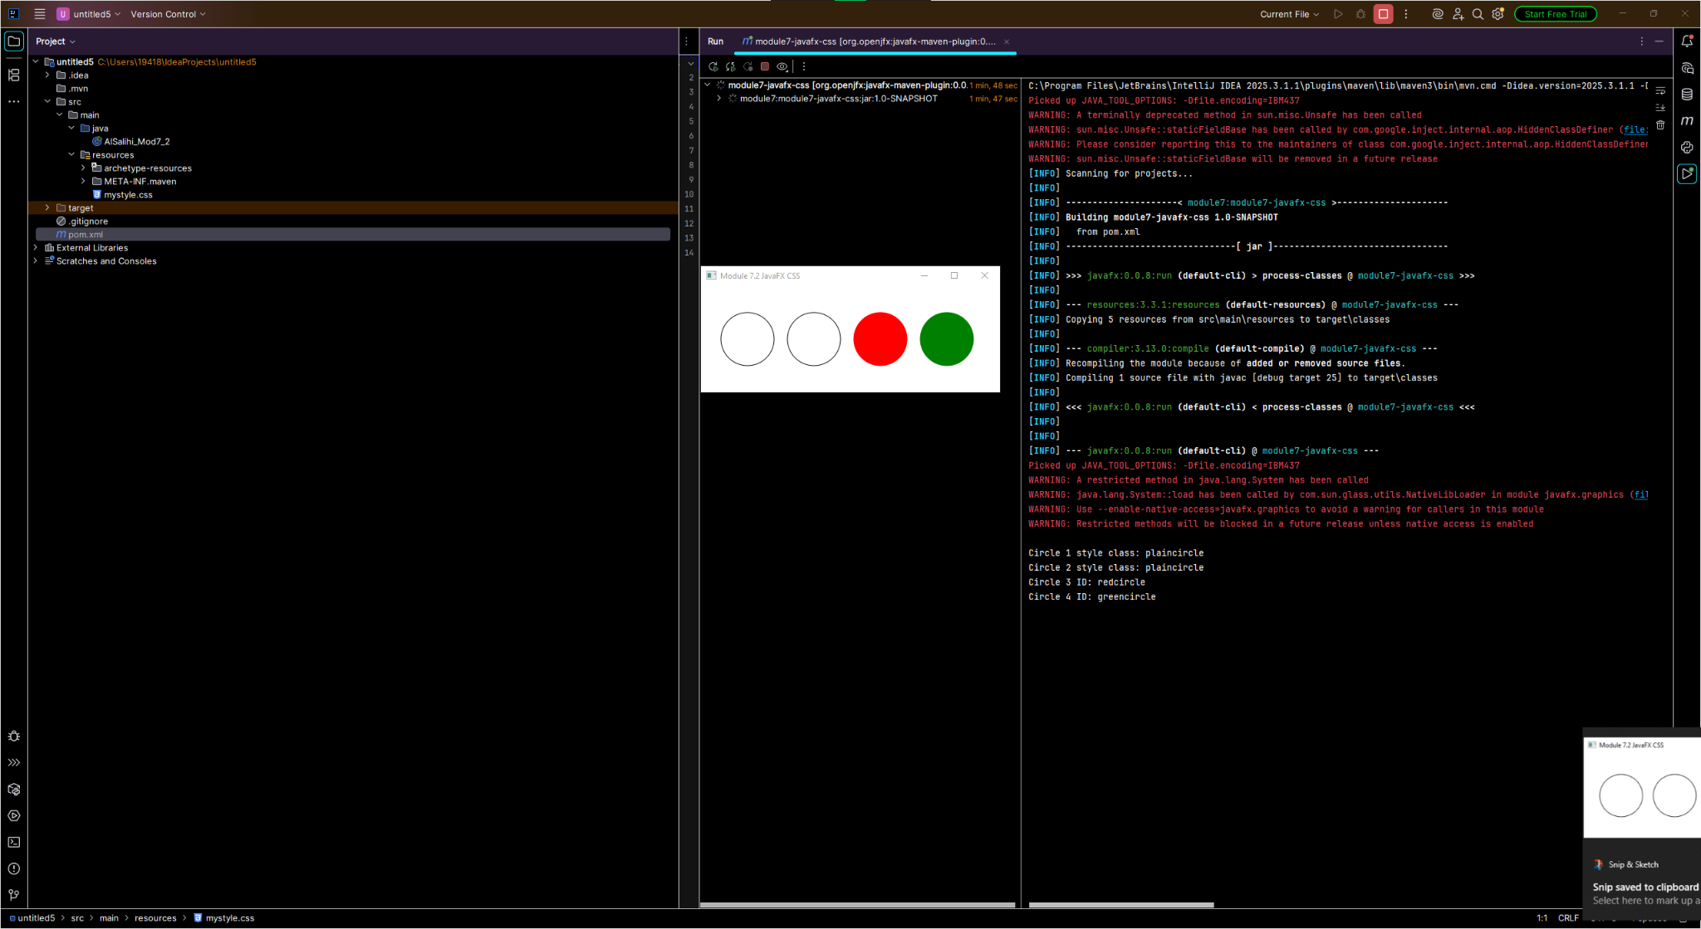
Figure 5: Maven Execution and Console Output

