Module 1.3 Programming Assignment - Screenshots
Name: Noor Alsalihi
Course: CSD420-340A Advanced Java Programming
Assignment: Module 1.3
Date: March 28, 2026

Figure 1
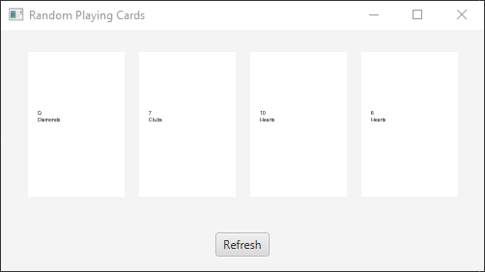

Figure 2
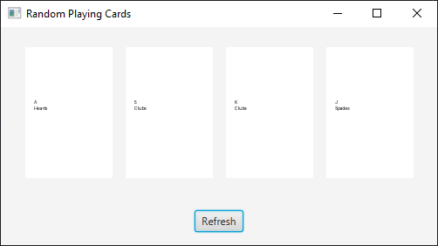

Figure 3
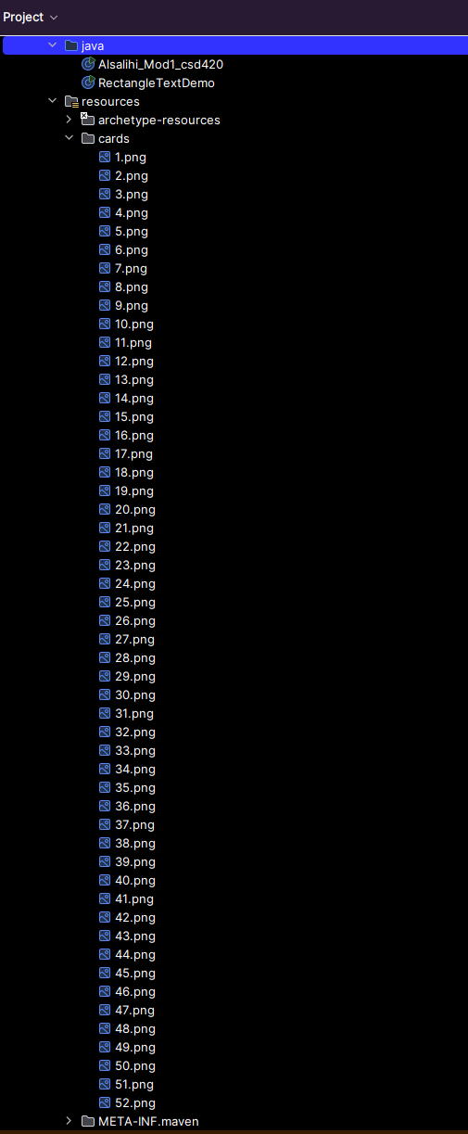

Figure 4
