CSD430-340A Server Side Development (2267-DD)

Module 2.2 Programming Assignment
Student Name: Noor El-din Al Salihi
Assignment: Module 2.2 Programming Assignment
Date: June 2026

Assignment Description
This document provides screenshots demonstrating the successful completion of the JSP assignment using Scriptlets, external CSS, and Apache Tomcat.

IntelliJ Project Structure and JSP Code
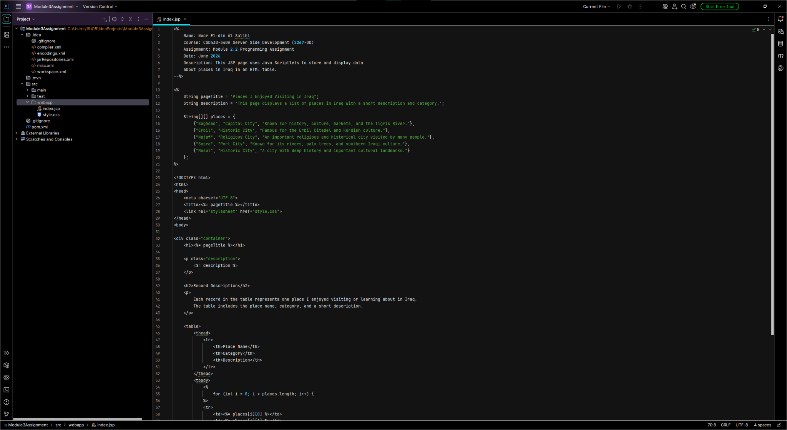

Tomcat Execution
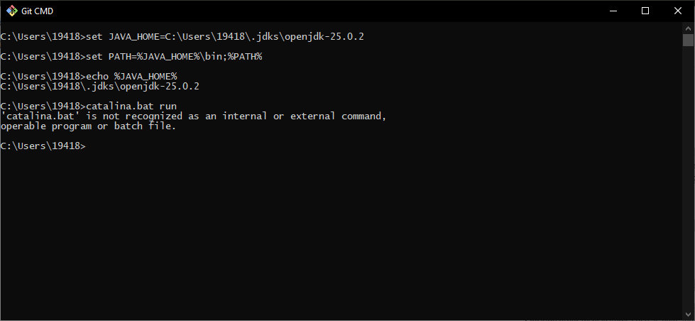

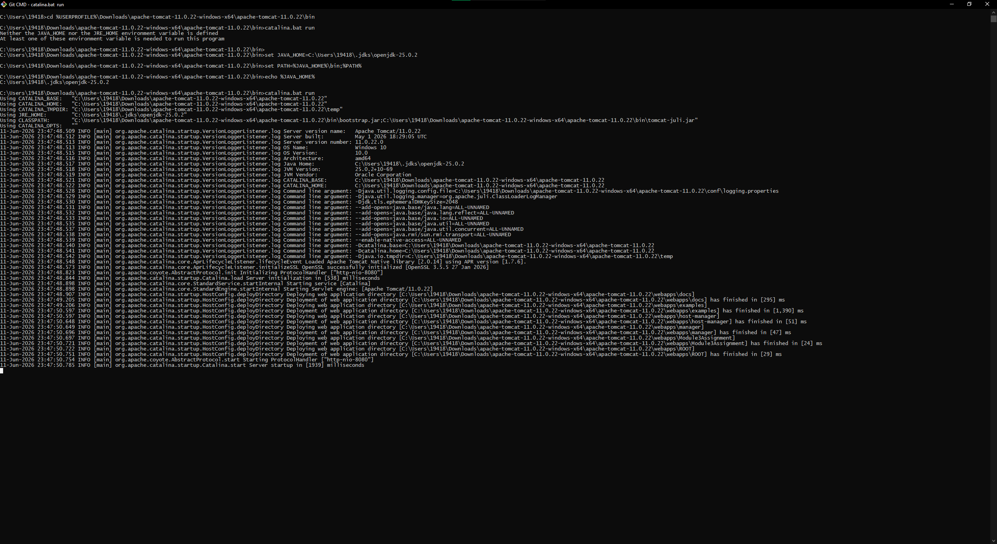

Final JSP Output in Browser
