Module 9.2 – CRUD DELETE & JavaBeans
Project Part 4 Documentation
Name: Noor El-din Al salihi
Course: CSD430-340A Server Side Development
Assignment: Module 9.2 – Working with CRUD-DELETE & JavaBeans – Project Part 4

Figure 1. Main application page showing Create, Display, Update, and Delete sections.
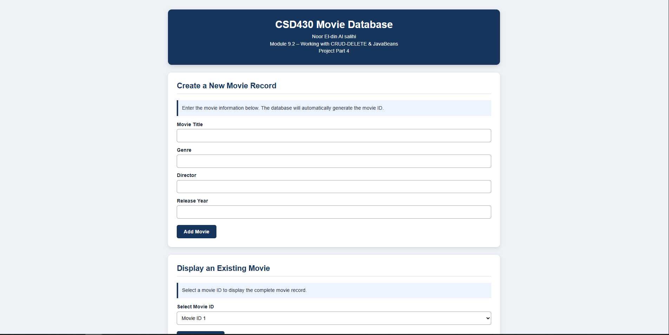

Figure 2. Delete page displaying all movie records in an HTML table.
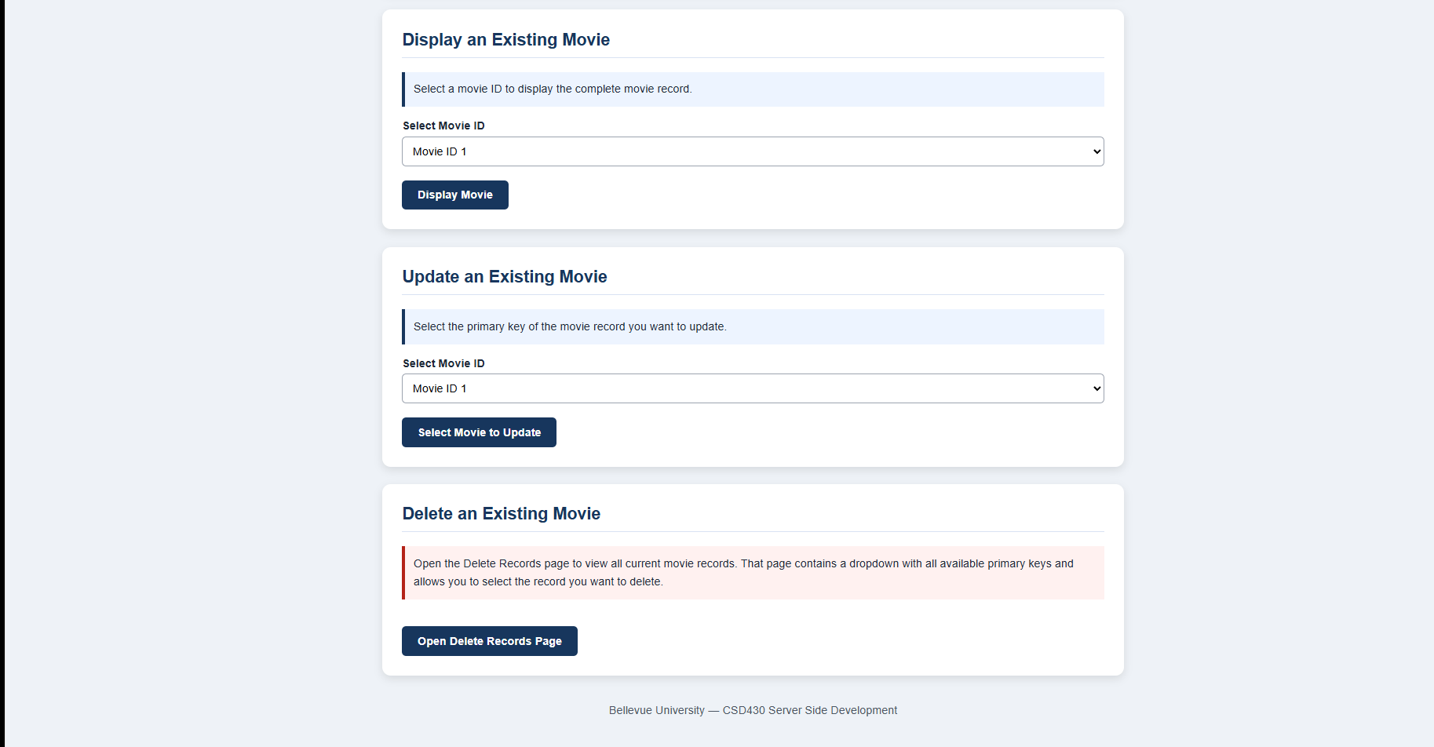

Figure 3. Delete page with remaining movie keys available for deletion.
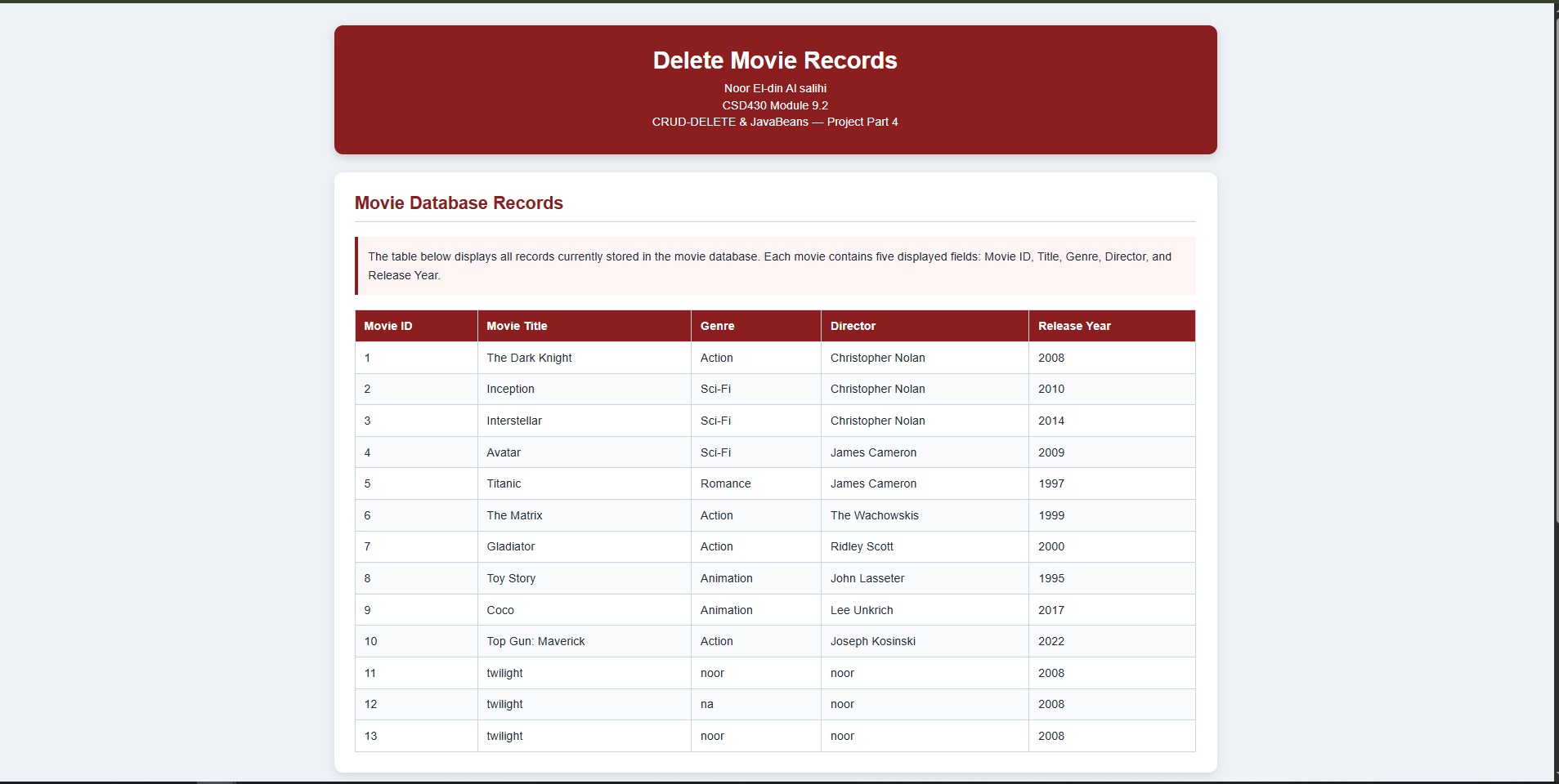

Figure 4. Successful deletion of a selected movie record.
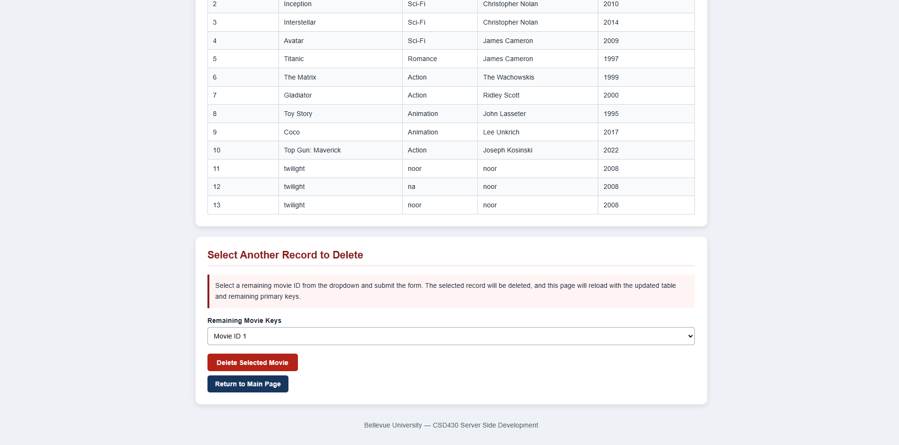

Figure 5. Remaining records displayed after deletion.
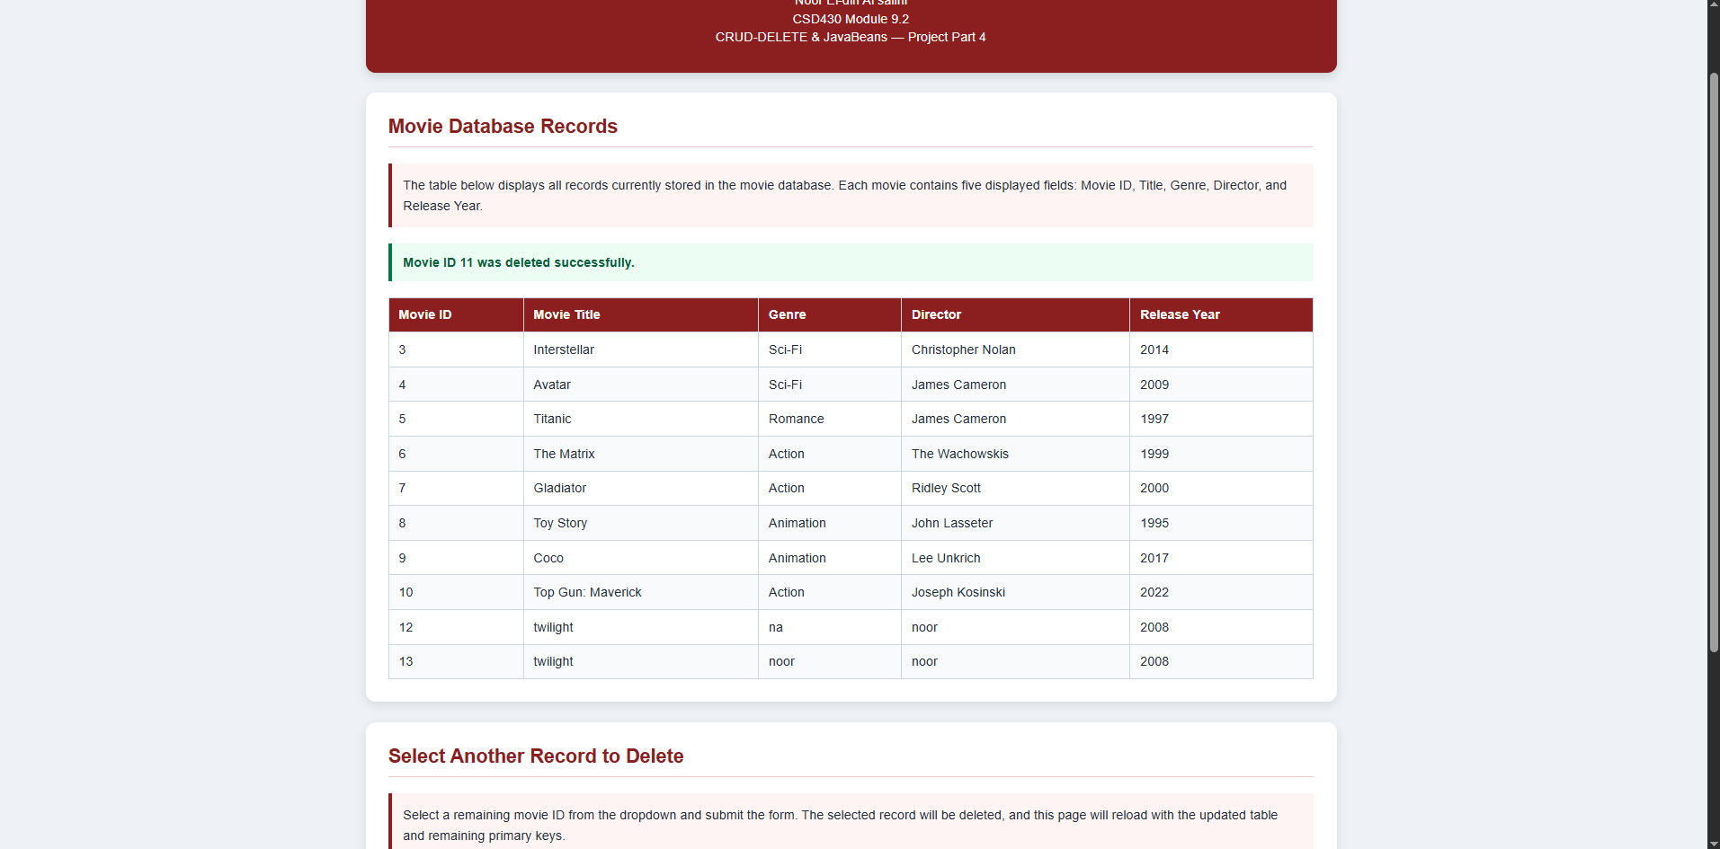

Figure 6. Empty table with table header still visible after all records have been deleted.
