CSD430-340A Server Side Development
Module 1.3 Programming Assignment
Student Name: Noor Al Salihi
Assignment: Module 1.3
Date: June.7. 2026

Objective
The objective of this assignment was to install and configure Java and Apache Tomcat, create a JSP application using IntelliJ IDEA, deploy it to Tomcat, and verify that the application executes successfully through a web browser.

Implementation and Screenshots

Java Version Verification
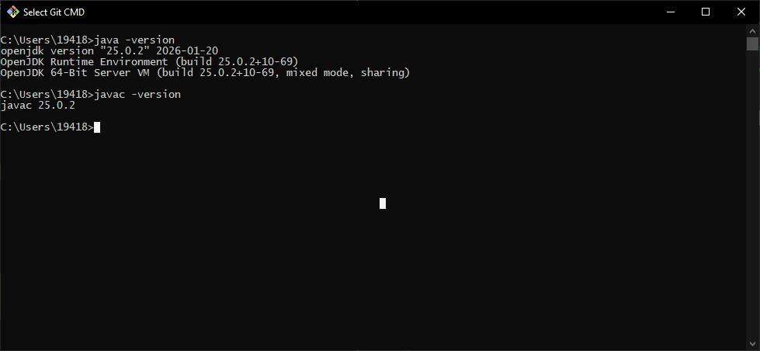

Tomcat Environment Check
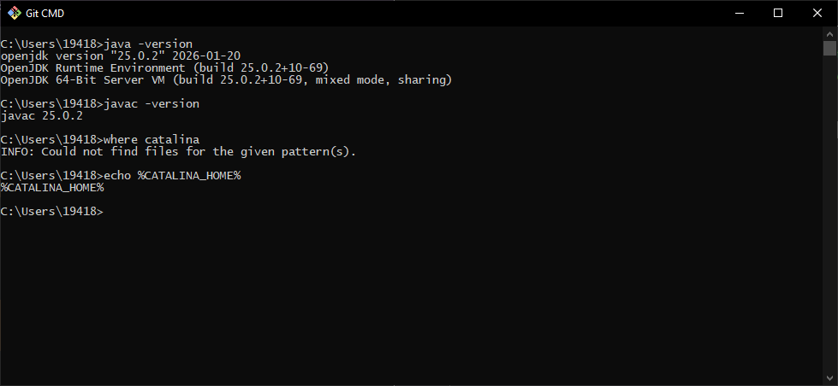

Apache Tomcat Download Page
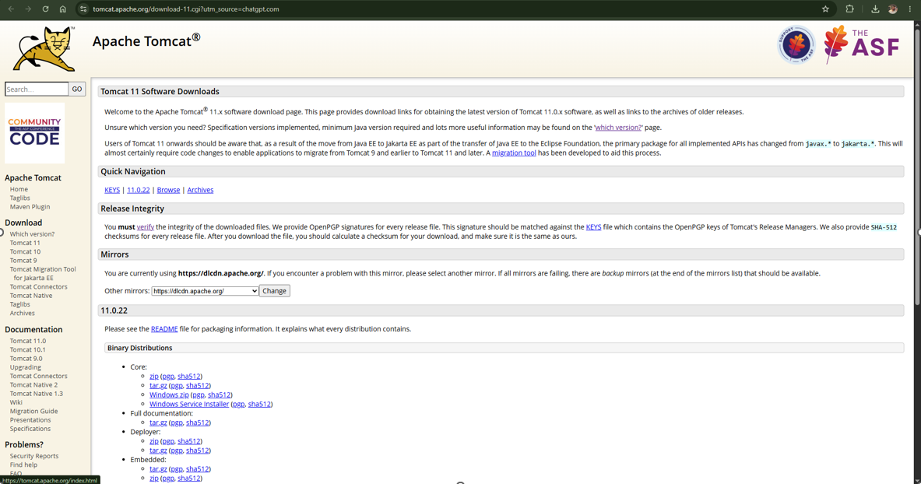

Tomcat Downloaded ZIP File
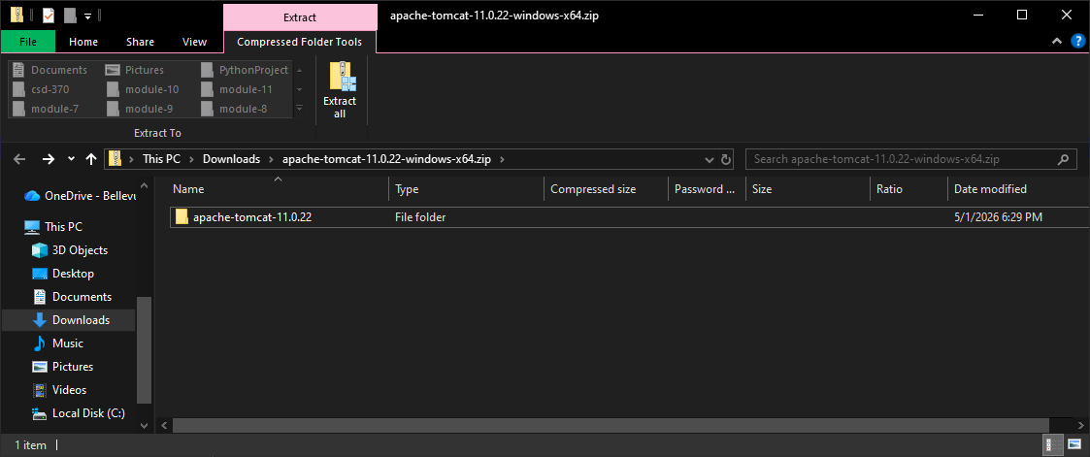

Tomcat Folder Structure
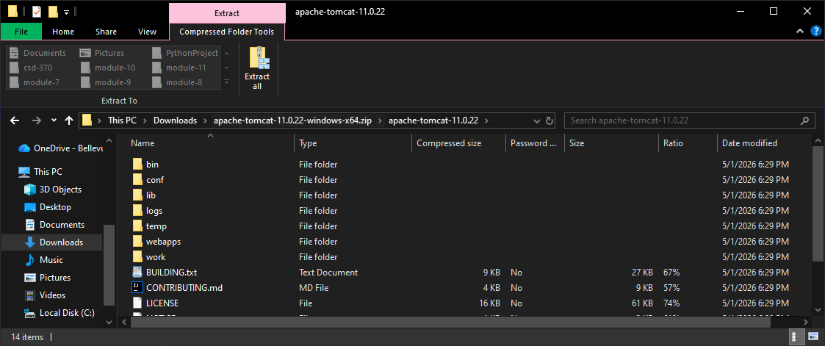

Tomcat Startup Execution
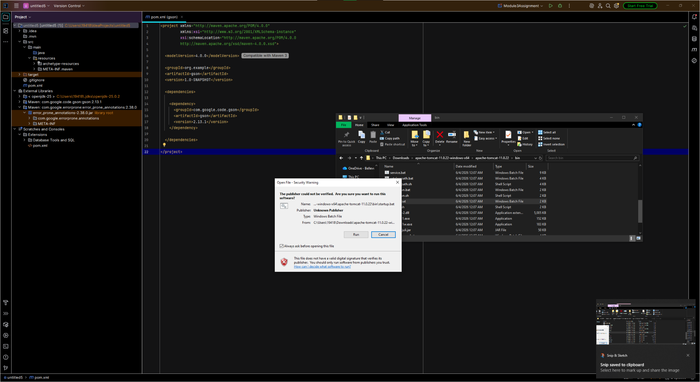

Tomcat Welcome Page
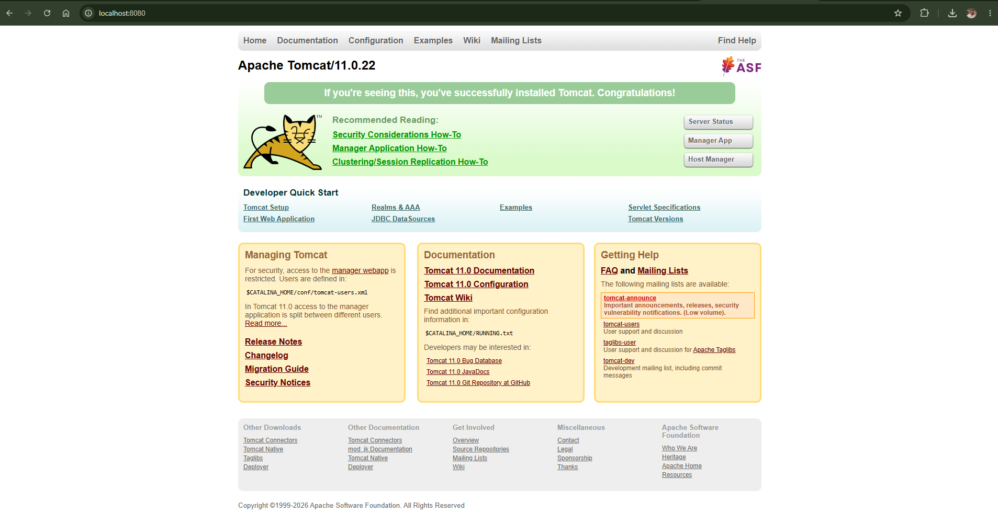

IntelliJ Maven Project Setup
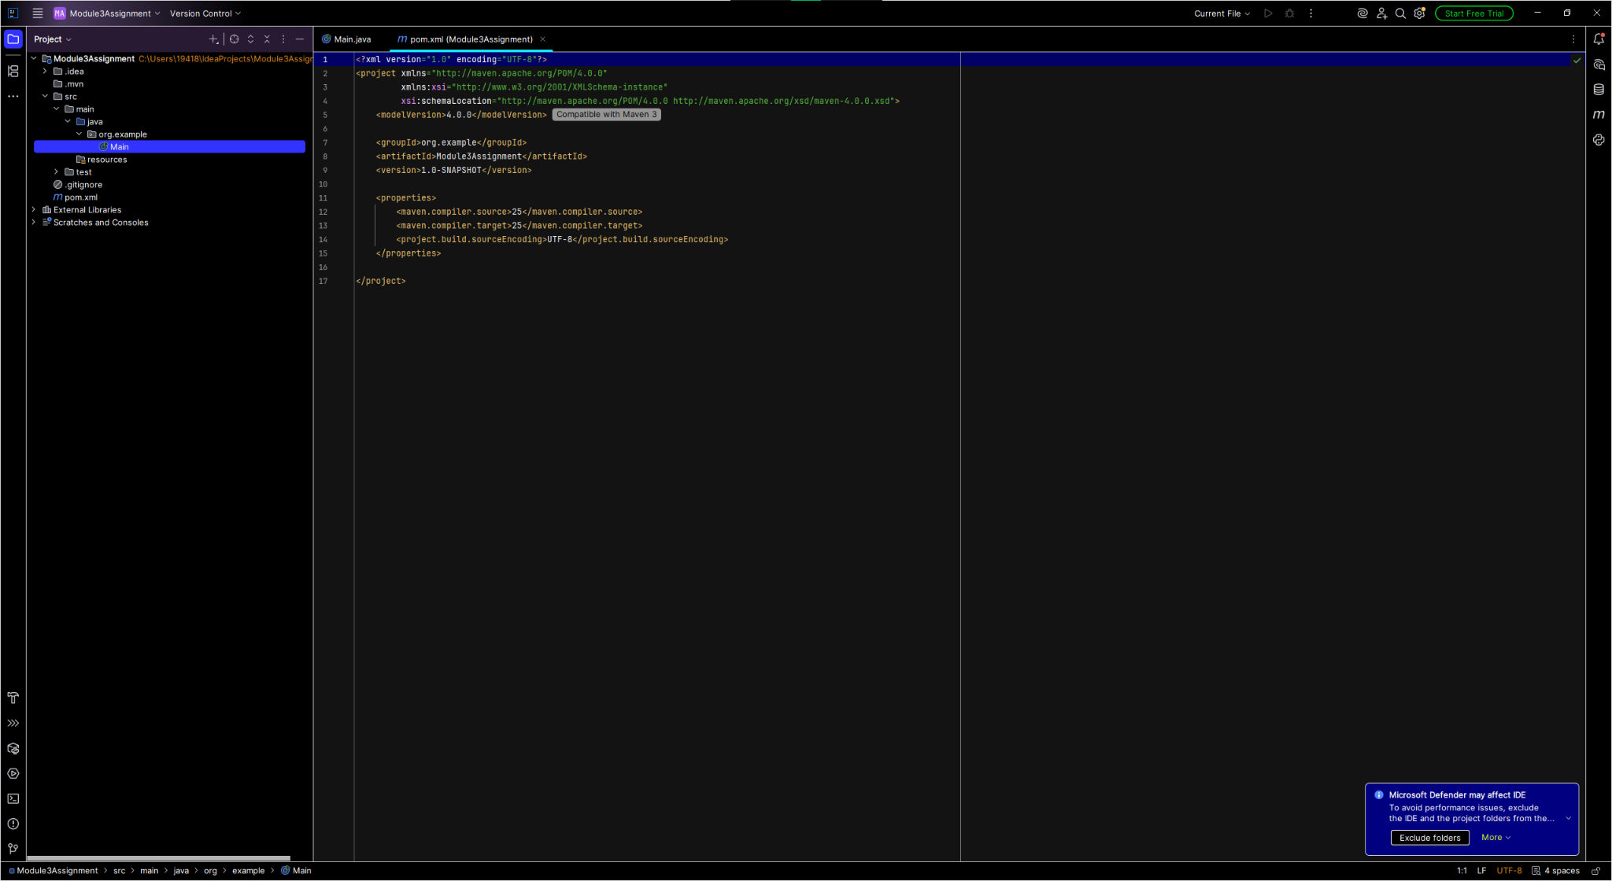

JSP Source Code (index.jsp)
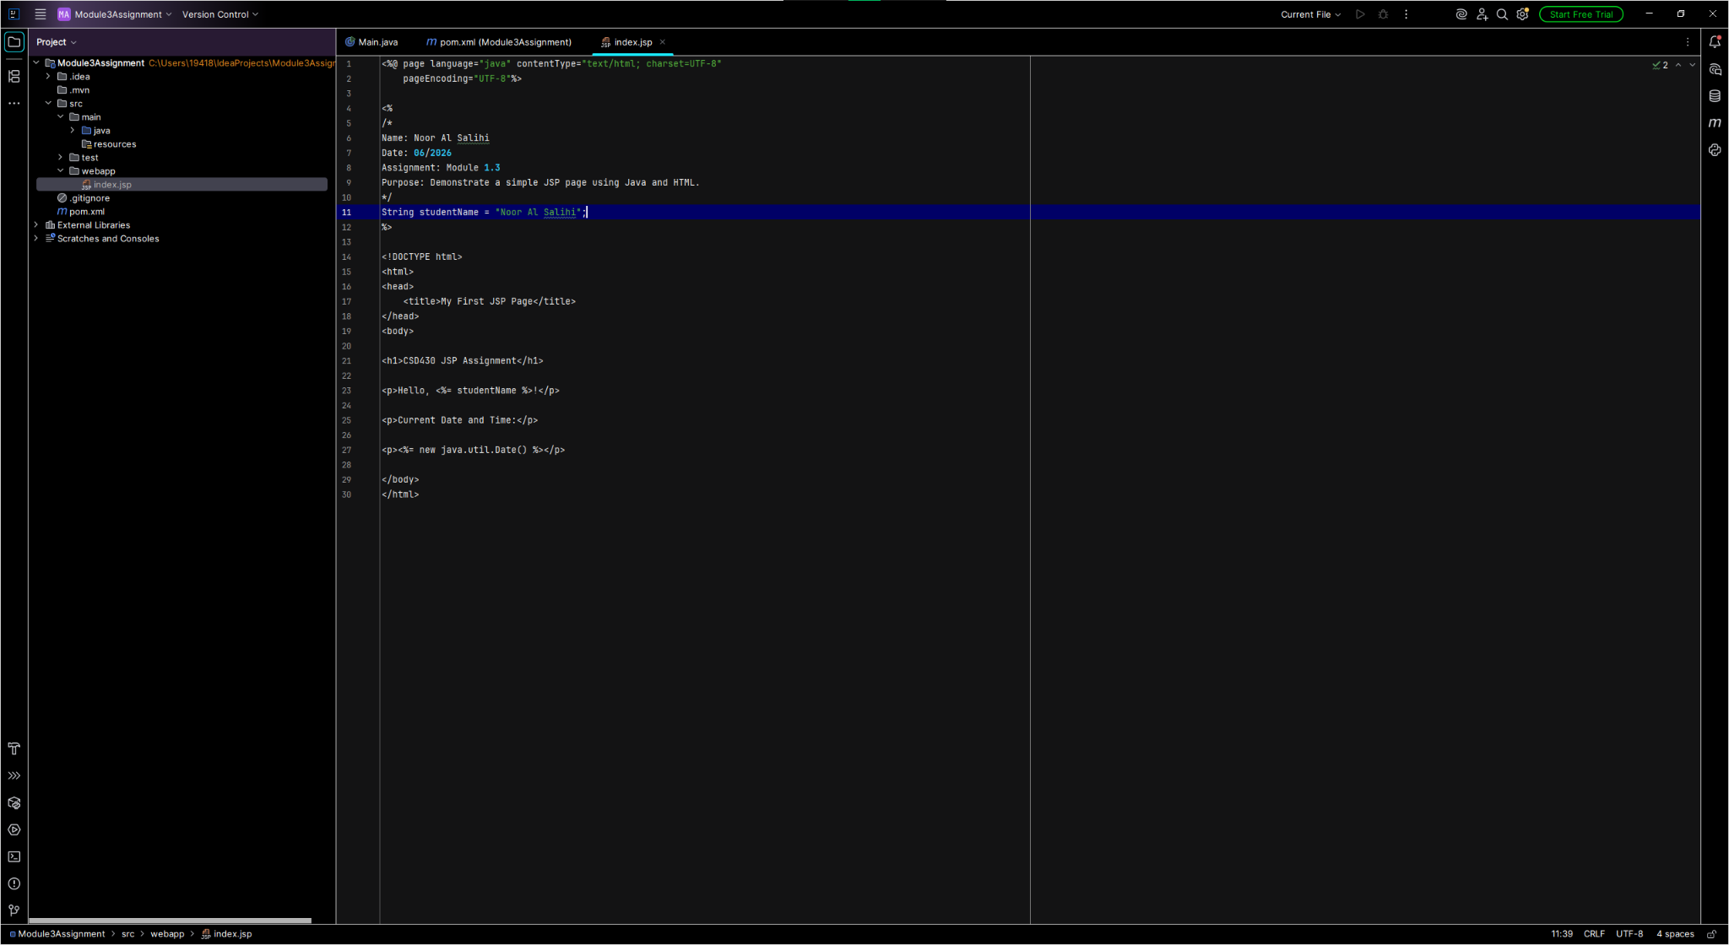

Final JSP Output
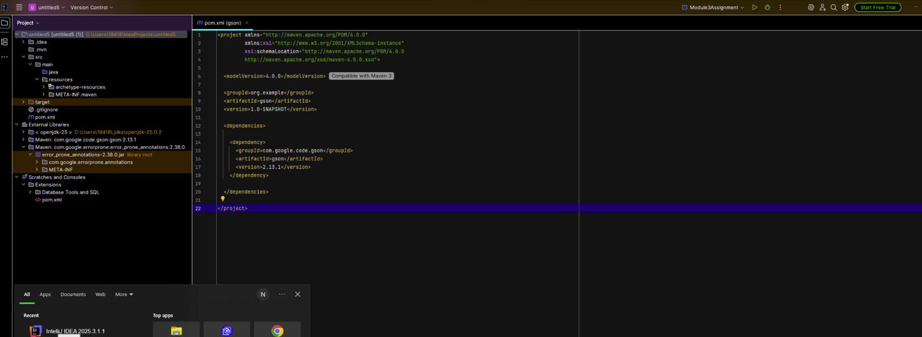

Conclusion
Every instruction for the assignment was followed. Java and Apache Tomcat were installed properly, the JSP page was made through IntelliJ IDEA, and deployed/run through Apache Tomcat server.

