CSD430-340A Server-Side Development
Module 1.2 Assignment: GitHub Repository Setup
Student: Noor Al Salihi

GitHub Repository Link
https://github.com/nalsali98/csd-430

Assignment Summary

This repository is how I created a repository from GitHub via Gitbash (CLI). Created repository csd-430 from GitHub, Initialized Git with global username and email, cloned repository to local computer under C:\csd directory

.Screenshot 1: Git Global Configuration
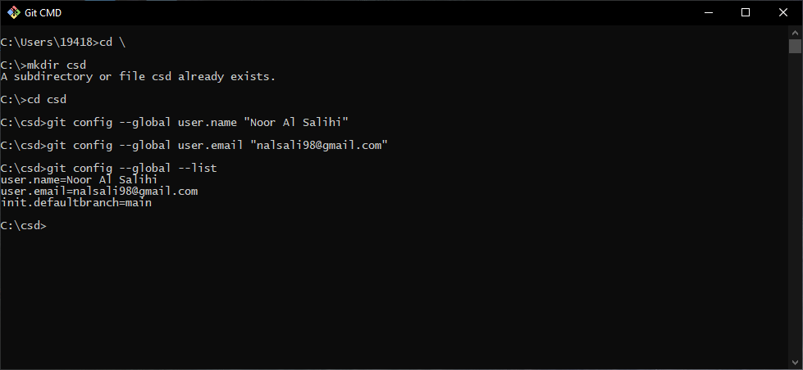

Screenshot 2: Repository Clone and Local Directory Structure
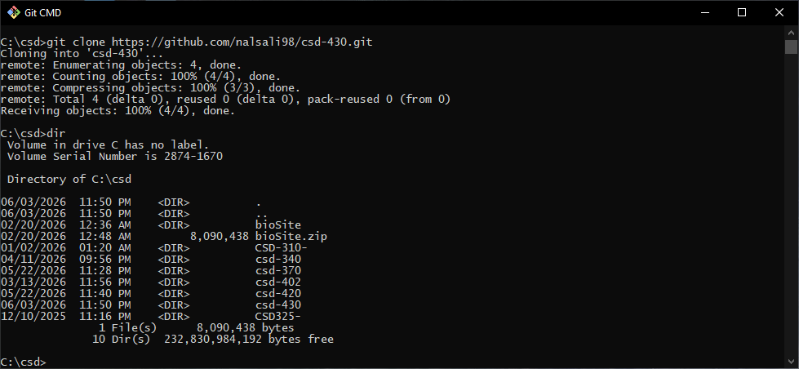

Screenshot 3: GitHub Account / Repository Page
