CSD430-340A Server Side Development (2267-DD)

Module 4.2 Programming Assignment Documentation
Student: Noor El-din Al salihi
Date: June 25, 2026

Final Webpage Output
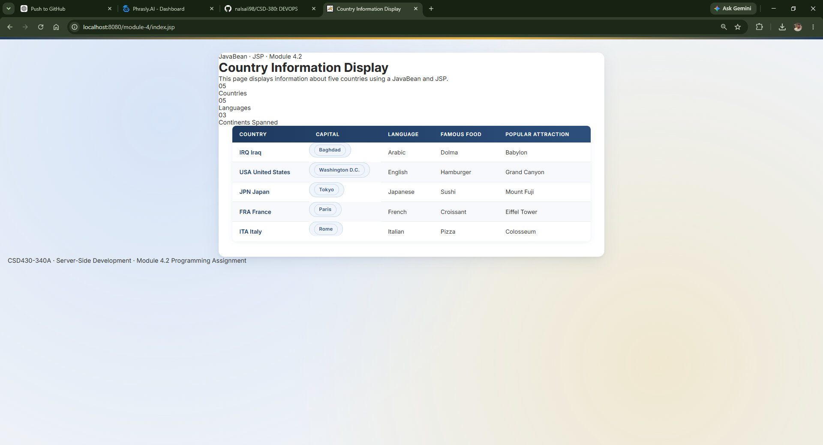

Project Folder Structure
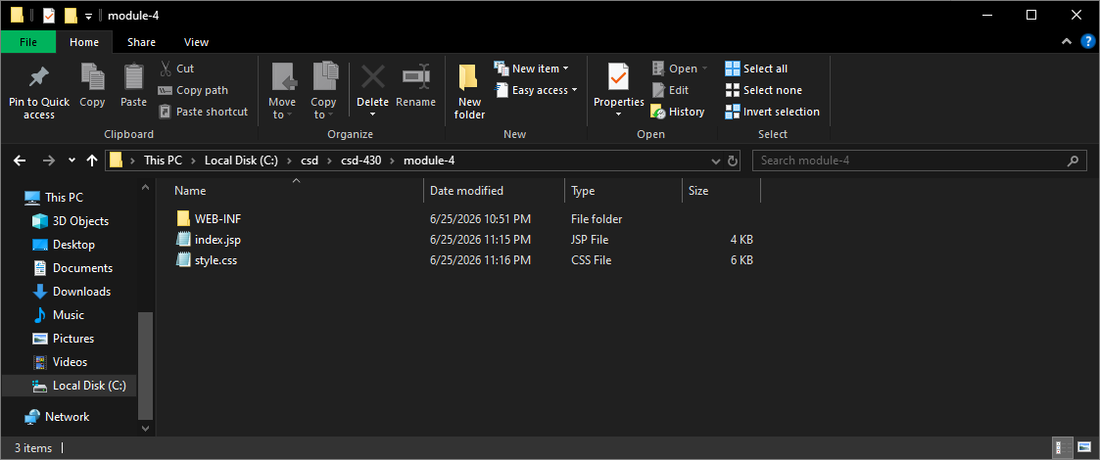

JavaBean Compilation Success
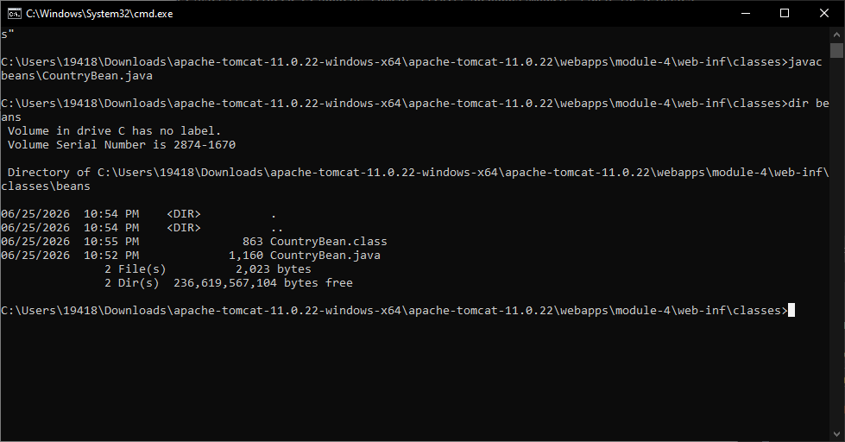

JAVA_HOME Configuration
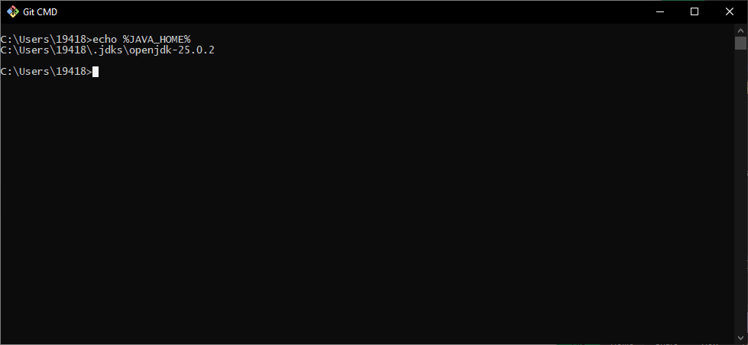

Tomcat Successful Startup
